Pivot tables are also one of the most extensively used tables in the industry. They are constructed out of a raw dataset and statistics of a combination of rows and columns. In order to understand it more let’s look at the example below.

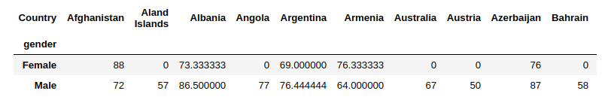

The above table shows us the mean weight of both males and females (rows) in each of the countries. The values inside the table are the means of the weights calculated across the given sample of countries. We will be constructing this table in the below code.