VIT BHOPAL UNIVERSITY
Department of Computer Science & Engineering
Course: Computer Vision

PRACTICAL FILE

────────────────────────────
Naruto Jutsu Hand Gesture Recognizer
A Real-Time Hand Sign Detection System with Anime-Style Visual Effects using OpenCV and MediaPipe
────────────────────────────

Submitted By
Name: Naman Singh
Registration No.: 23BAI10024
Submitted To
Department of Computer Science & Engineering
VIT Bhopal University
Date of Submission: 31st March 2026

────────────────────────────
Academic Year 2025–26

Declaration

I, Naman Singh, bearing Registration Number 23BAI10024, a student of the Department of Computer Science & Engineering at VIT Bhopal University, hereby declare that this practical file on the project titled “Naruto Jutsu Hand Gesture Recognizer” has been prepared by me independently and represents my original work carried out under the guidance of the faculty of this institution.
I further declare that this work has not been submitted, either in part or full, to any other examination board or institution for the award of any degree or diploma. All sources of information and references used in this report have been duly acknowledged.

Name: Naman Singh
Registration No.: 23BAI10024
Course: Computer Vision
Department: Computer Science & Engineering
University: VIT Bhopal University

1. Aim
To develop an interactive real-time hand gesture recognition application that identifies specific hand signs and combo sequences, triggering corresponding Naruto-inspired Jutsu effects — including Shadow Clone Jutsu, Rasengan, Fire Style: Fireball Jutsu, and Chidori — with dynamic particle systems, glowing visuals, lightning effects, and on-screen user guidance.

2. Objectives
- Implement accurate hand landmark detection using the MediaPipe Hand Landmarker (21-point model).
- Define and recognize multiple hand gestures: Open Hand, Fist, Pointing Finger, Two Fingers, and Ram Seal.
- Design a combo-based gesture recognition system where users perform a timed sequence of hand signs to activate Jutsus.
- Create visually compelling anime-style effects for each Jutsu: glowing blue spinning Rasengan chakra ball, electric lightning bolts for Chidori, multiple translucent clone auras for Shadow Clone, and flaming particles for Fireball Jutsu.
- Display a persistent semi-transparent on-screen instruction panel showing required combos and live progress status.
- Integrate optional sound effects using Pygame for a fully immersive experience.
- Ensure smooth real-time performance with screen-shake animations and fluid particle rendering.

3. Tools and Technologies Used
- Programming Language: Python 3.12
- Computer Vision Libraries: OpenCV, MediaPipe
- Numerical Operations: NumPy
- Audio Handling: Pygame
- Development Environment: Visual Studio Code
- Hardware: Webcam-enabled laptop / desktop

4. Methodology
The system captures live video from the webcam and processes each frame through a sequential pipeline:
- Hand Detection: MediaPipe Hand Landmarker detects 21 landmarks on the hand in real time, providing accurate joint and fingertip position data.
- Gesture Recognition: Finger extension states and relative inter-landmark distances are analyzed frame-by-frame to classify the current posture into a predefined gesture category.
- Combo Detection: A short time-windowed gesture history buffer tracks the sequence of recognized gestures and matches it against predefined Jutsu combo patterns.
- Effect Triggering: On a successful combo match, the system activates the corresponding visual effect (particle emission, glowing chakra ball, lightning arcs, or clone auras) along with dramatic text overlay and screen-shake animation.
- User Guidance: A semi-transparent overlay panel rendered in the top-left corner displays the required hand sign sequence for each Jutsu and tracks live combo progress.

5. Screenshots / Output
The following screenshots illustrate the system during live operation:
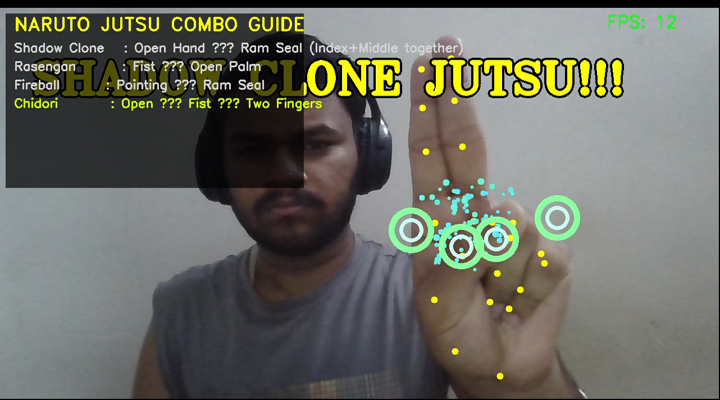
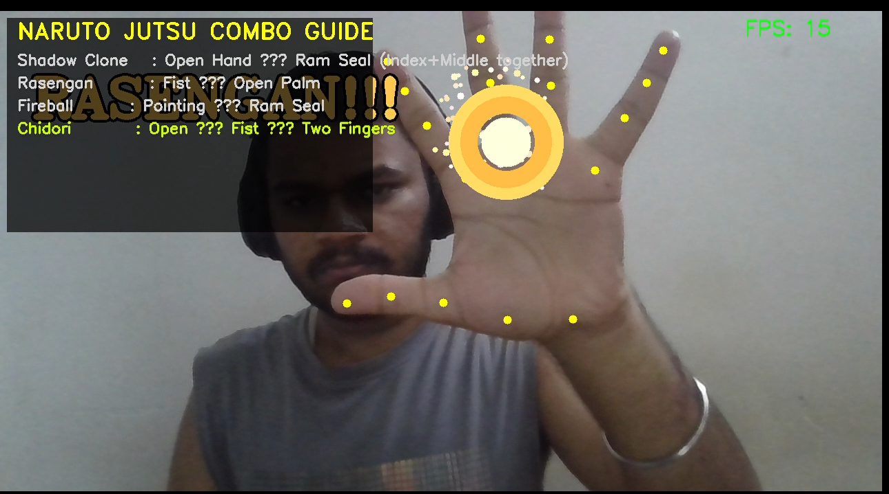
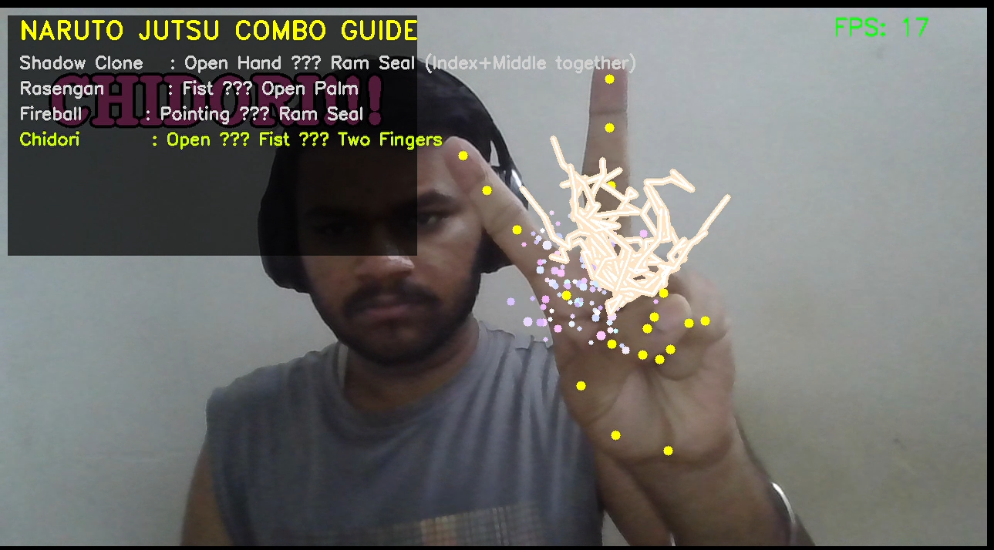

6. Code Implementation
Main File: naruto_jutsu.py
The complete source code is attached separately as naruto_jutsu.py along with the required hand_landmarker.task model file. It is recommended to submit the .py file as a separate appendix alongside this practical file.

7. Results and Observations
- The system runs smoothly at acceptable FPS on a standard laptop with an integrated webcam.
- Gesture recognition and combo detection work reliably when hand signs are performed clearly and in the correct sequence.
- Visual effects — particle systems, glowing Rasengan, and lightning arcs — deliver a convincing anime-style aesthetic.
- The on-screen instruction panel significantly reduces the learning curve for new users attempting combo sequences.
- Enabling Pygame sound effects noticeably improves user engagement and overall immersion.
- Minor performance degradation may be observed on low-end hardware due to the real-time MediaPipe inference pipeline.

8. Conclusion
This project successfully demonstrates the practical application of Computer Vision techniques in building an entertaining, interactive, and technically rigorous gesture recognition system. By integrating real-time hand tracking, gesture classification, particle-system rendering, and intuitive UI design, it covers a broad range of core CV concepts within a coherent and engaging context. The Naruto theme makes both development and demonstration enjoyable while effectively showcasing landmark detection, frame-level event triggering, and animated visual feedback.

Future Enhancements
- Support for additional traditional Naruto hand seals: Tiger, Dragon, Snake, Horse, and Bird.
- Voice output announcing the Jutsu name upon successful activation.
- Video recording and export feature for sharing activated Jutsu sequences.
- A settings GUI enabling users to customize effect intensity, sound volume, and combo timing thresholds.
- Multi-hand support for enabling two-handed combos and expanded Jutsu categories.

