ABSTRACT

Conceptual Security has consistently been a significant worry to the general public either in the family units or the workplace condition. Nowadays the use of Internet of Things(IoT) technology has developed that almost all aspects in human’s life utilize IoT technology to increase the quality of life. There are different methodologies set up to address these issues. The COVID-19 pandemic has highlighted a large amount of challenges to address. To combat the spread of the virus, several safety measures, such as wearing face masks, sanitizing , have been taken. Temperature controls at the entrance of public places to prevent the entry of virus carriers have been shown to be inefficient and inaccurate. COVID-19 has always shown an increase from time to time, this is due to the rise of physical contact, both directly between humans and through contact with equipment or public facilities. Body temperature is one indicator that shows how the human body is and its ability to generate or reduce heat in the body. Based on the information obtained, the normal human temperature is in the range of 36.5-37.20C, whereas if it is above that temperature a person can be said to have a fever, where fever is a symptom of COVID-19. This paper presents a smart door that allows to monitor body temperature and whether a person is wearing mask or not. We can extend our project by adding a data storing database that we can see in web application which contains rules violating persons picture and time of each person of entering the room.

Introduction

The purpose of security is to provide freedom from any risk of danger to his or her life, property etc. Every person should feel both safe and secure in his/her home, office or any of his/her place and that is more important because both safety and security affect an individual’s well-being. In this present world, every home is filled with large number of gadgets that keep the person comfortable and secure, that all connects to the internet in such a way that it rightly have us concerned for our security and privacy. As Countries around the Globe are Reopening, living with the Novel Coronavirus is becoming the new way of life. But to Stop the Spread of the Virus we need to separate people having the Coronavirus from the Rest. According to the CDC, fever is the leading symptom of the Coronavirus with up to [83%](https://www.cdc.gov/coronavirus/2019-ncov/hcp/clinical-guidance-management-patients.html) of Symptomatic Patients showing some signs of fever. Many Countries are making Temperature Checkups and Masks mandatory for Schools, Colleges, Offices, and other Workplaces. Currently, Temperature Checkups are done manually using Contactless Thermometer. Manual Checkups can be Inefficient, Impractical (in places with a large footfall), and Risky. Automatic Door is a **simple automated system**, where the door is automatically opened up on detecting a person’s body temperature with a maximum distance of 5cm and weather the person is wearing a mask and automatically closes after some time. This automatic door system is made for daily use during the pandemic to avoid the spread of the corona virus disease which can be transmitted through direct contact with objects contaminated with the virus. So far, the spread of this disease is very difficult to prevent and reduce because transmission can occur through non-physical contact which can be easily done without being noticed by people when touching common items or objects that are often used, one of which is doorknobs. The security is assured by different electronic gadgets such as Smart Home, Smart Locks, Fingerprint Scanning, Facial Recognition, Hand gesture, Audio Recognition, through SMS/MMS. In our paper we have used two different verification techniques that is, Face mask Recognition and Body Temperature Recognition based Smart door.

Propsed System

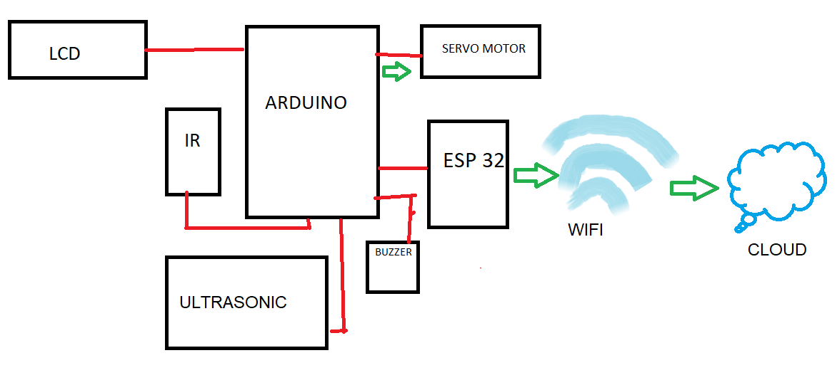

SOFTWARE APPLICABLE