

C

C

CRN

ICHSSA 1 PROJECT

DIALOUGE SESSION IN OBUFI, OKOBO

Submitted by: APPLICANTS WELFARE AND DEVELOPMENT CENTRE

Month/Quarter: APRIL/ Quarter 3

Submission Date: 25/4/2022

Executive Summary
AWANDEC is committed to driving policies that protect children in their various communities while strengthening existing community structures to help enhanced rights based approach in addressing child protection issues and ensuring the involvement of gatekeepers for safeguarding children from harm and abuse.
Within the reporting month, AWANDEC held a dialogue session in OBUFI community in OKOBO LGA. The aim of the session was to discuss issues on Child Abuse and to solicit support from the Child Protection Committee members in addressing this issue.

Summary of Key activities (In bullet point please)
- Dialogue session in OBUFI, OKOBO LGA.

Progress Narrative:
As children remain exposed to conflict, violence, neglect and abuse, Community-Based Child Protection/Quality Improvement Committee becomes essential to mobilize community responses, enhance referrals, raise awareness on child rights and ensure communities take part in creating a protective environment for children.
Following increasing reports of out of school children and teenage pregnancies in across various project communities, AWANDEC Community system strengthening Staff and AWANDEC Staff Team with support from the community program monitor of CCCRN collaborated to hold monthly CCPC meeting with the CCPC member on the effective ways to address the identified issues.
The forum was held on the 25th April 2022 at CHIEF PETER OKON EFFIONG’s compound in Obufi community at 2:00 p.m. The approach used in facilitating the session was a participatory approach which included structured presentations, Question & Answer sessions, experience sharing, and healthy debates among the participants.
The meeting began with an opening prayer led by Mr. Mark. Deliberations followed thereafter the CSS officer enlightened the participants on ICHSSA 1 Project goals and presented the topics for discussion which included issues on increased of out-school children and teenage pregnancy. The participants were briefed on teenage pregnancies and increased out-of school children in project communities which was backed up by data obtained during home visits for service provision. The facilitator enhanced on the reasons why they committee needs to act together to stop and reduce the reoccurrences of these issues in their communities. There were numerous questions raised in relation to the issues discussed as the attendees shared views and perspectives on various issues hampering teenage pregnancies and out-of school children.
The dialogue session exposed committee lack of knowledge of the issues raised in their community. One of the members, Bassey Ekpeyong pointed out that it would be good to set up a commitee that would look into this issues raised being that they are issues affecting the children in the community. Comfort Umoh Etim also added that some teachers in school will send students to their farms to do farm work instead of teaching the child what is needed that is the reason why some children do not want to go to school. To address this, Mary Peter the nutrition officer pointed out that if there are such cases recorded in the community the matter should be reported to the P.T.A of the school. Mr Orok Atte added that to reduce the incidence of out of school school children, families of the defaulters should be fined. Everyone agreed to the suggestion as it will serve as a deterrent to both child and make the parent or caregiver of the defaulter serious with the educational development of the child.
On sexual reproductive health issues and the increased in teenage pregnancies, a participant was of the opinion that teenagers be introduced to family planning to teenagers in the communities to curb the rise in teenage pregnancy, which other members kicked against.
The community program monitor Emem allayed her fears, explaining that advising the girls to go for family planning may encourage promiscuity and increase in HIV transmission. Instead, abstinence should be encouraged.
Mr Mark complained of some persons coming into the community to teach the young girls on family planning.
Emem Udofia reminded the chief and his opinion leaders that they are supposed to screen information from anybody before allowing the information be passed down. This will regulate and control the type of information been passed to the people.
Finally, after exhaustively discussing of ways manner to curb this issues it was decided that a child protection committee should be formed to look into these matters. Chief Okon Effiong mandated Mr Mark to setup the committee.

Output:
- 37(M 15: F12) persons were in attendance.
- A CQIT is to be setup to address the issues discussed during the dialogue session.
- Membership of the CPC was itemized to the village.

2. Outcome
- A Child Protection Committee would be set up.
- Issues surrounding gender based violence was discussed.
- Screening of messages by gatekeepers of the community before passing it to the populace.

Challenges:

Recommendations

4. Follow Up Action
- Setting up a commitee.
- Identification for school that practice using of students on their personal farming and reporting them to the appropriate authority.
- To set up a team of youths to monitor loitering during school hours.
- To fine families of children who are seeing farming and Loitering during school hours.

PICTURES
Community Dialogue, OKOBO

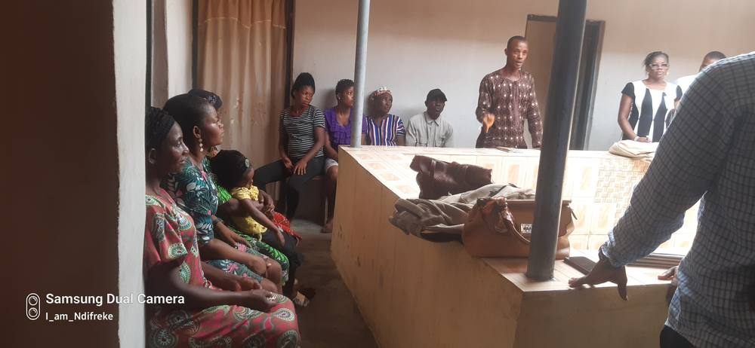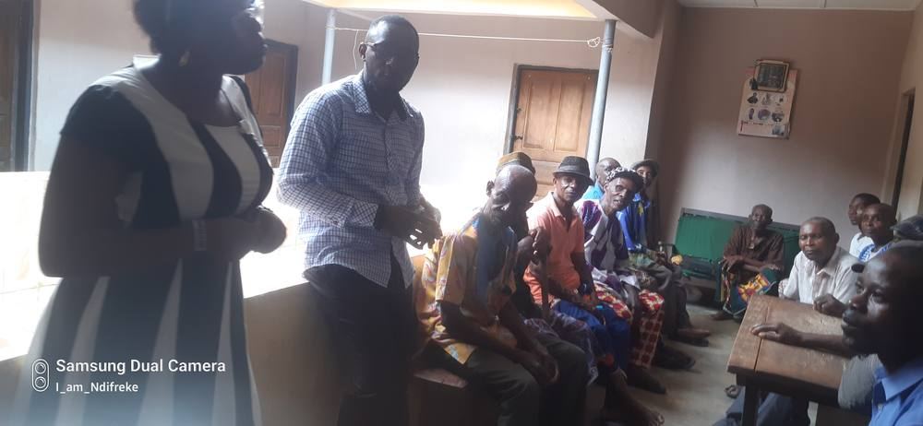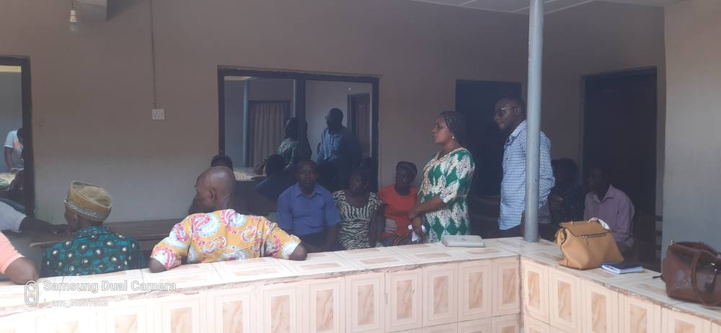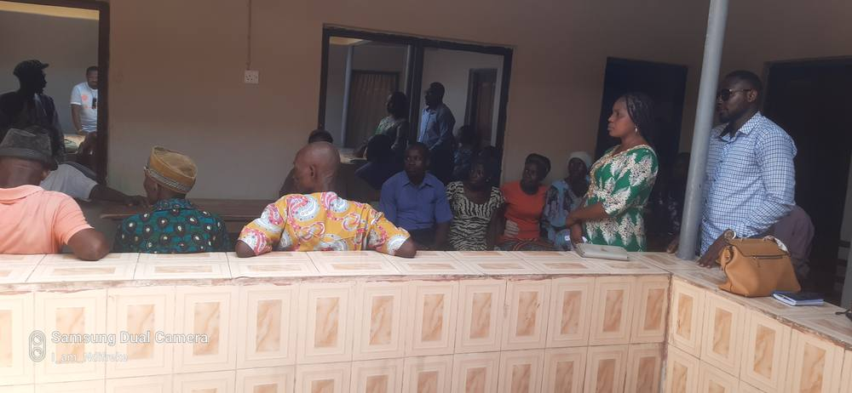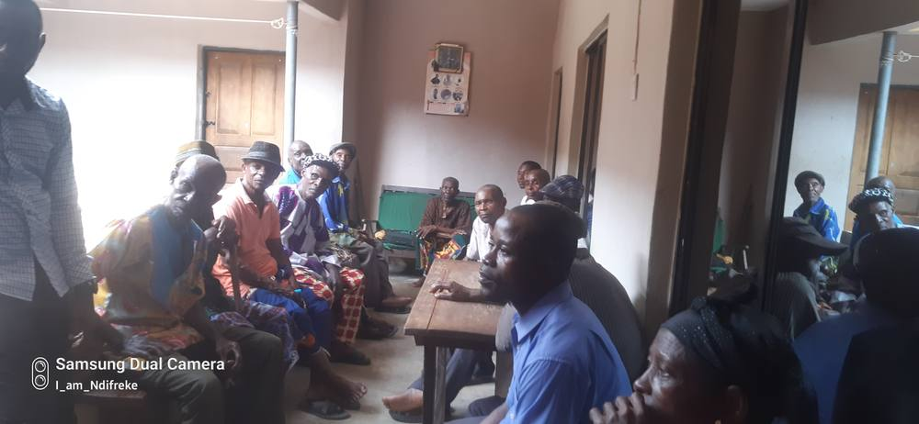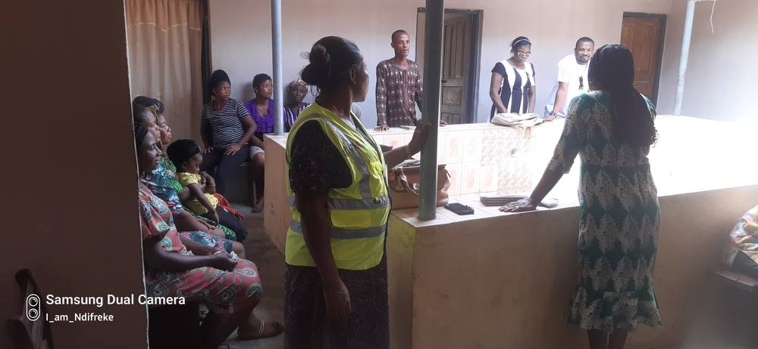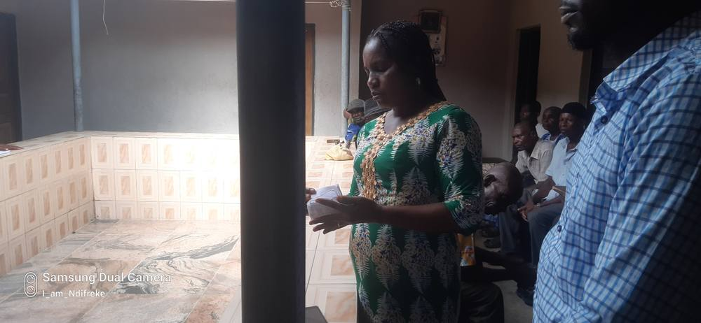

Reported by:
AKPAN EMMANUEL NDIFREKE/CCS&GO , AWANDEC

25/4/2022

REVIEWED BY:
ARIT UDOAKAGHA/PROGRAM MANAGER, AWANDEC

26/4/2022

