Integrated Child Health and Social Service Award (ICHSSA 1)
- Akwa Ibom, Cross River and Bayelsa -

Programmatic Progress Report

MAY/2022

Programmatic Progress Report – Integrated Child Health and Social Service Award (ICHSSA1)
State: | Akwa-Ibom
Cooperative Agreement | No: 72062020CA00006
Period of Performance: | FY: 2020 __☐; 2021 __☐; 2022 __☒; 2023__☐; 2024__☐
Reporting Period: | Oct-Dec_ ☐; Jan-March__ ☒; Apr-Jun__ ☐; Jul-Sep__ ☐
Report Type: | Monthly___☒ | Quarterly___☐ | Semi-Annual___☐ | Annual___☐
Submitted by: | Arit Udoakagha PM-AWANDEC
Submission date: | 31ST MAY, 2022.

- Project Overview and Objectives.

The Integrated Child Health and Social Service Award ICHSSA 1 is a newly awarded five-year agreement by USAID, commenced on December 19, 2019. ICHSSA 1 is implemented by Center for Clinical Care and Research Nigeria in partnership with Catholic Relief Services, alongside other local resource experts.

CCCRN is an indigenous, leading organization promoting best practices in clinical health care delivery, medical trainings and research using locally adapted models of health systems strengthening. Key intervention areas also cover providing HIV counseling and testing; care and treatment for children, adults and key population; support for PMTCT; case management for OVC; TB/HIV integration and care; laboratory services and evidence building through strategic information.

The project will ensure that Orphans and Vulnerable Children (OVC) are cared for, and protected by their households, communities, and local and state government to reduce their vulnerability to HIV. ICHSSA 1 is implemented in 31 LGAs in Akwa Ibom and 15 LGAs in Cross River States, Nigeria.

The project expected results is highlighted as follows:
- Households have increased access to basic services and care for OVC
- Communities ensure that OVC secure their rights
- Local and State Government deliver basic services, detect and respond to child rights violations
- Prioritized targeted services for specific OVC subpopulations delivered

Project Strategy:
- Comprehensive case management and integrated child health interventions for OVC and HHs
- Optimization of HIV Care and Support for OVC Sub-population (HIV exposed infants, CLHIV, C-FSW, ALHIV etc)
- Institutional, community and household strengthening for self-reliance, social security and sustainability
- Strengthen community-facility linkage and support services including HIV-TB service integration
- Data demand, use and adaptive management for improved quality of care to OVC and HHs; including promoting program learning and social accountability.
SUMMARY OF OVC/BENEFCIARY ENROLMENT AND SERVICE PROVISION

 |  | SEX
S/N | INDICATOR | M | F | TOTAL
1 | OVC_OFFER | 240 | 246 | 406
2 | TOTAL NO OF OVC NEWLY ENROLLED | 30 | 35 | 65
3 | TOTAL NO OF OVC SERVED | 2490 | 3469 | 5959
4 | TOTAL | 2490 | 3469 | 5959

ENROLMENT BY STREAMS
 |  |  | SEX
S/N | CSO | ENROLMENT STREAM | M | F | TOTAL
1 |  | CHILDREN AND ADOLESCENTS LIVING WITH HIV (C/ALHIV) | 13 | 9 | 22
2 |  | CHILDREN LIVING WITH HIV-POSITIVE ADULT (C-PLHIV) | 9 | 9 | 18
3 |  | CHILDREN OF KEY POPULATION/KP MINORS (C-KP) | 0 | 0 | 0
4 |  | HIV EXPOSED INFANT (HEI) | 1 | 0 | 1
5 |  | SURVIVORS OF VIOLENCE AGAINST CHILDREN (SVAC) | 0 | 0 | 0
6 |  | HIGH RISK ADOLESCENTS (HRA) | 0 | 0 | 0
7 |  | POSITIVE CAREGIVERS | 0 | 4 | 4
8 |  | NEGATIVE CAREGIVERS | 7 | 13 | 20
 |  | TOTAL | 30 | 35 | 65

- Accomplishments during reporting period (describe activity title/type and achievements at output levels, without deleting any output not achieved for the period)
Section 1: Project Management
Output PM1: Project Management Coordination and Supervisory Function
During the month under review, the project Management supervised activities and sustainable services carried out by AWANDEC TEAM aimed at improving the wellbeing of Orphans and vulnerable Children (OVC) and their Households. Some activities conducted included, direct service provision, increased access to HIV services, Savings and Internal Lending Community (SILC) groups formation in project LGAs to contribute to household economic strengthening (HES), provision of improved seedlings to vulnerable households, meetings with Traditional Birth Attendance to strengthen referral coordination between the traditional birth attendants and the health facility aimed at preventing mother to child transmission, Mobilization for OTZ meetings, support to access Antiretroviral Therapy, Nutrition Assessment, Food Demonstration, LGA task coordination meeting to enhance capacities of community stakeholders in addressing issues in their communities, provision of birth certificate to children without birth certificate, Gender Norms sessions, as well as mentoring and supportive supervision for community case workers(CCWs).
Overall, a total of 3922(1828M:2094F) OVC and 2037(662M:1375F) caregivers were served during the reporting period. Similarly, a total of 2311 (1034M:1177F) active beneficiaries who were at risk of HIV infection were risked and provided access to HIV services, 328(161M:167F) OVC provided with Birth certificate, 124 (49M:75F) ALHIV were mobilized by CCWs to attend OTZ meetings, 20(11M: 9F) beneficiaries were assisted with support to the facilities for ARV pickup, 1219(491M:728F) participants completed 10 Gender Norms sessions, 41(8M:33F) vulnerable households received improved seedlings to start homestead gardening, while a total of 30 (11M: 19F) Participants benefitted from food demonstration exercise within the reporting period.

- CASH TRANSFER POST DISBURSEMENT MONITORING SURVEY
On the 17th and 18th of May 2022, AWANDEC HES/Nutrition Officer, Community Program Monitor and CCWs carried out a post disbursement monitoring survey of phase 2 cash transfer that took place between July and September 2021 cross communities in Okobo LGA, this was aimed at assessing increased access to health care services by beneficiaries as well as assessing the impact of the cash transfer in improving the economic status of the orphans and vulnerable children and their households. A total of 30 households were sampled for the survey. From the survey, it was gathered that, 2(1M:1F) got enrolled in vocational training centers to learn Design pillars and Tailoring respectively, 6F purchased temporary farmlands for cultivation, 4(1M:3F) started petty businesses, 2F were able to pay for children’s’ school fees/purchase some school materials, while 16 households used the cash to meet household consumption needs. Overall, the vulnerability status of all households who benefitted from the cash transfer scheme have been greatly improved.

- FORMATION OF SILC GROUPS
As part of the efforts to strengthen household economic sustainability, SILC groups were formed in 7 project communities within the reporting period. A total of 7 active SILC groups with a total of 131(27M:104F) members have been formed in Okobo and Mbo LGA. Of the 7 SILC groups, only 4 groups have commenced savings as all groups are still in the early stage. So far, the cumulative value of all group savings stands at N86,700.

- SUPPORTIVE SUPERVISION:
The project Management conducted supportive supervision visits to CCWs and monitoring visits were made to collect data as well as provide supportive supervision in ensuring data quality. Some data quality issues such as incomplete data, cancellations were identified and corrected. Supportive supervisory visits were conducted in all project communities to support CCWs in collecting quality data and to ensure quality service delivery.
Activities also monitored were, OTZ meetings, Food demonstration, SILC formation, Gender Norms, LGA task coordination meetings, ARVs uptake.

- BIRTH REGISTRATION AND CERTIFCATION:
As part of increased effort to create safe environment for children in project communities, AWANDEC in the reporting period facilitated the linkage of 328 OVC who were without birth certificate prior to enrollment into OVC program to National Population commission for registration and issuance of birth certificate in the month of May across Okobo, Mbo, Udung-Uko, and Urue Offong Oruko LGAs. A total of 328 OVC were provided with birth certificate.

- Mobilization of ALHIV for OTZ meetings:
OTZ is a platform which brings positive adolescents (10-24) on board to actively participates in the management of their own health with support from OTZ trained coordinators and facilitators and this was conducted in the month under review, AWANDEC facilitated the mobilization of a total of 124 ALHIV to attend OTZ meetings which held in AWANDEC’s four (4) project LGAs; in namely; Primary Health Care Operational Base, Enwang, Mbo; Primary Health Care Centre, Eyokponung, General Hospital, Urueoffong Oruku and Primary Health Centre Okopedi in Okobo within the reporting period.

Key area point discussed were status disclosure, HIV/AIDS prevention and menstrual hygiene. Key psychosocial support services provided to children include; story-telling, recreation/play, group activities and traditional games to children based on their age groups and production of Zobo drink.

OTZ was also a platform used in distributing sanitary pads to adolescent girls where a total of 58 Positive adolescent girls were reached during the meeting across the four LGAs.

Below is the number of adolescents provided with sanitary pads per LGAs

S/N | LGA | NO OF ADOLESCENT GIRLS REACHED BY LGA
1 | OKOBO | 20
2 | URUE OFFONG/ORUKO | 10
3 | MBO | 8
4 | UDUNG UKO | 20

- LGA TASK COORDINATION MEETING:
As part of increased effort to create safe environment for children and strengthen community stakeholders to take action in health and social challenges to help create a protective environment for children, an LGA coordination task team meeting was held on the 27th of May, 2022 in Okobo. Issues discussed include; increase in out of school children, sexual and gender based violence(GBV), stigma and discrimination against HIV positive persons. A total of 13 persons were in attendance. A Task Team was agreed to be setup to address the issues discussed during the dialogue.

- DISTRIBUTION OF IMPROVED SEEDLINGS TO CAREGIVERS.
In a bid to combat malnutrition amongst project beneficiaries, AWANDEC undertook activities aimed at improving household food security. 41 households; 10 from Mbo, 10 from Udung Uko, 6 from Urue Offong Oruko benefitted from the supply of different seedlings distribution. Seedlings distributed include, OKro seeds, pumpkin seeds and Maize seeds. Through this, Caregivers have adequate knowledge on the importance and benefits of developing a nutritional home garden.

- FOOD DEMONSTRATION:
Food demonstration in project communities is a good avenue to create awareness on nutrition tips. Within the reporting period, Food demonstration was conducted in Eyonsek community in Udung Uko on the 24th of May, 2022 to reach 30(11M:19F) project beneficiaries and community members.

Some key activities carried out during the food demonstration exercise were; Practical demonstration of TOMBROWN production and preparation, Sensitization of caregiver on the need to setup homestead gardens, educating nursing mothers on the importance of exclusive breastfeeding, Distribution of improved seedlings to caregivers, introduction of caregivers to income generating activity, as well as Distribution of Nutritional supplement(TOMBROWN) to children.

- Mobilization for Drug pick and Viral load sample collection:
In the month under review, a total of 20 (11 M: 9F) beneficiaries were mobilized and support for ARVs pickup in Urueoffong Oruko, mbo and Okobo LGAs.

- GENDER NORMS SESSIONS:
Gender Norms sessions are beneficial in facilitating the exploration of interrelationships between gender, child protection and HIV while also supporting individual, family and community level action plans to mitigate the impact of negative gender norms. AWANDEC within the reporting period facilitated Gender norms sessions in 15 communities of AWANDECs four (4) LGAs to reach 1219 participants. The gender norms discussions were delivered in 10 sessions for parents/caregivers (sessions 1 – 10) and for youths/adolescents aged 10 – 17 years (sessions 1 – 8; 11 – 20) with clear illustrations shown to the participants during the group discussions. The focus of these discussions was on Gender and Sex, Gender-based Violence, Gender and Child Protection, Early Child Marriage, Neglect of Girl-child Education, Male Involvement and Women Empowerment and Sexual and Reproductive Health Education for Adolescents.

Output PM2: Monitoring, Evaluation, Learning and Reporting
- SERVICE PROVISION
In May 2022, while AWANDEC Team carried out supportive supervision to AWANDEC’s project sites (Mbo, Okobo, Udung Uko and Urue-offong Oruko), OVC and caregivers/household service forms were collected and reviewed for Nomis entry. From the data collected and assessed, 32 CCWs (14M:18F) provided quality services to 5,959 (2,490M: 3,469F) beneficiaries from 1,997 households in the month of May 2022. These comprised 3,922 OVC (1,828M: 2,094F) and 2,037 caregivers (662M: 1,375F).
Service provision analysis
The table below contains the breakdown of beneficiaries reached with qualitative support services within the reporting period.
S/N | LGA | VC |  | CAREGIVERS |  | OVC_SERV | HH SERVED
S/N | LGA | M | F | M | F | OVC_SERV | HH SERVED
1 | MBO | 179 | 276 | 100 | 207 | 762 | 310
2 | OKOBO | 1424 | 1509 | 461 | 948 | 4342 | 1363
3 | URUEOFFONG ORUKO | 134 | 174 | 57 | 119 | 484 | 173
4 | UDUNG UKO | 91 | 135 | 44 | 101 | 371 | 151
TOTAL |  | 1828 | 2094 | 662 | 1375 | 5959 | 1997

Enrolment Analysis
Within the reporting period, 65 new beneficiaries were enrolled into the project to access qualitative OVC services. This number consists of 41 OVC (24 M, 17 F) and 24 Caregivers (7 M, 17 F) in 23 Households across the four (4) AWANDEC project sites (Mbo, Okobo, Udung Uko and Urue Offong Oruko). Analysis by enrolment streams can be seen in the table below

S/N | LGA | VC |  | CAREGIVERS |  | OVC_ENROLLED | HH ENROLLED
S/N | LGA | M | F | M | F
1 | MBO | 5 | 3 | 2 | 6 | 16 | 7
2 | OKOBO | 15 | 12 | 2 | 8 | 37 | 10
3 | URUEOFFONG ORUKO | 0 | 0 | 0 | 0 | 0 | 0
4 | UDUNG UKO | 4 | 2 | 3 | 3 | 12 | 6
TOTAL |  | 24 | 17 | 7 | 17 | 65 | 23

Section 2: Program Results
RESULT 1 - HOUSEHOLDS HAVE INCREASED ACCESS TO BASIC SERVICES AND CARE FOR OVC
IR 1.1 Households are economically stable and have food security
Output 1.1.1: Households have increased access to at least one predictable source of income and able to cover the costs of important family needs
Suggested Activities:
- Cash Transfer
Data Request:
- # of beneficiaries (disaggregated state, sex, age-specific, LGA and sub-population)

CSO | LGA | MEAN  AGE | SEX |  | SUB-POPULATION
CSO | LGA | MEAN  AGE | M | F | CLHIV | C-PLHIV | C-KP/KP MINOR | OLDER ADOLESCSENTS
AWANDEC
TOTAL

- Amount disbursed:
- Mechanism of disbursement
- Period of disbursement
- Amount disbursed to each sub-population.
- Stakeholders’ engagement and collaborations; reporting to LG and State (CT office); Linkage/Access: #beneficiaries supported/absorbed by Government.
- Private sector involvement and inclusion – Linkage/Access: #beneficiaries absorbed/supported.
- Utilization of CT – by type of support: healthcare, education, IGAs
In the month under review, Post disbursement monitoring survey of phase 2 cash transfer that took place between July and September 2021 cross communities in Okobo LGA, this was aimed at assessing increased access to health care services as well as assessing the impact of the cash transfer in improving the economic status of the orphans and vulnerable children and their households. 60% of cash transfer beneficiaries which is a total of 30 households were sampled for the survey. From the survey, it was gathered that, 2(1M:1F) were enrolled in vocational training centers to learn Design pillars and Tailoring respectively, 6F purchased temporary farmlands for cultivation, 4(1M:3F) started petty businesses, 2F were able to pay for children’s’ school fees/purchase some school materials, while 16 households used the cash to meet household consumption needs. Overall, the vulnerability status of all households who benefitted from the cash transfer scheme have been greatly improved.

- Capacity Building (training, mentoring) – Financial Literary, Value Chain Development
- Participants – disaggregated by sex, CBO, LGA and state actors (LG & State)

CBO | LGA | SEX |  | CATEGORY OF PARTICIPANT
CBO | LGA | M | F | LGA | STATE

- CB approach – training (virtual, residential and non-residential), mentoring (handholding/OJT, exchange visits, shadowing), coaching and platforms (community structures, existing peer groups, leveraging with TX partners etc)

- Savings Group
As part of the efforts to strengthen household economic sustainability, SILC groups were form in 7 project communities within the reporting period. A total of 7 active SILC groups with a total of 131(27M:104F) members have been formed in Okobo and Mbo LGA. Of the 7 SILC groups, only 4 groups have commenced savings as all groups are still in the early stage. The cumulative value of all group savings stands at N86,700 across the 7 SILC Groups.
- Group membership (by sex, age range – adults or adolescents)

- Number of groups (disaggregated by peer-led; beneficiary group – ICHSSA1 vs non; location/settings – rural; urban and semi-urban)

CSO | LGA | Average Age of Group Members | Beneficiary Group |  | Location of group
CSO | LGA | Average Age of Group Members | ICHSSA 1 | NON-ICHSSA | RURAL | SEMI-URBAN | URBAN
 | OKOBO | 45 | 12 | 4 | 16 | 0 | 0
 | MBO | 30 | 13 | 12 | 25 | 0 | 0
 | OKOBO | 22 | 5 | 14 | 19 | 0 | 0
 | OKOBO | 30 | 8 | 9 | 17 | 0 | 0
 | OKOBO | 25 | 10 | 14 | 24 | 0 | 0
 | OKOBO | 30 | 6 | 9 | 15 | 0 | 0
 | OKOBO | 30 | 8 | 7 | 15 | 0 | 0

- Loan portfolio (disaggregated by savings – by sex, location/settings, ROI -)
CSO | LGA | Name of savings group | Number of members |  | Location of group |  |  | Savings Group Performance
CSO | LGA | Name of savings group | M | F | Rural | Semi Urban | Urban | Savings | Interest on loan
AWANDEC |  | NKA UFORO | 0 | 25 | 25 | 0 | 0 | N25,000 | 0
 |  | NKA UWAM MBIEDUO | 5 | 11 | 16 | 0 | 0 | N10,600 | 0
 |  | UTITOFON IDARA | 1 | 16 | 17 | 0 | 0 | N24,100 | 0
 |  | NKA IDOREYIN | 4 | 15 | 19 | 0 | 0 | N27,000 | 0
TOTAL |  |  | 10 | 67 | 77 | 0 | 0 | N86,700 | 0

- Social fund (disaggregated by areas utilized)
CSO | LGA | Name of Savings group | Amount in social fund portfolio | Amount of social funds disbursed | Area of utilization of disbursed fund

- Savings outcomes (by areas – healthcare, IGAs, education support etc.)

- Financial Education: Outcomes of financial education sessions
As part of the efforts to strengthen household economic sustainability, Caregivers in the month under review were reached with financial education during SILC group meetings and during home visits. Through these sensitization, a total of 7 SILC groups were formed in project communities for the sole purpose of generating income to help cater for immediate family needs.

CSO | LGA | M | F | Total
AWANDEC | OKOBO | 449 | 656 | 1105
AWANDEC | MBO | 39 | 73 | 112
AWANDEC | URUE OFFONG ORUKO | 21 | 59 | 80
AWANDEC | UDUNG UKO | 13 | 45 | 58

Output 1.1.2 Households are able to provide minimum acceptable diet to all children
Suggested Activities:
- IYCF
- Beneficiaries (disaggregated by sex, age, LGA, men-involvement)
CSO | LGA | No. of beneficiaries of IYCF | Mean Age | Sex |  | Location Setting
 |  |  |  | M | F | Rural | Semi Urban | Urban

- Cohorts (by sessions completed, pre-post KAP results)
- Integration (by existing community groups, TX partners structures)

- Food Demonstration:
Food demonstration in project communities is a good avenue to create awareness on nutrition tips. Within the reporting period, Food demonstration was conducted in Eyonsek community in Udung Uko on the 24th of May, 2022 to reach 30(11M:19F) project beneficiaries and community members.
Some key activities carried out during the food demonstration exercise were; Practical demonstration of TOMBROWN production and preparation, Sensitization of caregiver on the need to setup homestead gardens, educating nursing mothers on the importance of exclusive breastfeeding, Distribution of improved seedlings to caregivers, introduction of caregivers to income generating activity, as well as Distribution of Nutritional supplement(TOMBROWN) to children.

- Beneficiaries (disaggregated by sex, age, LGA, men-involvement, number of groups)

CSO | LGA | No. of beneficiaries of food demonstration | Mean Age | Sex
 |  |  |  | M | F
AWANDEC | MBO | 30 | 20 | 11 | 19

- Sessions (by location – rural and semi-urban, pre-post KAP/utilization results)
- Nutrition Assessment
- Assessment report (by age, sex, LGA, location settings – rural, semi-urban)
In the month of May, a total of 2083 (967M:1116F) beneficiaries were provided with nutrition education and assessment across the 4 implementing LGAs, Mbo, Okobo, Udung uko and Urue Offong Oruko.
CSO |  | NO. OF BENEFICIARIES ASSESSED | SEX |  | LOCATION SETTING
CSO |  | NO. OF BENEFICIARIES ASSESSED | M | F | RURAL | SEMI-URBAN | URBAN
AWANDEC | UDUNG UKO | 147 | 60 | 87 | 147 | 0 | 0
AWANDEC | OKOBO | 1435 | 703 | 732 | 1435 | 0 | 0
AWANDEC | URUE OFFONG ORUKO | 216 | 91 | 125 | 216 | 0 | 0
AWANDEC | MBO | 113 |  | 172 | 285 | 0 | 0

- Assessment findings (by MAM, SAM and Well-nourished; sub-set: by age, sex and LGA, location settings – rural, semi-urban)

Nutrition assessment was carried out for project beneficiaries within the reporting period, all beneficiaries assessed were recorded to be well nourished. this was due to acceleration of program strategies for improving access to nutrition education, counselling and food demonstration sessions across all LGAs experiencing malnutrition, while beneficiaries were encouraged to continue proper nutrition in order to maintain healthy nutrition status.
CSO | LGA | Mean Age of beneficiaries assessed | Sex |  | Nutrition  assessment findings |  | Location setting
CSO | LGA | Mean Age of beneficiaries assessed | M | F | MAM | SAM | Rural | Semi-Urban | Urban
AWANDEC | OKOBO | 7 | 703 | 732 | 0 | 0 | 1435 | 0 | 0
AWANDEC | UDUNG UKO | 5 | 60 | 87 | 0 | 0 | 147 | 0 | 0
AWANDEC | MBO | 6 | 113 | 172 | 0 | 0 | 285 | 0 | 0
AWANDEC | URUE OFFONG/ORUKO | 5 | 91 | 125 | 0 | 0 | 216 | 0 | 0

- Linkage (by facility – PEPFAR or Non-SDPs; completed referrals)

- Interventions (by type of support, age-specifications, sex and LGA)
CSO | LGA | Mean Age of beneficiaries of intervention | Sex |  | Type of intervention provided.
CSO | LGA | Mean Age of beneficiaries of intervention | M | F

- Management of SAM and MAM
- Commodities (by types, LGA)

CSO | LGA | Commodity provided
CSO | LGA | Fortified Food | Vitamin A | Other Vitamin Angels | Iron Folic Acid | Insecticide treated net | Food

- Reviews (by pre-post results) quarterly
- Homestead Gardening
In a bid to combat malnutrition amongst project beneficiaries, AWANDEC undertook activities aimed at improving household food security. 41 households; 10 from Mbo, 10 from Udung Uko, 6 from Urue Offong Oruko benefitted from the supply of different seedlings distribution. Seedlings distributed include, OKro seeds, pumpkin seeds and Maize seeds. Through this, Caregivers have adequate knowledge on the importance and benefits of developing a nutritional home garden.

- Beneficiaries (by sex, location settings – rural, semi-urban)
CSO | LGA | Sex |  | Location setting (Rural/Semi-Urban)
CSO | LGA | M | F | Rural | Semi-Urban | Urban
AWANDEC | OKOBO | 5 | 10 | 15 | 0 | 0
AWANDEC | MBO | 2 | 8 | 10 | 0 | 0
AWANDEC | URUE OFFONG/ORUKO | 1 | 5 | 6 | 0 | 0
AWANDEC | UDUNG UKO | 0 | 12 | 12 | 0 | 0

- Established gardens (by households, location settings – rural, semi-urban)
- Capacity building (by CBOs, Households, LGA)
- MNCH services:
- Vit A Supplementation:
- Deworming:
- Prenatal IFA for pregnant women:
- Beneficiaries 0-5 years fully immunized:
To ensure improve routine immunization coverage and to ensure project beneficiaries under the ages of 5 years are fully immunized the Community case workers mobilized beneficiaries within the reporting period, a total of 808 (397M:411F). comprising of 547(264M:283F) OVC in Okobo, 52(26M:26F) OVC in Udung Uko, 116(58M:58F) OVC in Mbo and 93(49M:44F) OVC in Urue Offong Oruko.
- Beneficiaries (disaggregated by sex, age, LGA, men-involvement, number of groups)

CSO | LGA | Mean Age of beneficiaries reached with MNCH services | Sex
CSO | LGA | Mean Age of beneficiaries reached with MNCH services | M | F

- Linkage (by facility – PEPFAR or Non-SDPs; completed referrals)

- Linkage (by facility – PEPFAR or Non-SDPs; completed referrals)
- Nutrition, Education, Counseling and Support (NAC)
- Beneficiaries (disaggregated by sex, age, LGA, men-involvement, number of groups)

CSO | LGA | Age |  |  | Sex

- Sessions (by location – rural and semi-urban, pre-post KAP/utilization results)
- Beneficiaries (disaggregated by sex, age, LGA, men-involvement)

CSO | LGA | No. of beneficiaries of NAC sessions | Mean Age | Sex |  | Location Setting
 |  |  |  | M | F | Rural | Semi Urban | Urban

Output 1.1.3: Increased number of adolescents able to achieve financial self-sufficiency after participating in market driven livelihoods development activities
- IGAs/Vocational Skills training narrative should include choice of vocational skills
- Beneficiaries (disaggregated by LGA, sex, age group – adolescents and adults)
CSO | LGA | Age group |  | Sex
CSO | LGA | Adolescents | Adult | M | F

S/N | Vocational skill | Total number of beneficiaries enrolled

- Direct types of support – (disaggregated by IGA type, graduated, mobilized)
- Financial/Resourcing – improvement in household income from baseline,
- Indirect types of support – (disaggregated by number, SMEs/groups, LGA,)
IR 1.2 Caregivers adopt appropriate parenting practices
Output 1.2.1: Improved mental health among parents and caregivers caring for OVC including parents of subpopulation
- Mental health assessment and profiling
- Assessment report (by findings – mild, moderate, and severe; age, sex, LGA, location settings – rural, semi-urban)
CSO | LGA | Mean Age | Sex |  | Assessment findings |  |  | Location setting
CSO | LGA | Mean Age | M | F | Mild | Moderate | Severe | Rural | Semi-Urban | Urban

- Mental Health sensitization
- Beneficiaries (disaggregated by LGA, sex, age group – adolescents and adults)

CSO | LGA | No of HHs sensitized | Mean Age | Sex
 |  |  |  | M | F

- Integration (by existing community groups, TX partners’ structures)
- Capacity building
- Capacity building (by CBOs, Households, LGA)
Output 1.2.2: Improved relationships between parents/caregivers and the OVC in their care
- Caregiver’s forum
- Beneficiaries (disaggregated by LGA, sex, age)

CSO | LGA | No of Caregivers | Mean Age | Sex
 |  |  |  | M | F

- Cohorts (by completed sessions, location – rural and semi-urban, pre-post KAP/utilization results)
CSO | LGA | No. of sessions completed by cohort | Mean Age | Sex |  | Location Setting
 |  |  |  | M | F | Rural | Semi Urban | Urban

- Home visits: avenue for improved parenting skill
In the month of April, household folders were randomly selected for home visits. This was necessary to keep track of what the CCWs are doing and how they are discharging their duties. The necessary services and interventions were provided to the households by the Staff team during the visits.
- Households (disaggregated by LGA, rural and semi-urban)
CSO | LGA | No. of HHs visited | Mean Age | Sex |  | Location Setting
 |  |  |  | M | F | Rural | Semi Urban | Urban
AWANDEC | URUE OFFONG ORUKO | 10 | 5 | 4 | 6 | 10 | 0 | 0
AWANDEC | UDUNG UKO | 10 | 5 | 3 | 7 | 10 | 0 | 0
AWANDEC | MBO | 16 | 10 | 9 | 6 | 16 | 0 | 0
AWANDEC | OKOBO | 44 | 6 | 16 | 28 | 44 | 0 | 0

- Interventions (disaggregated by type of support)
- Capacity building
- CB approach – training (virtual, residential and non-residential), mentoring (handholding/OJT, exchange visits, shadowing), coaching and platforms (community structures, existing peer groups, leveraging with TX partners etc)

IR 1.3: Caregivers support OVC to access age appropriate educational, development, and health services
Output 1.3.1: Increase OVC enrolment, attendance and progression in formal education opportunities
- In the month of May 2022, School performance assessment was conducted during home visits to beneficiary’s households and during school visits to track the performance of beneficiaries in school using the educational performance assessment tool. from the assessment conducted, result reveals a total of 4684(2261M:2423F) OVC served within the reporting period are doing well in school and do not miss classes.

CSO | LGA | SEX |  | No. of OVC newly enrolled in school | No. of OVC who progressed to the next class | No. of OVC who regularly attended school | No. of OVC who are to repeat classes. | Total
CSO | LGA | M | F
AWANDEC | OKOBO | 1813 | 1870 | 0 | 0 | 3683 | 0 | 3683
AWANDEC | MBO | 227 | 284 | 0 | 0 | 511 | 0 | 511
AWANDEC | UDUNG UKO | 64 | 76 | 0 | 0 | 140 | 0 | 140
AWANDEC | URUE OFFONG/ORUKO | 157 | 193 | 0 | 0 | 350 | 0 | 350

Output 1.3.2: Increase OVC enrolment and progression in informal education opportunities
- No of OVC enrolled in vocational skills: narrative should include the skill each beneficiary is enrolled into.

CSO | LGA |  | M | F | Total

IR 1.4: Caregivers support OVC to access age appropriate health and nutrition services
Output 1.4.1 Increased number of OVC and caregivers who are linked to and accessing critical HIV testing, treatment and prevention services
- Number risked assessed, significant HIV risk, linked to HTS, No positive (Sex, age, LGA)
Within the reporting period, 2103 OVC (941M:1162F) were risk assessed in Okobo, Mbo, Udung Uko and Urue Offong Oruko LGA out of which 67OVC (29M:38F) with prior negative or unknown HIV status who were duly risk assessed were found to be at significant risk of HIV infection and without HIV tests in the last 3 months and were for referred for HTS services in the facilities out of which non came out positive.

CSO | LGA | AGE | No. of OVC Risk assessed. |  | No eligible for HTS. |  | AGE | TEST OUTCOMES
 |  |  |  |  |  |  |  | POSITIVE |  | NEGATIVE
CSO | LGA | AGE | M | F | M | F | AGE | M | F | M | F
AWANDEC | OKOBO | <1 | 0 |  | 0 | 0 | <1 | 0 | 0 | 0 | 0
 |  | 1-4 | 43 | 98 | 1 | 2 | 1-4 | 0 | 0 | 0 | 0
 |  | 5-9 | 254 | 287 | 4 | 5 | 5-9 | 0 | 0 | 0 | 0
 |  | 10-14 | 312 | 369 | 7 | 7 | 10-14 | 0 | 0 | 0 | 0
 |  | 15-17 | 169 | 174 | 3 | 3 | 15-17 | 0 | 0 | 0 | 0
 |  | 18+ | 0 | 0 | 0 | 0 | 18+ | 0 | 0 | 0 | 0

CSO | LGA | AGE | No. of OVC Risk assessed. |  | No eligible for HTS. |  | AGE | TEST OUTCOMES
 |  |  |  |  |  |  |  | POSITIVE |  | NEGATIVE
CSO | LGA | AGE | M | F | M | F | AGE | M | F | M | F
AWANDEC | MBO | <1 | 0 |  | 0 | 0 | <1 | 0 | 0 | 0 | 0
 |  | 1-4 | 5 | 14 | 0 | 1 | 1-4 | 0 | 0 | 0 | 0
 |  | 5-9 | 32 | 33 | 2 | 3 | 5-9 | 0 | 0 | 0 | 0
 |  | 10-14 | 21 | 23 | 3 | 5 | 10-14 | 0 | 0 | 0 | 0
 |  | 15-17 | 3 | 25 | 1 | 2 | 15-17 | 0 | 0 | 0 | 0
 |  | 18+ | 0 | 0 | 0 | 0 | 18+ | 0 | 0 | 0 | 0

CSO | LGA | AGE | No. of OVC Risk assessed. |  | No eligible for HTS. |  | AGE | TEST OUTCOMES
 |  |  |  |  |  |  |  | POSITIVE |  | NEGATIVE
CSO | LGA | AGE | M | F | M | F | AGE | M | F | M | F
AWANDEC | UDUNG UKO | <1 | 0 | 0 | 0 | 0 | <1 | 0 | 0
 |  | 1-4 | 3 | 6 | 0 | 0 | 1-4 | 0 | 0 | 0 | 0
 |  | 5-9 | 16 | 19 | 2 | 2 | 5-9 | 0 | 0 | 0 | 0
 |  | 10-14 | 8 | 8 | 1 | 2 | 10-14 | 0 | 0 | 0 | 0
 |  | 15-17 | 2 | 5 | 0 | 1 | 15-17 | 0 | 0 | 0 | 0
 |  | 18+ | 0 | 0 | 0 | 0 | 18+ | 0 | 0 | 0 | 0

CSO | LGA | AGE | No. of OVC Risk assessed. |  | No eligible for HTS. |  | AGE | TEST OUTCOMES
 |  |  |  |  |  |  |  | POSITIVE |  | NEGATIVE
CSO | LGA | AGE | M | F | M | F | AGE | M | F | M | F
AWANDEC | URUE OFFONG ORUKO | <1 | 0 | 0 | 0 | 0 | <1 | 0 | 0 | 0 | 0
 |  | 1-4 | 15 | 12 | 1 | 1 | 1-4 | 0 | 0 | 0 | 0
 |  | 5-9 | 27 | 38 | 2 | 2 | 5-9 | 0 | 0 | 0 | 0
 |  | 10-14 | 23 | 30 | 1 | 3 | 10-14 | 0 | 0 | 0 | 0
 |  | 15-17 | 8 | 21 | 1 | 0 | 15-17 | 0 | 0 | 0 | 0
 |  | 18+ | 0 | 0 | 0 | 0 | 18+ | 0 | 0 | 0 | 0

- Number of beneficiaries that were supported to access treatment by Age, Sex and LGA:
- health emergencies attended to.

CSO | LGA | Diagnosis | AGE Sex
CSO | LGA | Diagnosis | Years | M | F
 |  |  | > 1
 |  |  | 1-4
 |  |  | 5-9
 |  |  | 10-14
 |  |  | 15-17
 |  |  | 18+

Output 1.4.2: Increased number of OVC accessing routine preventive and treatment services

Output 1.4.3: Increased number of OVC and their care givers with accurate knowledge and skill on HIV and sexual violence prevention and response
- HIV prevention messages: details of HIV prevention messages provided for beneficiaries during Home Visits
Within the reporting period, HIV prevention messages educating the beneficiaries on modes of HIV transmission with the aim of preventing HIV transmission and with a particular focus on avoiding teenage pregnancy amongst the adolescent beneficiaries was discussed during home visits for service provision.

CSO | LGA | Number of beneficiaries reached |  | Total
CSO | LGA | M | F | Total
AWANDEC | OKOBO | 353 | 365 | 718
AWANDEC | MBO | 10 | 24 | 34
AWANDEC | UDUNG UKO | 10 | 15 | 25
AWANDEC | URUE OFFONG/ORUKO | 40 | 56 | 96

IR 1.5: Caregivers’ support OVC to access age appropriate protection services
Output 1.5.1: Children enrolled in the OVC program have birth certificate and birth records updated in existing and improved
As part of increased effort to create safe environment for children in project communities, AWANDEC in the reporting period facilitated the linkage of 328 OVC who were without birth certificate prior to enrollment into OVC program to National Population commission for registration and issuance of birth certificate in the month of May across Okobo, Mbo, Udung-Uko, and Urue Offong Oruko LGAs. A total of 328 OVC were provided with birth certificate.
- Birth certificate provision details
CSO | LGA | No. of OVC previously with Birth certificate |  | No. of New Birth Certificates Provided |  | Birth Certificate Gap
CSO | LGA | M | F | M | F | M | F
AWANDEC | OKOBO | 1882 | 1928 | 139 | 156 | 1885 | 1804
AWANDEC | MBO | 290 | 360 | 6 | 5 | 175 | 223
AWANDEC | UDUNG UKO | 89 | 131 | 16 | 6 | 84 | 100
AWANDEC | URUE OFFONG/ORUKO | 222 | 256 | 0 | 0 | 72 | 104

RESULT 2 - COMMUNITIES ENSURE THAT OVC SECURE THEIR RIGHTS.
IR 2.1. Communities promote child and family friendly, gender and HIV sensitive cultural norms and practices
Output 2.1.1: Community develop capacity to improve equal acceptance and access to resources for male and female children including education
- Beneficiaries reached with gender norms session (disaggregated by LGA, sex, age group – adolescents and adults)

Gender Norms sessions are beneficial in facilitating the exploration of interrelationships between gender, child protection and HIV while also supporting individual, family and community level action plans to mitigate the impact of negative gender norms. AWANDEC within the reporting period facilitated Gender norms sessions in 15 communities of AWANDECs four (4) LGAs to reach 1219 participants. The gender norms discussions were delivered in 10 sessions for parents/caregivers (sessions 1 – 10) and for youths/adolescents aged 10 – 17 years (sessions 1 – 8; 11 – 20) with clear illustrations shown to the participants during the group discussions. The focus of these discussions was on Gender and Sex, Gender-based Violence, Gender and Child Protection, Early Child Marriage, Neglect of Girl-child Education, Male Involvement and Women Empowerment and Sexual and Reproductive Health Education for Adolescents.

CSO | LGA | Age group |  | Sex
CSO | LGA | Adolescents | Adult | M | F
AWANDEC | OKOBO | 342 | 482 | 337 | 487
AWANDEC | MBO | 128 | 74 | 85 | 117
AWANDEC | URUE OFFONG | 52 | 48 | 32 | 68
AWANDEC | UDUNG UKO | 36 | 57 | 37 | 56

- Key Negative norms identified in the community
LGA | Key Negative Norms Identified | Next steps
1 | The over emphasis of business to young ones in coastal areas making them neglect their education. | Educational awareness and sensitization should to focused on the coastal areas to reduce and stem neglect towards education.
2 | High handiness and lackadaisical attitudes of some parents towards the well-being of their children leaving them to fall into wrong hands at a tender age. | Better parenting to be focused on caregivers to reduce the rate of neglect.

Output 2.1.2: Community leaders, members and traditional institutions utilize community instruments and existing structures to achieve reduction in HIV stigma and discrimination
- Community Dialogue sessions facilitated by Activistas, STAR implementation, CQIT meetings and new group formations and allied matters should be reported here. Attendance should be disaggregated by sex and participants (GoN, partners etc.)

- LGA TASK COORDINATION MEETING:
As part of increased effort to create safe environment for children and strengthen community stakeholders to take action health and social challenges to help create a protective environment for children, an LGA coordination task team meeting was held on the 27th of May, 2022 in Okobo. Issues discussed include; increase in out of school children, sexual and gender based violence(GBV), stigma and discrimination against HIV positive persons. A total of 13 persons were in attendance.

Output 2.1.3: Communities and government implements sustainable approaches to decrease incidence of GBV in households caring for OVC MIS

IR 2.2. Communities advocate for child and family friendly, gender and HIV sensitive government protection and support
Output 2.2.1: Community leaders have improved knowledge of OVC rights, implement actions to protect and support children rights
Output 2.2.2: Communities have capacity to analyze issues, develop, implement and monitor community advocacy plans
- QIT formation
- Capacity building for QIT etc. Attendance should be disaggregated by sex and participants (GoN, partners etc.)

Output 2.2.3: Communities develop systems to monitor Local Government accountability

IR 2.3: Social service providers and health service providers have the capacity to coordinate child and family friendly OVC, gender and HIV services and support
Output 2.3.1: Increased number of community based OVC programs embedding health, nutrition, violence and HIV prevention services within community-based platforms.

Output 2.3.2: OVC program improves HIV positive OVC beneficiaries’ treatment and clinical outcomes, including viral suppression
- OTZ support – Attendance, LGA, sex, age, ARVs refill, viral load pick-up, bio-metric capture, enrollment.
OTZ is a platform which brings positive adolescents (10-24) on board to actively participates in the management of their own health with support from OTZ trained coordinators and facilitators and this was conducted in the month under review, AWANDEC facilitated the mobilization of a total of 124 ALHIV to attend OTZ meeting which held in AWANDEC’s four (4) project LGAs; in namely; Primary Health Care Operational Base, Enwang, Mbo; Primary Health Care Centre, Eyokponung, General Hospital, Urueoffong Oruku and Primary Health Centre Okopedi in Okobo within the reporting period.

Key area point discussed were status disclosure, HIV/AIDS prevention and menstrual hygiene. Key psychosocial support services provided to children include; story-telling, recreation/play, group activities and traditional games to children based on their age groups and production of Zobo drink.
OTZ was also a platform used in distributing sanitary pads to adolescent girls where a total of 58 Positive adolescent girls were reached during the meeting.

CSO | LGA | Sex |  | Services provided during OTZ meeting only
CSO | LGA | M | F | Viral load pick up | ARV refill | OVC consent elicitation for ICHSSA 1 enrollment
AWANDEC | URUE OFFONG/ORUKO | 6 | 4 | 0 | 10 | 0
AWANDEC | MBO | 3 | 2 | 0 | 5 | 0
AWANDEC | OKOBO | 2 | 3 | 0 | 5 | 0

- Support for ARV refill: this speaks to ARV refills for OVC who are either not eligible for OTZ or weren’t mobilized for OTZ.
Assigned target budgeted for ARV refill was achieved during OTZ meetings within the reporting period.

CSO | LGA | Number of OVC due for ARV refill |  | Number of OVC supported for ARV refill
CSO | LGA | M | F | M | F
AWANDEC | OKOBO | 15 | 23 | 0 | 0
AWANDEC | URUE OFFONG/ORUKO | 8 | 19 | 0 | 0
AWANDEC | UDUNG UKO | 4 | 9 | 0 | 0
AWANDEC | MBO | 17 | 23 | 0 | 0

Output 2.3.3: CCCRN OVC program facilitate a coordinated approach to improve health facilities support to OVC case management and data sharing

RESULT 3 - LOCAL AND STATE GOVERNMENTS DELIVER BASIC SERVICES AND DETECT AND RESPOND TO CHILD RIGHTS VIOLATIONS
IR 3.1. Local and state governments plan for, finance, and deliver and monitor high- quality services to protect and care for OVC
Output 3.1.1: Systems developed to track investment in Orphans and Vulnerable Children programs

Output 3.1.2: Local and state governments developed costed OVC Plans of Action for providing high quality services to protect and care for OVC

Output 3.1.3: Local child protection management and coordination structures improved to effectively coordinate OVC response at loc al and state levels

Output 3.1.4: Financial resources mobilized from the public sector through allocation from local and state governments for OVC interventions

Output 3.1.5: Financial and non-financial resources mobilized to support Orphans and vulnerable children from private, community and non-USG sources

IR 3.2. Local and state governments collect, analyze and use data to improve services and to take strategic decisions to protect and care for OVC
Output 3.2.1: Local and state government utilized data from NOMIS for advocacy, program design and development, policy making, planning, target setting and accountability

Output 3.2.2: Strengthen data coordination mechanism for health and social services from community, local and state levels

Output 3.2.3: Local and state government contributes to data quality improvement

IR 3.3. Local and state governments have sufficient, high-performing human resources to protect and care for OVC
Output 3.3.1: Local and state government develop capacity in human resource management of the social service workforce

Output 3.3.2: Local and state government achieved up to date human resource registry and information management system

Output 3.3.3: Qualified and competent social service providers available within the local and state government for deployment as needed by government and other programs

RESULT 4: PRIORITIZED TARGETED SERVICES FOR SPECIFIC OVC SUBPOPULATIONS UTILIZED
IR 4.1. Evidence-based OVC services are available for children and adolescents infected by or exposed to HIV
Output 4.1.1: Increased number of CLHIV are retained in (or returned to) care and linked to adherence support (peers, adult mentors and/or groups) and other services
- CLHIV who had treatment interruption, tracked by OVC partners and returned to care by LGAs, age/sex. Those returned to care must be enrolled on OVC
CSO | LGA | AGE Sex
CSO | LGA | Years | M | F
 |  | > 1
 |  | 1-4
 |  | 5-9
 |  | 10-14
 |  | 15-17
 |  | 18+

- No. of CLHIV placed on DSD
CSO | LGA | DSD TYPE
CSO | LGA | MMD 3 | MMD 6

Output 4.1.2: Improved viral suppression among CLHIV and HIV positive caregivers
- Viral load eligible in the reporting period only, Test pick up, results (suppressed and un-suppressed), EAC and c-EAC (captured in the viral load tracker and submitted monthly). Age and sex disaggregation of unsuppressed clients will help in age-appropriate targeted interventions

CSO | LGA | Eligible for VL pick up | Viral load cascade
CSO | LGA | Eligible for VL pick up | Sample pick up | Test result | Suppressed < 1000 copies/ml | EAC | C-EAC | Un-suppressed | M | F
 |  |  |  |  |  |  |  | <1
 |  |  |  |  |  |  |  | 1-4
 |  |  |  |  |  |  |  | 5-9
 |  |  |  |  |  |  |  | 10-14
 |  |  |  |  |  |  |  | 15-17
 |  |  |  |  |  |  |  | 18+

Output 4.1.3: Increased number of pregnant and new mothers living with HIV regularly adhering to ANC and PMTCT protocols.
- Case findings from TBA engagement
Within the reporting period, 8 pregnant women in TBAs were risk assessed in Okobo, Mbo, Udung Uko and Urue Offong Oruko LGA out of which 3 women with prior unknown HIV status were referred for HTS services in the nearby facilities. Of these, 1 pregnant woman tested positive in Okobo LGA and was linked to PMTCT services.

Output 4.1.4: Decreased number of HIV exposed infants and CLHIV moderately or severely malnourished or experiencing development delays

Output 4.1.5: Decreased number of HIV exposed infants seroconverting
- HEIs – Sex, DBS, EIDs results (positive/negative), Sex, LGAs. This shows our contribution to prevention of mother to child transmission of HIV (PMTCT)

CSO | LGA | Supported for Nevirapine pick up | DBS pick up | EID results total | AGE Sex
 |  |  |  |  | Positive EID results | M | F
AWANDEC | UDUNG UKO
AWANDEC | MBO

Output 4.1.6: Decreased number of children with HIV/TB
- Number of children linked for GeneXpert test with suspected TB Cases by sex/age LGAs, positive by age and sex disaggregation
CSO | LGA | TB suspected children after screening | Referred for GeneXpert, chest-X-ray | AGE Sex  Confirmed TB Cases only
 |  |  |  | Years | M | F
 |  |  |  | > 1
 |  |  |  | 1-4
 |  |  |  | 5-9
 |  |  |  | 10-14
 |  |  |  | 15-17
 |  |  |  | 18+

Output 4.1.7: Increased number of OVC tested positive and linked to treatment
- Newly diagnosed children from community or through joint Community –Treatment partner’s effort linked to ART by age/sex/LGA disaggregation: number of newly identified HIV positive children linked to ART and enrolled into OVC.

CSO | LGA | AGE Sex |  |  | Linked to ART
CSO | LGA | Years | M | F | Total
 |  | > 1
 |  | 1-4
 |  | 5-9
 |  | 10-14
 |  | 15-17
 |  | 18+

IR 4.2. Evidence-based OVC services are available for adolescent girls at high risk of HIV infection and Sexual Violence in high burden areas
Output 4.2.1: Increased knowledge and use of HIV prevention, care and treatment services, SRH and FP, post GBV care and antenatal care (ANC) among adolescent girls.

Output 4.2.2: Increased conversation between/among adolescent girls and trusted adults

Output 4.2.3: Increased number of out of school adolescent girls returned to school or accessing non formal educational opportunities (e.g. “Second Chance” education programs)

Output 4.2.4: Decreased engagement in risky behavior by sexually active adolescents

IR 4.3. Evidence-based OVC service models are available for other sub-populations of children at a high risk of HIV infection
Output 4.3.1: Increased number of OVC living with Female sex workers reached with OVC services
- KP intervention: enrolment, service provision, intervention (cash transfer, emergency health and nutrition support, school enrolment etc.) All data should be disaggregated by CSO, LGA, Sex.
14 children of key population were reached with quality services within the period.

CSO | LGA | M | F
AWANDEC | OKOBO | 2 | 1
AWANDEC | UDUNG UKO | 1 | 4
AWANDEC | MBO | 2 | 4

Output 4.3.2: Reduce risk of HIV infection among OVC living with an HIV positive

- Key Overarching non-result related Achievements
Indicate additional achievements for the period not directly related to the project results but significant to the project goal.
Number of GBV Survivors linked for Support

CSO | LGA | Age | Sex
CSO | LGA | Age | M | F

- Challenges and Lessons Learned / Way Forward
Document the challenges encountered during the reporting period and what will be done to address them. Any issues with major over/under spending or shortfall in intended indicator targets should be included. Also include lessons learned, as appropriate.
Challenge | Way forward/ Lessons Learned
High cost of implementing HIV/OVC Programs in the creeks and hard to reach areas. | Creek Implementation should be budgeted for by partners for a better service delivery in these terrains.
Reduction of transportation affected some beneficiaries who lived far away from the facilities | OTZ funding should be increased to encourage participation

- Key Learnings
- The review of increased out of school children indicates high costs rate to be paid in school during re-enrollment, meanwhile, it is highly speculated that education in Akwa Ibom state for primary and secondary Schools is free. Actual implementation of tuition free education will contribute to increasing school attendance.

- Nutrition assessment was carried out for project beneficiaries within the reporting period, all beneficiaries assessed were recorded to be well nourished. Acceleration of program strategies for improving access to nutrition education/counselling and food demonstration sessions across all LGAs experiencing malnutrition was responsible for the success recorded in reducing malnutrition cases within the reporting period.

- Gender Inclusion
Document any activities and achievements that have an explicit gender focus (e.g., both female and male, gender mainstreaming activities; gender-based training; gender policies, etc.)

- Success Stories
If possible, document one or two success stories obtained from the beneficiaries or any local recognition. Please see Success story SOP

- Plans for next reporting period
Provide a brief explanation of key activities planned for the next reporting period.
- Continue with stream enrollment.
- Prioritize creek enrollment
- Link beneficiaries without birth certificate to NPOC for registration and certification.
- Roll out plan and Formation of SILC groups to encourage savings.
- Mobilization to set up and continue with learning hub sessions in Okobo.

Annexes
- Tracked Detailed Implementation Plan (DIP)
- Activity Reports
- Success Stories
- MEAL Tracking Sheet

SOME SELECTED PICTURES DURING OTZ MEETINGS.

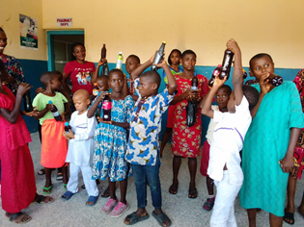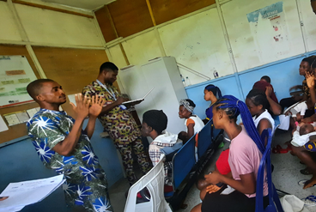

PICTURES FROM LGA TASK TEAM COORDINATION MEETING IN OKOBO
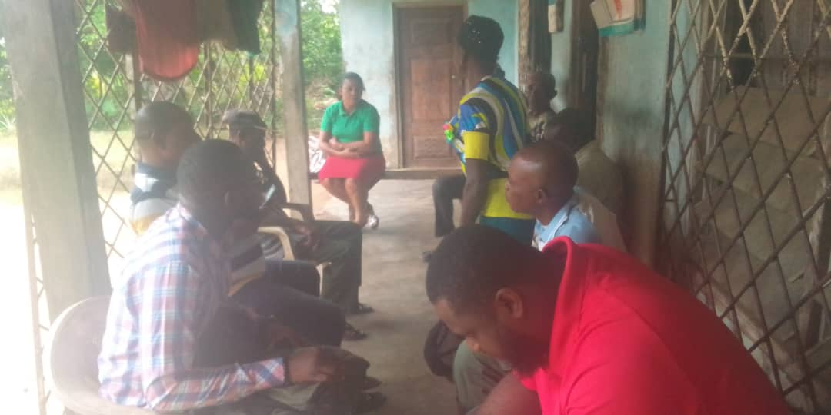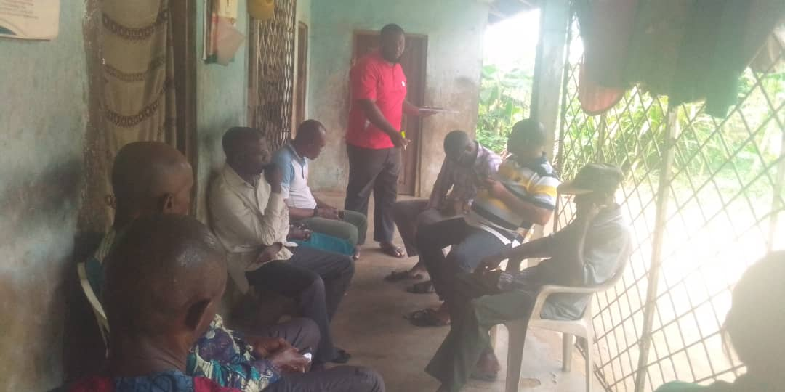

FOOD DEMONSTRATION PICTURES
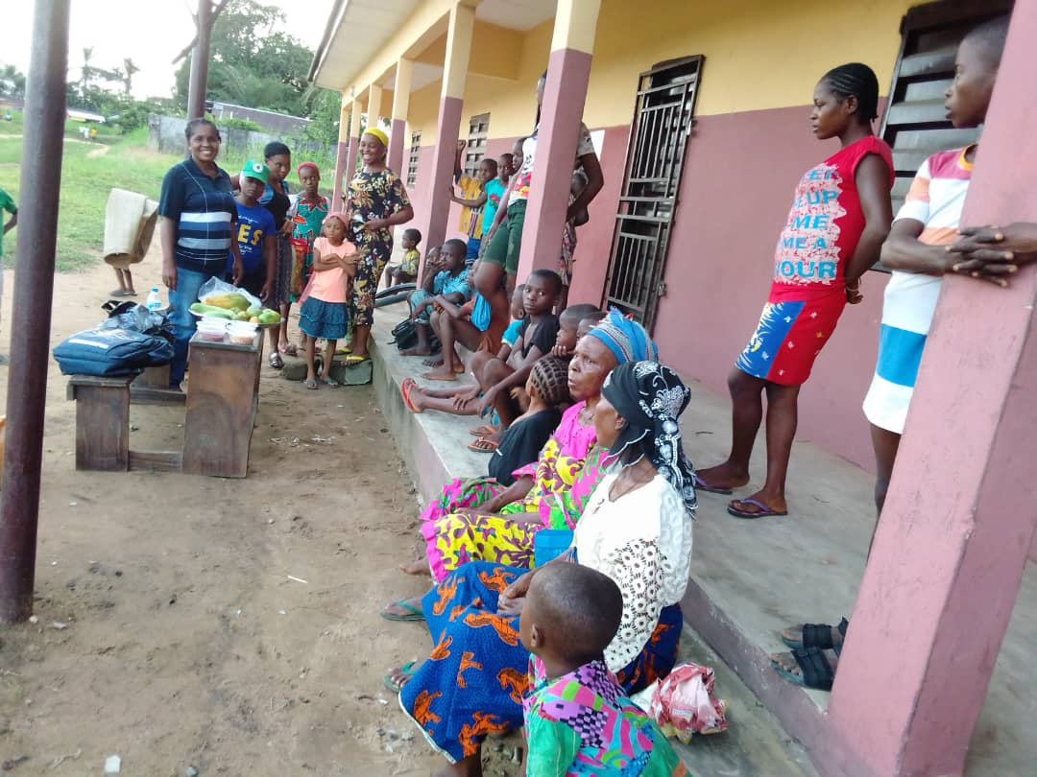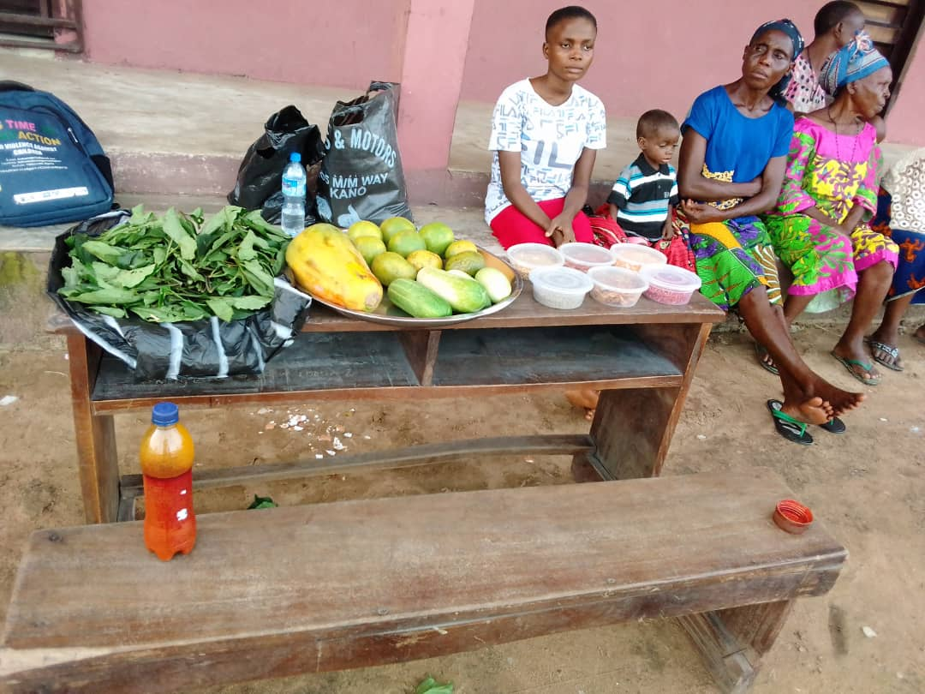

SILC GROUP MEETINGS
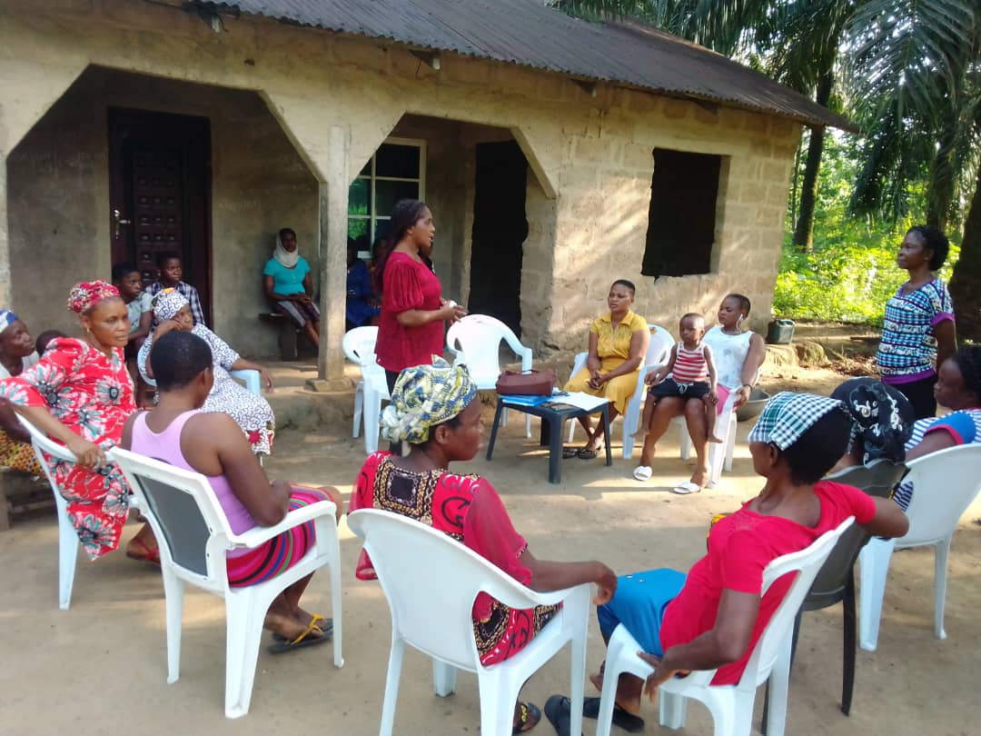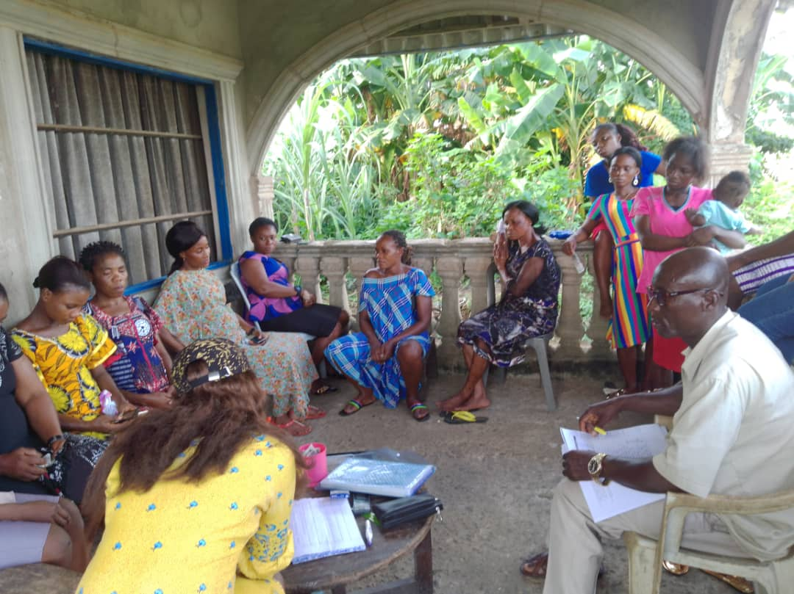

SOME SELECTED PICTURES DURING GENDER NORM SESSION
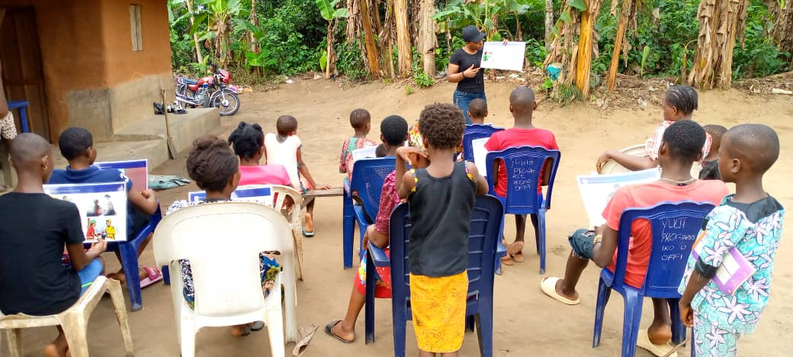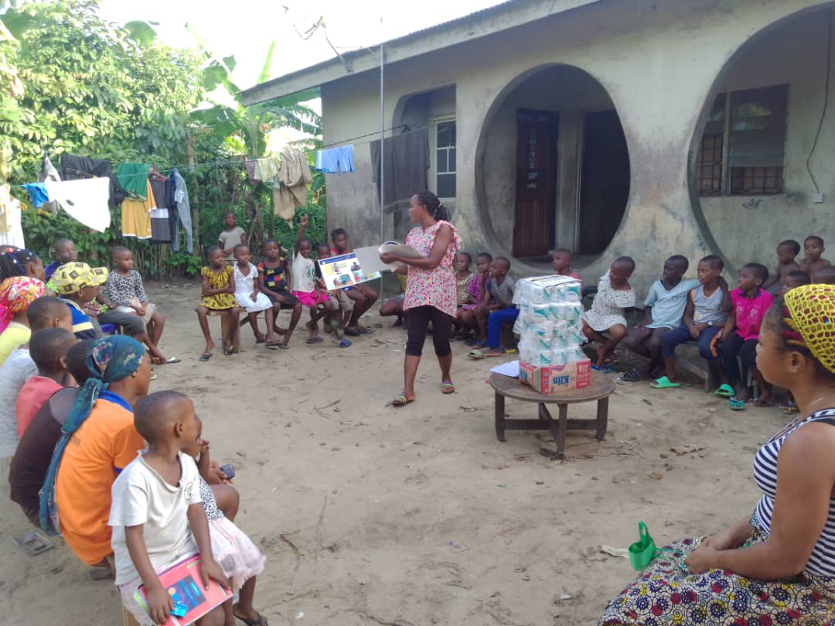

SOME SELECTED PICTURES OF BENEFICARIES RECEIVING BIRT CERTIFICATE
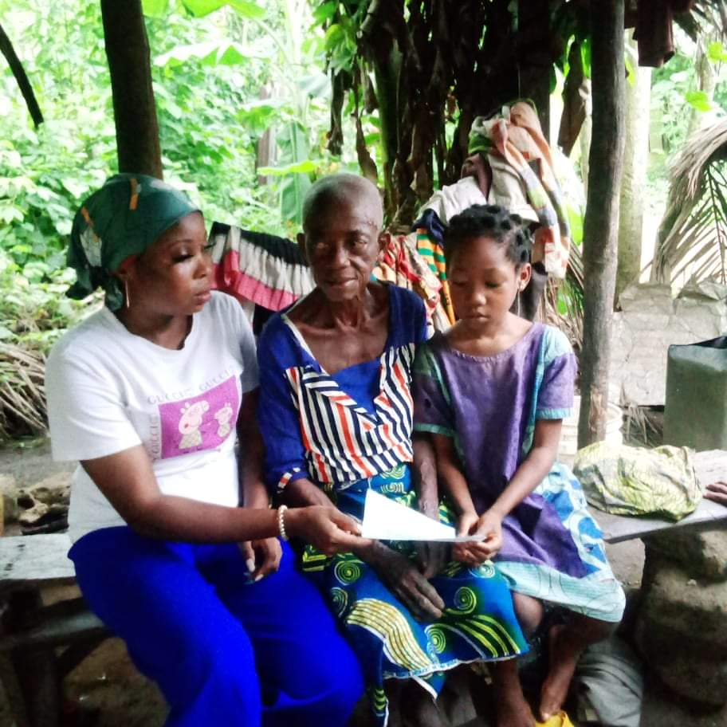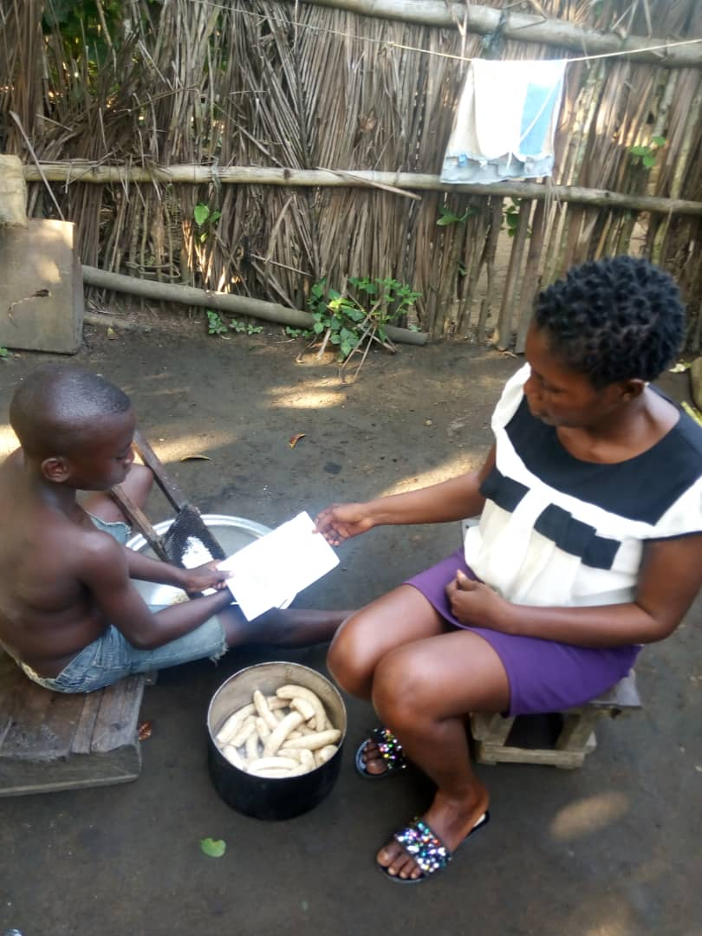

SOME BENEFICIARIES RECEIVING IMPROVED SEEDLINGS TO STARTUP HOMESTEAD GARDENING
