

C

C

CRN

ICHSSA 1 PROJECT

COMMUNITY SYSTEM STRENGTHENING REPORT

  - Submitted by: APPLICANTS WELFARE AND DEVELOPMENT CENTRE

  - Month/Quarter: March/ Quarter 2

  - Submission Date: 31/3/2022

Executive Summary

Summary of Key activities (In bullet point please)
- CPC meeting in ANUA, OKOBO LGA.

Progress Narrative:
As children remain exposed to conflict, violence, neglect and abuse, Community-Based Child Protection/Quality Improvement Committee becomes essential to mobilize community responses, enhance referrals, raise awareness on child rights and ensure communities take part in creating a protective environment for children. To this end and as part of the community system strengthening strategy in ensuring that orphans and vulnerable children are protected and cared for by their community, therefore it is important to hold regular CPC meeting AWAT, OKOBO LGA to address these issues and proffer solutions.
The meeting held on the 29th of March 2021 at CHIEF Joseph OKON ESUK compound at 4 : 45 p.m. Opening prayer was taken by Engineer Effiong Effiong.
The chairman continued the meeting with the reading of the AGENDA:
- Issues of Identification.
- Abuse and Molestation.
- Bullying in school

Chief Joseph Okon complained of issues of identification saying that the group doesn’t have any means of identification.
Akpan Emmanuel responded that the issue of identification will be looked into internally though it is not covered in the budget.
Mr Clement Emmanuel reported a case of bullying in community secondary school which has made some children become recalcitrant and high handed while those on the receiving are scared of going to school.
Akpan Emmanuel gave the opinion that a visit should be made to the school and discuss the issues with the school authority to address the issues before the matter gets out of hand.
Chief Joseph also added that it would be good to do that before it will deter other children from going to school.
The secretary Mr. Clement Emmanuel also suggested to look into abuse and molestation which is a factor that makes young one’s bully others in school. He also cited a case of molestation that took place some years ago and how the matter was resolved.
After the deliberation and resolutions, the meeting came to and end.
Madam Martha gave the closing Prayer.

Output:
- 9(M 8 ,F1) persons were in attendance.
- Issues surrounding bullying in school was addressed.

Challenges:
- Too many activities in the community coupled with the farming season made hold the meeting difficult.
- Means of identification.

Recommendations
- Visit to the school authority to look into the matter.
7. Follow Up Action

PICTURES
CPC AT ANUA , OKOBO
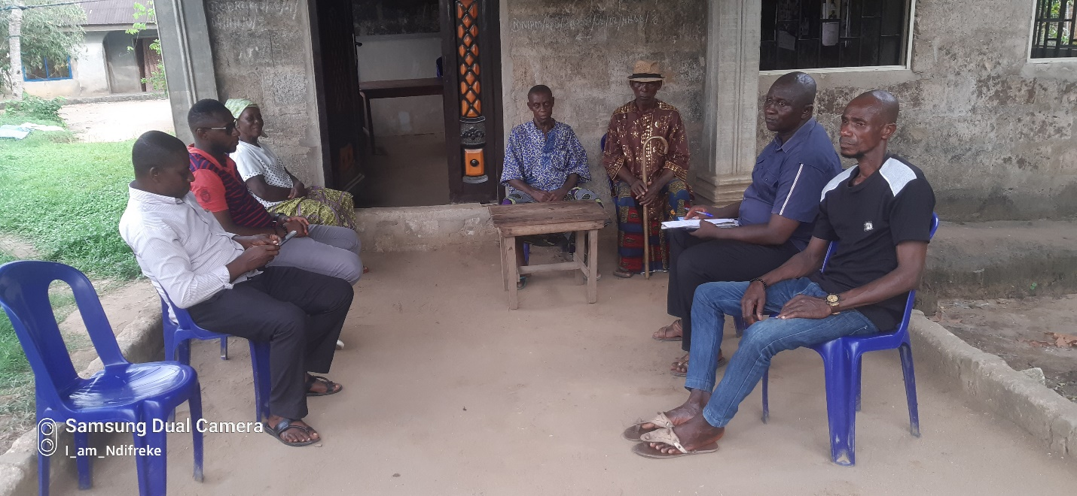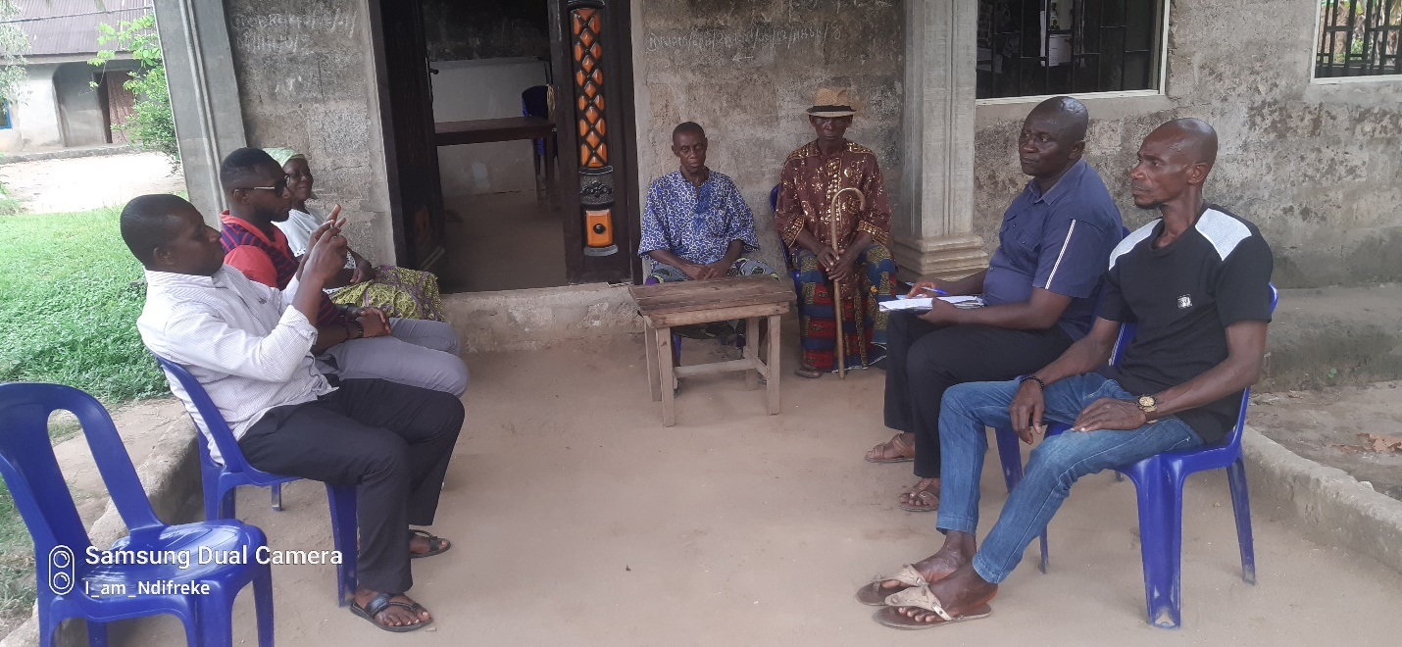

  - Reported by:
AKPAN EMMANUEL NDIFREKE/CCS&GO , AWANDEC

31/3/2022

REVIEWED BY:
ARIT UDOAKAGHA/PROGRAM MANAGER, AWANDEC

31/3/2022

