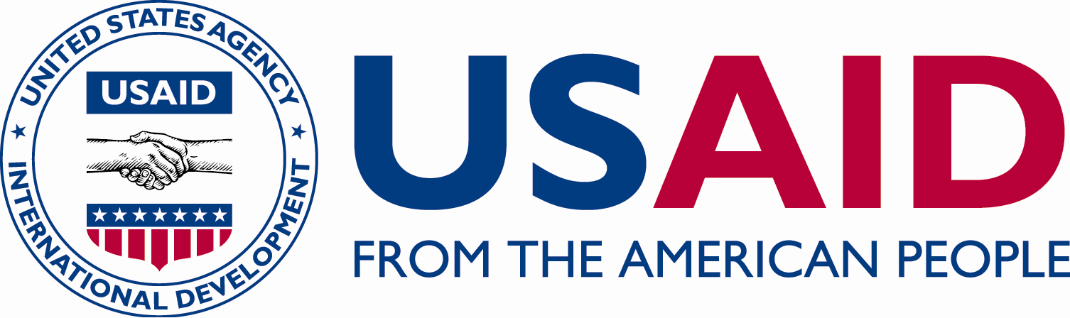

C

C

CRN

ICHSSA 1 PROJECT

TBA meeting , UDUNG UKO

Submitted by: APPLICANTS WELFARE AND DEVELOPMENT CENTRE

Month/Quarter: MAY/ Quarter 3

Submission Date: 25/5/2022

Executive Summary
AWANDEC is committed to reduction of HIV been transmitted from mother to child. One of the major ways to achieve this is to strengthen referral coordination between the traditional birth attendants and the health facility, also training of traditional birth attendants and sharing of best practice. This will help strengthen Prevention from mother to child transmission, reduction of infant mortality, reduction pre-natal and post natal mortality and protect the traditional birth attendants from hazards in carrying out their business.

Summary of Key activities (In bullet point please)
- TBA MEETING, UDUNG UKO LGA.

Progress Narrative:
Traditional birth attendants is the structure that supports women who cannot afford modern medicine birth their children into the world. This age long institution has birthed many children, provided support for families in rural areas and less privileged persons. As their importance cannot be overlooked it is important to carry TBAs along in this fight for epidemic control and reduction in infant mortality rate. That's why AWANDEC attended the TBA meeting at Eyotai, Udung Uko.
The meeting took place in Mrs Alice Atti Okpo compound at 3 pm on the 12th May 2022. The agenda of the meeting are as follows:
- To strengthen referral coordination
- Sharing of best community practices.
Madam Alice introduced AWANDEC’S team to the meeting and appreciated them for coming to the meeting.
Akpan Emmanuel welcomed everyone to the meeting, appreciating their efforts of coming to the meeting even with their busy schedules, also appreciating the work done so far.
Atim Asukwo complained that they do not materials to carry out their work well and also there has been no training in a while for them that it should be looked into.
Helen Joseph also added that the Monitoring team has not been to their place to visit or inspect her place of business.
Madam Alice also complained of the attitude of the facility staff at the facility. "They do not regard them as heath practitioners.

Output:
- 18 (3 M : F15) persons were in attendance.

2. Outcome
- .

Challenges:
- Lack of funds.
- Lack of support from facility. They facility doesn't regard them as health practitioners and doesn't allow them hold meetings at the facility.
- No training from the facility.

Recommendations
- Engagement of the stakeholders at the facility.

4. Follow Up Action
- A visit to the facility with the community program monitor and linkage facilitators to the address the concerns raised by TBA.

PICTURES
TBA MEETING , UDUNG UKO

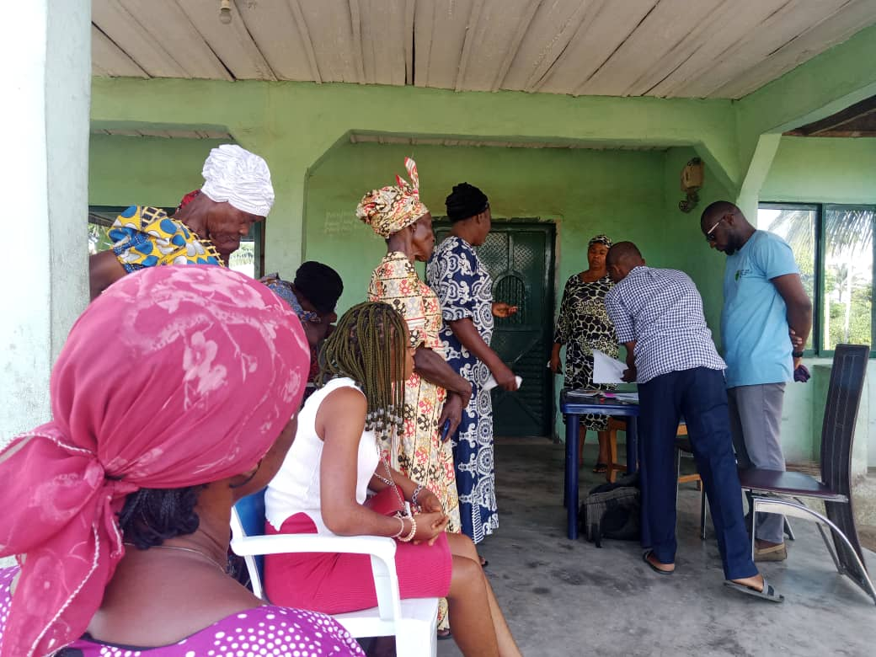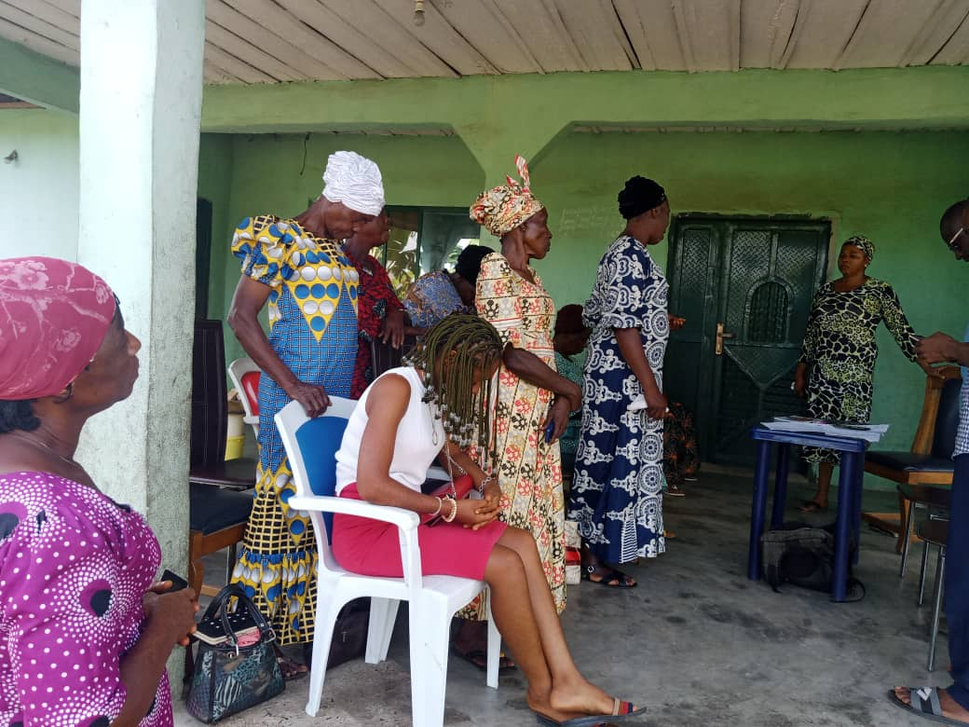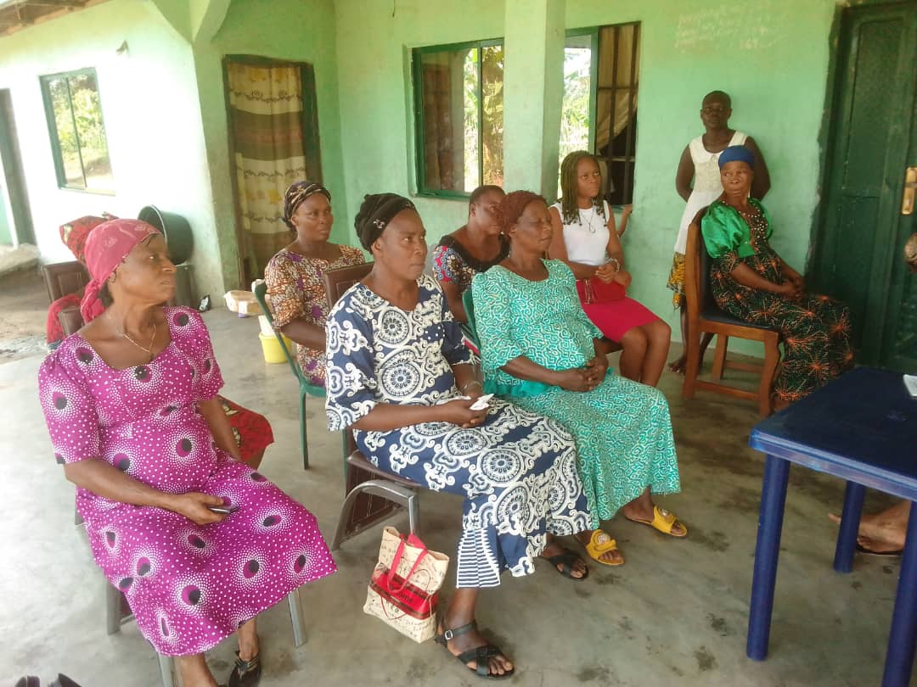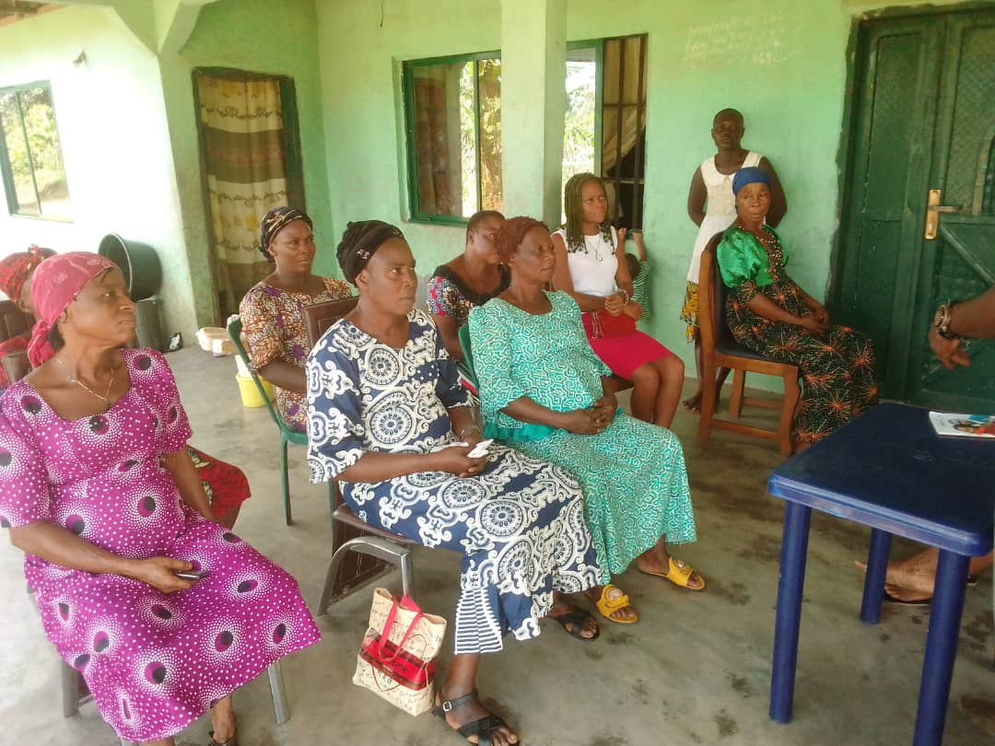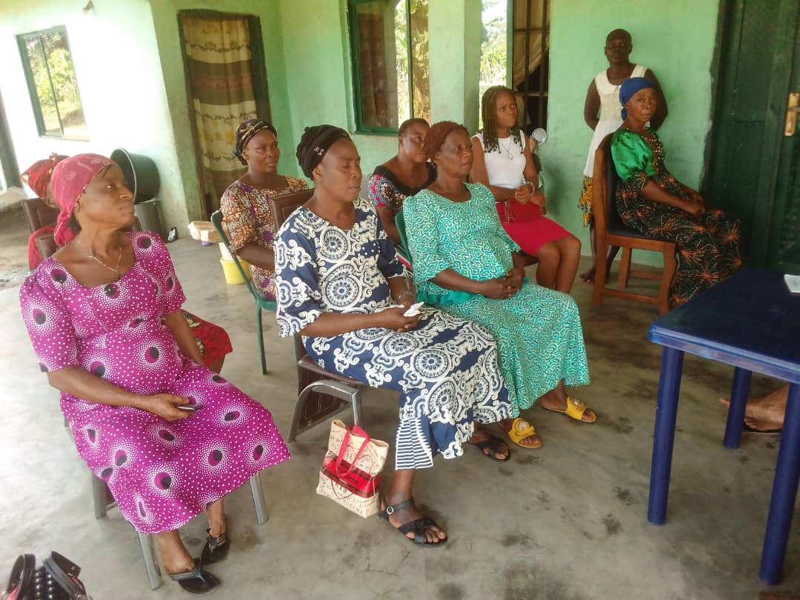

Reported by:
AKPAN EMMANUEL NDIFREKE/CCS&GO , AWANDEC
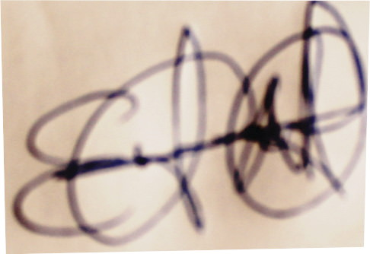
16/5/2022

REVIEWED BY:
ARIT UDOAKAGHA/PROGRAM MANAGER, AWANDEC

16/5/2022

