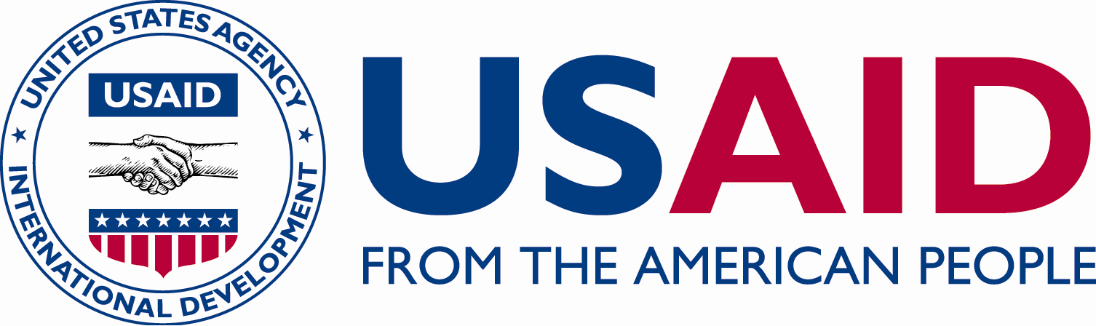

C

C

CRN

ICHSSA 1 PROJECT

LGA TASK TEAM CORDINATION MEETING.

  - Submitted by: APPLICANTS WELFARE AND DEVELOPMENT CENTRE

  - Month/Quarter: May/ Quarter 3

  - Submission Date: 30TH /5/2022

Executive Summary
AWANDEC is committed to driving policies that protect children in their various communities while strengthening existing community structures to help enhanced rights based approach in addressing child protection issues and ensuring the involvement of gatekeepers for safeguarding children from harm and abuse.
Within the reporting month, AWANDEC set up a TASK CORDINATION TEAM in OKOBO to address the following issues.
1.Stigma against HIV positive persons and children in the community.
2.Gender based violence and violence amongst partners.
3. increase in Out of School Children.

Summary of Key activities (In bullet point please)
- Set up TASK TEAM CORDINATION in Awat, OKOBO LGA.

Progress Narrative:
As children remain exposed to stigma due the vulnerability of HIV, gender based violence a Cordinated Task Team becomes essential to mobilize community responses, enhance referrals, raise awareness on child rights and ensure communities take action health and social challenges to help create a protective environment for children.
Following increasing reports of out of school children across various project communities, stigmatisation and gender based violence, AWANDEC collaborated with partners and stakeholders to set up Local Government Task Team on the 27th of May 2022 at CHIEF ODIONG JOSEPH'S compound in Awat community in Okobo at 12:00 PM.
The aim of the meeting was to discuss issues surrounding increase in out of school children, sexual and gender based violence(GBV), stigma against HIV positive persons meeting and to explore effective ways to address the identified issues in their communities.
Some Project key stakeholders were invited including a member of the judiciary, community health workers/OTZ Facilitator, social welfare Officer, Awat community village head, a clergy man, youth leader, and a Traditional birth attendance (TBA). There were 13 participants during the forum. The attendees shared views and perspectives on various issues hampering effective school attendance, GBV and stigma amongst people living with HIV in the area.

The meeting began with an opening prayer by a TBA, Deliberations followed thereafter on the topics presented on including issues relating to increase in out of school children, GBV, stigma and discrimination. The facilitator, educated the team on issues of stigma, how to reduce/curb it, the referral pathway of cases and the dangers of stigmatization which he stated to include; depression, aggravated spread of the virus and death of the infected person. Misconceptions around HIV and people living with it were discussed bringing out numerous cultural beliefs that discouraged some people living with HIV from seeking medical attention.
The Community system strengthening Officer talked on gender based violence reminding participants of the dangers it poses to the family, child, abuser, abused and the community as a whole if nothing is done to stop and reduce the occurrence in the Communities.
The legal officer educated the group on the legal ramifications of stigmatisation and gender based violence. He reminded the group that as long as the individual is a Nigerian that individual if HIV positive or not is protected by the constitution and as such be treated like a Nigerian. He also reminded the group of the human rights which condems victimisation of weaker sex which leads to gender base violence in our society.
After this questions were asked by participants:
1. Chief Joseph asked how do we help an HIV positive person if they tell us they are positive? He also asked how to remove anger and strive from quarrels.
2. Pastor Bassey asked what do we do when we find a new case.
3. Madam Arit asked what do we do with abusers and women beaters.
Mr. Ubong answered the question starting with the chief's question: the only way to help a positive client is by referring them to Health center or hospital, he also mentioned that wisdom in settling disputes between supposed spouses is important and finally resolving disputes and reporting cases of stigmatisation and gender based violence to the appropriate authority.
After much deliberation a team was setup to look into cases of stigma and gender-based violence with MR ENO as the Chairman of the team.

Output:
- 13(11M:2F) persons were in attendance.

- Outcome
- A Task Team is to be setup to address the issues discussed during the dialogue session.
- Participants have knowledge on the referral pathway as it concerns HIV identification
- Issues surrounding gender based violence, stigma and discrimination were discussed.

Challenges:
- The sessions started late as a result of the participant’s late arrival; this posed the challenge of having detailed discussions most especially on out of school children.

Recommendations
- Issues on increased number of children of school age and the ways to address it to be discussed elaborately during the next meeting.

7. Follow Up Action
- Setting up a commitee.
- Identification for school that practice using of students on their personal farming and reporting them to the appropriate authority.
- To set up a team of youths to monitor loitering during school hours.
- To fine families of children who are seeing farming and Loitering during school hours.

- PICTURES
LGA TASK TEAM CORDINATION MEETING, OKOBO

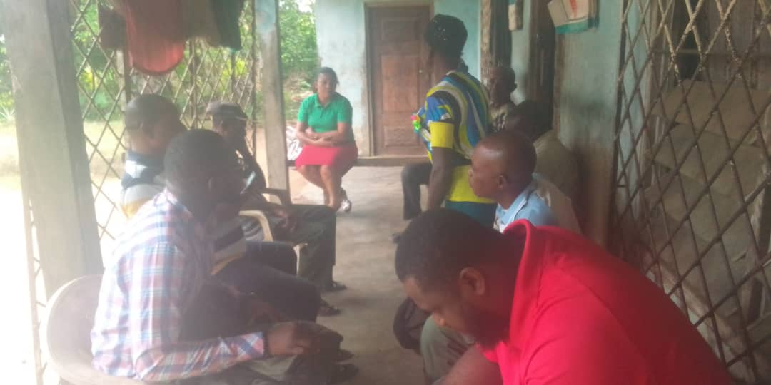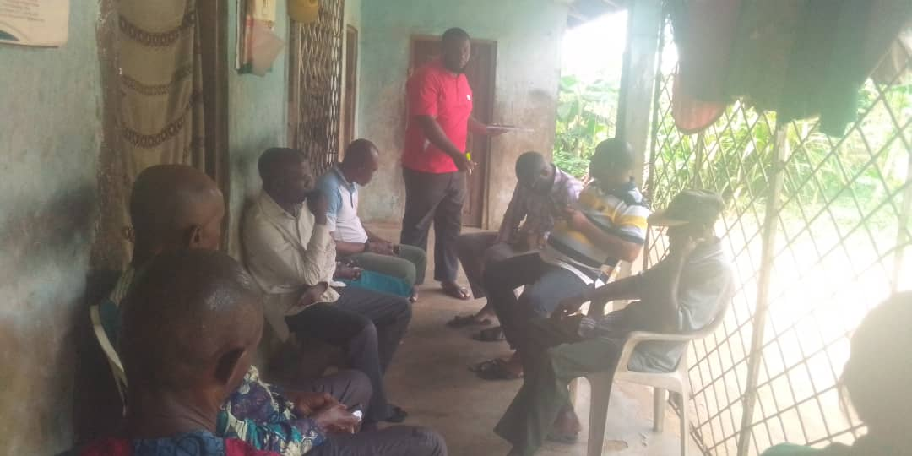
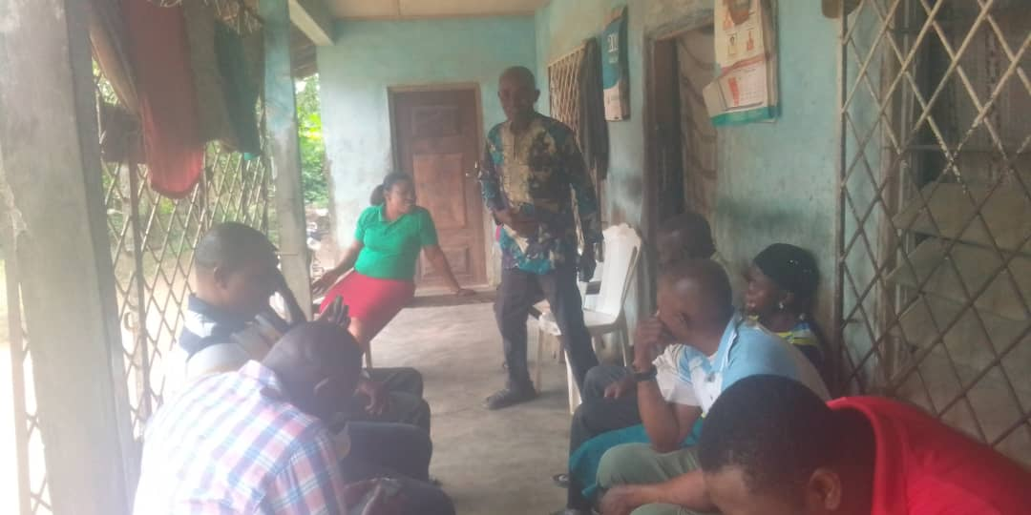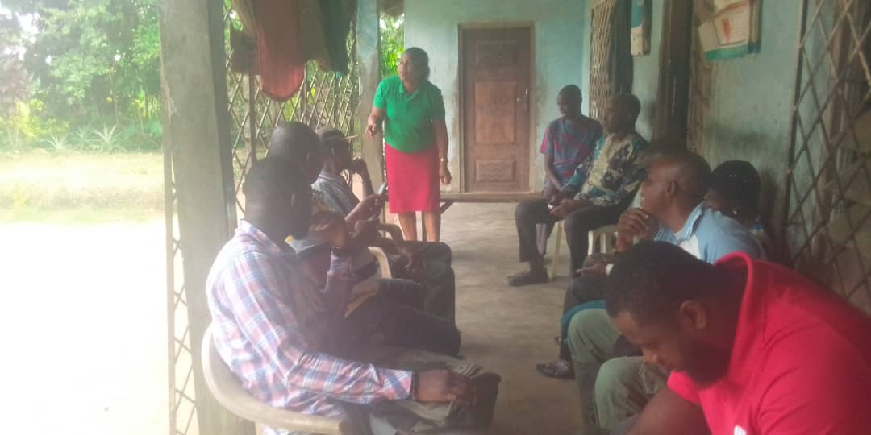

  - Reported by:
AKPAN EMMANUEL NDIFREKE/CCS&GO, AWANDEC

27/5/2022

REVIEWED BY:
ARIT UDOAKAGHA/PROGRAM MANAGER, AWANDEC

29/5/2022

