CENTRE FOR FAMILY HEALTH INITIATIVE
Monthly Activity Report
JANUARY REPORT - ACHIEVE OVC PROJECT
- OVERVIEW
The ACHIEVE OVC Care & Support project is a yearlong activity which involves the provision of care and support to assess, enroll and provide interventions to vulnerable children infected and/or affected by HIV & AIDS under the age of Eighteen (18) and their households in AMAC. The services include advocacy and sensitization on reduction of stigma and discrimination towards vulnerable children and their households within their communities, health education interventions at community and household levels, establishment of functional child protection committees and networks at LGA and community levels, provide educational services tailored to the needs of beneficiaries, provide and maintain shelter and care services, map community and provide available economic resources and opportunities, as well as develop a referral system linkage to other beneficial services.
1.1 OBJECTIVES FOR JANUARY
- To follow up on assigned facilities for referral and viral load monitoring
- To implement planned community and facility planned activities

- ACTIVITIES CARRIED OUT IN JANUARY
- Coordination of PSS activities: kiddies, adolescent, AGYW and gender norms meetings across four communities
- Coordination of IYCF support group meeting across two communities
- Tracking, viral load monitoring and referral coordination across six assigned facilities: Maitama district hospital, Kabusa CHC, Shereti PHC, Lugbe PHC, Medical Missionaries of Mary and Mabuchi PHC.
- Coordination of community volunteer review meeting and mentoring
- Data mop up and update
- Coordinated the identification and selection of 90 caregivers to participate in the planned FMP training in Kabusa
- Participated in the NTT Monitoring team for the Non- Venue Based Key Population Mapping and Population size estimation in Calabar
- Participation in the documentary for the CSW event
- Followed up on MICSEP beneficiaries
- Received the IHVN program and M&E team for TA
- Payment of WAEC/NECO registration

  - OUTPUTS/OUTCOMES OF ACTIVITIES
- 371 (M=205, F=166) children reached with PSS during kiddies club across 3 communities as against expected 300
- 241 (M=118, F=123) adolescent reached with life skills across 3 communities as against expected 300
- 50 adolescent girls and young women reached with sexual and reproductive health issues. expected target was reached
- 312 (M= 15, F= 297) caregivers across 3 communities increased knowledge on values during gender norms meeting
- 47 breast feeding women across two communities participated in the food demonstration and increased knowledge on quality but affordable locally available food for their infants.
- 60 out of the 120 identified caregivers for the FMP training were grouped into two. The remaining 60 would be grouped next week. Training to commence first week of February.
- 38 community volunteers who participated in the monthly review meeting, were mentored on proper data capturing and facilitation of community interventions
- Complete viral load information and PEPFAR Identification number, was updated for 58 reactive VC
- The TA visit by IHVN identified gaps that needs to be covered especially as regards to the care plan
- 5 (M= 0, F= 5) students had their WAEC/NECO Registration fee paid.

  - CHALLENGES
- A lot of double entries are still being found in the NOMIS. The M&E unit is currently working hard to mop up data. Also, the volunteers are going to be put through over and over again for better understanding.
- The reactive VC line list sent to IHVN was reduced to 39 due either to no complete viral information or no PEPFAR ID. The team is working through caregivers and hospital staff to ensure new update. So far, the number has increased from 39 to 58.

RECOMMENDATIONS

- NEXT STEPS/ACTION PLAN
- Coordinate implementation of planned community and facility activities
- Advocacy visits to identified schools for education block grant
- Coordinate volunteer review meeting
- Commence assessment of HES
- Prepare work plan, activity profile and volunteer stipend for the month of February
- Send monthly reports to
PHOTO SPEAKS
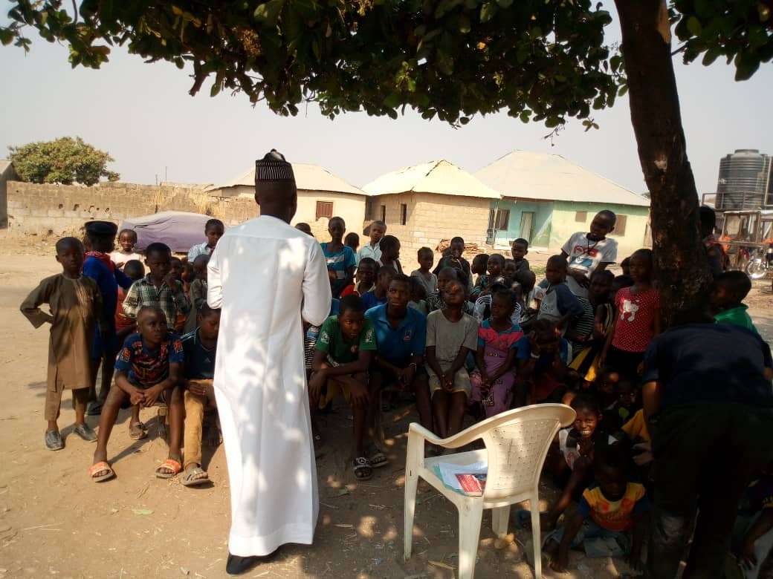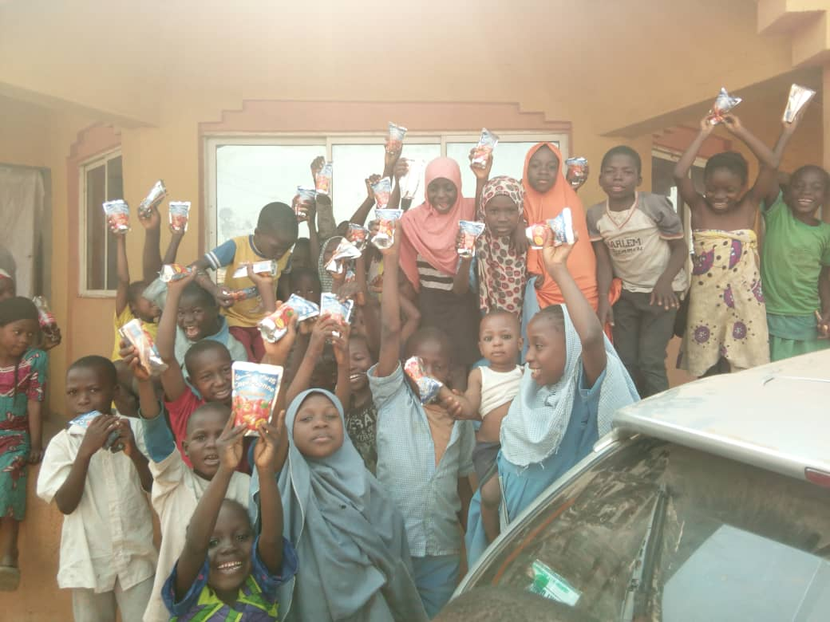
Kiddies Club Angwa Sayawa Adolescent Club - Jahi
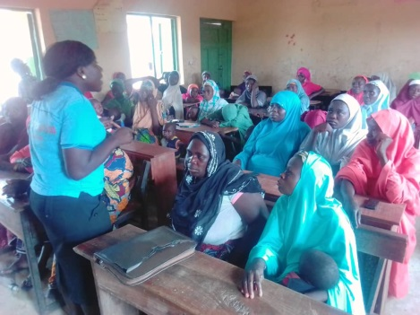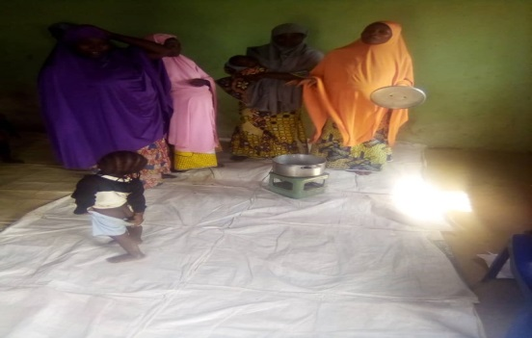
Gender Norm Meeting – Dape IYCF SG Meeting - Dape
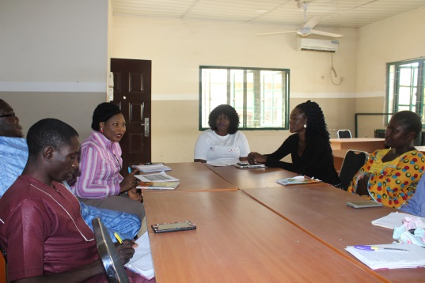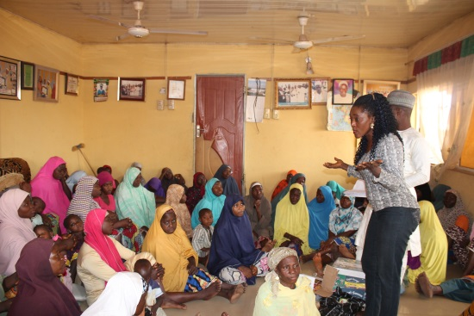
FMP meeting with CFHI ACHIEVE Gender Norm Meeting - Dape
Team and CV

