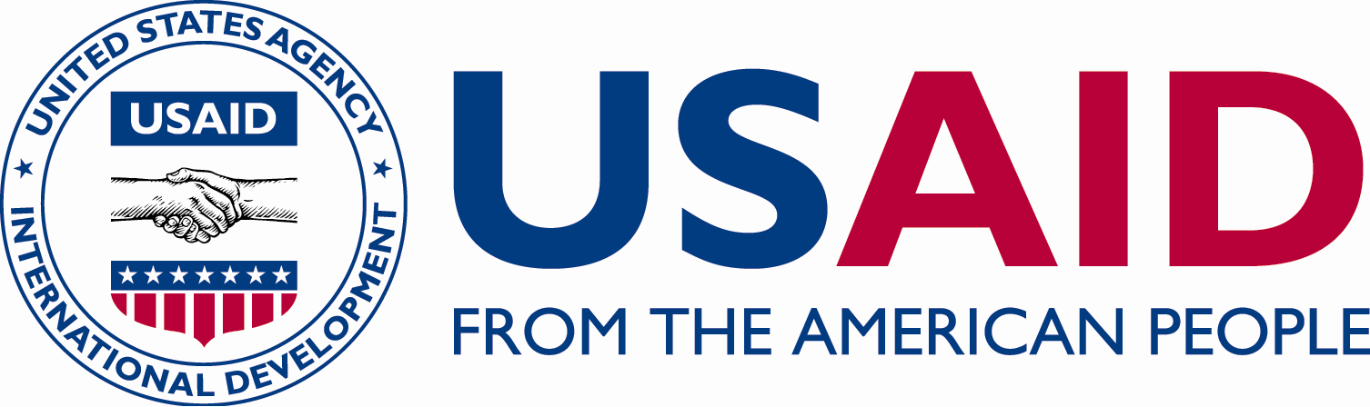

C

C

CRN

ICHSSA 1 PROJECT

GENDER NORMS SESSIONS REPORT

  - Submitted By: APPLICANTS WELFARE & DEVELOPMENT CENTRE (AWANDEC)

  - Month/Quarter: MARCH 2022/ QUARTER 2 – FY22

  - Submission Date: 24/3/ 2022

Executive Summary

Facilitating community gender norms sessions is important in enhancing gender discourse among community members. Gender norms sessions are beneficial in facilitating the exploration of interrelationships between gender, child protection and HIV while also supporting individual, family and community level action plans to mitigate the impact of negative gender norms.
The gender norms discussions focused on the following topics:
- Gender and sex.
- Female Child Education
- Gender based violence.
- Gender and child protection.
- Male involvement and women empowerment.
- Sexual and reproductive health education for Adolescents.
The discussion was delivered in 10 sessions for parents/caregivers (sessions 1 – 10) and for youths/adolescents aged 10 – 17 years (sessions 1 – 8; 11 – 20) with clear illustrations shown to the participants during the group discussions.
In MARCH 2022, 1092 participants were reached with these gender norms discussions in Okobo, Udung Uko, Urueoffong Oruko and Mbo LGAs of Akwa Ibom State. These four (4) LGAs are AWANDECs LGAs of ICHSSA 1 project implementation.

Summary of Key activities

- The community-based gender Norms sessions took place in 15 communities across AWANDECs four (4) LGAs of The ICHSSA 1 project Implementation namely; Okobo, Udung Uko, Urueoffong Oruko and Mbo LGAs.
- 16 facilitators conducted and completed 10 gender norms sessions for participants.
- A total of 1092 (385 M, 707 F) participants were reached with gender norms discussions in the month of MARCH, 2022
- The sessions were held in the following venues and on the following dates:
- Compound close to Mt. Zion Church, Urue Ita, Okobo (18th – 20th MARCH, 2022)
- Amadung community, Urue offong Oruko (21th – 22th MARCH, 2022)
- Anglican Church Ibiakpan Nung Atai, Okobo (18th – 20th MARCH, 2022)
- ST Peter Obufi, Okobo (20th – 18th MARCH, 2022)
- Elder Sunday Essang’s compound, Oyoku village, Urue offong (20th – 22th MARCH, 2022)
- The village head’s compound, Awat Nung Atai, Okobo (20th – 15th MARCH, 2022)
- Compound beside The Apostolic Church, Udung Ulo, Eweme, Okobo (18th – 20th MARCH, 2022)
- Peter,s catholic church, Ekeya, Okobo (^{20th} MARCH, 2022)
- Master’s compound, Idibi Enin, Anua, Ekeya, Okobo (18 – 20th MARCH, 2022)
- Village Square, Uda community, Mbo (18th – 20th MARCH, 2022)
- Udessi community, Mbo (18th – 20th MARCH, 2022)

- Inehh Ekongcommunity, Udung Uko (21th – 22th MARCH, 2022)

LGA | TOTAL NO OF PARTICIPANTS PER LGA | TOTAL NO OF CAREGIVERS PER LGA | TOTAL NO OF ADOLESCENTS PER LGA
URUE OFFONG ORUKO | 100 (49 M, 51 F) | 42 (13 M, 29 F) | 58(36 M, 22F)
UDUNG UKO | 60 (18 M, 42 F) | 34 (6 M, 28 F) | 26(12 M, 14 F)
MBO | 262 (82 M, 80F) | 110 (21 M, 89F) | 152 ( 61 M, 91 F)
OKOBO | 670 (236 M, 434 F) | 347 (115M, 232 F) | 323 (121 M, 202 F)
TOTAL | 1,092 (385 M, 707 F) | 533 (155 M, 378 F) | 559 (230 M, 329 F)

Progress Narrative
Gender Norms discussions were held in 15 communities of AWANDECs four (4) LGAs of ICHSSA 1 project implementation in MARCH 2022. These gender norms discussions was delivered in 10 sessions for parents/caregivers (sessions 1 – 10) and for youths/adolescents aged 10 – 17 years (sessions 1 – 8; 11 – 20) with clear illustrations shown to the participants during the group discussions. The focus of these discussions was on Gender and Sex, Gender-based Violence, Gender and Child Protection, Early Child Marriage, Neglect of Girl child Education, Male Involvement and Women Empowerment and Sexual and Reproductive Health Education for Adolescents.
Community wide mobilizations of participants was done by Community case workers who were the part of the facilitators alongside Staff members of AWANDEC. The group discussions started with opening prayers followed by brief introduction of the project and implementing organization/partner. The project’s aims of ensuring that vulnerable children are cared for by their families and communities were explained to the understanding of the participants. The overall goal of the gender norms discussion which is to facilitate gender discourse among community members as well as helping the exploration of interpersonal relationships between gender, child protection and HIV while supporting individual, family and community level action plans to mitigate the impact of negative gender norms in our communities was elaborately discussed.
Ground rules were established to guide the discussions and the facilitators presented the agenda of the training to help the participants understand the different sub-topics of discourse. Discussion guides and illustrations were used and topics were discussed in the order which they were arranged in the discussion guide.
Discussions were quite participatory as the participants were encouraged to share opinions and views on the different sub-topics of discourse. Participants (caregivers) were asked by facilitators to share their views on parenting styles they adopt and how it positively impacts their children. The facilitators then highlighted that some parenting styles may also hinder our children’s proper development and increase their vulnerability to crime, abuse and poverty.
Various gender perceptions practiced in our communities that increase a child’s vulnerability status includes;
- Perception that women/girls are solely responsible for caregiving and household chores which negatively affects girls’ school attendance.
- Prioritization of the needs of boys over girls.
- Low turn-out of children in school
Participants were given opportunities to ask questions and make contributions on gender perceptions and gender roles in their households and communities.
Below are some of questions asked by the participants and answers given.
- One of the participants in Okobo (NUNG ATAI) Emem Athony “What is the right age of marriage for child”?
Answer: The Nigerian constitution has illegalized child marriage, therefore anyone who gives out his or her child in marriage would be tried and prosecuted. We encourage families to send their children to school instead of marrying them out at a young age because this could lead to molestation, rape, teenage pregnancy, infant mortality and even death of the teenager.
- What happens to a child that the parents can’t afford to send a child to school?
Answer: Education in Akwa Ibom is free and parents should be ready to support their children in any little way they can. Registration fee and school uniform are the only thing needed to pay for. The child can start education after registration and little by little uniform and other materials will come. The organization would mobilize support to re-enroll the child in school.

Output

• A total of 1060 (407 M: 653 F) participants completed 10 gender norms sessions in AWANDEC’s four (4) implementation LGAs.

Outcomes

- Participants now know the differences between sex and gender.
- Participants identified some negative gender roles in the community and ways this can be stopped.
- Participants understand the need for male involvement in child training.

Challenges
• Lack of availability of funds made the beneficiaries forget what was taught because of the vacuum created by unavailability of funds.

Recommendations
- Funds should be made available to conduct sessions in other not to create a vacuum.

Follow Up Action
- Follow-up on gender mainstreaming in the household during home visits and
Service provision.

8. Pictures
NUNG ATAI ETA ( ANGLICAN CHURCH)
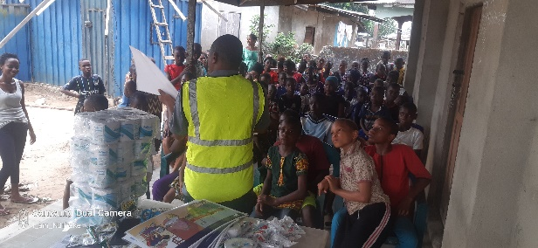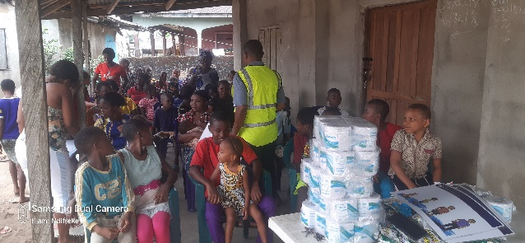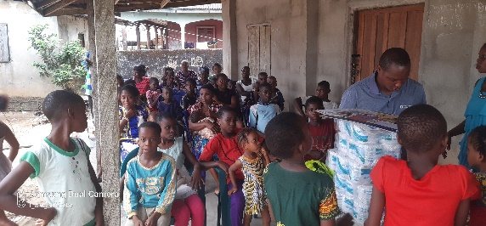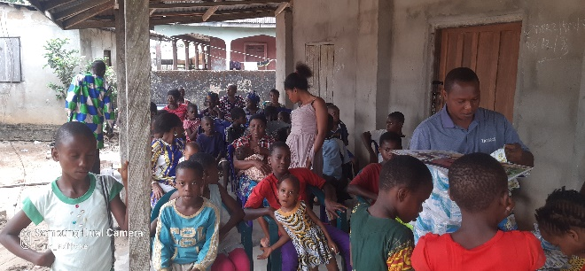
OBUFI ( ST JAMES CHURCH)
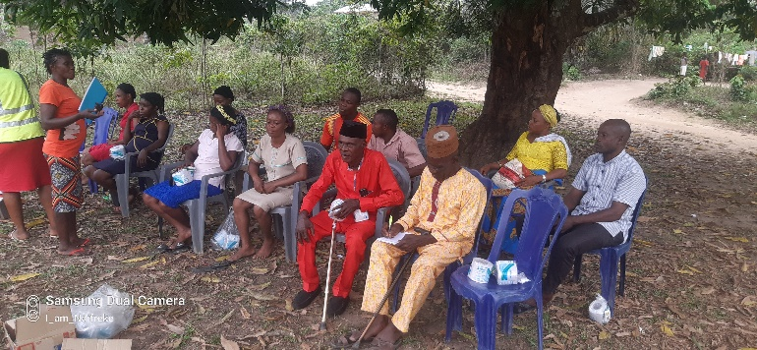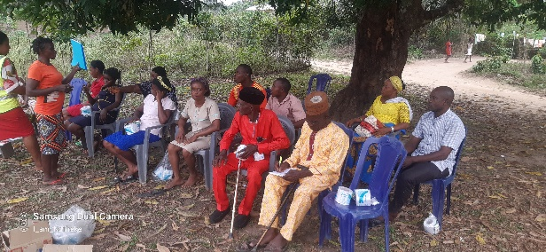

OKOPEDI (CHIEF ANTTIP COMPUND)
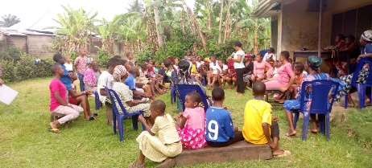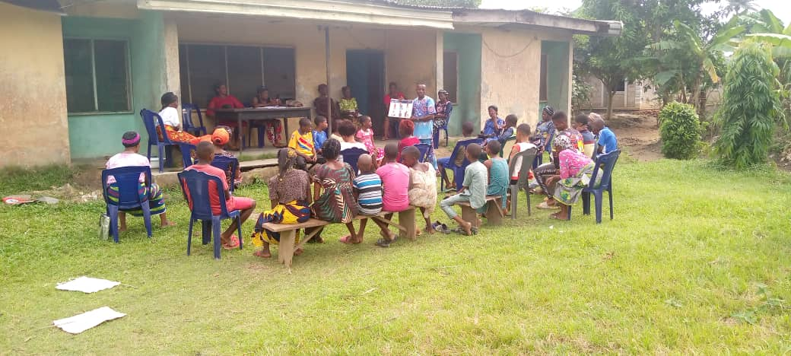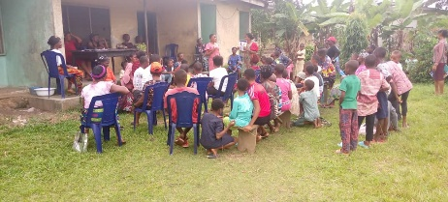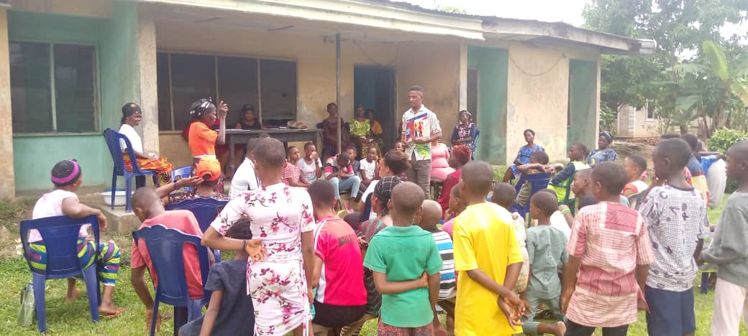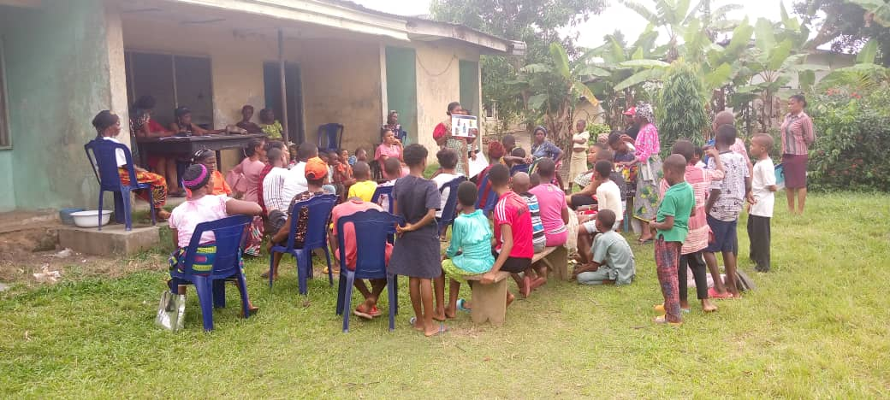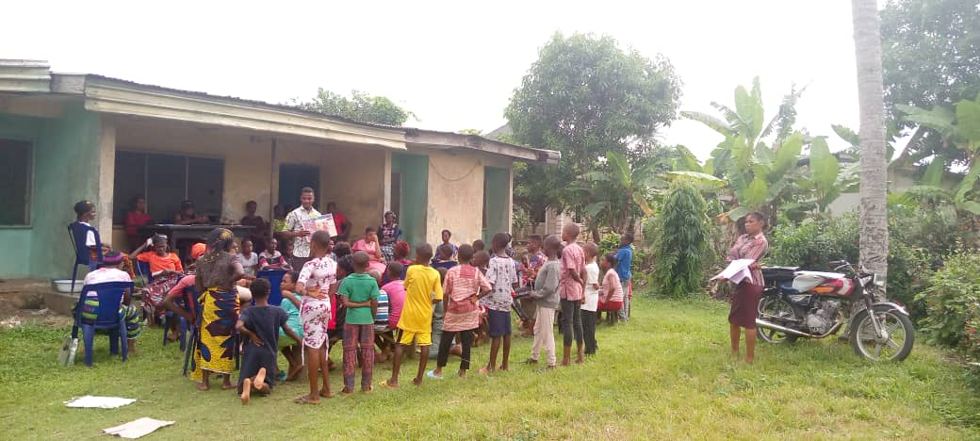

MBO ( UDESSI)
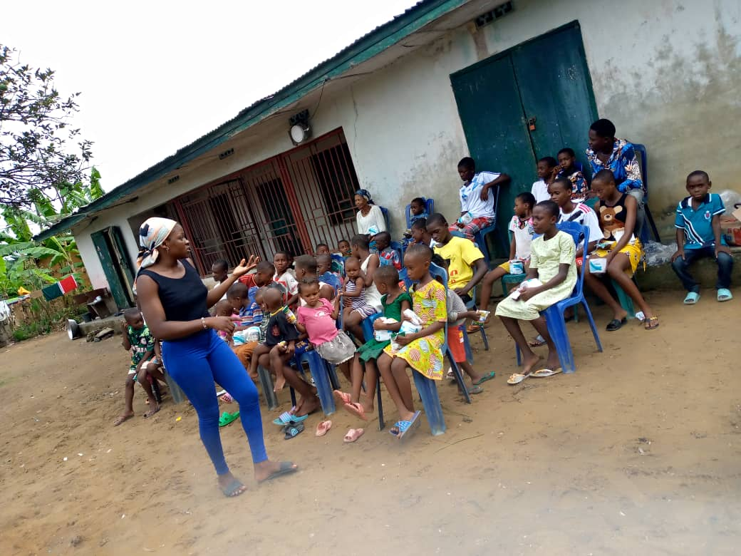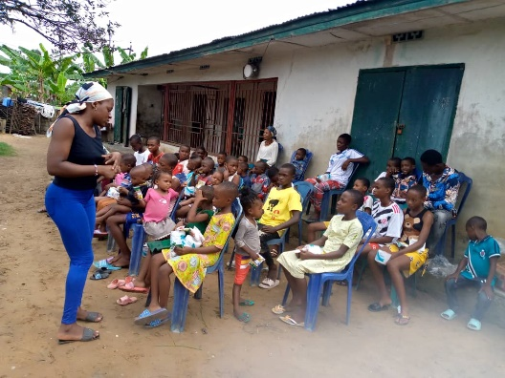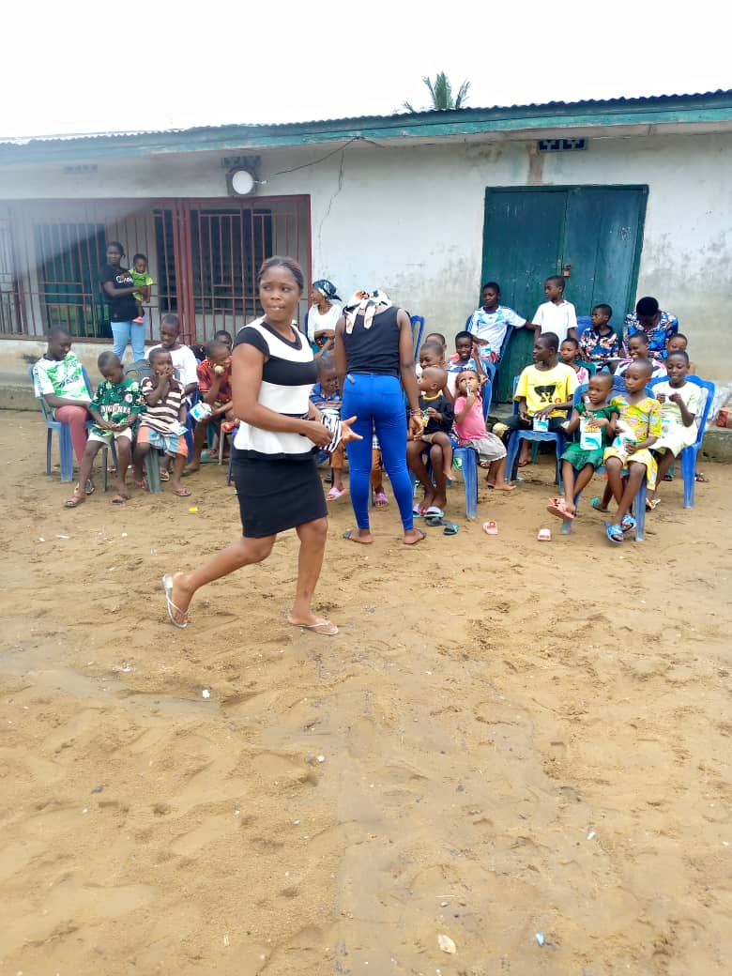

MBO ( EWANG COMMUNITY)
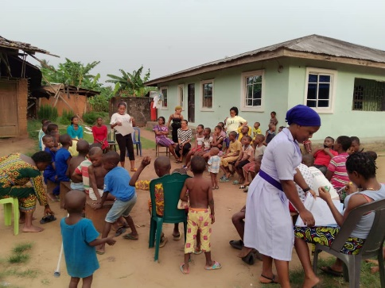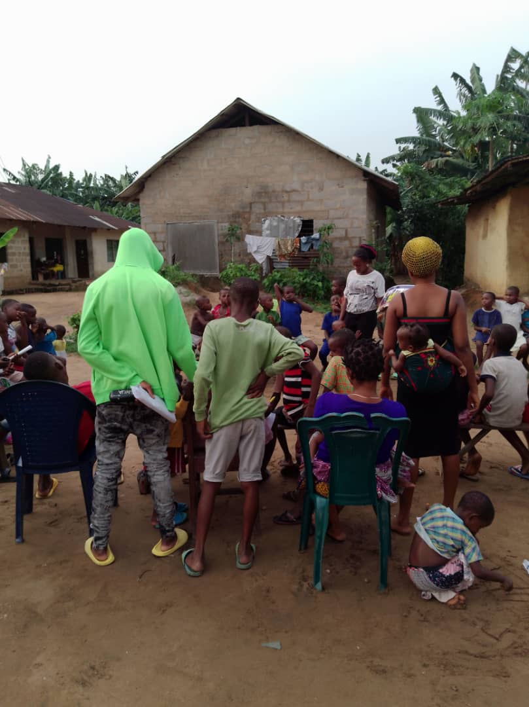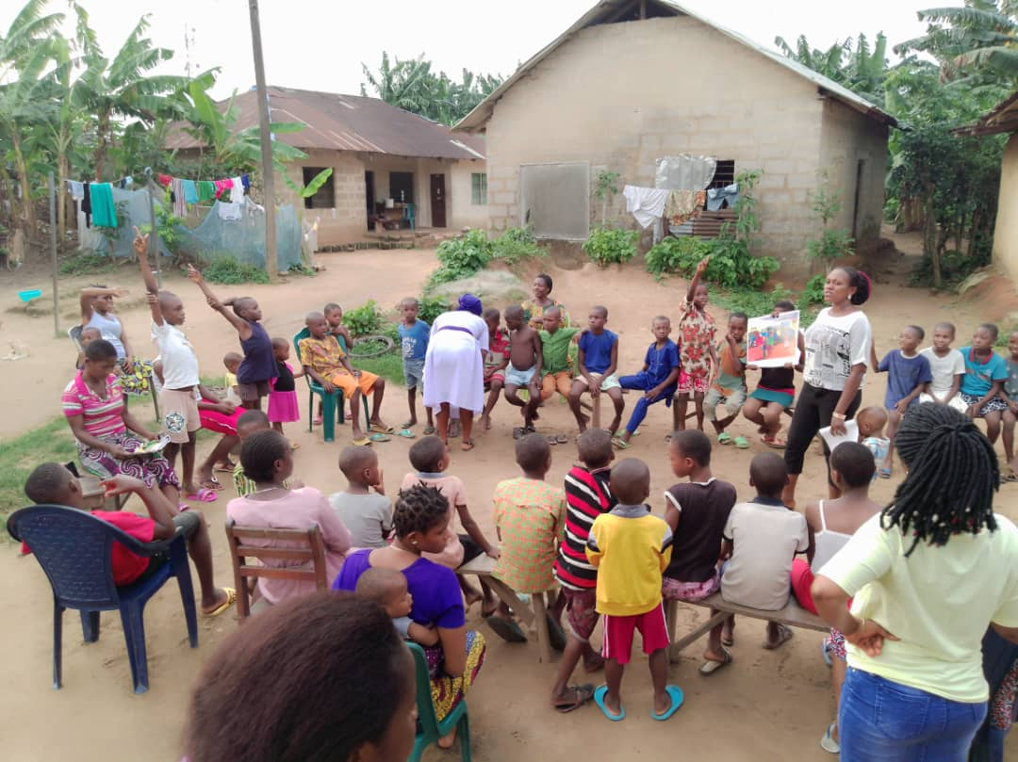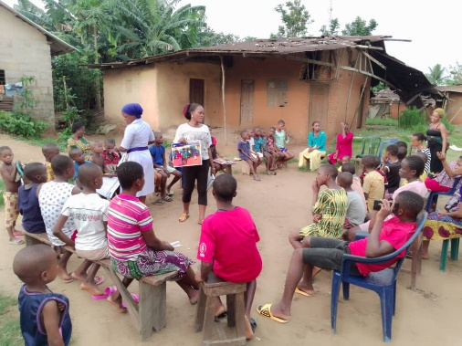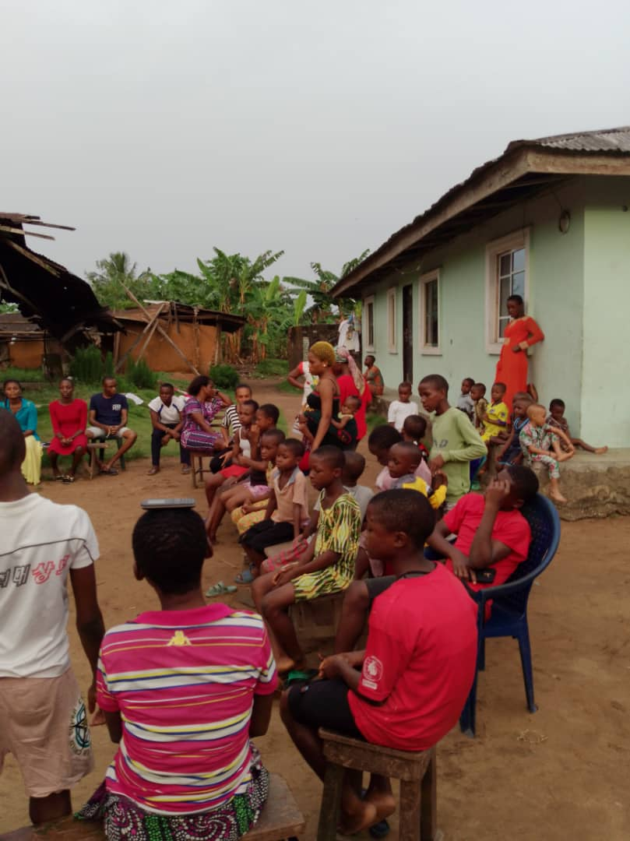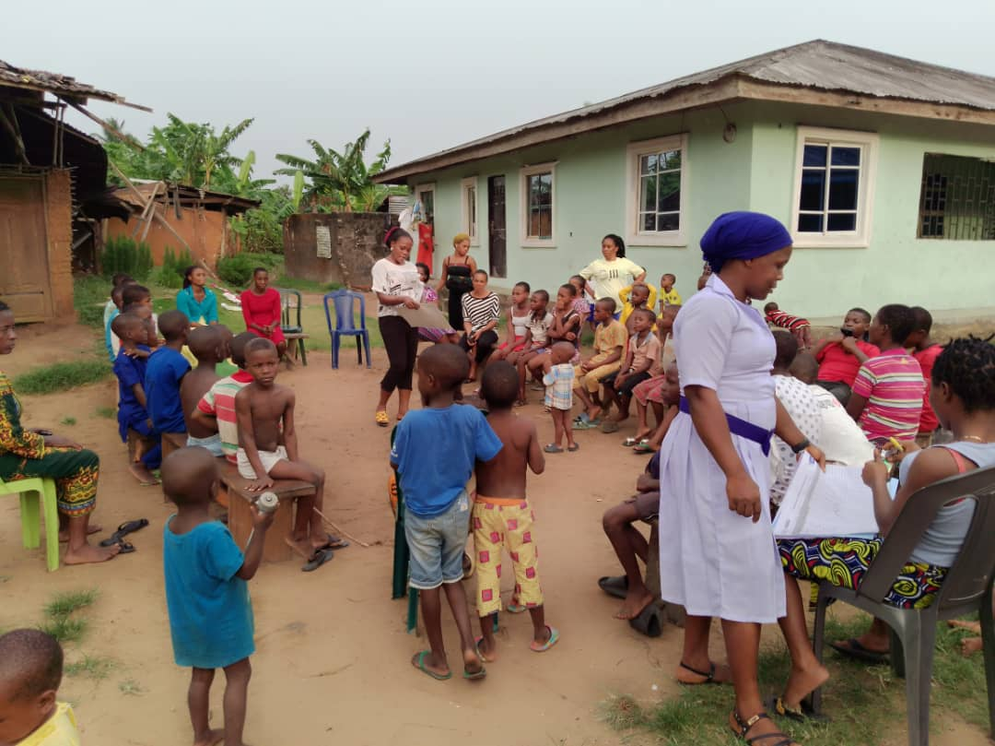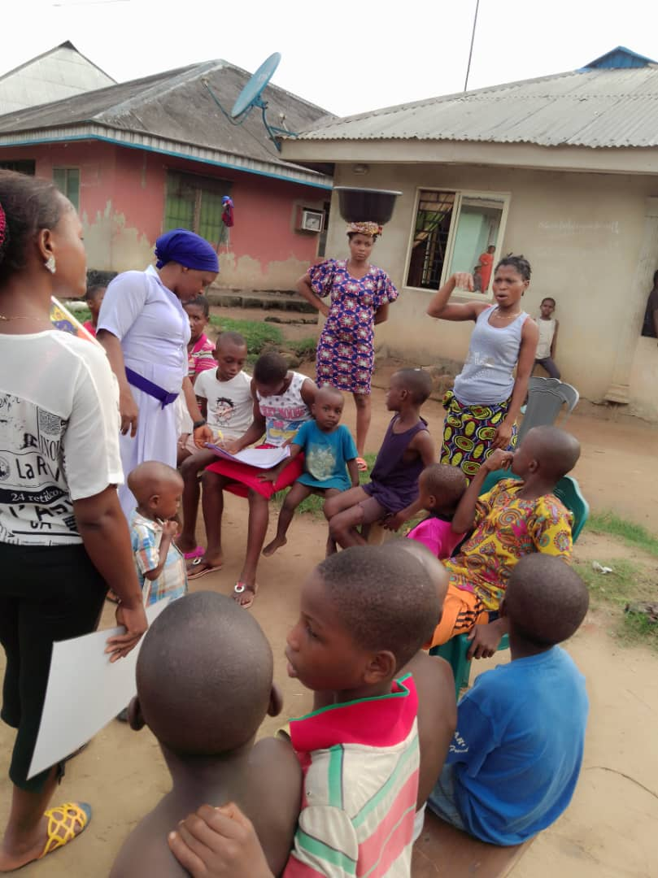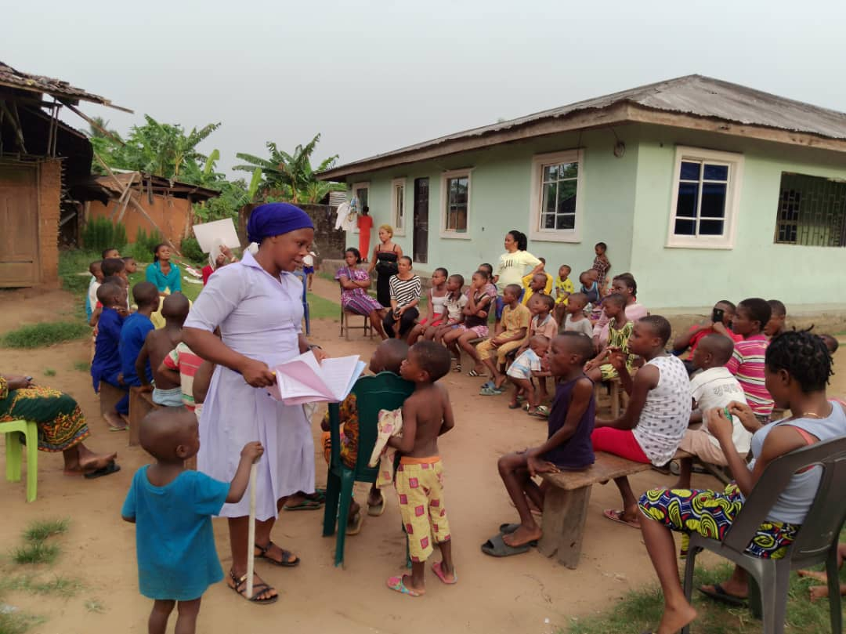

EWEME ( LUTHERAN CHURCH)
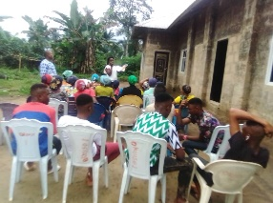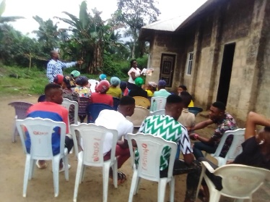

EWEME (URUE ITA)

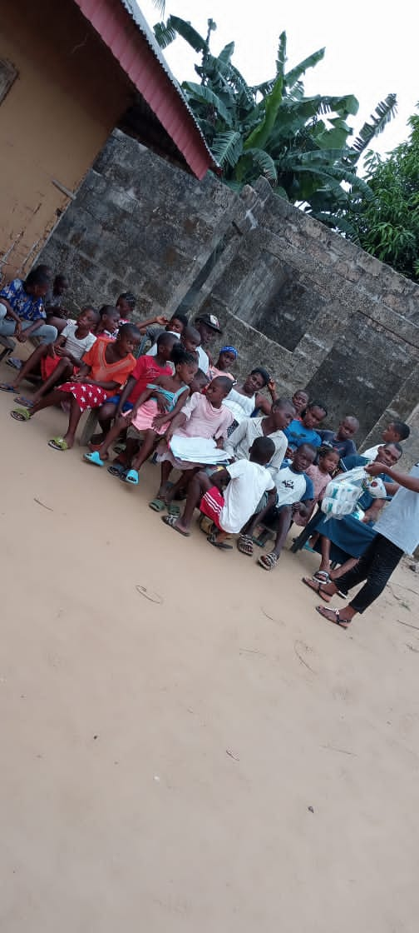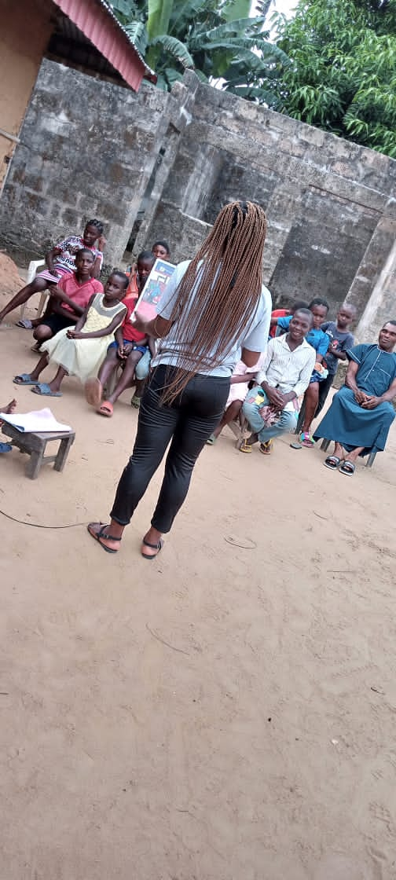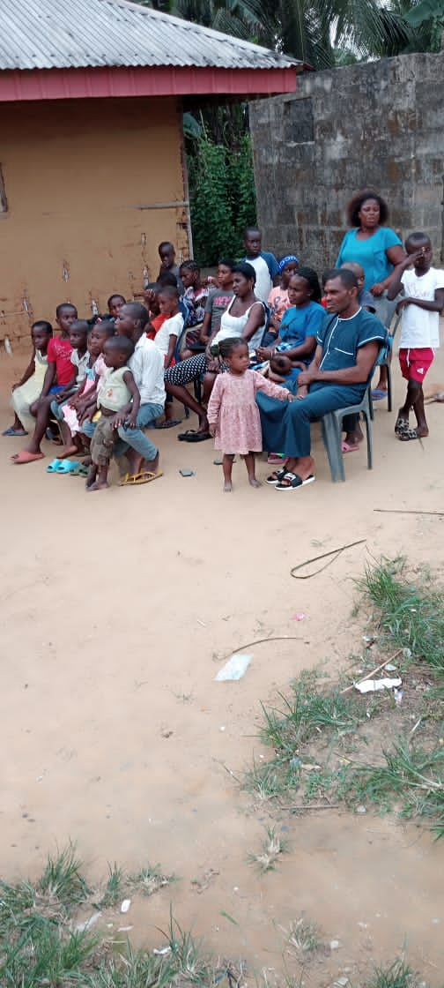

OKOBO (EKEYA, ESUK IWANG)
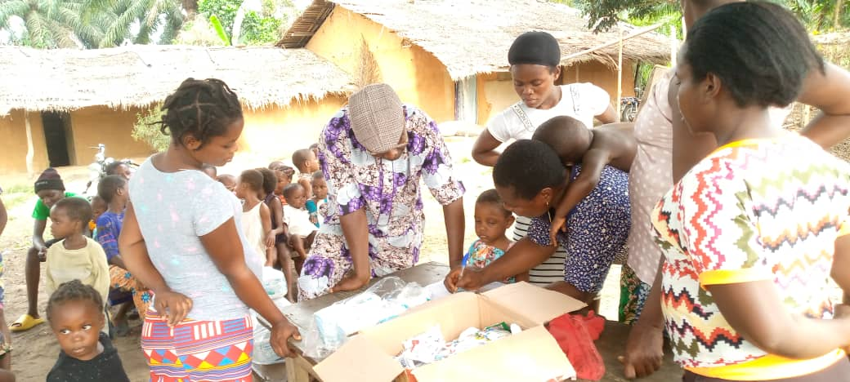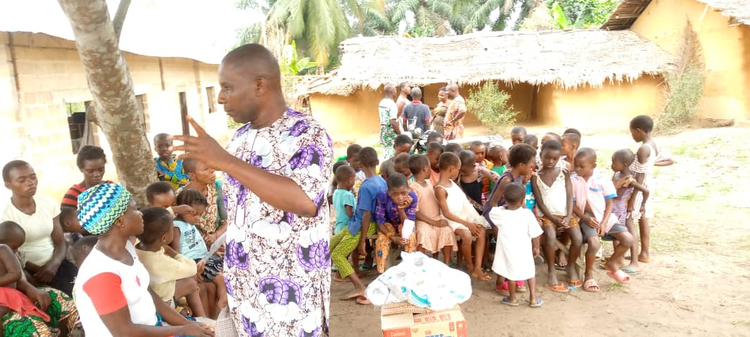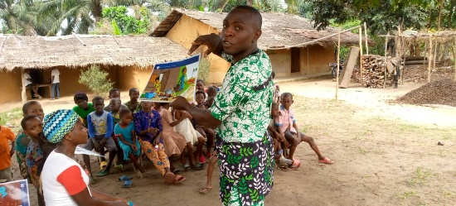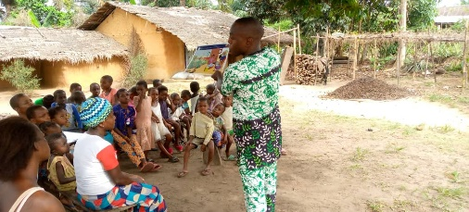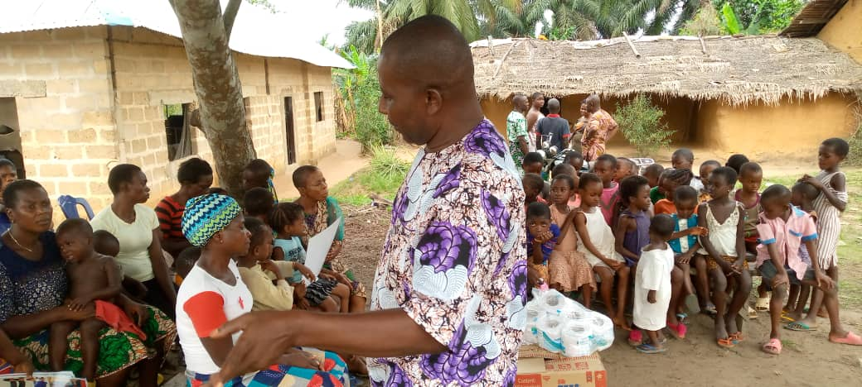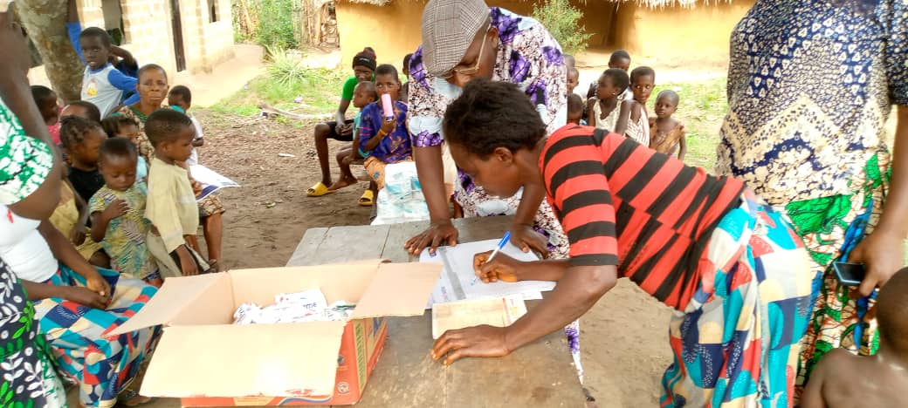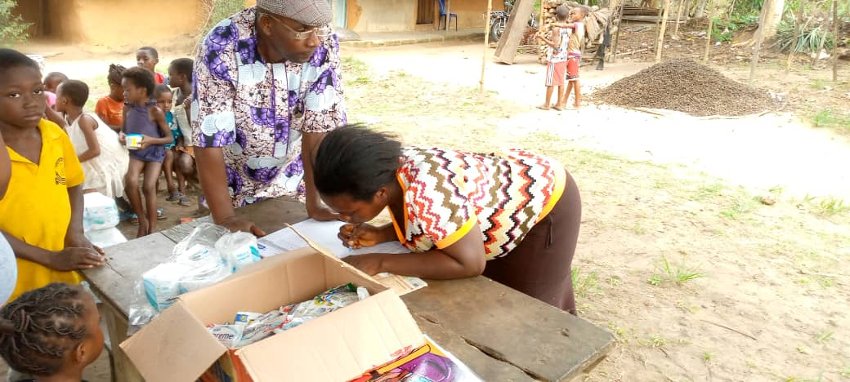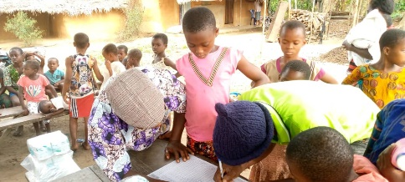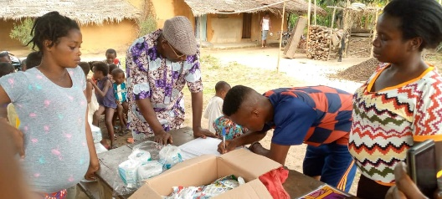

URUE OFFONG (AMADUNG)
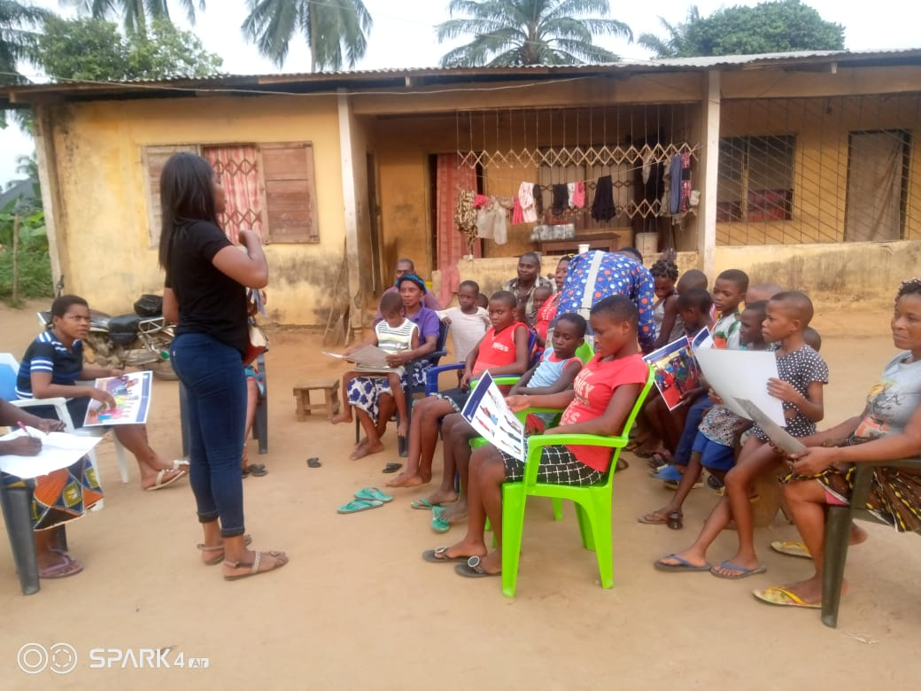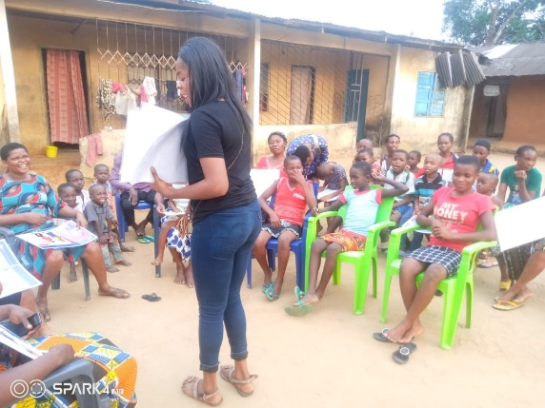
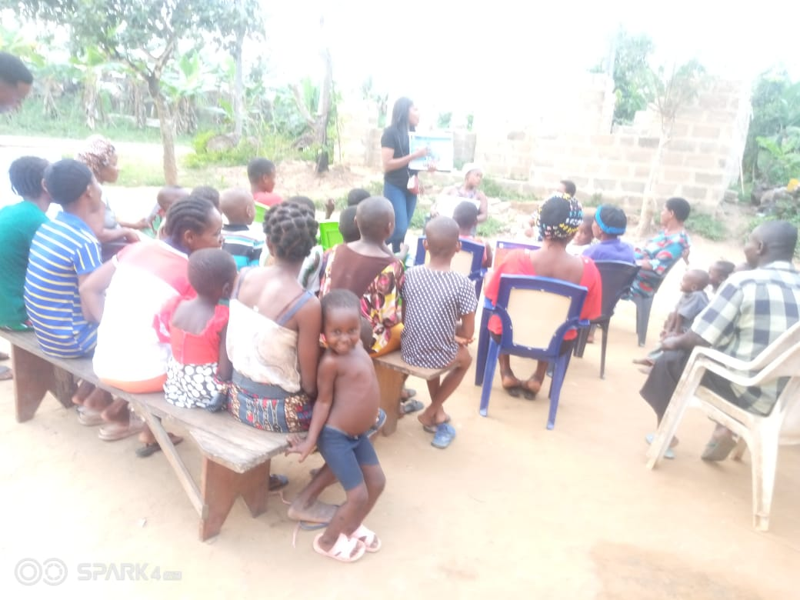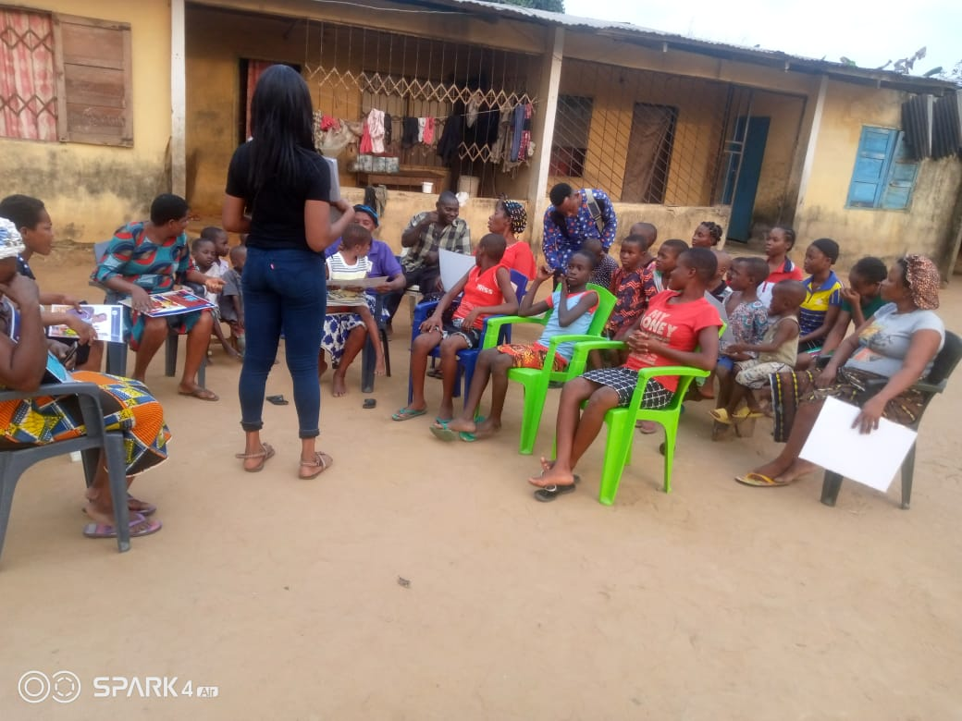
OKOBO (IKONO OFUI CHIEF LINUS COMPOUND)
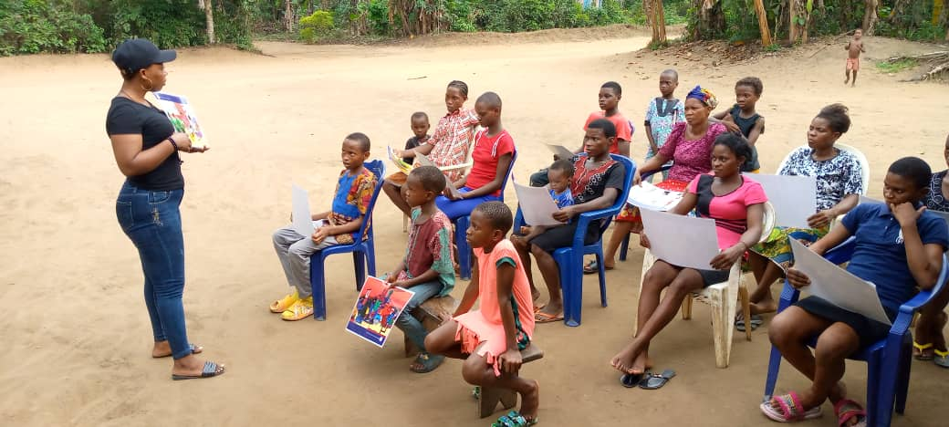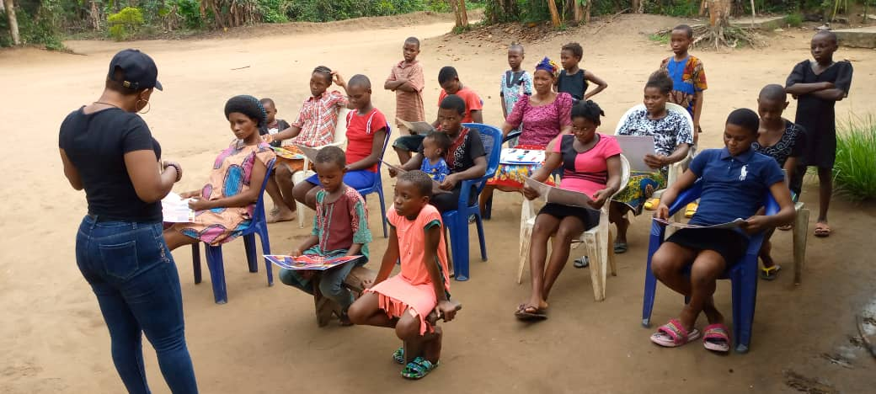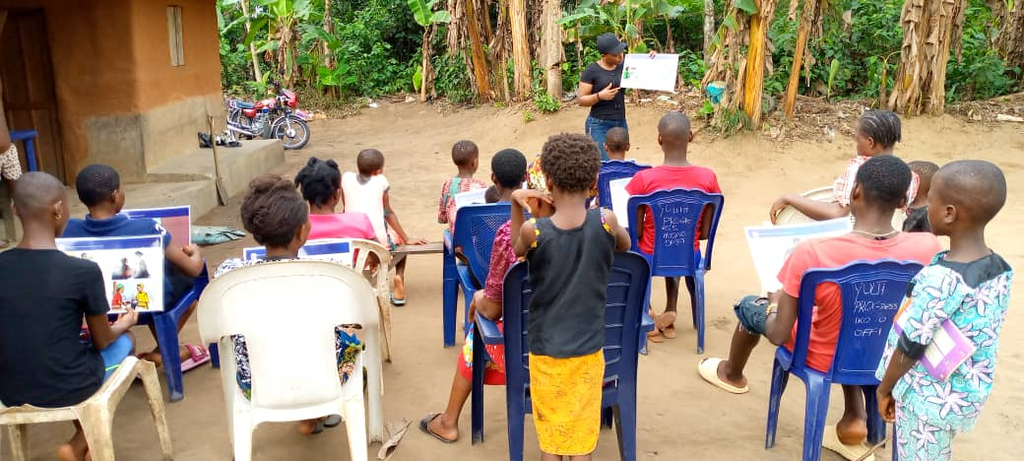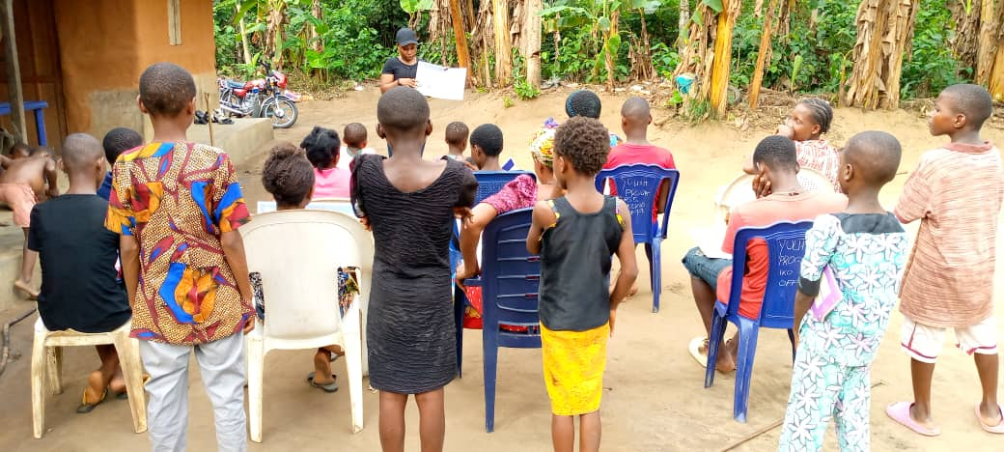

UDUNG UKO ( EKIN)
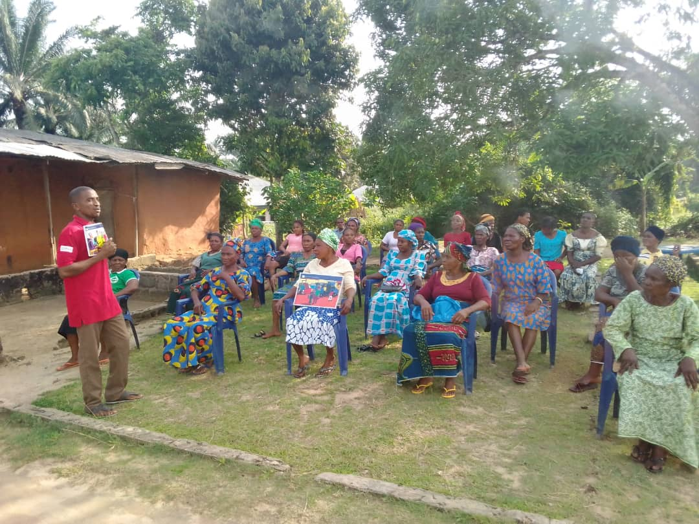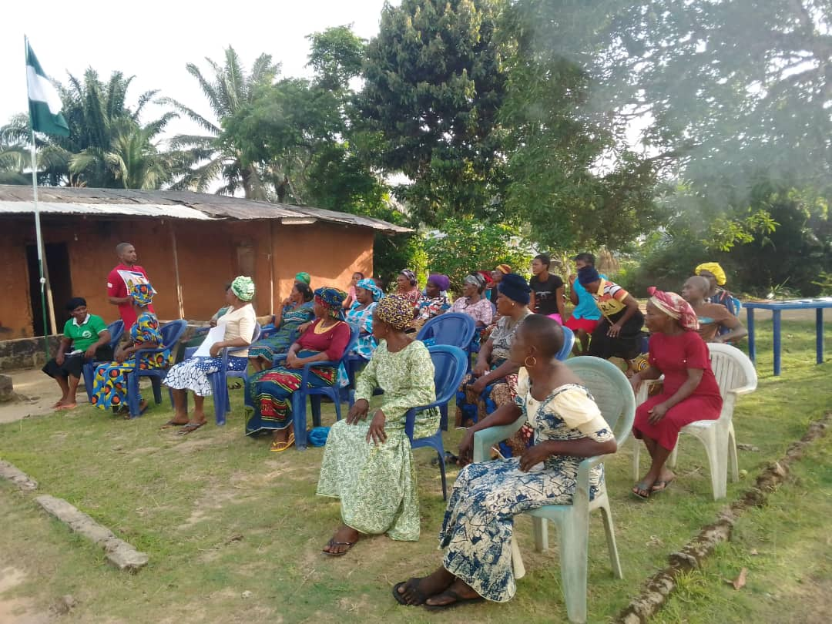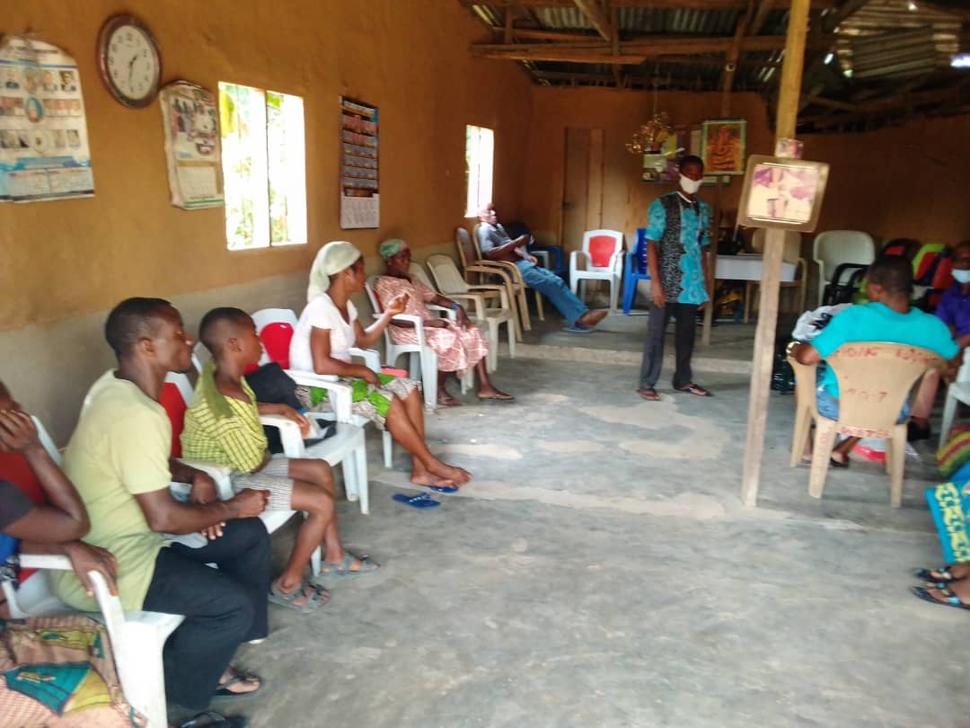

REPORTED BY: AKPAN EMMANUEL NDIFREKE
CSS/GO

24/3/2022

