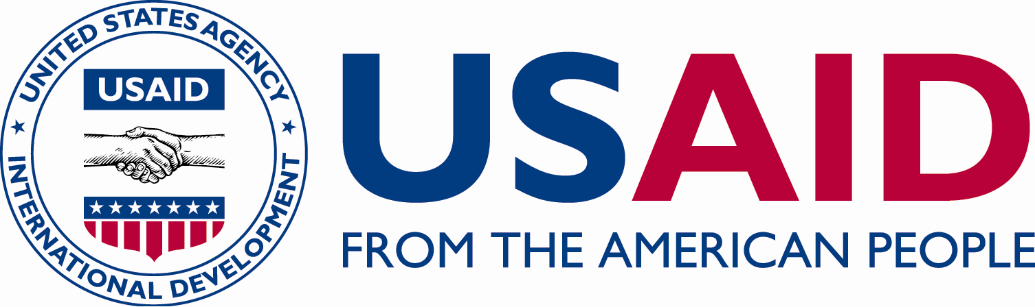

C

C

CRN

ICHSSA 1 PROJECT

BIRTH REGISTRATION REPORT

Submitted By: APPLICANTS WELFARE & DEVELOPMENT CENTRE (AWANDEC)

Month/Quarter: February /Q2

Submission Date: 28/2/2023

Executive Summary
Applicants Welfare & Development Centre (AWANDEC), one of the Community Based Organizations implementing ICHSSA I Project in Akwa Ibom State is focused on ensuring that children are protected by Stakeholders, Community, Local and State government in order to reduce their vulnerability to HIV and one of the ways of achieving this goal is ensuring that every child enrolled on the program is legally protected (has birth certificate).
To achieve this, AWANDEC leveraged on her good relationship with National Population Commission (NPOPC) in the State and facilitated the registration and certification of 200 project children in the month of February across Okobo, Mbo, Udung-Uko, and Urue Offong Uruku Local Government Areas of Akwa Ibom State.

Summary of Key activities (In bullet point please)
- Birth registration was carried out for 200 vulnerable children.
- OVC without birth certificates were tract from NOMIS extract.
- The tracked OVC were provided with form B1 which were correctly filled by AWANDEC’s Community Case Workers (CCWs) and returned to AWANDEC’S Sub-Office, Okobo.
- The completed Form B1 were taken to NPOPC for documentation and certification.
- The completed birth certificates were retrieved from NPOPC and photocopied.
- The photocopied birth certificates (form B2) were kept in the OVC’s household folders.
- While the original certificates (form B2) were handed over to the beneficiaries (OVCs) for their use.

Progress Narrative
AWANDEC in the reporting period facilitated the provision of 200 birth certificate to 200 OVC across her four implementation LGAs.
Form B1 were distributed to AWANDEC’s Community Case Workers (CCWs) to capture the information/details of OVC in the project without Birth Certificates. these form B1 were taken to the different communities across the implementation LGAs to obtain the necessary information concerning the OVC to be issued birth certificates. The filled form B1 were then forwarded to NPOPC for birth documentation and certification.
The completed birth certificates were retrieved from NPOPC, photocopied.
and kept in the OVC’s household folders while the original certificates (form B2) were handed over to the beneficiaries (OVC) for their use.
Below is the breakdown of Birth certificate provided to beneficiaries by LGA.
LGA | BENEFICIARIES MOBILIZED PER LGA
Udung Uko | 22(16 M : 6F)
Okobo | 145 (58 M : 87F)
Mbo | 33 (16M : 17F)
TOTAL | 200 (90M :110 F)

Output

- Details of 200 (90M; 110F) OVCs were captured on form B1.
- 200(90M; 110F)) OVC were provided with Birth certificates (Form B2).

Outcomes
- Legal protection service was provided for 200 (90M:110F) OVC

5.Follow up Action
- Work with CCWs for speed-up registration of OVC and timely submission of form B1 at the head office.
- Follow-up with NPOPC for the issuance of birth certificates to our OVC.

Pictures:

Reported By:

AKPAN EMMANUEL NDIFREKE
CSS/GO
28/2/2023

