

C

C

CRN

ICHSSA 1 PROJECT

LGA TASK TEAM CORDINATION MEETING.

  - Submitted by: APPLICANTS WELFARE AND DEVELOPMENT CENTRE

  - Month/Quarter: JULY/ Quarter 4

  - Submission Date: 22/7/2022

Executive Summary
AWANDEC is committed to driving policies that protect children in their various communities while strengthening existing community structures to help enhanced rights based approach in addressing child protection issues and ensuring the involvement of gatekeepers for safeguarding children from harm and abuse.
Within the reporting month, AWANDEC set up a TASK CORDINATION TEAM in UDUNG UKO to address the following issues.
- High rate of teenage pregnancy.
- Neglect and abandonment of children.

Summary of Key activities (In bullet point please)
- Set up TASK TEAM CORDINATION in Eyotai, UDUNG UKO LGA.

Progress Narrative:
As children remain exposed to due to neglect which has lead to cases of teenage pregnancy a Task Team becomes essential to mobilize community response to raise awareness on dangers of teenage pregnancy, importance of community child upbringing and to enact a law to discourage children from “hustling “.
Following increasing reports of Teenage Pregnancy in Udung Uko, AWANDEC collaborated with partners and stakeholders to set up Local government Task Team meeting with the Task of the effective ways to address the identified issues.
The forum was held on the 20th July 2022 at CHIEF Edet E. Uweh compound in Eyotai community at 1:30 p.m. The approach used in facilitating the session was a mentoring and participatory approach which included structured lectures on Teenage Pregnancy, questions were asked by the participants and resolutions to solving these issues were made and taken.
The meeting began with an opening prayer led by Mrs Alice Otiotkpoh deliberations followed thereafter the CSS officer enlightened the participants on ICHSSA 1 Project goals and presented the topics for discussion which included Teenage Pregnancy and Child neglect/ abandonment. The participants were lectured on Teenage Pregnancy which leads to the following:
- Illiteracy
- Medical complications such as Premature birth etc
- Infant mortality
- Death of the mother
- Cervical cancer
- Poverty
- Emotional and psychological trauma
- Early Child Marriage
The main factor leading and contributing to teenage pregnancy in Udung Uko is INEH. Whenever these children are pulled out of school to go to INEH they come back Pregnant. Today we have eight cases of teenage pregnancy amongst the children that returned from INEH, two cases of abandonment and neglect. There is a need to stop this from reoccurring or we would have a menace looming on our hands and that is why we came here today to discuss how we stop these from happening in our local community and local government.
The Linkage facilitator Mrs Uniyme further added the need for parents to educate their children, 95% of the cases results from lack of home training on the part of the parents and the society. She also told the group of some of the health faced by teenagers during child birth for example perinea laceration which can lead to infections, leaking stool, not being to hold gas, etc
Emem Udofia the community program monitor also educated the group on the societal and cultural implications of teenage pregnancy. She made the group to understand that teenage pregnancy leads to early child marriage in some occasion and molestation of the child in the marriage which has lead to the return of these young women to the parent’s house thereby increasing the financial burden on the household. If the community does not discourage early teenage pregnancy soon the community would be flooded with young mothers who have not complete secondary school education talk more of university education with no means of livelihood to cater for the children and no father to raise the child.
Patience Atteh the Director for SIDEC thanked the chief for his time and giving audience to the team. She however appealed to the chief to work closely with the team in reduces the reoccurrence of teenage pregnancy.
Elder Etim Umiom decried the failure of teachers in school in correcting children when they stray, the church has also failed to educate the parents on how to train children, parent no longer see the need to correct children when they stray and the society at large has also failed in its responsibility of training children because a child belongs to a particular village or community. Finally he asked what they would do to stop this menace.

After this questions were asked by participants:
1. How do they stop this?
Chief Edet suggested that the task team to be created, a public hearing should be held at the town hall involving other communities, letter and support should be given from the local government to enact a bye law to curb teenage pregnancy.
Elder Etim Umiom also added that a program should be conducted educating both the parents, teachers and community on the dangers of teenage pregnancy.

Output:
- 13(M 8:F5) persons were in attendance.
- A Task Team is to be setup to address the issues discussed during the dialogue session.
- A community dialogue session to place in the community.

2. Outcome
- A Task Team would be set up.
- Visit to the local government chairman to seek support to address this through legislation.
- Community dialogue session to take place with all the chiefs in the LGA.
- To enact a law and a task force to enforce the law.

Challenges:

Recommendations

4. Follow Up Action
- Setting up a committee.
- Follow up with a meeting with the local government chairman.
- Follow up with the team formation.

PICTURES
LGA TASK TEAM CORDINATION MEETING, UDUNG UKO
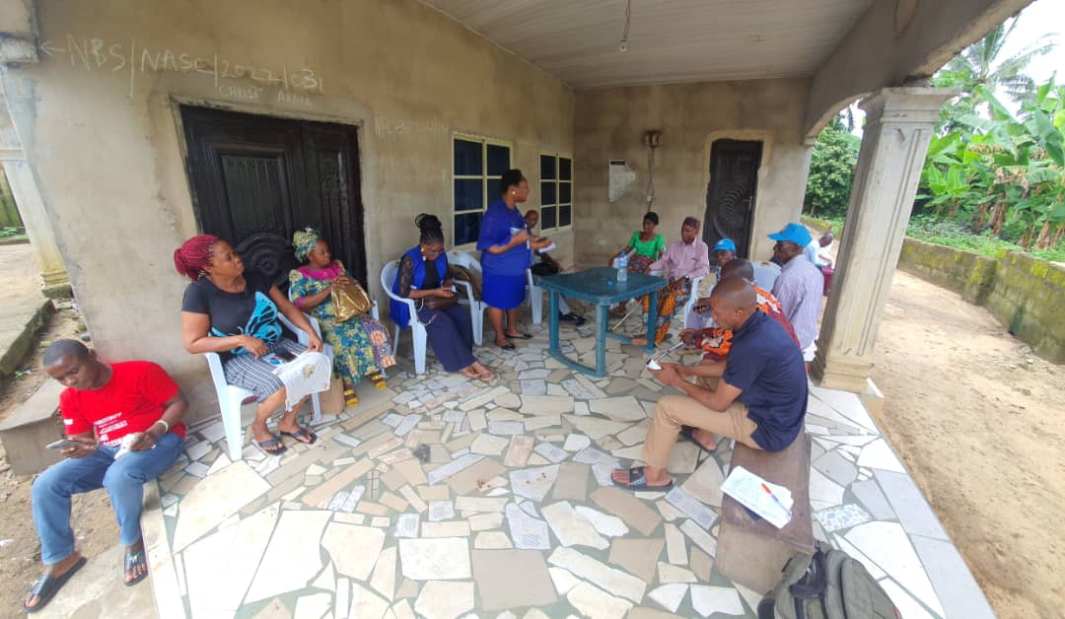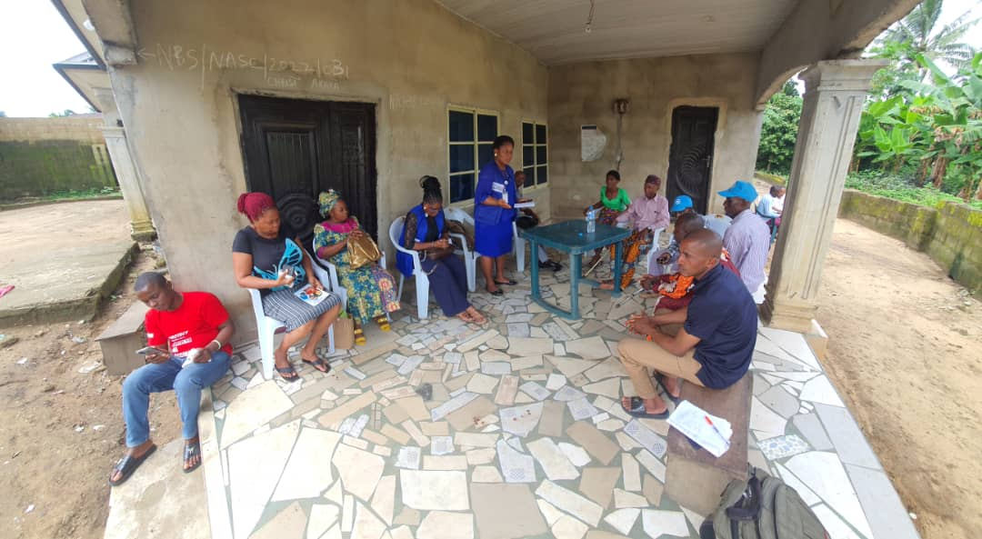

  - Reported by
AKPAN EMMANUEL NDIFREKE/CCS&GO , AWANDEC

20/7/2022

REVIEWED BY:
ARIT UDOAKAGHA/PROGRAM MANAGER, AWANDEC

20/7/2022

