This document serves as a general guideline for the participants of this dataset collection. Please follow the instructions documented.
The subject should be positioned as depicted in the diagram below:
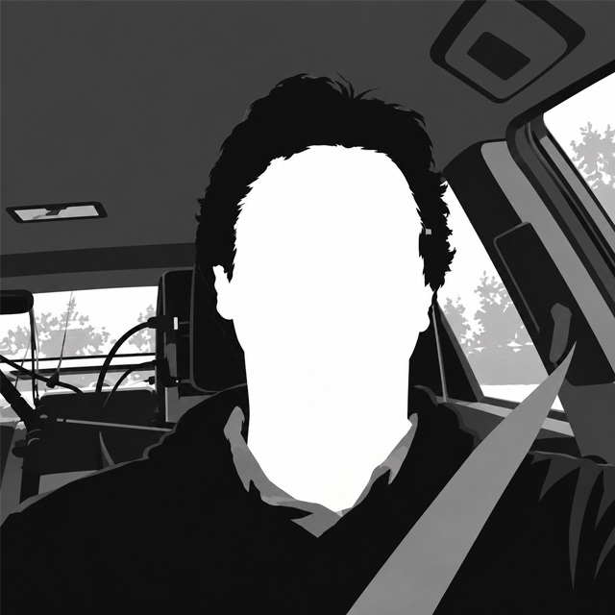

The subject must act in a similar manner as depicted in the diagram below:
- Holding a phone
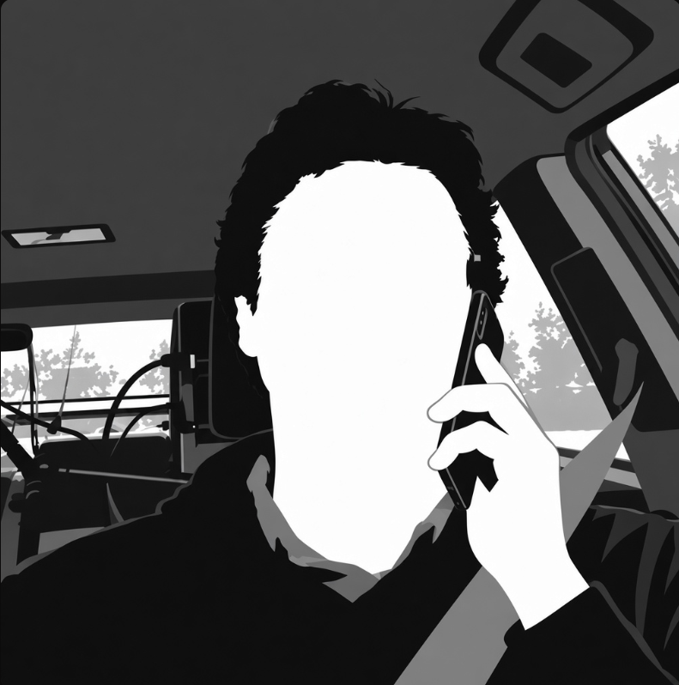

- Yawning
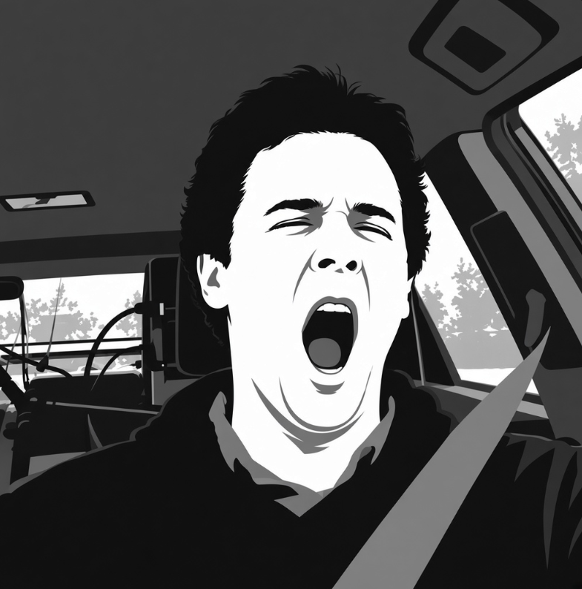

- Hands covering mouth while yawning

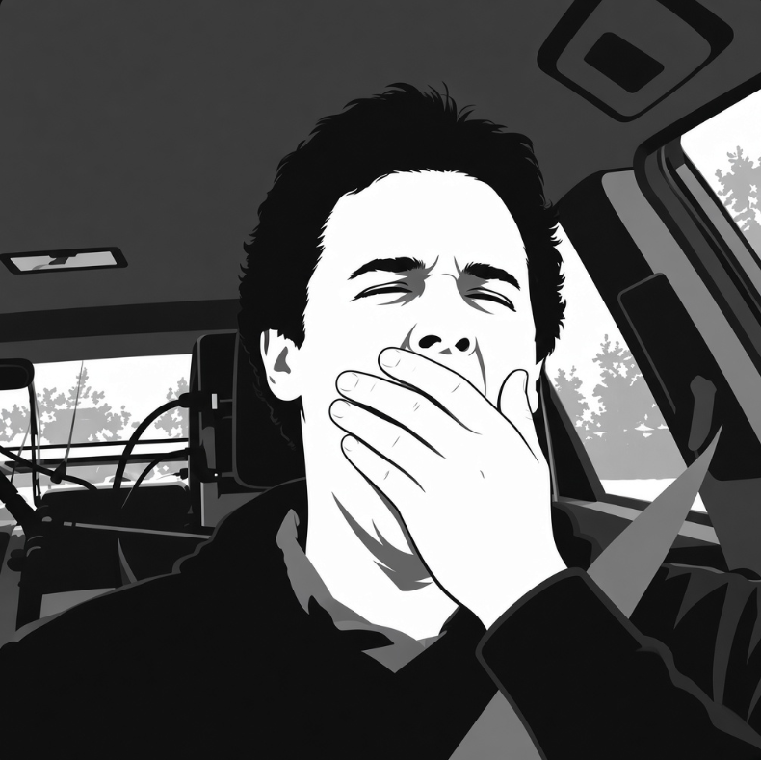

- Drinking
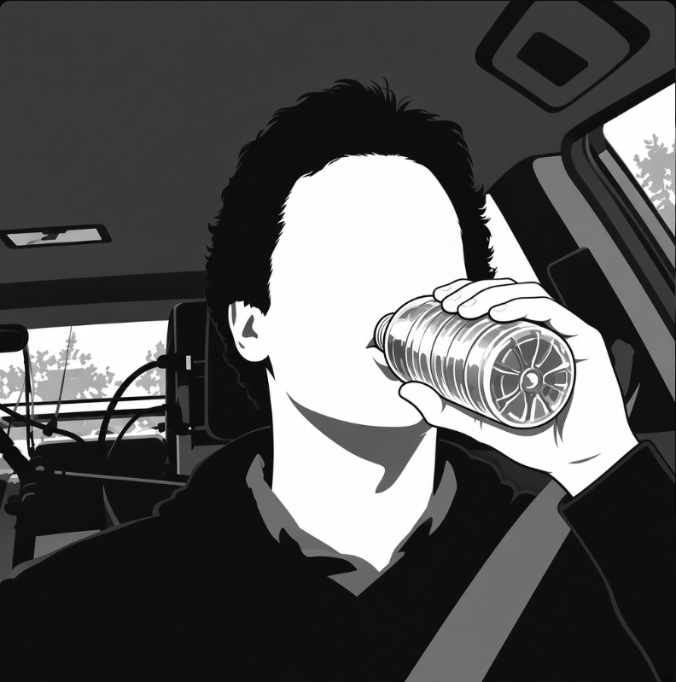

- Looking away


