Customer Shopping Behavior Analysis

Prepared By: Prashant Bhattarai

1. Project Overview
This project focuses on analyzing customer purchasing behavior using transactional data from approximately 3,900 records across multiple product categories. The objective is to extract meaningful insights related to spending habits, customer segmentation, product trends, and subscription patterns to support data-driven business decisions.

2. Dataset Overview
Total Records: 3,900
Total Features: 18
Key Attributes:
- Customer Information: Age, Gender, Location, Subscription Status
- Purchase Details: Product Name, Category, Purchase Value, Season, Size, Color
- Behavioral Indicators: Discount Usage, Promo Code Usage, Purchase Frequency, Previous Orders, Review Score, Shipping Method
Missing Values: 37 entries missing in the Review Rating column

3. Data Preparation & Exploration (Python)
Initial data exploration and preprocessing were performed using Python:
- Data Import: Loaded dataset using pandas
- Preliminary Analysis: Used df.info() and df.describe()
- Handling Missing Values: Filled missing review ratings using median per category
- Column Formatting: Converted column names to snake_case
- Feature Creation: age_group and purchase_frequency_days columns created
- Data Validation: Removed redundant fields like promo_code_used
- Database Integration: Loaded cleaned data into PostgreSQL

4. Business Analysis using SQL

1. Revenue Distribution by Gender

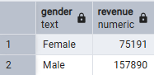

2. High-Value Discount Users
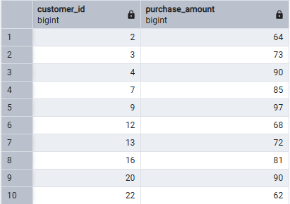

3. Top Rated Products

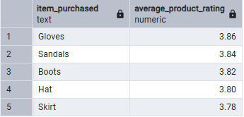

4. Shipping Method Comparison

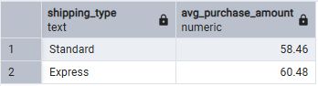

5. Subscribers vs Non-Subscribers

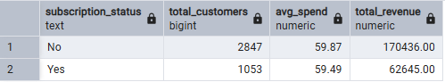

6. Discount-Driven Products

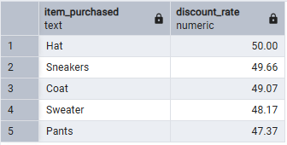

7. Customer Segmentation

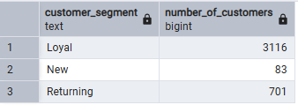

8. Top Products by Category

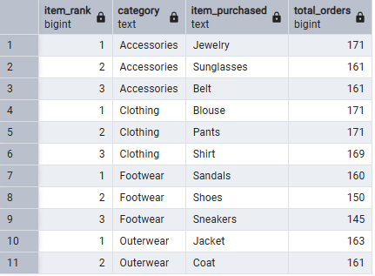

9. Repeat Buyers & Subscription Behavior

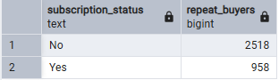

10. Revenue by Age Group

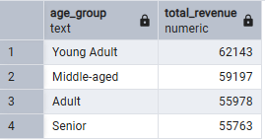

5. Power BI Dashboard
An interactive dashboard was developed using Power BI to visualize key insights and trends. It includes customer count, average purchase value, revenue breakdown, and sales trends.

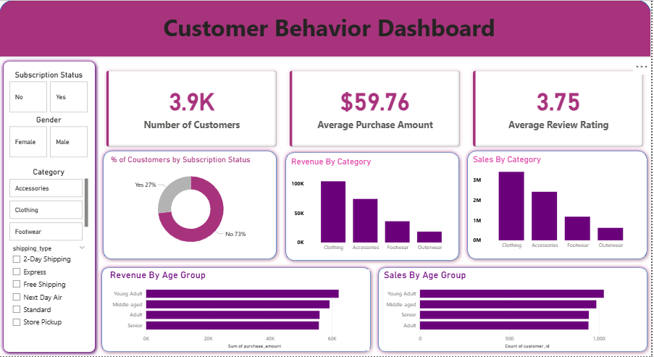

6. Business Insights & Recommendations
- Increase Subscription Adoption by offering exclusive benefits
- Strengthen Customer Loyalty through rewards programs
- Optimize Discount Strategy to maintain profitability
- Promote High-Performing Products in marketing campaigns
- Use Targeted Marketing for high-value segments

Unlock the complete presentation of this analysis from this link https://gamma.app/docs/Customer-Purchase-Behavior-Analysis-wgvimqnohsd6fdi

