**BookShop**

**Web pages**

1. **Sign In**: Signing In a user(both Customer & Distributor)
2. **Sign Up**: Signing Up a new user(both Customer & Distributor)
3. **Homepage:** To view books by different categories like latest arrival, best seller etc.
4. **Individual Book Page**: To view an individual book with more details
5. **Shopping Cart**: To view the books that have been added to the cart for purchase
6. **Buy**: To carry out the purchase

**Functional Requirements**

|  |  |
| --- | --- |
| **Requirement Id** | **Requirement** |
| FR1 | The website shall have a home page where books are shown in different categories like latest, best selling, popular etc. |
| FR2 | Home page shall have a search bar which could search books by title, author, and genre. |
| FR3 | User shall be able to sort the search result by reviews, price or date of arrival. |
| FR4 | User shall be able to view each book individually with much more details like customer reviews. |
| FR5 | Buyer shall be able to add multiple books to the virtual shopping cart to buy them at once. |
| FR6 | cash on delivery payment |
| FR7 | online payment |
| FR7 | Distributor shall be able add book for sale for specific period of time. |
| FR8 | Distributor shall be able to view the sales record of the books uploaded. |
| FR9 | The website shall have good UX in on mobile browsers as well. |

**Non-Functional Requirements**

**Performance and scalability:** How fast does the system return results? How much will this performance change with higher workloads?

**Portability and compatibility:** Which hardware, operating systems, browsers, and their versions does the software run on? Does it conflict with other applications and processes within these environments?

**Reliability, availability, maintainability:** How often does the system experience critical failures? And how much time is it available to users against downtimes?

**Security:** How are the system and its data protected against attacks?

**Localization:** Does the system match local specifics?

**Usability:** How easy is it for a customer to use the system?

**ER Diagram**

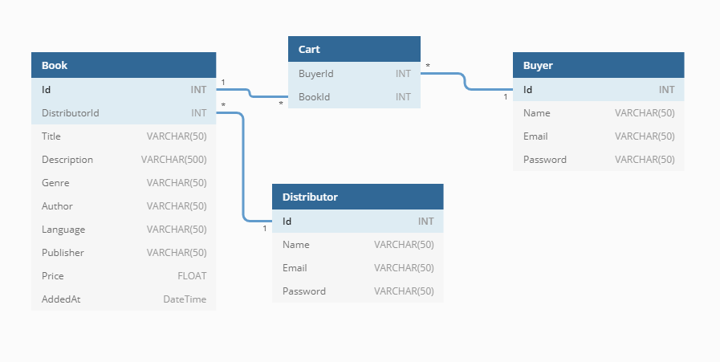

**Data Access Layer (DAL)**

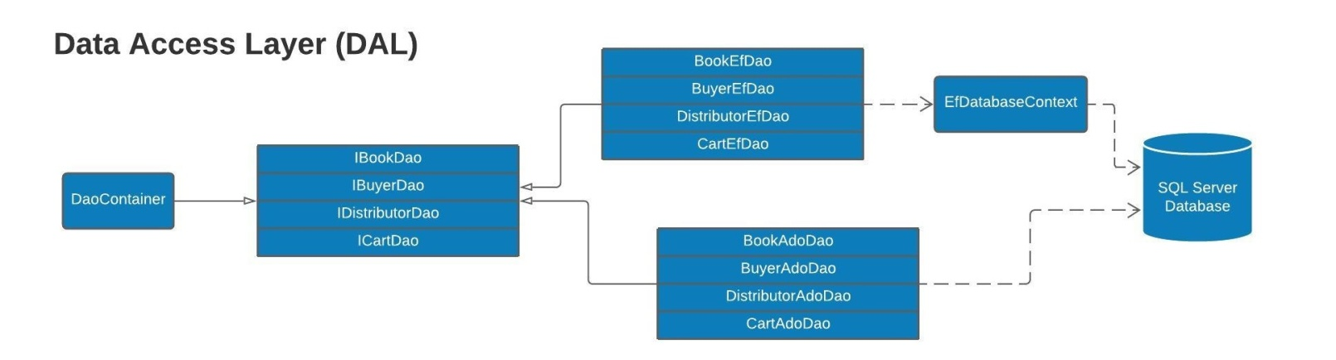

**UML**

