# Ahsanullah University of Science & Technology

Department of Computer Science & Engineering Semester Fall 2021

CSE 3216

Microcontroller Based System Design Lab

Project Final Report

Project Name: **Home Automation & Safety System**

Submitted To

**Dr. Md. Raqibul Hasan** Assistant Professor Dept. of CSE, AUST

**Mr. Farzad Ahmed**

Lecturer

Dept. of CSE, AUST

Submitted By

Lab Section: A2 Group No: 06

|  |  |
| --- | --- |
| 190104039 | S.M. Raiyan Reza Rabab |
| 190104045 | Md. Sirajus Salekin Shafi |
| 190104047 | Asif Mamun Hridoy |
| 190104049 | Md. Saidur Rahman Sujon |

# Contents

|  |  |  |
| --- | --- | --- |
| No | Topic | Page |
| 1 | Objectives | 1 |
| 2 | Social Values | 1 |
| 3 | Required Components | 2 |
| 4 | Working Procedure | 2 |
| 5 | Budget Comparison | 7 |
| 6 | Contribution of Team-Members | 9 |
| 7 | Challenges of the Project | 9 |
| 8 | Conclusion | 10 |
| 9 | Reference | 10 |

**Objectives**

Nowadays, mobile devices are part of our daily lives. Our mobile phone can be used to control our home appliances. In this upgraded generation we can switch home appliance without going to switch. People in a hurry may forget to turn off the lights/fans. They can turn off the light/fan while travelling by their android phone. This will reduce the power consumption. The main goal of this project is to build smart home devices that can control home appliances over the internet.

All of us worry about the safety of our homes. In this project home security will be introduced with buzzer, ultrasonic sensor, PIR sensor, sound sensor, gas sensor, fire sensor, password protection.

Moreover, these features, the temperature and humidity of the user's surroundings are also be displayed.

The main objectives, in short, are:

* **Ease of Use**: We can control all operations using only smartphones.
* **Using Bluetooth**: We will use Bluetooth for data communication and operating.
* **Automated Door System**: We can open or close entrances using passwords.
* **Home Security**: We will detect intrusion by someone’s motion.
* **Preventing Accidents**: We will detect fire and gas leakage.
* **Showing Home Data**: Information like room temperature, humidity etc. will be displayed.

# Social Values

A *smart home* is a great leap in technology that can enable people to live a new lifestyle at home with the utmost ease.

Some of the social values are: This project is cheap and it’s in affordable price range. It can provide home security to old and disabled people. It can detect any intruder trying to access door. User can access to door by providing correct password. User can also check states of the home like room temperature and Humidity.

Thus, this project can provide ease of accessibility and home safety.

# Required Components

1. Arduino Uno R3
2. Breadboard
3. Jumper Wires (M-M, F-F, M-F)
4. Variable Voltage Adapter
5. Active Buzzer
6. Keypad - 4x4 - Matrix Membrane Type
7. I2C LCD Screen 16x2
8. Servo Motor SG90
9. 3V DC Motor Small
10. White 5mm LED bulbs
11. Temperature Sensor (DHT11)
12. MQ2 Flying Fish Gas Sensor
13. HL-01 Flame Sensor
14. HC-SR501 PIR Motion Sensor
15. HC-05 Bluetooth Module

# Working Procedure

**Arduino Mega 2560 R3:** This device takes all the inputs from users and other sensors, stores code and gives output according to the stored code.

**Temperature Sensor (LM35):** This device calculates temperature as input.

**I2C LCD Screen:** This displays all the texts in our project such as home info, password inputs etc.

**Keypad - 4x4 - Matrix Membrane Type:** This device has a total 16 keys. Users can press the keys and assign them for different tasks.

**Servo Motor SG90:** This is a motor that can be rotated between speciﬁc angles. Used for our door.

**3V DV Motor Small:** Used to rotate our demo fan.

**MQ2 Flying Fish Gas Sensor:** Detects gasses in our home.

**DHT11 Motion Sensor:** Detects biological movements and is used as intrusion detector.

**HL-01 Flame Sensor:** Detects fire in our home.

**HC-05 Bluetooth Module:** This device is a Bluetooth sensor. We control our lights and fans via Bluetooth using this device.

**Breadboard:** This component is used to connect different sensors and components.

**Jumper Wires:** Connects different ports.

**Variable Voltage Adapter:** Works as a power source.

**White 5mm LED bulbs:** Used for our demo light.

**Active Buzzer:** Works as an alert sound.

# Circuit Diagram

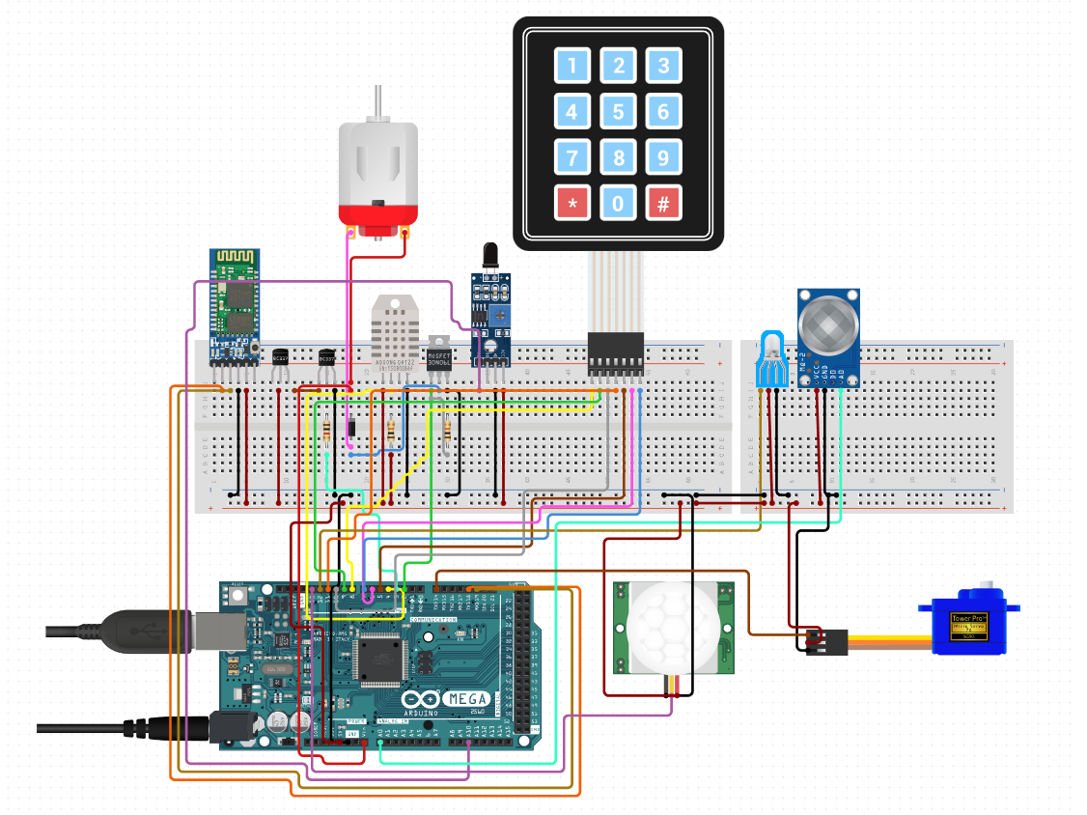

*Fig 1: Circuit diagram of Home Automation and Safety System*

# Block Diagram

# *Fig 2: Block diagram of Home Automation and Safety System*

# Project Images

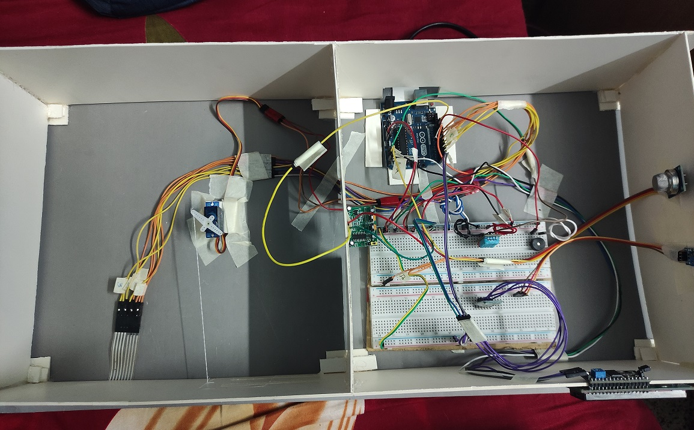  
*Fig 3: Top view*

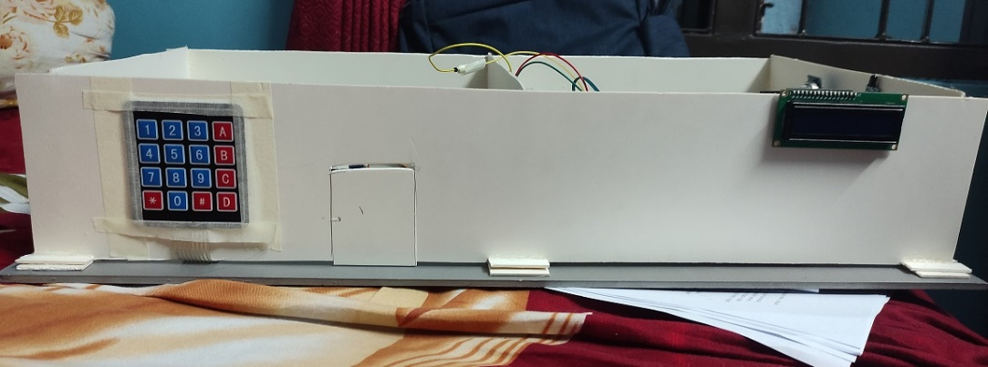

*Fig 4: Front view*

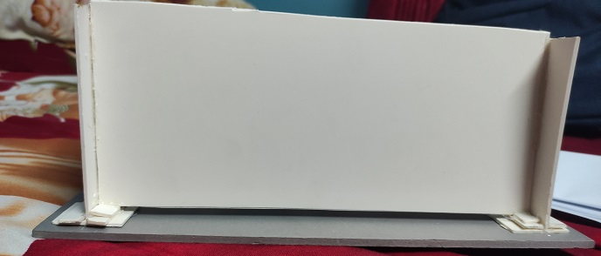

*Fig 5: Right view*



*Fig 6: Left view*

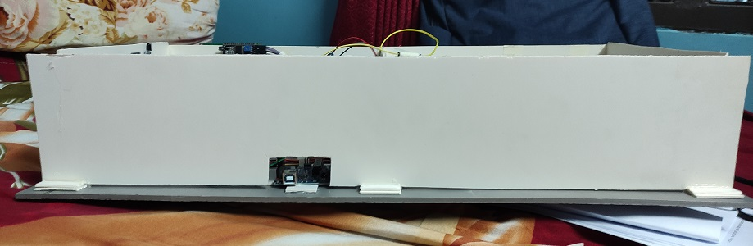

*Fig 7: Back view*

*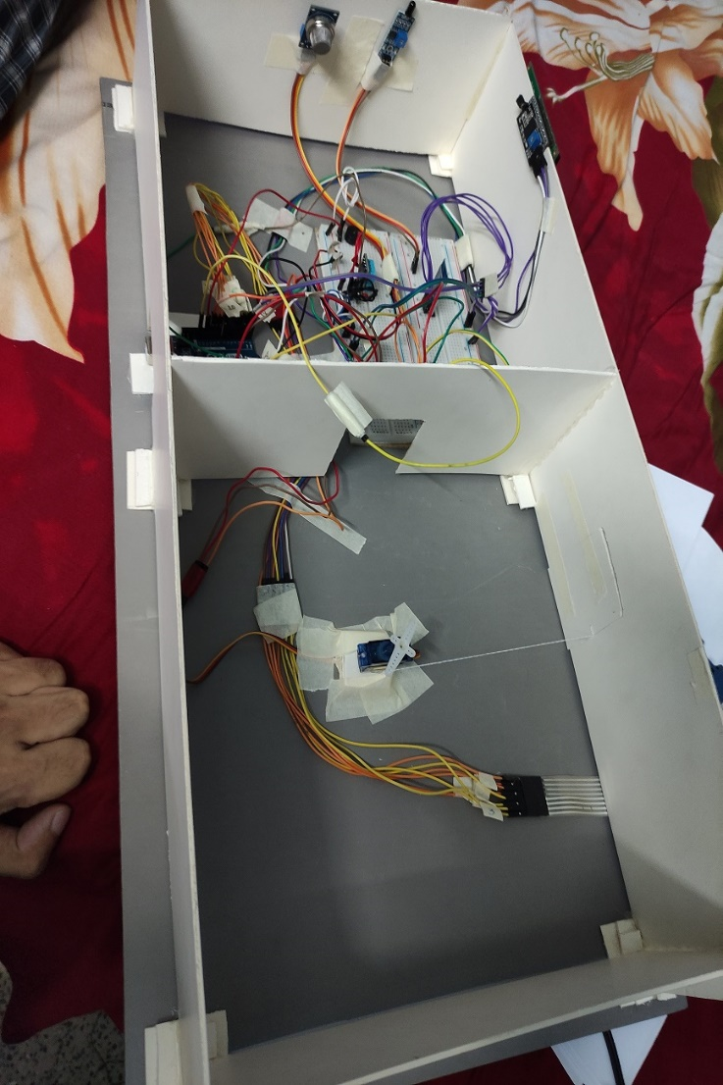  
Fig 8: Aerial view*

# Budget Comparison

**Initial Estimation:**

|  |  |  |
| --- | --- | --- |
| **Equipment** | **Quantity** | **Unit Price (Tk.)** |
| Arduino UNO | 1 | 640 |
| I2C LCD Display 16x2 | 1 | 332 |
| Matrix Key Pad (4x4) | 1 | 90 |
| Gas Sensor Module (MQ-4) | 1 | 160 |
| LED Light | 1 | 100 |
| DC Motor 3v | 1 | 65 |
| Buzzer 5v active | 2 | 30 |
| Wires (mixed) | as required | 100 |
| DHT11 Sensor Module | 1 | 155 |
| IR YG1006 Flame Sensor Module | 1 | 88 |
| Double connection on/off switch | 2 | 50 |
| Servo Motor SG90 | 1 | 200 |
| Breadboard (830 Point) | 1 | 124 |
| HC05 Bluetooth Module | 1 | 300 |
| GSM SIM 800 C Module | 1 | 1200 |
| HC-SR501 PIR Motion Detector | 1 | 100 |
| Universal Automatic 1.5V to 12V Power Adapter | 1 | 120 |
| **Total:** | | **3854** |

**Final Expenditure:**

|  |  |  |
| --- | --- | --- |
| **Equipment** | **Quantity** | **Unit Price (Tk.)** |
| Arduino UNO | 1 | 443.37 |
| I2C LCD Display 16x2 | 1 | 198.88 |
| Matrix Key Pad (4x4) | 1 | 54.32 |
| Gas Sensor Module (MQ-4) | 1 | 96.07 |
| LED Light | 1 | 36.00 |
| DC Motor 6v | 1 | 65.00 |
| Buzzer 5v active | 1 | 10.90 |
| Wires (mixed) | 100 | 100.00 |
| DHT11 Sensor Module | 1 | 90.10 |
| IR YG1006 Flame Sensor Module | 1 | 72.00 |
| Servo Motor SG90 | 1 | 119.80 |
| Breadboard (830 Point) | 1 | 102.13 |
| HC05 Bluetooth Module | 2 | 438.52 |
| HC-SR501 PIR Motion Detector | 1 | 51.00 |
| Universal Automatic 1.5V to 12V Power Adapter | 1 | 120 |
| **Total:** | | **1832.69** |

# Contribution of Team-Members

**Challenges of the Project:**

1. The Bluetooth module is very vulnerable; applying a little excess voltage damaged it. We had to buy a new one.
2. Keypad keys do not work sometimes.
3. Buzzer stopped working perfectly; it started making distorted buzz later on.
4. The PIR Motion sensor does not take inputs properly, and showed wrong outputs.

# Conclusion

The Arduino-based project *Home Automation & Safety System* uses different types of sensors to react to different situations and automate various activities in a home. Hence, it reduces the workload of the home owner(s) and makes the maintenance process easier. It lessens the probability of human error as well. Using this system, a person's lifestyle will before more secure, fast and easier.

# Reference

1. [https:/ www.arduino.cc/](https://www.arduino.cc/)
2. [https:/ www.circuito.io](https://www.circuito.io/)