

Functional Safety Concept Lane Assistance

**Document Version: [Version]**

**Template Version 1.0, Released on 2017-06-21**



# Document history

**[Instructions: Fill in the date, version and description fields. You can fill out the Editor field with your name if you want to do so. Keep track of your editing as if this were a real world project.**

**For example, if this were your first draft or first submission, you might say version 1.0. If this is a second submission attempt, then you'd add a second line with a new date and version 2.0]**

|  |  |  |  |
| --- | --- | --- | --- |
| Date | Version | Editor | Description |
| 5/24/2018 | 1.0 | Shivam Jaiswal | First attempt |
|  |  |  |  |
|  |  |  |  |
|  |  |  |  |
|  |  |  |  |

# Table of Contents

Document history

Table of Contents

Purpose of the Functional Safety Concept

Inputs to the Functional Safety Analysis

Safety goals from the Hazard Analysis and Risk Assessment

Preliminary Architecture

Description of architecture elements

Functional Safety Concept

Functional Safety Analysis

Functional Safety Requirements

Refinement of the System Architecture

Allocation of Functional Safety Requirements to Architecture Elements

Warning and Degradation Concept

# Purpose of the Functional Safety Concept

**[Instructions: Answer what is the purpose of a functional safety concept?]**

Functional Safety Concept is looking at the item from a higher level and to look at the general functionality of the item. The goal is to identify safety requirements and then to allocate these safety requirements to the relevant parts of the system diagram. Allocation means defining which part of the system architecture will implement each requirement. This could involve expanding the system architecture with new element blocks and then refine the system architecture to handle the new requirements. Functional safety requirements also have a few attributes that need to be specified in the functional safety concept. At last to prove that a system actually meets your requirements, they have to be verified and validated.

# Inputs to the Functional Safety Concept

## Safety goals from the Hazard Analysis and Risk Assessment

**[Instructions:**

**REQUIRED:**

**Provide the lane departure warning and lane keeping assistance safety goals as discussed in the lessons and derived in the hazard analysis and risk assessment.**

|  |  |
| --- | --- |
| **ID** | **Safety Goal** |
| Safety_Goal_01 | The oscillating steering torque from the lane departure warning function shall be limited |
| Safety_Goal_02 | The Lane Keeping Assistance function shall be time limited, and additional steering torque shall end after a given time interval so the driver cannot misuse the system for autonomous driving. |

**OPTIONAL:**

**If you expanded the hazard analysis and risk assessment to include other safety goals, include them here.**

**]**

**OPTIONAL:**

|  |  |
| --- | --- |
| **ID** | **Safety Goal** |
| Safety_Goal_03 | The camera should be calibrated every time system boots up to check if it performing correctly. |
| Safety_Goal_04 | The Lane Keeping Assistance has to be deactivated if camera sensor is not able to detect lanes correctly. |

## Preliminary Architecture

**[Instructions: Provide a preliminary architecture for the lane assistance item. Hint: See Lesson 3: Item Definition]**

Preliminary architecture for the lane assistance item is following

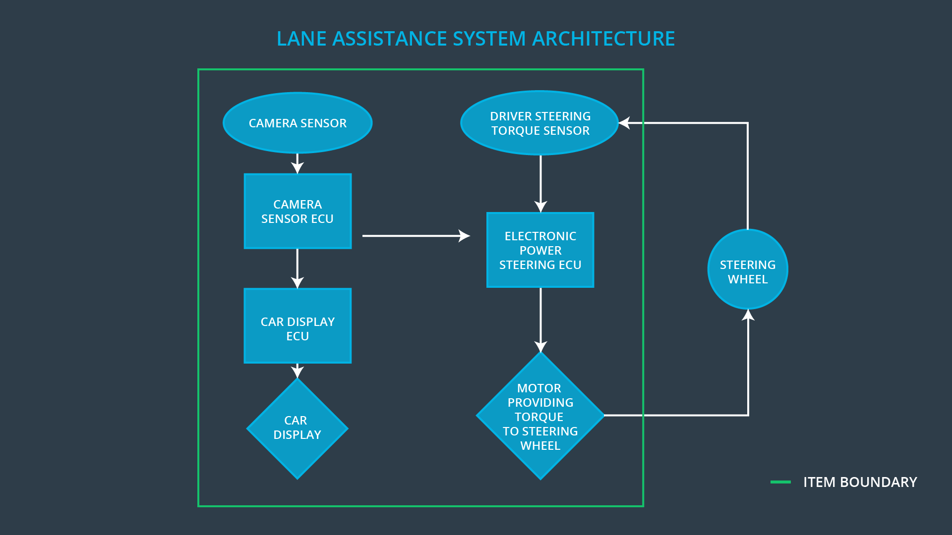

The item boundary is drawn to include three sub-systems:

* Camera system
* Electronic Power Steering system
* Car Display system

### Description of architecture elements

**[Instructions: Provide a description for each of the item elements; what is each element's purpose in the lane assistance item? ]**

|  |  |
| --- | --- |
| **Element** | **Description** |
| Camera Sensor | The camera sensor reads images from the road. |
| Camera Sensor ECU | The camera sensor ECU identifies when the vehicle has accidentally departed its lane, and send the appropriate messages to the Car Display ECU and the Electronic Power Steering ECU. |
| Car Display | Car Display system displays warnings and the lane departure status |
| Car Display ECU | The Car Display ECU send signals to Car Display from Camera Sensor ECU and Electronic Power Steering ECU. |
| Driver Steering Torque Sensor | Measures the torque applied to the steering wheel by driver |
| Electronic Power Steering ECU | Process input torque from Driver Steering Torque Sensor and requested by Lane Keeping Assistant and Lane Departure Warning |
| Motor | Receives final torque and applies it to wheel |

# Functional Safety Concept

The functional safety concept consists of:

* Functional safety analysis
* Functional safety requirements
* Functional safety architecture
* Warning and degradation concept

## Functional Safety Analysis

**[Instructions: Fill in the functional safety analysis table below.]**

|  |  |  |  |
| --- | --- | --- | --- |
| **Malfunction ID** | **Main Function of the Item Related to Safety Goal Violations** | **Guidewords (NO, WRONG, EARLY, LATE, MORE, LESS)** | **Resulting Malfunction** |
| Malfunction_01 | Lane Departure Warning (LDW) function shall apply an oscillating steering torque to provide the driver a haptic feedback | MORE | The Lane Departure Warning function applies an oscillating torque with very high torque frequency (above limit**)** |
| Malfunction_02 | Lane Departure Warning (LDW) function shall apply an oscillating steering torque to provide the driver a haptic feedback | MORE | The Lane Departure Warning function applies an oscillating torque with very high torque amplitude (above limit**)** |
| Malfunction_03 | Lane Keeping Assistance (LKA) function shall apply the steering torque when active in order to stay in ego lane | NO | The Lane Keeping Assistance function is not limited in time duration which lead to misuse as an autonomous driving function |

## Functional Safety Requirements

**[Instructions: Fill in the functional safety requirements for the lane departure warning ]**

Lane Departure Warning (LDW) Requirements:

|  |  |  |  |  |
| --- | --- | --- | --- | --- |
| **ID** | **Functional Safety Requirement** | **ASIL** | **Fault Tolerant Time Interval** | **Safe State** |
| Functional  Safety  Requirement  01-01 | The lane keeping item shall ensure that the lane departure oscillating toque amplitude is below **Max_Torque_Amplitude** | C | 50 ms | Vibration torque amplitude below **Max_Torque_Amplitude** |
| Functional  Safety  Requirement  01-02 | The lane keeping item shall ensure that the lane departure oscillating toque frequency is below **Max_Torque_Frequency** | C | 50 ms | Vibration torque amplitude below **Max_Torque_Frequency** |

Lane Departure Warning (LDW) Verification and Validation Acceptance Criteria:

|  |  |  |
| --- | --- | --- |
| **ID** | **Validation Acceptance**  **Criteria and Method** | **Verification Acceptance**  **Criteria and Method** |
| Functional  Safety  Requirement  01-01 | Test how drivers react to different torque amplitude and torque amplitude should be high enough to be detected by a driver | Verify that if system turns off if LDW exceeded **Max_Torque_Amplitude** |
| Functional  Safety  Requirement  01-02 | Test how drivers react to different torque frequencies and torque frequencies should be high enough to be detected by a driver | Verify that if system turns off if LDW exceeded **Max_Torque_Amplitude** |

**[Instructions: Fill in the functional safety requirements for the lane keeping assistance]**

Lane Keeping Assistance (LKA) Requirements:

|  |  |  |  |  |
| --- | --- | --- | --- | --- |
| **ID** | **Functional Safety Requirement** | **ASIL** | **Fault Tolerant Time Interval** | **Safe State** |
| Functional  Safety  Requirement  02-01 | The electronic power steering ECU shall ensure that the Lane Keeping Assistance torque is applied only Max_Duration. | B | 500ms | Lane Keeping Assistance torque is zero. |

Lane Keeping Assistance (LKA) Verification and Validation Acceptance Criteria:

|  |  |  |
| --- | --- | --- |
| **ID** | **Validation Acceptance**  **Criteria and Method** | **Verification Acceptance**  **Criteria and Method** |
| Functional  Safety  Requirement  02-01 | Validate the Max_Duration chosen not allow the driver to use the car as self-driving car. | Verify the system does deactivate if the Lane Keeping Assistance torque application exceeded Max_Duration. |

## Refinement of the System Architecture

**[Instructions: Include the refined system architecture. Hint: The refined system architecture should include the system architecture from the end of the functional safety lesson including all of the ASIL labels.]**

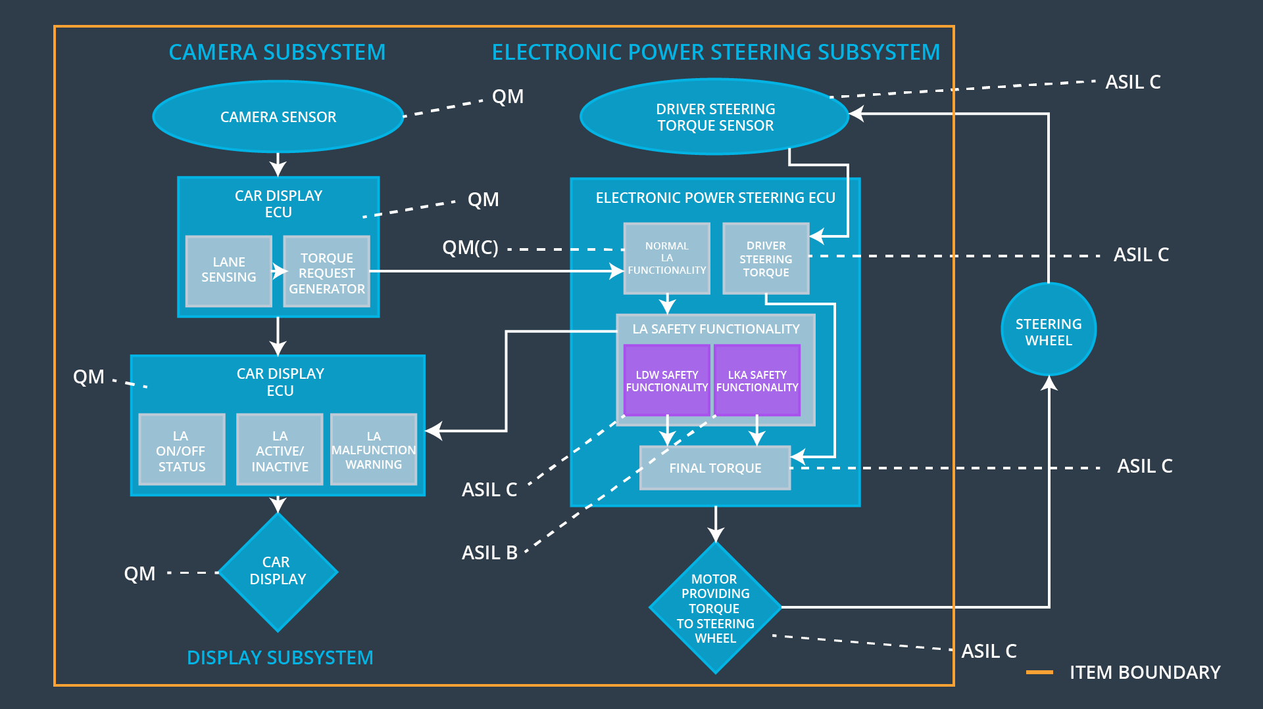

## Allocation of Functional Safety Requirements to Architecture Elements

**[Instructions: Mark which element or elements are responsible for meeting the functional safety requirement. Hint: Only one ECU is responsible for meeting all of the requirements.]**

|  |  |  |  |  |
| --- | --- | --- | --- | --- |
| **ID** | **Functional Safety Requirement** | **Electronic Power Steering ECU** | **Camera ECU** | **Car Display ECU** |
| Functional  Safety  Requirement  01-01 | The lane keeping item shall ensure that the lane departure oscillating toque amplitude is below **Max_Torque_Amplitude** | **X** |  |  |
| Functional  Safety  Requirement  01-02 | The lane keeping item shall ensure that the lane departure oscillating toque frequency is below **Max_Torque_Frequency** | **X** |  |  |
| Functional  Safety  Requirement  02-01 | The electronic power steering ECU shall ensure that the Lane Keeping Assistance torque is applied only Max_Duration. | **X** |  |  |

## Warning and Degradation Concept

**[Instructions: Fill in the warning and degradation concept.]**

|  |  |  |  |  |
| --- | --- | --- | --- | --- |
| **ID** | **Degradation Mode** | **Trigger for Degradation Mode** | **Safe State invoked?** | **Driver Warning** |
| WDC-01 | Turn off Lane Departure Warning functionality | Malfunction_01,  Malfunction_02 | Yes | Lane Departure Malfunction Warning on Car Display |
| WDC-02 | Turn off Lane Keeping Assistant functionality | Malfunction_03 | Yes | Lane Keeping Assistance Malfunction Warning on Car Display |