GT ASSIGNMENT 2

## BY SHUBHAM GUPTA PES1201801295

### Summary:

A graph database of technology giants (Google, Apple, AMD), E commerce Services (Amazon.com) and business companies (Reliance Industries Limited). The relationship consists of the companies most notable people related to them along with some basic information.

### Node Information:

Organisation: {Name -> Name of the organisation,

Type -> Type of the organisation}

Person: {Name-> Name of person, Gender-> Gender of person,

DoB-> date of birth, Nationality-> Present Nationality,

Height-> Height of person in meters}

Types of Relationships between Person and Organisation

1. Founder
2. Chairman
3. President
4. MD
5. CEO

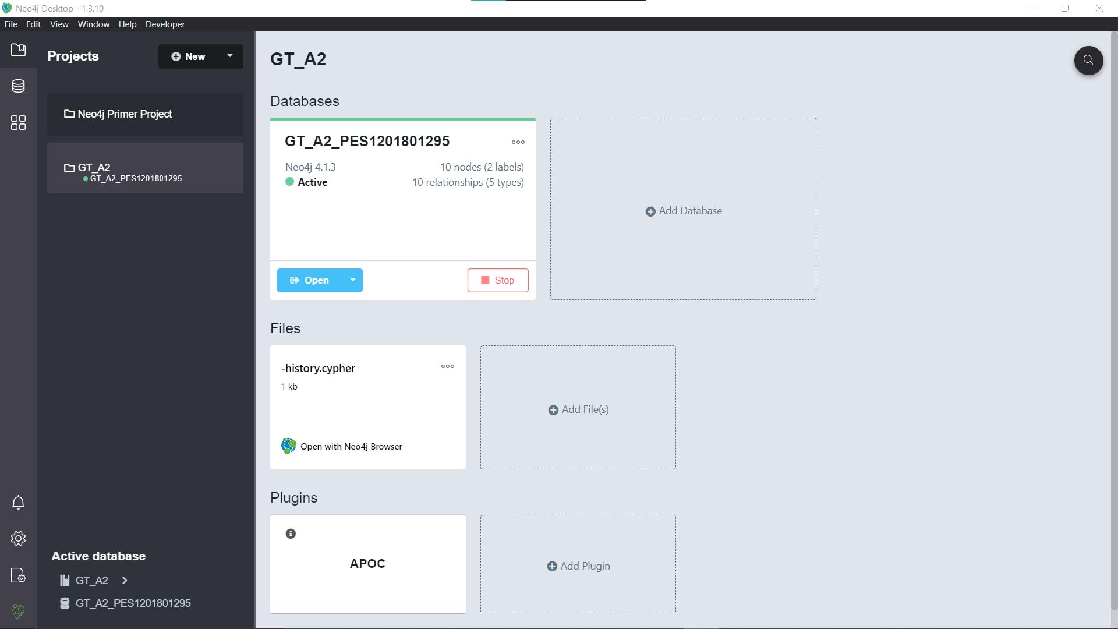

# Creating nodes

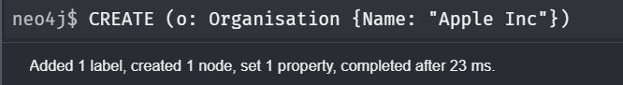

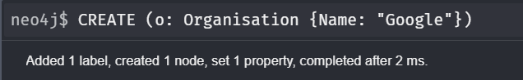

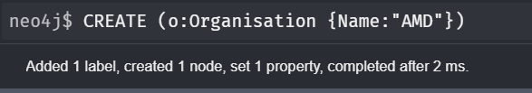

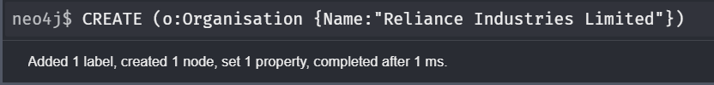

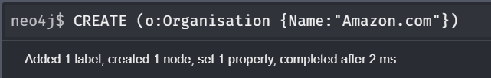



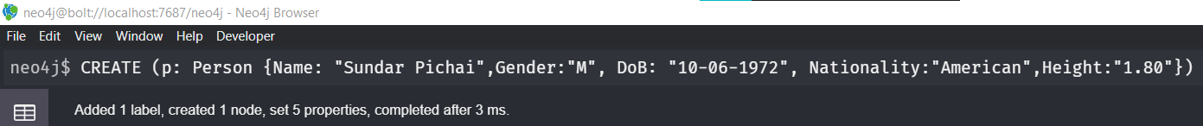

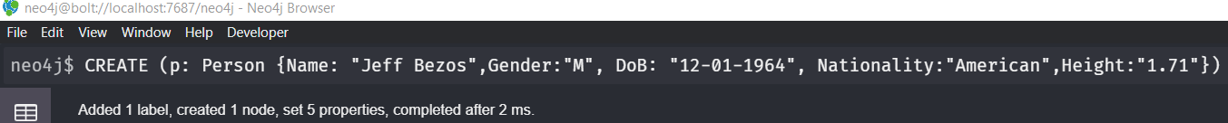

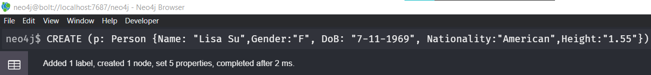



# Creating Relationships

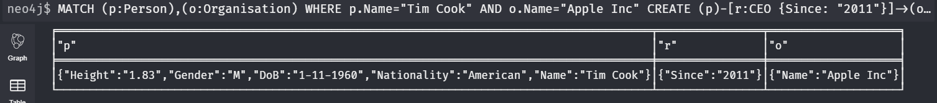

# Selecting all nodes

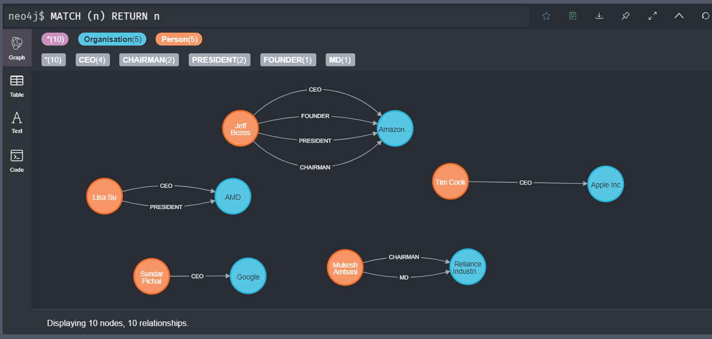

# Adding Type property to Organisation nodes



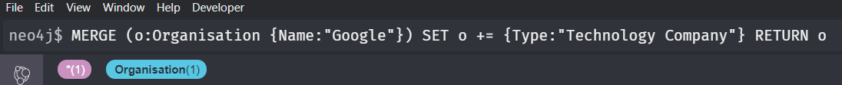







# Updating Person’s nationality



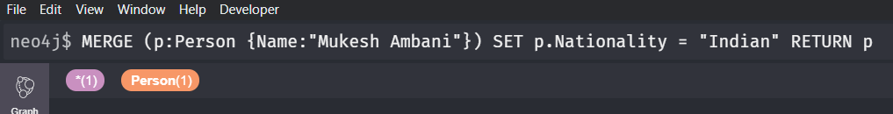

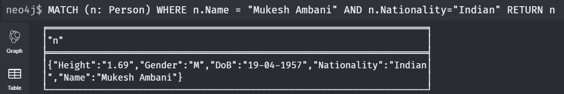

# Updating a relationship between nodes

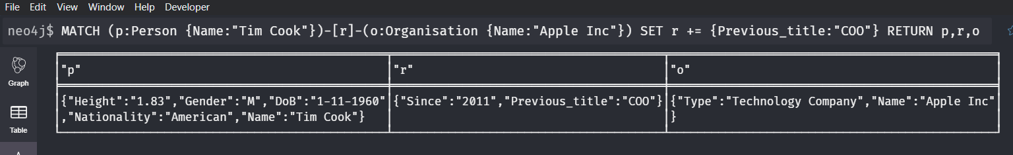

# Applying COUNT and WHERE on node selection

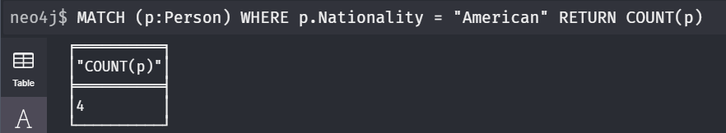

# Updating datatype of property of a node

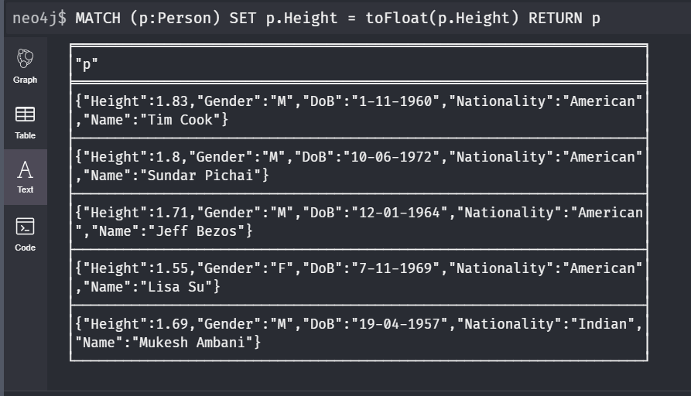

# Finding the AVERAGE height of people in the database

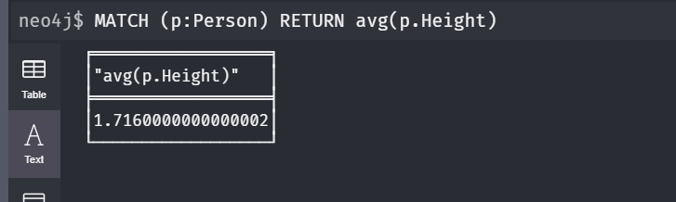

# Display COUNT of different kinds of Organisations in the Database

# 

# Use DELETE and DETACH commands to delete nodes and relationships

