OS lab week 1:

BY: SHUBHAM GUPTA PES1201801295 5G

# Question 1:

* 1. Command: ls

Flag: -al

Outcome: Shows all files and folders present in the present directory including hidden files in long listing format.

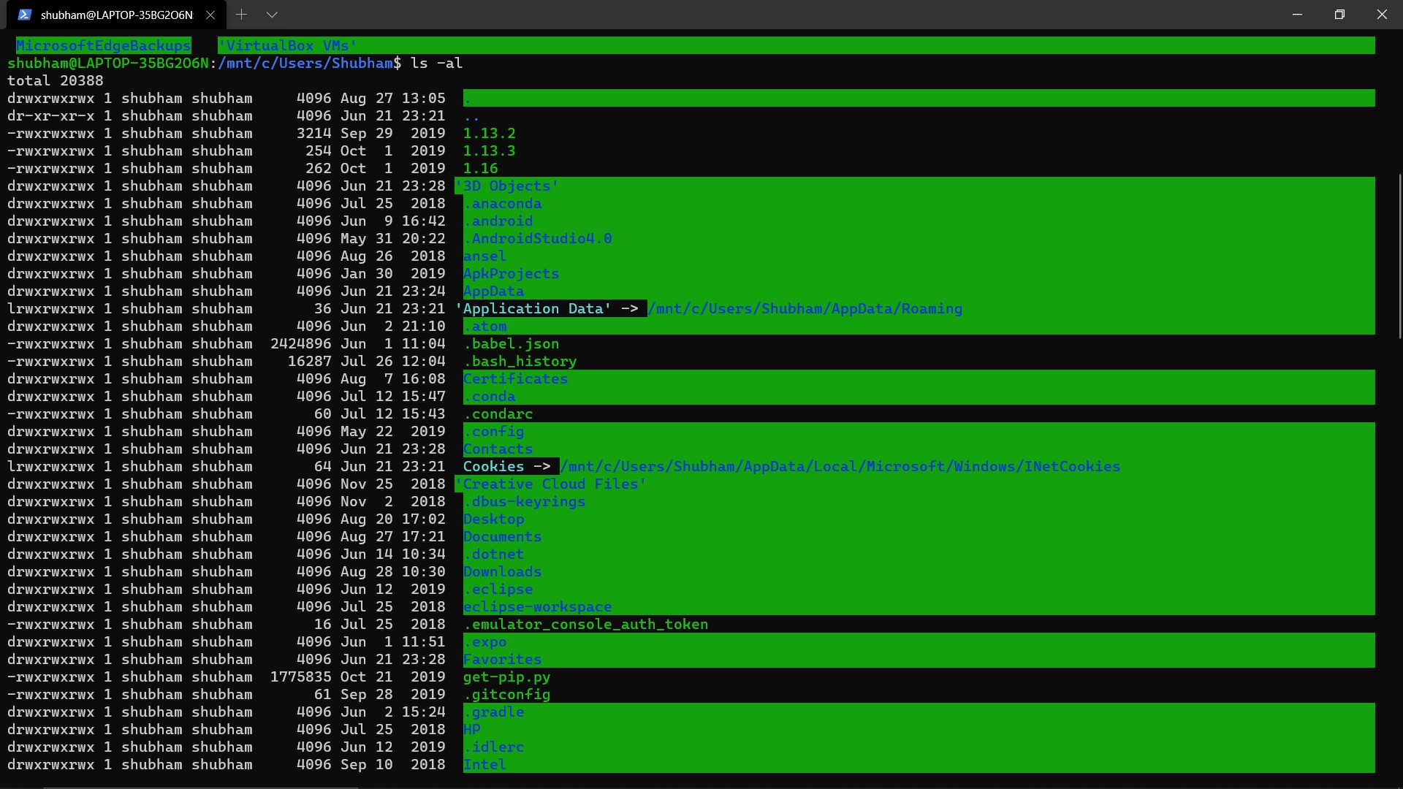

* 1. Command: cd <dir>

Flag: None

Outcome: Change the present working directory to the given path in <dir>. Changes to home if <dir> is empty.

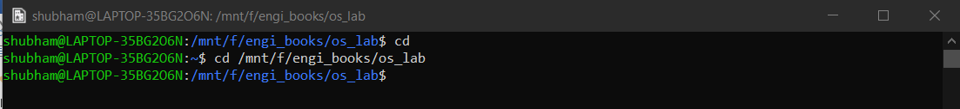

* 1. Command: ping

Flag: -c <N>

Outcome: Checks if a network / host is reachable. The flag -c defines how many times the system should ping the network/ host (N).

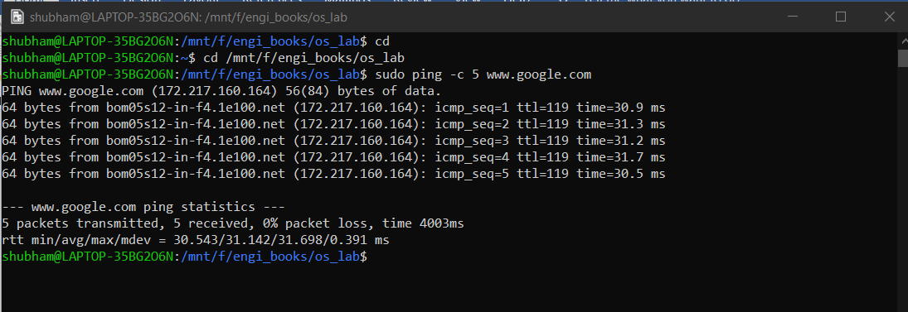

BY: SHUBHAM GUPTA PES1201801295 5G

* 1. Command: ds

Flag: None

Outcome: shows amount of disk used and available in the entire system.

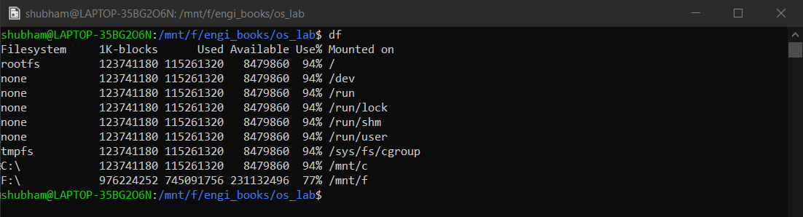

* 1. Command: whereis <app>

Flag: None

Outcome: Returns installation path of the application <app> specified.

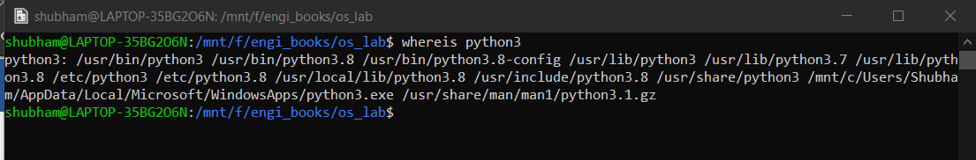

# Question 2:

Execute make file command: make -f make.mk

Execute the program command: ./prog

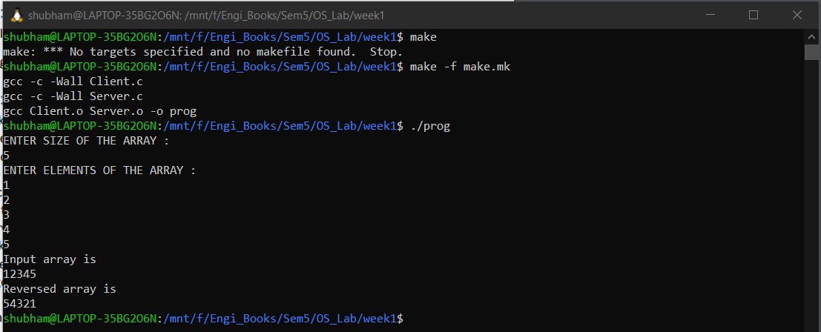

# Question 3:

* 1. The makefile is used to manage and maintain programs with multiple component files. The makefile sets a set of rules to determine which parts of the program needs to be recompiled and issues command to recompile them
  2. Yes, the makefile is a shell script containing files and dependencies and instructions for file creation.

BY: SHUBHAM GUPTA PES1201801295 5G

* 1. “clean” tells the makefile to delete all the object files and executables in the directory. It allows the users to start fresh
  2. The make utility compares the modification time of the target file to the dependency file. If the dependency file has a more recent modification time than the target file, the target file is forced for recompilation.
  3. CFLAGS are makefile variables which can be set to specify options to be passed to the compiler.
  4. The -f flag is used to specify the makefile to be compiled. Incase not defined, the make utility looks for a make file in the present directory by default.