**ACKNOWLEDGEMENT**

We would like to thank everyone for their help and support, without which this project couldn't have been so simple, interest and may not have been possible.

We would like to express our special thanks of gratitude to our teacher as well as our principal Prof. Ashish Ukhivide who gave us the golden opportunity to do this wonderful project on the topic Redeveloping Nishu Enterprise website, which also helped us in doing a lot of Research and we came to know about so many new things. Even their small comments made this better project.

We are really thankful to them.

We are grateful to our project guide Ms. Supriya Agne for the guidance, inspiration and constructive suggestions that helpful us in the preparation of this project. We are also thankful of the computer staff for the cooperation and assistance provided by them.

Secondly we would also like to thanks friends who helped us a lot in finishing this project with all functionalities specified within the limited time.

Finally we would like to thanks all those people who are indirectly connected with our project and lastly our colleagues.

**ABSTRACT**

The project centers on redesigning and enhancing the Nishu Enterprise website to deliver a modern, responsive, and user-friendly experience. By implementing a visually appealing layout that aligns with the brand’s identity, the website aims to offer improved navigation, optimized content, and faster load times, resulting in a more engaging user interface. This redesign is intended to streamline user interaction and ensure a seamless experience across devices.

Additionally, the integration of an AI-powered chatbot will enhance user engagement by providing real-time assistance, answering queries, and guiding visitors through the site. The chatbot functionality will be powered by a vector database and Lang Chain, allowing for dynamic and personalized user support.

This revamped platform will not only address the limitations of the existing website but also serve as a robust digital catalog for Nishu Enterprise’s extensive range of machinery. By embracing cutting-edge technologies and prioritizing user-centric design, the project aims to boost customer satisfaction, increase lead generation, and establish a strong online presence, positioning the company for sustained growth in the competitive marketplace.

**PHOTOGRAPH OF THE PROJECT**

**INDEX**

|  |  |  |
| --- | --- | --- |
| **Sr. No**. | **TOPICS** | **Pg. No.** |
| 1. | Introduction |  |
| 2. | Review of Literature |  |
| 3. | Plan of Work |  |
| 4. | DFD/Flowchart |  |
| 5. | Implementation |  |
| 6. | Testing |  |
| 7. | Feasibility Analysis |  |
| 8. | Pros and cons |  |
| 9. | Applications |  |
| 10. | Future Development |  |
| 11. | Conclusion |  |
| 12. | Appendix |  |
| 13. | Bibliography |  |

**CHAPTER 1**

**INTRODUCTION**

**INTRODUCTION**

**Background:** Nishu Enterprise is a well-established company specializing in the sale of industrial and aqua machinery to various industries. Over the years, the company has earned a reputation for providing high-quality products and excellent customer service. However, the existing website, developed several years ago using PHP, has become outdated, resulting in a subpar user experience and missed opportunities for growth.

Key Issues with the Current Website:

* Lack of responsiveness, making it difficult to use on mobile devices.
* Slow loading speeds that frustrate users.
* Complicated navigation leading to poor usability.
* Limited ability to generate leads and engage customers effectively.

In today’s digital age, an outdated website can significantly hinder business growth. Addressing these challenges is crucial for maintaining competitiveness and improving customer satisfaction.

**Project Overview**: The main objective of this project is to redesign the Nishu Enterprise website to meet modern standards and improve its functionality and user experience. By focusing on key aspects such as design, performance, and usability, the new website will better serve the needs of the company’s customers.

Key Features of the Redesigned Website:

* A responsive design that works seamlessly across all devices.
* Enhanced navigation for easier product browsing.
* Faster loading times to improve overall performance.
* Integration of a chatbot for real-time customer assistance.

These improvements aim to create a more engaging and user-friendly platform that enhances customer satisfaction and drives business growth.

**Technological Shift:** To achieve the project’s objectives, the website will transition from a PHP-based framework to modern web technologies. The redesign will leverage:

* Frontend Technologies:
  + HTML5 and CSS3 for a modern and visually appealing interface.
  + JavaScript for dynamic and interactive elements.
* Backend Technologies:
  + Next.js for improved performance and server-side rendering.
  + MongoDB for scalable and efficient data management.

The integration of a chatbot powered by artificial intelligence will provide users with instant support, helping them find products and resolve queries without delay. These advancements will ensure a robust and flexible platform that meets both current and future business needs.

Scope and Importance: The redesigned website will serve as a digital catalog, showcasing the company’s extensive product range and enhancing its online presence. By addressing the limitations of the current website, this project aims to:

* Boost lead generation through improved functionality and usability.
* Strengthen customer engagement with real-time assistance.
* Position Nishu Enterprise as a forward-thinking and customer-focused company.

**CHAPTER 2**

**REVIEW OF LITERATURE**

**REVIEW OF LITERATURE**

|  |  |  |
| --- | --- | --- |
| **Feature** | **Nishu Enterprises** | **Ultracare Group** |
| Technology Stack | Modern coding languages (React, Node.js, or Python) enabling fast performance and scalability. | Standard tech stack, may use older frameworks. |
| Design | Enhanced UI/UX with modern, responsive design for seamless mobile and desktop navigation. | Functional design, but lacks the modern aesthetic appeal. |
| Chatbot  Integration | Advanced AI chatbot for instant customer support, product queries, and troubleshooting assistance. | No chatbot or limited customer support options. |
| Product  Information | Detailed product descriptions, comparison features, and downloadable manuals. | Standard product listings without in-depth details. |
| Interactive  Features | Interactive tools like product configurators and video guides. | Basic features, no advanced interactivity. |
| User  Engagement | Blog section, safety tips, and feedback forms encourage interaction. | Limited engagement features beyond product inquiries. |

Why Nishu Enterprises is Better than other’s?

* Modern Technology: The updated Nishu Enterprises website uses cutting-edge coding languages, ensuring faster performance, scalability, and future-ready solutions compared to older frameworks.
* Enhanced User Experience: Its sleek, responsive design caters to all devices, providing a smooth browsing experience, unlike traditional websites that might feel outdated.
* Customer Support with AI Chatbot: The integration of a chatbot ensures 24/7 customer assistance, making the platform more accessible and user-friendly compared to Ultracare, which lacks such innovation.
* Interactive and Informative: With detailed product information, video guides, and tools like product configurators, customers can make informed decisions, which gives Nishu Enterprises an edge.
* Speed and SEO Optimization: Optimized for performance and search rankings, Nishu Enterprises ensures faster access and higher visibility on search engines.
* Community and Insights: By including blogs, safety tips, and feedback options, the site builds a sense of community and keeps users engaged.

**CHAPTER 3**

**PLAN OF WORK**

**PLAN OF WORK**

We are using the “Modified Waterfall Model. This model is generally used when a project is to be developed from scratch, when there is sufficient time to develop it and we know the requirements. The time is the crucial factor since all the activities involved in development process should be carried out properly.

Simple waterfall model doesn’t support the changes suggested at any stage of the development process. Hence we have used Modified Waterfall Model so that we can go back to any previous stage to make the necessary changes

The second point is time factor. We allocated the best part of 5 month to fully develop the project. So we had enough time to perform the activities of Modified Waterfall Model.

**Figure: WATERFALL MODEL**

FLEXEBILITY STUDY

ANALYSIS

DESIGN

CODING

TESTING

The Modified Waterfall Model approach adopted for the redesign of the Nishu Enterprise website follows a structured progression through the stages of Analysis, Design, Coding, Testing, and Maintenance. It incorporates the capability to revisit earlier stages to make necessary modifications, ensuring flexibility and thoroughness throughout the development process.

The various steps are as follows:

1. INFORMATION GATHERING:

This step involves gathering and analyzing requirements at the system level, along with initial design considerations.

We collected information using tools such as:

* Interviews: Conducted with stakeholders to understand requirements and expectations.
* Questionnaires: Distributed to gather user feedback on the existing website.

A feasibility study was performed to evaluate the technical and operational aspects of the redesign. This included assessing hardware and software requirements, ensuring the system could be configured for optimal performance across different devices, and providing seamless accessibility to users anytime and anywhere.

1. ANALYSIS: Given that we are using a combination of modern web technologies, our analysis followed a systematic approach. The analysis phase included:

* Study of the current website: Identified limitations such as lack of responsiveness, slow loading times, and absence of interactive features.
* Determining improvements: Highlighted areas for enhancement, including navigation, performance, and integration of an AI-powered chatbot.

1. DESIGN: The design phase focused on creating a user-friendly and visually appealing interface aligned with the brand's identity. This phase involved:

* Designing modules for different functionalities, such as product categories, chatbot integration, and the contact form.
* Creating data flow diagrams to map out the interactions between system components.
* Developing flowcharts to outline the user journey across the website.
* Crafting a responsive and intuitive interface using HTML5, CSS3, and JavaScript frameworks.

1. CODING: During this phase, the designs were translated into a functioning system using:

* Frontend Technologies: HTML5, CSS3, JavaScript for dynamic and responsive user interfaces.
* Backend Framework: Next.js for scalability and efficient server-side rendering.
* Database Management: MongoDB for seamless handling of data.

The focus was on writing clean, modular code that adheres to best practices, ensuring maintainability and scalability.

1. TESTING: In this phase, rigorous testing was conducted to identify and address any errors or inconsistencies. The testing process included:

* Input Validation: Ensured all inputs produced the expected results and prevented invalid entries.
* Performance Testing: Evaluated the website’s loading speed and responsiveness across devices.
* Functionality Testing: Verified that all modules, including the chatbot and navigation, functioned as intended.

**CHAPTER 4**

**DFD / FLOWCHART**

**FLOWCHART**

A flowchart is a graphical representation of a process, system, or algorithm. It uses symbols, shapes, and arrows to illustrate the sequence of steps involved in completing a task or solving a problem. Flowcharts are widely used in various fields, including software development, project management, and business process analysis, to visualize workflows and improve understanding.

Key Components of a Flowchart:

1. Start/End Symbols: Represent the beginning or conclusion of a process, typically depicted as ovals.
2. Process Steps: Shown as rectangles, these indicate tasks, actions, or operations to be performed.
3. Decision Points: Represented by diamonds, these indicate a decision to be made, often leading to multiple outcomes (e.g., Yes/No).
4. Arrows: Show the flow or direction from one step to the next.
5. Inputs/Outputs: Parallelograms are used to represent data input into or output from the process.

Purpose in the Project:

The provided flowchart illustrates the user interaction process for the redesigned Nishu Enterprise website. It highlights various functional modules, such as:

* Homepage Options: Users can navigate through product categories, perform searches, use an AI chatbot, fill out contact forms, or provide feedback.
* AI Chatbot: Facilitates real-time assistance and query resolution.
* Search Functionality: Guides users through the search process to find desired products.
* Feedback Submission: Captures user feedback for improvements.

This flowchart ensures clarity in understanding the user journey and helps in systematic development by visually mapping out all necessary interactions and validations.

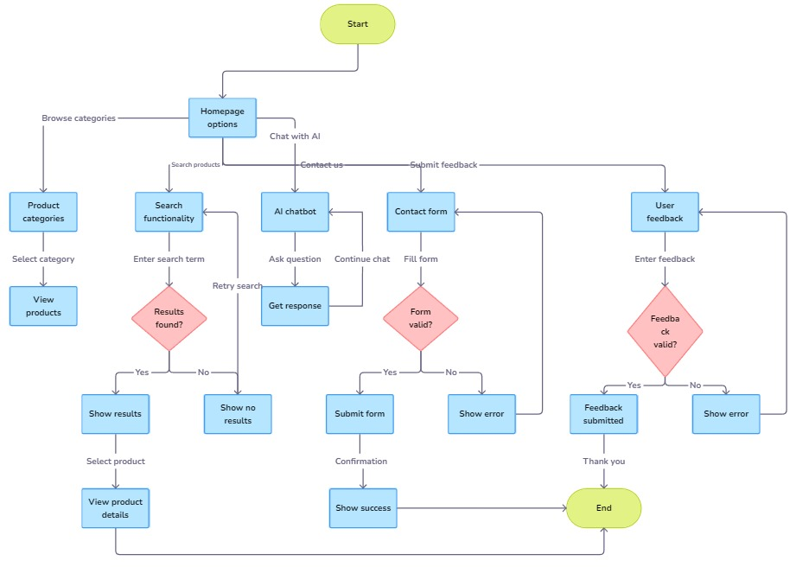

**DFD (Data Flow Diagram)**

**DFD 0**

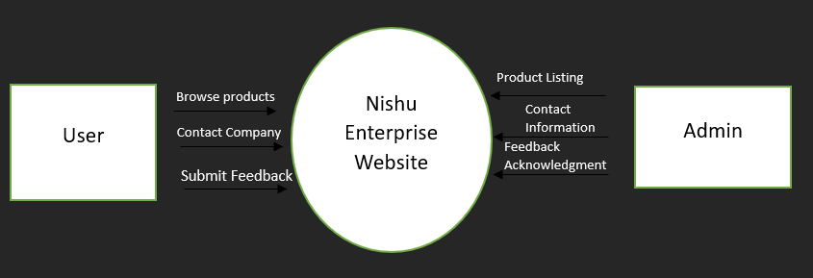

**DFD 1**

**CHAPTER 5**

**IMPLEMENTATION**

**IMPLEMENTATION**

The implementation of the redesigned Nishu Enterprise website focuses on using modern technologies to deliver a seamless and user-friendly experience. The key steps include:

User Interaction Capture:

Customers can browse products, search, and provide feedback through intuitive forms. An AI-powered chatbot offers real-time assistance and guides users effectively.

AI Chatbot Functionality:

The chatbot processes user inputs using smart algorithms, providing instant responses or directing users to relevant sections like product categories or contact forms.

Data Processing:

User interactions are sent from the frontend to the backend, where they are processed to generate outputs like product details or form confirmations.

Real-Time Feedback:

Users receive instant responses for actions like submitted forms or chatbot queries, ensuring a smooth experience.

Testing and Optimization:

All functionalities are rigorously tested to identify and resolve bugs, ensuring reliable performance across devices.

This approach ensures the website is efficient, interactive, and aligned with user needs.

**CHAPTER 6**

**TESTING**

**TESTING**

Testing is a crucial phase in the development of the redesigned website to ensure it functions correctly, meets user expectations, and operates seamlessly. The testing process includes the following steps:

1. Test Plan Preparation

Define the objectives of testing.

Identify test scenarios for various website functionalities such as chatbot interactions, product searches, and feedback forms.

2. Program Testing

Syntax Errors: Check for any violations in coding standards or syntax rules.

Logic Errors: Ensure the output aligns with the expected results by validating inputs, detecting incorrect data fields, and fixing discrepancies.

3. String Testing

Test interactions between different modules, such as the AI chatbot, search functionality, and contact forms.

Verify seamless communication between the frontend and backend systems using live and test data.

4. System Testing

Forced Failure Testing: Simulate unexpected scenarios to ensure the system handles errors gracefully.

Validation: Test the entire website as an integrated unit to ensure proper functionality in a real-world operational environment.

Recovery Testing: Validate that data remains intact during failures and recovery mechanisms work effectively.

5. User Acceptance Testing (UAT)

Allow users to test the website in its final form to confirm it meets their needs and expectations.

Validate the performance of the chatbot, navigation, and overall user interface.

6. System Documentation

Finalize and store all design and testing documentation for future reference and maintenance. Ensure the documentation follows system standards for consistency.

Testing Types for the Website

Program Testing: Identify and resolve syntax and logic errors.

String Testing: Verify communication between interrelated modules.

System Testing: Test the entire system under different conditions to identify weaknesses.

User Acceptance Testing: Validate the system's performance from the user’s perspective.

By conducting these tests, the website ensures high reliability, user satisfaction, and smooth operational performance.

**CHAPTER 7**

**FEASIBILITY ANALYSIS**

**FEASIBILITY ANALYSIS**

The Nishu Enterprise website redesign, time feasibility ensures that each phase of the development process, from analysis to testing, can be accomplished within the allotted time without compromising quality.

The timeline includes key milestones such as:

* Information gathering and analysis.
* Designing the user interface and database structure.
* Developing the front-end and back-end functionalities.
* Testing and debugging the website, including AI chatbot functionality.
* Deployment and final review**.**

The software and hardware availability focuses on ensuring that the required technical infrastructure is in place to support the development and implementation of the Nishu Enterprise website redesign project. According to the feasibility analysis procedure, the technical feasibility of the system is assessed by identifying the necessary hardware, software, and other technical requirements.

Key Aspects of the Feasibility Analysis:

Software Requirements:

The project utilizes HTML5, CSS3, JavaScript, Next.js, and MongoDB for development.

AI functionality is powered by LangChain and a vector database for chatbot responses.

Testing tools and debugging environments are incorporated to ensure smooth performance.

Hardware Requirements:

Development workstations with sufficient processing power.

Servers capable of hosting the redesigned website and handling real-time user queries.

Reliable internet connectivity for collaboration and deployment.

Operational Feasibility:

The system offers improved user-friendliness, faster processing speed, and a modernized interface. With reduced maintenance requirements and better efficiency, the project is operationally feasible, meeting the needs of Nishu Enterprise and its customers.

Sufficient Information Source:

The basic infrastructure required to develop and complete the project is readily available.

Factors Considered:

All minimum infrastructure facilities, such as PCs and development tools, are provided.

Proper guidance and documentation are available for reference during the development process.

All necessary data and files required for the project are collected and verified.

**Costing**

**CHAPTER 8**

**PROS AND CONS**

**PROS AND CONS**

|  |  |
| --- | --- |
| Pros | Cons |
| **Improved User Experience**: A modern design with better navigation enhances user satisfaction and engagement.  **Increased Lead Generation**: An appealing and functional website can attract more visitors, leading to higher conversion rates.  **Mobile Responsiveness**: A responsive design ensures a seamless experience on all devices, accommodating a wider audience.  **Real-Time Assistance**: The integration of an AI-powered chatbot provides immediate support, improving customer service.  **Skill Development for Students**: Students gain practical experience in modern web technologies, enhancing their employability.  **Better Performance**: Optimized load times can reduce bounce rates and keep users on the site longer. | **Development Costs**: Redesigning the website may incur costs for development, hosting, and maintenance.  **Time Investment**: The redesign process requires time, potentially diverting focus from other business activities.  **Ongoing Maintenance**: A modern website will require regular updates and maintenance to stay functional and secure.  **Dependency on Technology**: Relying on an AI chatbot for customer service may lead to frustrations if it fails to address user queries effectively. |

**CHAPTER 9**

**APPLICATION**

**APPLICATIONS**

* Product Display
* Contact Form
* Customer Support
* AI Chatbot
* Feedback Submission
* Inquiry Handling
* Responsive Design
* Search Functionality
* Real-Time Assistance
* User Engagement
* Navigation Optimization
* Mobile Compatibility
* Interactive Interface
* Dynamic Content
* Performance Enhancemen

**CHAPTER 10**

**FUTURE DEVELOPMENT**

**FUTURE DEVELOPMENT**

* 1. **E-commerce Capabilities:**Expanding the website to include an online store, allowing customers to browse and purchase products directly.
  2. **Personalization Features:**Incorporating personalized content and product recommendations based on user behavior and preferences.
  3. **Multi-Language Support:**Adding multi-language options to cater to a broader audience and enhance accessibility.
  4. **Mobile App Development:**Considering the development of a mobile app to complement the website and provide users with an additional platform for engagement.

**CHAPTER 11**

**COCLUSION**

**CONCLUSION**

The redesign of the Nishu Enterprise website represents a significant step forward in enhancing the company’s online presence and customer engagement. By implementing a modern, visually appealing layout and optimizing navigation, the new website aims to provide an improved user experience that captures customer attention and facilitates seamless interaction. The integration of an AI-powered chatbot will offer real-time assistance, addressing user queries and guiding them through the site, while the focus on responsiveness ensures accessibility across all devices. This project not only aims to showcase Nishu Enterprise's products effectively but also to create a platform that fosters communication between the company and its customers. Ultimately, the redesigned website is set to boost lead generation, improve customer satisfaction, and position Nishu Enterprise as a leader in its industry, ready to adapt to future market demands.

**CHAPTER 12**

**APPENDIX**

**SOFTWARE CODE**

**CHAPTER 13**

**BIBILIOGRAPHY**

**BIBILIOGRAPHY**

1. **HTML5 Documentation:** https://developer.mozilla.org/en-US/docs/Web/HTML

2. **CSS3 Documentation:** https://developer.mozilla.org/en-US/docs/Web/CSS

3. **JavaScript Documentation:** https://developer.mozilla.org/en-US/docs/Web/JavaScript

4. **Next.js Documentation:** https://nextjs.org/docs

5. **Software Engineering Textbook:** Web Development Fundamentals, Full Stack Architecture.

6. **Company Resources:** Internal documents and information from Nishu EnterprisesPvt. Ltd.

7. **Internet Resources:** Various articles and online resources on web application development and project management.

8. **Project Guide:** Supriya Mam, Department of Computer Engineering, Vidyalankar Polytechnic.

9. **MongoDB Documentation:** https://www.mongodb.com/docs/

10. **LangChain Documentation:** https://python.langchain.com/docs/get_started/introduction

11. **MongoDB Vector Documentation:** https://www.mongodb.com/docs/atlas/atlas-vector-search/