**Queries**

**Some examples of queries as follow:**

1. **Monthly Sales:**
2. Purpose:

Suppose the shop owner wants to know the total monthly sales of the month October with tax as well as without tax. The following query will help the owner to know the sales’ stats.

1. Syntax:

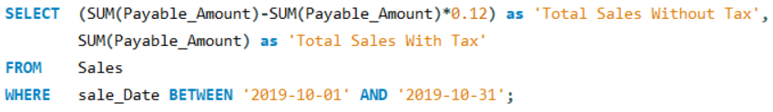

c:  Meaning of the results:

The result will show the total sales that have been occurred for the specified month with tax and without tax.

Example:

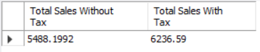

1. **Inventory Check:**

1. Purpose:

The following query will help the employees to do an inventory check i.e to check if all the product at the store are available in a required quantity.

1. Syntax:

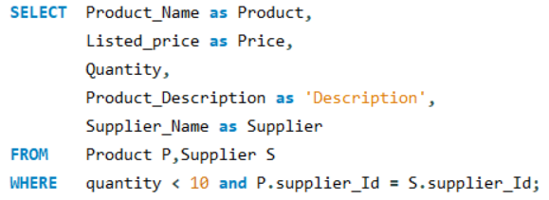

c: Meaning of the results:

The result of this query shows a table that contains the products whose quantity is less than 10 items. It also shows the Supplier name of those products respectably as well.

Example:



1. **Checking Due Date of repairs:**
2. Purpose:

This query helps the employees to know the due date of repair given a customer name and their phone number.

1. Syntax:

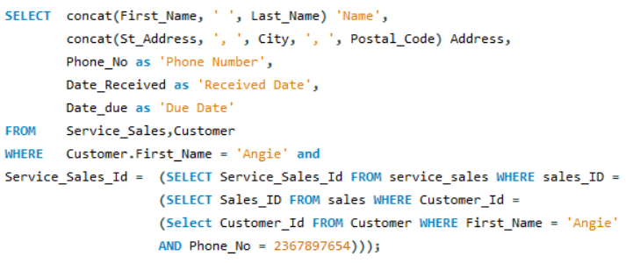

c: Meaning of the results:

The result will show a table with a row containing customer information along with the date received and due date of the repair request by respectable customer.

Example:

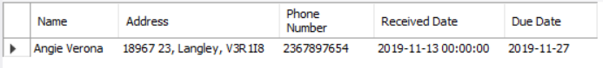

1. **Product Lookup:**

a. Purpose:

The following query shows the products that satisfy the customer budget constraints.

b. Syntax:

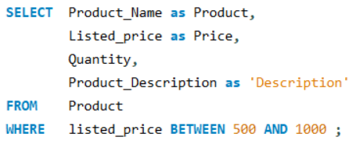

c: Meaning of the results:

The result will list the products from the product table those fall within certain range of price as requested by the customer

Example:

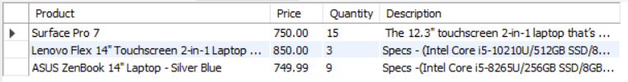

1. **Employee of the month:**
2. Purpose:

The purpose of the following query is to help the shop owner know who their best employee for a particular month is.

The employee who is engaged in maximum number of sales is selected as the employee of the month.

b. Syntax:

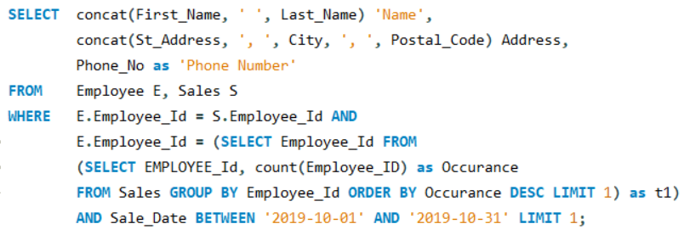

c: Meaning of the results:

The query will show the personal details of that employee who has achieved maximum number of sales for a specific month.

Example:

