**A.I. Assignment**

**Submitted by – Sumit Kumar (17/1432)**

**B.Sc.(H) CS 3rd Year @ RCDU**

**Q1 –**

**AI :** AI or artificial intelligence is the simulation of human intelligence processes by machines, especially computer systems.

**Various Applications –**

**Artificial Intelligence in Healthcare:**Companies are applying machine learning to make better and faster diagnoses than humans. One of the best-known technologies is IBM’s Watson. It understands natural language and can respond to questions asked of it. The system mines patient data and other available data sources to form a hypothesis, which it then presents with a confidence scoring schema. AI is a study realized to emulate human intelligence into computer technology that could assist both, the doctor and the patients in the following ways:

1. By providing a laboratory for the examination, representation and cataloguing medical information
2. By devising novel tool to support decision making and research
3. By integrating activities in medical, software and cognitive sciences
4. By offering a content rich discipline for the future scientific medical communities.

**Artificial Intelligence in business**: Robotic process automation is being applied to highly repetitive tasks normally performed by humans. Machine learning algorithms are being integrated into analytics and CRM (Customer relationship management) platforms to uncover information on how to better serve customers. Chatbots have already been incorporated into websites and e companies to provide immediate service to customers. Automation of job positions has also become a talking point among academics and IT consultancies.

**AI in education:** It automates grading, giving educators more time. It can also assess students and adapt to their needs, helping them work at their own pace.

**AI for robotics** will allow us to address the challenges in taking care of an aging population and allow much longer independence. It will drastically reduce, may be even bring down traffic accidents and deaths, as well as enable disaster response for dangerous situations for example the nuclear meltdown at the fukushima power plant.

**Q2 – Problem statement**

E A T

+ T H A T

= A P P L E

Consider A = the Carry(1), then T = 9; the greatest value in 0-9 to be A as 1.

Now T is assigned with 9 value, so T + T = 18 => E got a value 8, and carry 1 is shifted on left side;

So, now situation is like 1 + A + A = 3(because A is already assigned by value 1) => L value 3;

Now turn is on E + H = 8 + 2 = 10 => P is assigned by value 0, and carry 1 is shifted on left side;

Now on Carry + T = 1 + 9 = 10; where P is already assigned by 0 value, and A also got its value 1.

So, values assigned to alphabets are; **E – 8, A – 1, T – 9, H – 2, P – 0, L – 3.**

**Q3 -**

A frame is a record like structure which consists of a collection of attributes and its values to describe an entity in the world. Frames are the AI data structure which divides knowledge into substructures by representing stereotypes situations. It consists of a collection of slots and slot values.

Semantic Network representation for statements;

1. Every kid likes candy.
2. Every school going kid likes candy.

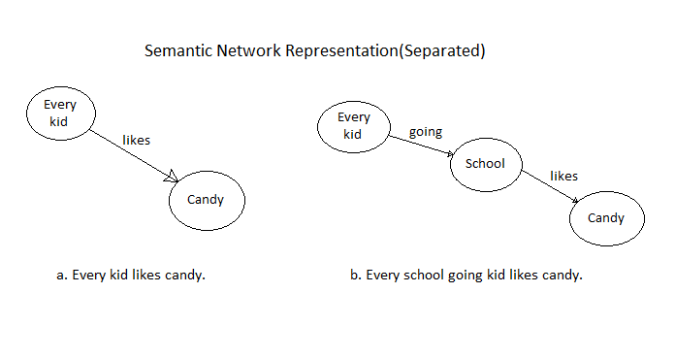

**Q4 –**

1. **Monotonic Reasoning :** In monotonic reasoning, once the conclusion is taken, then it will remain the same even if we add some other information to existing information in our knowledge base.

**Ex -** **Earth revolves around the Sun.**

It is a true fact, and it cannot be changed even if we add another sentence in knowledge base like, "The moon revolves around the earth" Or "Earth is not round," etc.

1. **Non-monotonic Reasoning :** In Non-monotonic reasoning, some conclusions may be invalidated if we add some more information to our knowledge base.

**Ex -** Let suppose the knowledge base contains the following knowledge:

* Birds can fly
* Penguins cannot fly
* Pitty is a bird

So from the above sentences, we can conclude that Pitty can fly.

1. **Default Reasoning :** This is a very common from of non-monotonic reasoning. Here We want to draw conclusions based on what is most likely to be true.

**Ex –** above both are included in default reasoning.

1. **Truth Maintenance System :** Truth maintenance as a data base management facility, which was in fact the original intention of the TMS.

 Truth maintenance as an inference facility, which provides a way to extend the role of the TMS in solving problems.

Truth maintenance as a verification facility, which illustrates a new and promising application of TMSs in the area of expert systems design.

**Q5 –**

Factorial Prolog :

predicates

start

find_factorial(real,real)

goal

clearwindow,

start.

clauses

start:-

write("Enter non negative number = "),

readreal(Num),

Result = 1.0,

find_factorial(Num,Result).

find_factorial(Num,Result):-

Num <> 0,

NewResult = Num * Result,

NewNum = Num - 1,

find_factorial(NewNum,NewResult).

find_factorial(_,Result):-

write("Factorial = ",Result),nl.

**Q6 –**

**Baye’s Theorem :** Baye’s theorem determines the probability of an event with uncertain knowledge.

In probability theory, it relates the conditional probability and marginal probabilities of two random events. It is used to calculate the value of P(B|A) with the knowledge of P(A|B).

Bayes' theorem can be derived using product rule and conditional probability of event A with known event B:

As from product rule we can write:

* + P(A ⋀ B)= P(A|B) P(B) or

Similarly, the probability of event B with known event A:

* + P(A ⋀ B)= P(B|A) P(A)

Equating right hand side of both the equations, we will get:

* + Bayes theorem in Artificial intelligence

P(A|B) is known as **posterior**, P(B|A) is called the **likelihood**, P(A) is called the **prior probability**, and P(B) is called **marginal probability**.

**Q7 –**

**NLP -** Natural Language Processing (NLP) refers to AI method of communicating with an intelligent systems using a natural language such as English.

**Steps in NLP -** There are general five steps ;

* **Lexical Analysis** − It involves identifying and analyzing the structure of words. Lexicon of a language means the collection of words and phrases in a language. Lexical analysis is dividing the whole chunk of txt into paragraphs, sentences, and words.
* **Syntactic Analysis (Parsing)** − It involves analysis of words in the sentence for grammar and arranging words in a manner that shows the relationship among the words. The sentence such as “The school goes to boy” is rejected by English syntactic analyzer.

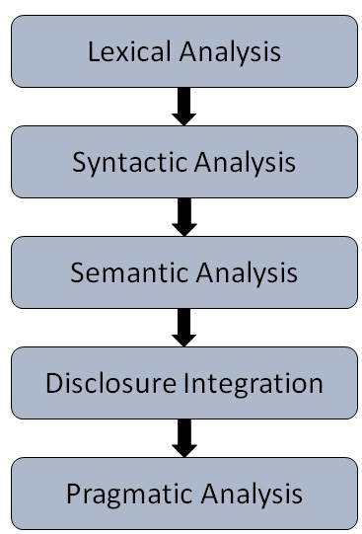

* **Semantic Analysis** − It draws the exact meaning or the dictionary meaning from the text. The text is checked for meaningfulness. It is done by mapping syntactic structures and objects in the task domain. The semantic analyzer disregards sentence such as “hot ice-cream”.
* **Discourse Integration** − The meaning of any sentence depends upon the meaning of the sentence just before it. In addition, it also brings about the meaning of immediately succeeding sentence.
* **Pragmatic Analysis** − During this, what was said is re-interpreted on what it actually meant. It involves deriving those aspects of language which require real world knowledge.

**Q8 –**

**Cut in Prolog -** Consider the following program.

a :- b.

b :- c.

c :- d.

b.

If you load this into Prolog and ask Prolog **?- a.**, Prolog will evaluate it by first searching for any rule that can make **a** true; it adds **a** to its list of goals to prove. The first rule states that **a** is true if **b** is true, so Prolog adds the goal **b** to its list. It finds a rule for **c** and now needs to prove **d**, which fails. Prolog now removes the goal **d** from its list, because it couldn't prove it, and tries to prove **c** in a different way. This is known as **backtracking**. Prolog can't prove **c** either, backtracks again and tries **b**. It can prove this, using the last line of the program and Prolog terminates.

Understanding how Prolog evaluates your query is essential in Prolog programming. To control the way Prolog evaluates your program, you can use the **cut** operator: **!**. the cut operator is an atom, and can be used in the following way:

a(X) :- b(X), c(X), !, d(X).

If Prolog finds a cut in a rule, it will not backtrack on the choices it has made. For instance, if it has chosen frank for the variable X and encounters a cut, Prolog will consider frank the only option for X, even if there are other possibilities in the database. This is illustrated by the following program

a(X, Y) :- b(X), !, c(Y).

b(1).

b(2).

b(3).

c(1).

c(2).

c(3).

**Fail in Prolog -** The query a(X). produces

1 ?- a(X).

false.

2 ?-

but with this code

a(X) :- b(X),!,c(X).

a(X) :- d(X).

b(1).

b(4).

c(1).

c(3).

d(4).

The query a(X). results in :

1 ?- a(X).

X = 1.

It fails because fail *must* fail.

The cut removes alternatives, then forbids values that otherwise would be 'returned' by means of X binding. Try

a(X) :- b(X),c(X),fail.

...

and get

?- a(X).

X = 4.

**Q9 –**

**Turing Test -** In 1950, Alan Turing introduced a test to check whether a machine can think like a human or not, this test is known as the Turing Test.

Turing Test was introduced by Turing in his 1950 paper, "Computing Machinery and Intelligence," which considered the question, "Can Machine think?"

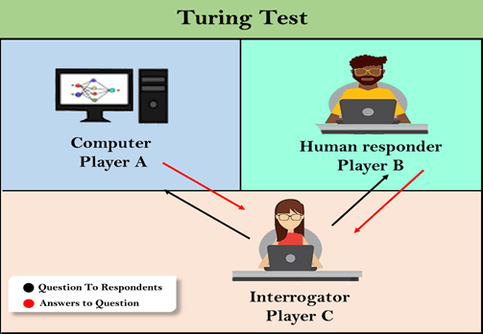

The Turing test is based on a party game "Imitation game," with some modifications. This game involves three players in which one player is Computer, another player is human responder, and the third player is a human Interrogator, who is isolated from other two players and is job is to find that which player is machine among two of them.

Consider, Player A is a computer, Player B is human, and Player C is an interrogator. Interrogator is aware that one of them is machine, but he needs to identify this on the basis of questions and their responses.

The questions and answers can be like:

**Interrogator:** Are you a computer?

**PlayerA (Computer):** No

**Interrogator:** Multiply two large numbers such as (256896489*456725896)

**Player A:** Long pause and give the wrong answer.

In this game, if an interrogator would not be able to identify which is a machine and which is human, then the computer passes the test successfully, and the machine is said to be intelligent and can think like a human.

**Q10 –**

domains

list=integer*

predicates

findsum(list)

sum(list,integer)

clauses

findsum(L):-

sum(L,Sum),

write(\"\\nSum Of Given List : \",Sum).

sum([],0).

sum([X|Tail],Sum):-

sum(Tail,Temp),

Sum=Temp+X.

**Submitted to –**

**Subodh Sir**