[ 2CEIT401 – Operating Systems ]

Practical: 5

AIM- Apply the concept of command line argument and array in scripting.

r


Department of Computer Engineering

Aim: Apply the concept of command line argument and array in scripting.
- Write a Shell script to accept a string as command line argument and reverse the same.
Code:
str=$1
len=${#str}
rev=''
for ((i=$len-1; i>=0; i--))
do
rev=$rev${str:$i:1}
done
echo $rev

Output:

- Write a shell script to calculate the loss percentage of an article, given the cost price and the selling price as command line arguments.
Code:
cost_price=$1
selling_price=$2
loss=$((($cost_price - $selling_price) * 100 / $cost_price))
echo "Loss Percentage: $loss%"

Output:

- Write a shell script to accept the name of the user and check out if the same has logged in or not.
Code:
user=$1
response=$(finger | grep $user)
if [ $? = 0 ]
then
echo "$user is Logged In!"
else
echo "$user is not Logged In!"
fi

Output:
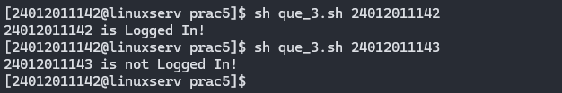

- Write a shell script to check whether the file whose name is scanned exists and readable.
Code:
file=$1
if [ -r "$file" ]
then
echo "File Is Readable!"
else
echo "File is not Readable!"
fi

Output:


- Write a shell script to check if the input string is a palindrome.
Code:
str=$1
len=${#str}
rev=''
for ((i=$len-1; i>=0; i--))
do
rev=$rev${str:$i:1}
done
if [ $str = $rev ];
then
echo "$str is Palindrome."
else
echo "$str is not Palindrome."
fi

Output:

- Write a shell script to accept a number and a word as command line arguments and print the word the given number of times on each line.
Code:
str=$1
num=$2
for ((i=0; i < $num; i++))
do
echo "$str"
done

Output:

- Write a shell script to find the file or directory with the maximum size in the current directory.
Code:
max_size=-1
for i in *
do
size=$(stat -c%s "$i")
if [ $size -gt $max_size ]
then
max_size=$size
fi
done
echo "$(ls -l | grep $max_size | awk '{ print $9}') is Largest With Size: $max_size"

Output:

- Write a shell script to accept two filenames and check if both exist. If the second filename exists, then the contents of the first filename should be appended to it. If the second filename does not exist then create a newfile with the contents of the first file.
Code:
file1=$1
file2=$2
if [ -f $file2 ];
then
$(cat $file1 >> $file2)
echo "$file1 is Appended in $file2"
else
$(cat $file1 > $file2)
echo "$file2 is Created and has Content of $file1"
fi

Output:
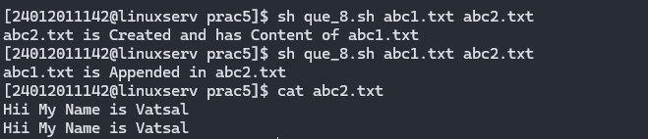

- Write a shell script to accept a number in the command line and displays the sum up to that number. By default, the sum up to 50 should be displayed.
Code:
num=$1
if [ $num ]
then
sum=$(($num * ($num + 1) / 2))
echo "Sum till $num is: $sum"
else
sum=$((50 * (50 + 1) / 2))
echo "Sum till 50 is: $sum"
fi

Output:
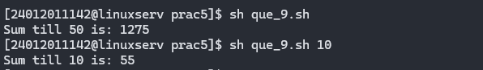

- Write a shell script to accept an alphabet from the user and list all the files/directory starting with that alphabet in the current directory.
Code:
echo "Enter Alphabet: "
read al
echo "files/directory:"
ls -l $al*

Output:
