[ 2CEIT401 – Operating Systems ]

Practical: 4

AIM- Perform various file operations.

r


Department of Computer Engineering

Aim: Perform various file operations.
- Write a shell script to check whether the entered number is prime or not.
Ans:
Code:
echo "Enter Number: "
read num
i=2
isPrime=1
while [ $i -lt $num ]
do
temp=`expr $num % $i`
if [ $temp = 0 ]
then
isPrime=0
fi
i=`expr $i + 1`
done
if [ $isPrime = 1 ]
then
echo "Number Is Prime"
else
echo "Number Is Not Prime"
fi

Output:

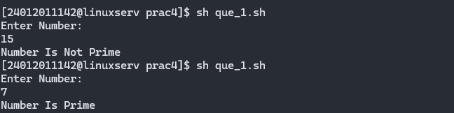

- Write a shell script to calculate HRA of employees depending upon their basic.
Ans:
Code:
echo "Enter Basic Salery: "
read sal
if [ $sal -lt 10000 ]
then
hra=`expr $sal \* 20 / 100`
hra_r=20
elif [ $sal -lt 20000 ]
then
hra=`expr $sal \* 25 / 100`
hra_r=25
else
hra=`expr $sal \* 30 / 100`
hra_r=30
fi

total=`expr $sal + $hra`

echo "Sal: $sal"
echo "HRA Rate %: $hra_r"
echo "HRA: $hra"
echo "Gross Salary: $total"

Output:
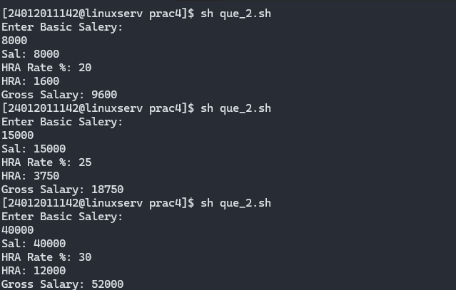

- Write a shell script that greets the user by saying Good Morning, Good Afternoon, and Good Evening according to the system time.
Ans:
Code:
hour=`date +%k`
if [ $hour -ge 5 ] && [ $hour -le 12 ]
then
echo "Good Morning"
elif [ $hour -ge 13 ] && [ $hour -le 17 ]
then
echo "Good Afternoon"
elif [ $hour -ge 18 ] && [ $hour -le 20 ]
then
echo "Good Evening"
else
echo "Good Night"
fi

Output:
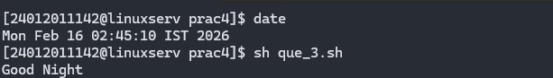

- Write a shell script that asks the capital of Gujarat and repeats the question until the user gives correct answer.
Ans:
Code:
isTrue=0
while [ $isTrue = 0 ]
do
echo "Enter Capital Of Gujarat:"
read cap
if [ $cap = "gandhinagar" ] || [ $cap = "Gandhinagar" ]
then
isTrue=1
fi
done
Output:
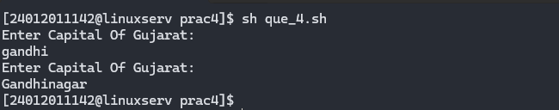

- Write a shell script to display desired line from a file.
Code:
line=$1
file=$2
head -n $line $file | tail -n 1
Output:
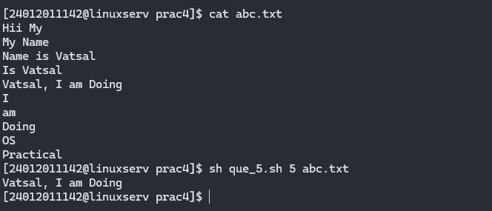
- Write a shell script to count number of newline characters in a file.
Code:
file=$1
lines=`wc -l $file | awk '{ print $1 }'`
echo "Lines: $lines"
Outputt:
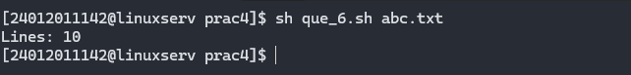

- Write a Shell script, which counts the number of words in a file, without taking into consideration the blank space, tab spaces and the newline characters using WC.
Code:
file=$1
words=`wc -w $file | awk '{ print $1 }'`
echo "Words: $words"
Output:
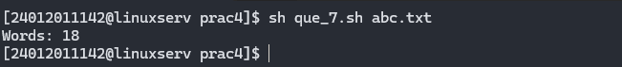
- Write a Shell script, which counts the number of words in a file, without taking into consideration the blank space, tab spaces and the newline characters without using WC.
Code:
file=$1
words=`awk '{num+=NF} END{print num+0}' $file`
echo "Words: $words"
Output:
