[ 2CEIT401 – Operating Systems ]

Practical: 3

AIM- Implements Shell script using decision making statement, branching and Looping.

r


Department of Computer Engineering

Aim: Implements Shell script using decision making statement, branching and Looping.
- Write a shell script to calculate the loss percentage of an article. Scan the cost price and selling price
Ans:
Code:
echo "Enter Cost Price: "
read cost_price
echo "Enter Selling Price: "
read selling_price
loss=`expr $cost_price - $selling_price`
loss=`expr $loss \* 100`
loss_percent=`expr $loss / $cost_price`
loss_percent1=`echo "scale=2; $loss / $cost_price" | bc`
echo "Loss Percentage: $loss_percent1% By bc"
echo "Loss Percentage: $loss_percent% By expr"

Output:

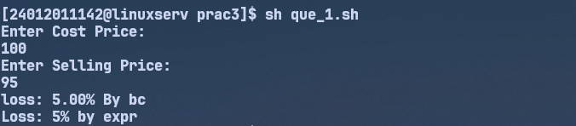

- Write a shell script to accept numbers below 50 and to display the square of each. This should continue as long as the user wishes.
Ans:
Code:
isRunning=1
while [ $isRunning -eq 1 ]
do
echo "Enter Number less Then 50: "
read num
while [ $num -ge 50 ]
do
echo "Please Enter Number less Then 50: "
read num
done
square=`expr $num \* $num`
echo "Square of $num is: $square"
echo "Do you want to continue? (y,n): "
read ch
if [ $ch = "n" ] || [ $ch = "N" ]
then
isRunning=0
fi
done
Output:
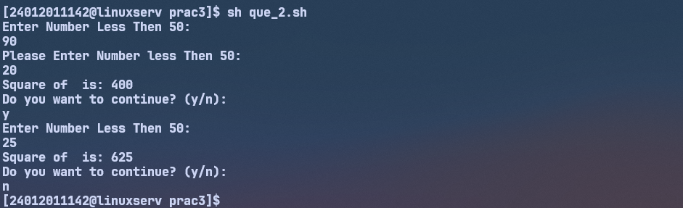

- Write a shell script to display $50
Ans:
Code:
echo \$50
Output:
- Write a shell script to check whether the scanned string is found in a file or not. Display appropriate message.
Ans:
Code:
a=`grep $1 $2`
if [ $? -eq 0 ]
then
echo "String Found"
else
echo "String Not Found"
fi
Output:
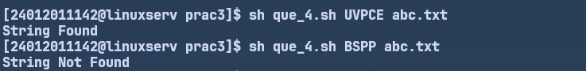

- Write a shell script, which scans the name of the command and executes it.
Code:
echo "Enter Name of Command You Want to Run: "
read cammand
$cammand
Output:
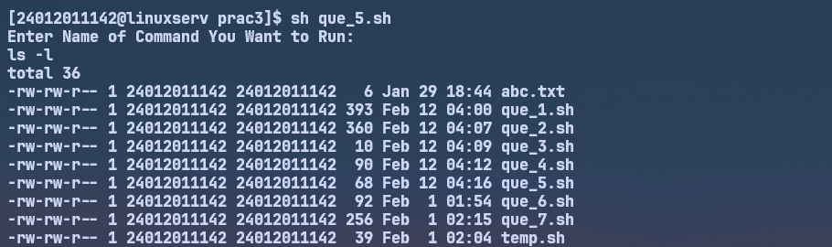
- Write a shell script which displays January if we enter Jan, Janu, Janua or January.
Code:
echo "Enter String"
read str1
jan="January"
if [[ "$jan" = *"$str1"* ] ]
then
echo "$jan"
fi
Output1:
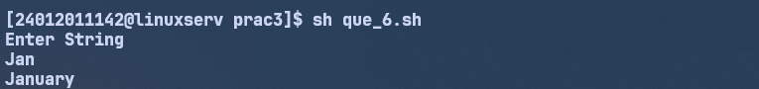
- Write a shell script to generate Fibonacci series.
Code:
echo "Enter Number 1"
read num1
echo "Enter Number 2"
read num2
echo "How Many Fibonnaci Numbers You Want to Print"
read n
n=`expr $n - 2`
i=0
fib=("$num1" "$num2")
while [ $n -gt $i ]
do
idx=`expr $i + 2`
temp=`expr ${fib[$i]} + ${fib[$i+1]}`
fib[$idx]=$temp
i=`expr $i + 1`
done
echo "Fibonnaci Series: ${fib[@]}"
Output:
