[ 2CEIT401 – Operating Systems ]

Practical: 1

AIM- Hands on Practice of various Linux commands and analyse the output of each command.

r


Department of Computer Engineering

Aim: Hands on Practice of various Linux commands and analyse the output of each command.
- TOUCH Command:
The touch command is used to create empty files. Multiple empty files can be created at once.
Syntax: touch <file_name> or touch <file1> <file2> ...
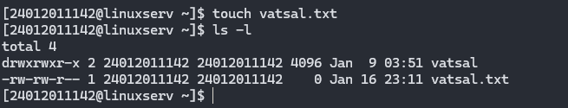
- CAT Command:
The cat command is used to create, display, and copy file contents.
Syntax:
- To create a file: cat > <file_name>
- To display a file: cat <file_name>
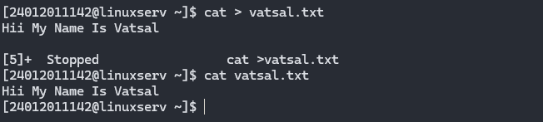
- LS Command:
The ls command lists the contents of a directory.
Syntax: ls [flags]
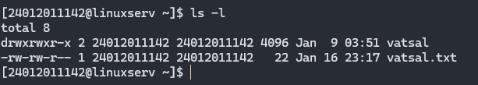
- MKDIR Command:
The mkdir command is used to create a new directory.
Syntax: mkdir <directory_name>
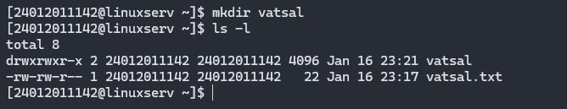
- RMDIR Command:
The rmdir command removes an empty directory.
Syntax: rmdir <directory_name>
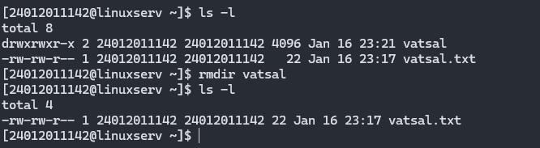
- CD Command:
The cd command is used to change the current directory.
Syntax: cd <directory_name>
- CLEAR Command:
Clears the terminal screen.
Syntax: clear
- CP Command:
The cp command is used to copy files or directories.
Syntax: cp <source> <destination>
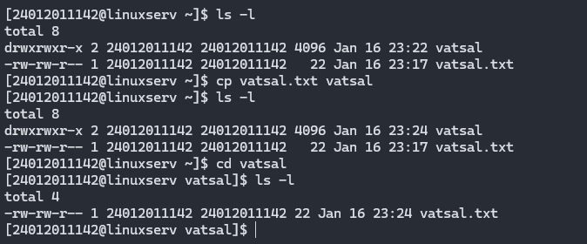
- CAL Command:
Displays the current month's calendar.
Syntax: cal [flags]
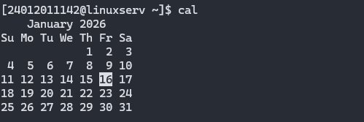

- HISTORY Command:
Displays previously executed commands.
Syntax: history
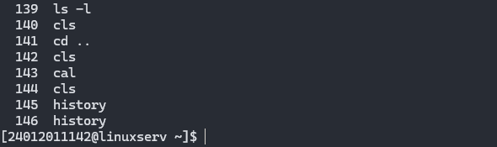
- CHMOD Command:
Changes file permissions.
Syntax: chmod [permission] [file]
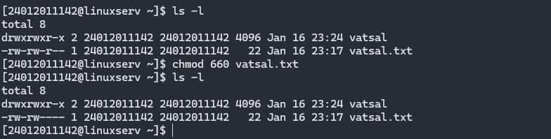
- UMASK Command:
Sets default permissions for newly created files.
Syntax: umask [mask]
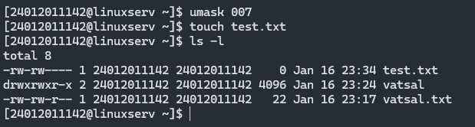
- HEAD Command:
Displays the first 10 lines of a file.
Syntax: head <file name>
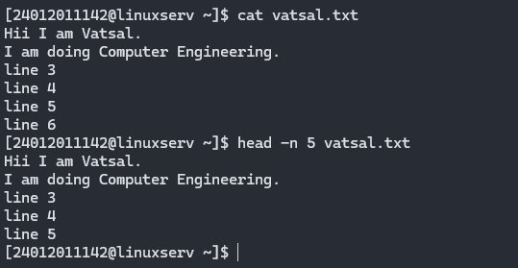
- TAIL Command:
Displays the last 10 lines of a file.
Syntax: tail <file name>
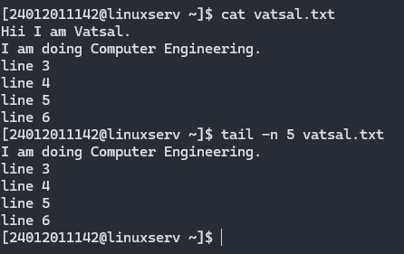

- DATE Command:
Displays date, time, and time zone.
Syntax: date
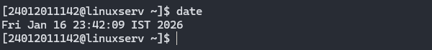
- EXPR Command:
Evaluates expressions, including arithmetic and string operations.
Syntax: expr expression
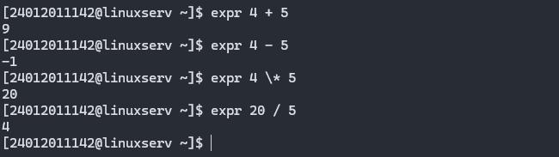
- WHO Command:
Shows information about currently logged-in users.
Syntax: who [options]
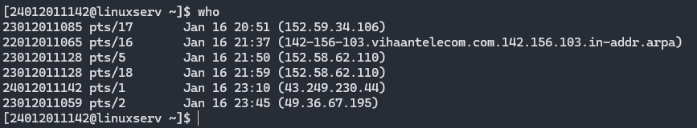

- UNAME Command:
Displays system information like OS name and kernel version.
Syntax: uname [options]
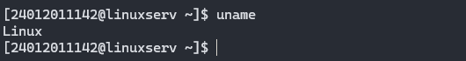
- FINGER Command:
Provides information about system users.
Syntax: finger [username]
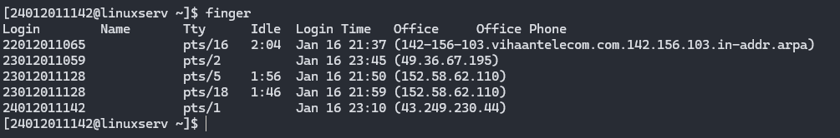
- CMP Command:
Compares two files byte by byte.
Syntax: cmp [file1] [file2]
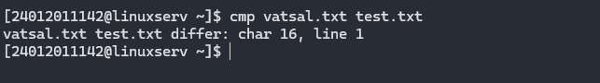
- COMM Command:
Compares two files and displays non-matching/matching items.
Syntax: comm <file1> <file2>
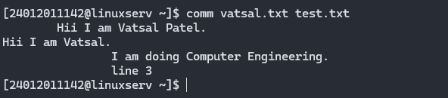
- SORT Command:
Sorts files in alphabetical order.
Syntax: sort <file name>
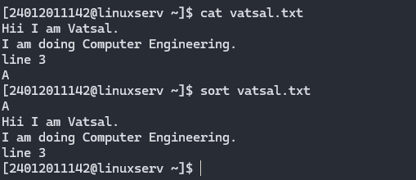
- SPELL Command:
Checks for spelling errors in a file.
Syntax: spell [file]
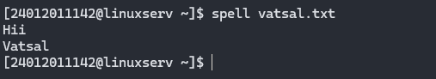
- WC Command:
Counts lines, words, and characters in a file.
Syntax: wc <file name>
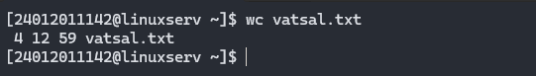

- TYPE Command:
Identifies the type of a command.
Syntax: type [command]
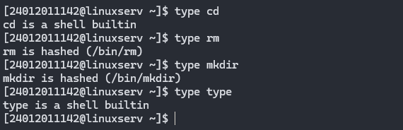
- TTY Command:
Displays the terminal name.
Syntax: tty
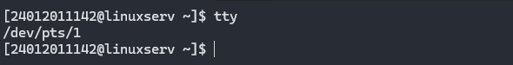
- ECHO Command:
Prints text or variables to the terminal.
Syntax: echo [string]

- MAN Command:
Opens the manual page for a command.
Syntax: man [command]
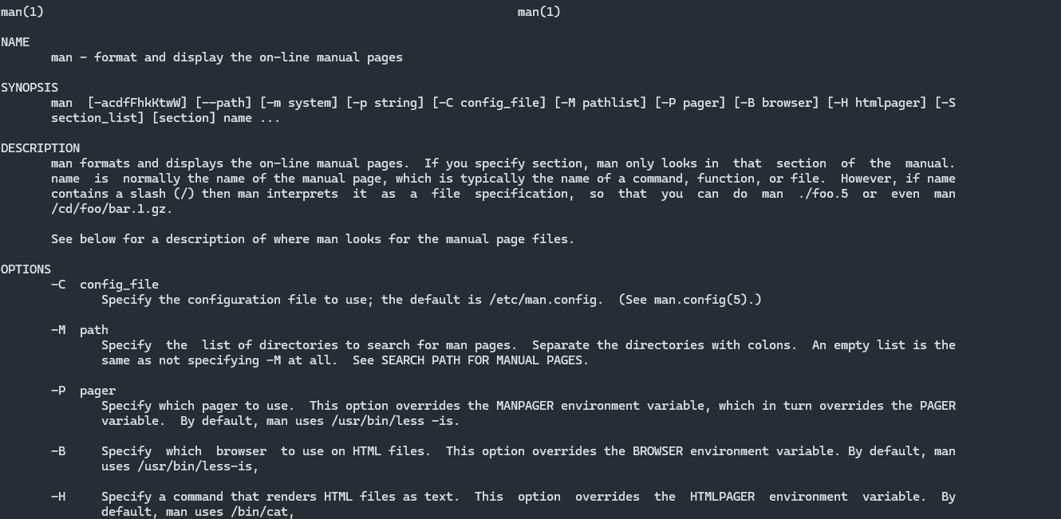
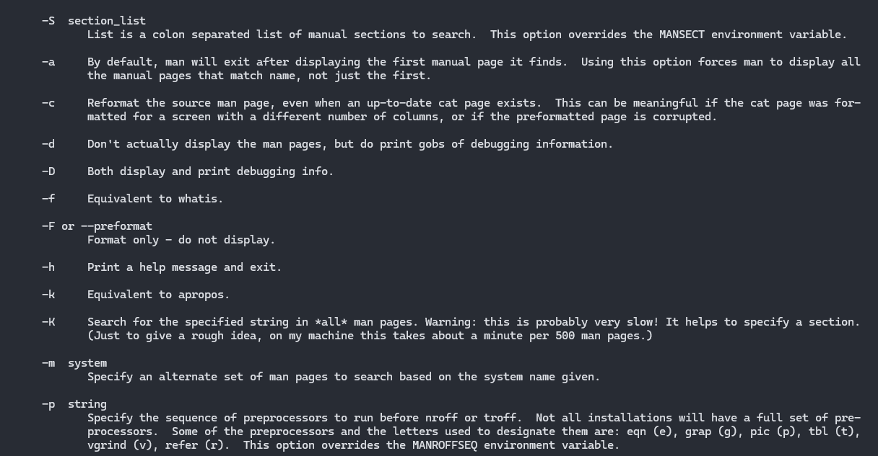

- MORE Command:
Displays file content one page at a time.
Syntax: more <file name>
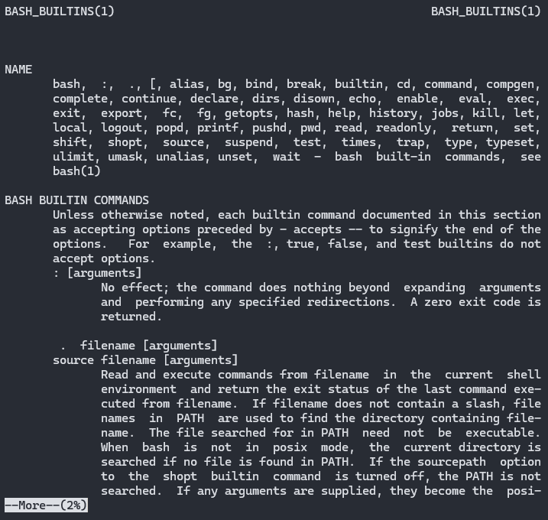

- PASSWD Command:
Creates and changes the user password.
Syntax: passwd <username>
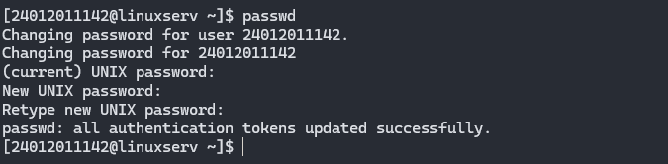
- PWD Command:
Displays the current working directory.
Syntax: pwd
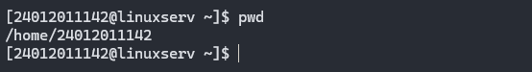
- GREP Command:
Searches for content within a file.
Syntax: command | grep <searchWord>
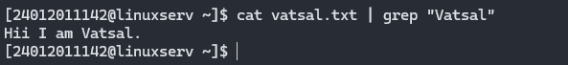

- PS Command:
The ps command displays currently running processes.
Syntax: ps [options]
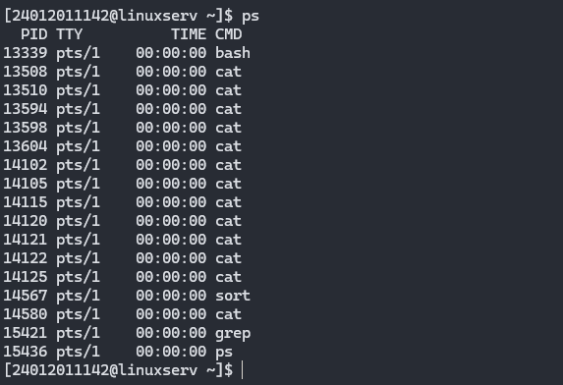
- RM Command:
The rm command is used to remove a file.
Syntax: rm <file name>
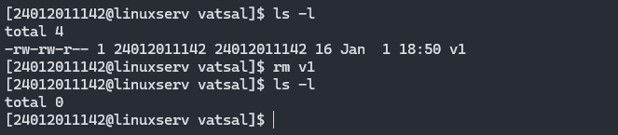

- SET Command:
The set command is used to set shell variables and options.
Syntax: set [option]
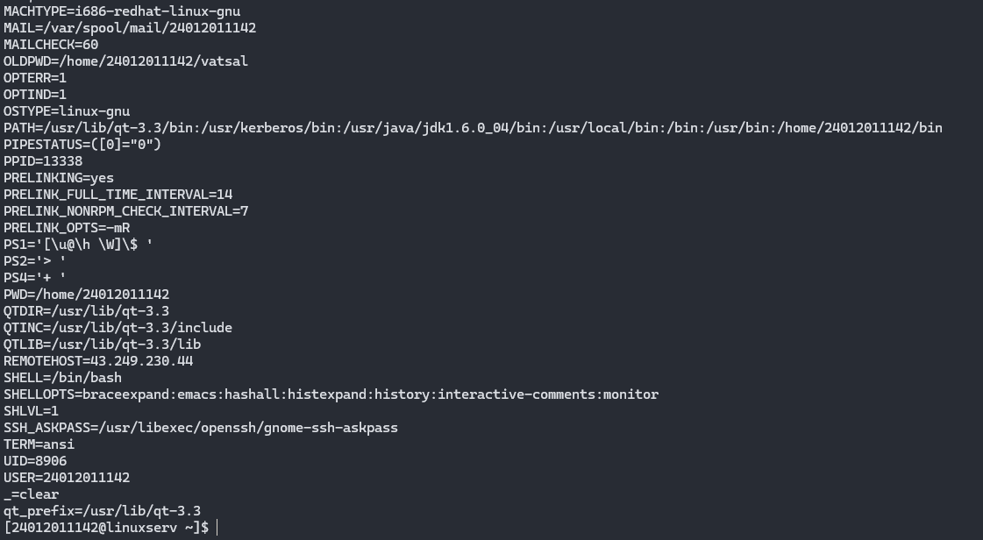
- CUT Command:
The cut command extracts specific columns from a file. The -d option specifies a delimiter - it can be a space (' '), a slash (/), a hyphen (-), or anything else, and the -f option selects a column.
Syntax: cut -d(delimiter) -f(columnNumber) <fileName>
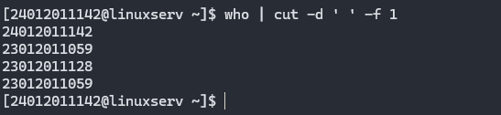

- READ Command:
The read command reads user input and stores it in a variable.
Syntax: read [variable]
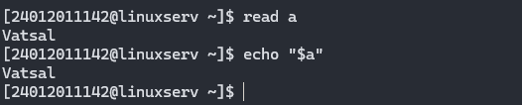
- JOBS Command:
Lists active background jobs in the current shell.
Syntax: jobs [options]
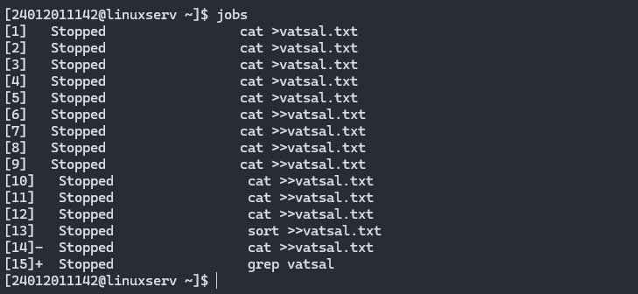
- AWK Command:
awk is a powerful text-processing and pattern-matching tool.
Syntax: awk 'pattern {action}' file
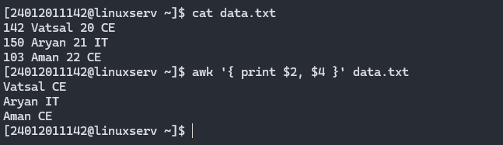
- LN Command:
The ln command creates hard or symbolic (soft) links to files.
Syntax: ln [options] target link_name
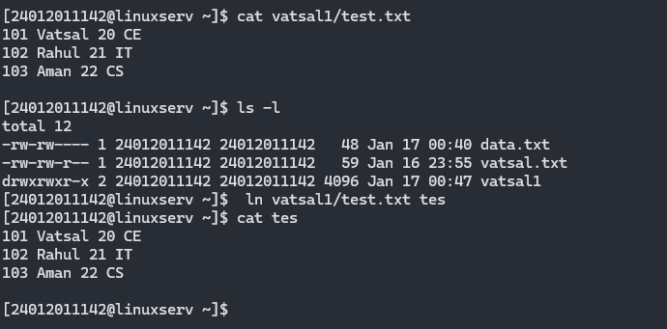
- ENV Command:
The env displays all environment variables or runs a command with a modified environment.
Syntax: env [options] ENVName=ENVValue
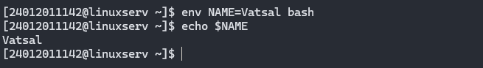
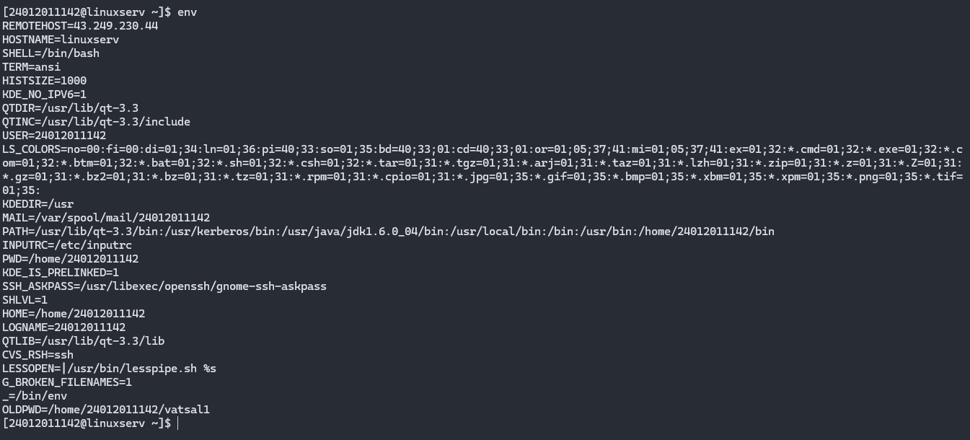
- KILL Command:
The kill command terminates a process using its Process ID (PID).
Syntax: kill [signal] PID
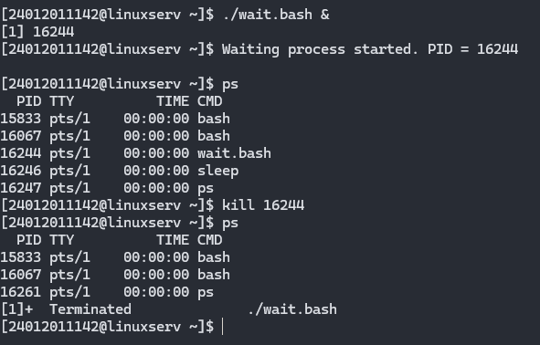
- ALIAS Command:
The alias command defines shortcuts for longer commands.
Syntax: alias name='command'
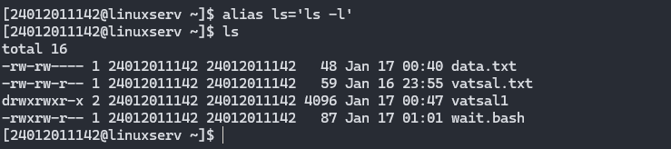

- DIFF Command:
The diff command compares two files line by line and shows differences.
Syntax: diff [file1] [file2]
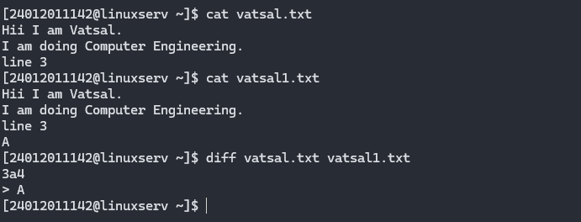
- LOCATE Command:
The locate command searches for a file by its name. Unlike find, it works in the background using a database, making it faster.
Syntax: locate <file name>
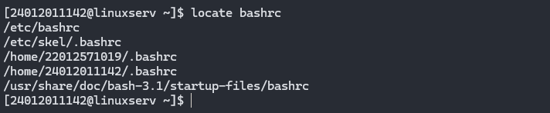
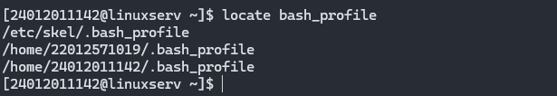

- FIND Command:
The find command searches for files in directories. It supports searching by name, type, date, and more.
Symbols Used in find Command:
- (.) → Current directory
- (/) → Root directory
Syntax: find . -name "*.pdf"
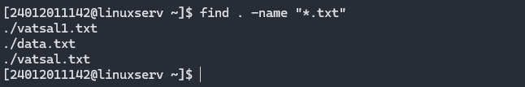
- INFO Command:
The info command provides detailed documentation about a command (alternative to man).
Syntax: info [command]
