[ 2CEIT401 – Operating Systems ]

Practical: 2

AIM- Introduction of basic shell programming. Write shell script using

operators.

r


Department of Computer Engineering

Aim: Introduction of basic shell programming. Write shell script using operators.
- Explain basic command of Vi Editor
Ans:
Vi (Visual Editor) is a text editor in Unix/Linux used to create and modify files.
Vi works in three main modes:

Command Mode (Default Mode)
- Used to navigate, delete, copy, paste, and execute commands.
- You enter this mode by pressing Esc.

Basic Navigation Commands

Command | Function
h | Move cursor left
l | Move cursor right
j | Move cursor down
k | Move cursor up
w | Move to next word
b | Move to previous word
0 | Move to beginning of line
$ | Move to end of line
gg | Go to first line
G | Go to last line

Insert Mode
- Used to insert or modify text.
- Entered from command mode.

Command | Description
i | Insert before cursor
I | Insert at beginning of line
a | Append after cursor
A | Append at end of line
o | Open new line below
O | Open new line above

Press `Esc` to return to command mode.

Last Line (Ex) Mode
- Used for saving, quitting, searching, etc.
- Entered by pressing : in command mode.

Command | Function
:w | Save file
:q | Quit
:wq | Save and quit
:q! | Quit without saving
:set number | Show line numbers

- Editing Command of Vi Editor.
Ans:
Editing commands are mainly used in Command Mode.
Delete Commands
Command | Action
x | Delete character under cursor
dd | Delete entire line
dw | Delete a word
D | Delete from cursor to end of line
d$ | Delete till end of line

Copy (Yank) and Paste Commands
Command | Action
yy | Copy (yank) a line
yw | Copy a word
p | Paste after cursor
P | Paste before cursor
Command | Action

Replace and Change Commands
Command | Action
r | Replace single character
R | Replace continuously
cw | Change a word
cc | Change entire line

Undo and Redo
Command | Function
u | Undo last action
U | Undo entire line
Ctrl + r | Redo

- Explain I/O redirection, Piping and Command Substitution
Ans:
I/O Redirection
I/O redirection allows changing the standard input/output of commands.
- Standard Streams
- stdin (0) → keyboard
- stdout (1) → screen
- stderr (2) → error messages
Types of Redirection
- Output Redirection
ls > file.txt
Writes output to file.txt (overwrites).
ls >> file.txt
Appends output to file.
- Input Redirection
sort < data.txt
Takes input from data.txt.
- Error Redirection
ls xyz 2> error.txt
Redirects error to file.
- Both Output and Error
command > out.txt 2>&1

Piping (|)
Piping sends the output of one command as input to another.
Syntax
command1 | command2
Examples
ls | wc -l
Counts number of files.
ps aux | grep root
Searches processes related to root.

Command Substitution
Command substitution allows using output of a command as an argument.
Syntax
`command`
or
$(command)

Example
date=$(date)
echo "Today is $date"

&
files=$(ls | wc -l)
echo "Total files: $files"
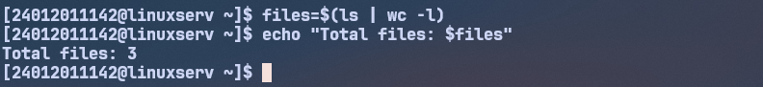

- What is shell script? Explain with Examples.
Ans:
Definition
A shell script is a text file containing a sequence of shell commands that are executed automatically by the shell.
Shell scripts are used for:
- Automation
- System administration
- File handling
- Task scheduling

Structure of a Shell Script
#!/bin/bash
# This is a comment
echo "Hello World"
- #!/bin/bash → Shebang (interpreter path)
- echo → Prints output
Example 1: Simple Shell Script
echo "Welcome to Shell Programming"
Example 2: Using Variables
name="Vatsal"
echo "Hello $name"
Example 3: Arithmetic Operators
a=10
b=5
sum=$((a + b))
echo "Sum = $sum"

Example 4: Conditional Statement
#!/bin/bash
read -p "Enter number: " n
if [ $n -gt 0 ]
then
echo "Positive number"
else
echo "Negative number"
fi
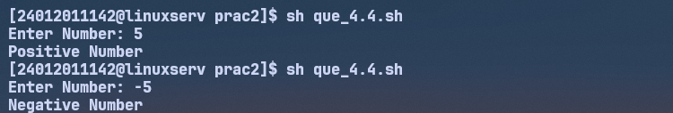
Advantages of Shell Script
- Saves time
- Reduces manual work
- Easy to write and modify
- Powerful automation too
- Write a shell script to scan your name and display it like My college Name
is :UVPC
Code:
echo "Enter Your College Name: "
read college_name
echo "My College Name is: $college_name"
Output:

- Write a shell script to scan two variables and to display their sum, mul, div,
sub and modulo division. Write a shell script to scan two variables and to
display their sum, mul, div, sub and modulo division as per the user choice.
(no need to continue, only once is OK)

Code1:
echo "Enter Two Numbers: "
read num1
read num2
sum=`expr $num1 + $num2`
sub=`expr $num1 - $num2`
mul=`expr $num1 \* $num2`
div=`expr $num1 / $num2`
mod=`expr $num1 % $num2`
echo "Sum: $sum"
echo "Sub: $sub"
echo "Mul: $mul"
echo "Div: $div"
echo "Mod: $mod"
Output1:
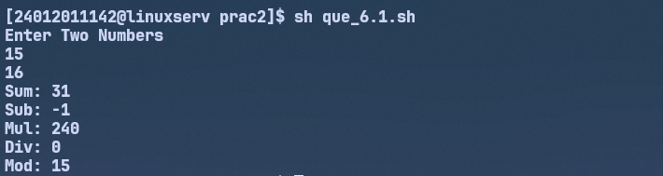

Code2:
echo "Enter Two Numbers: "
read num1
read num2
echo "Enter Choice "
echo "1. Add"
echo "2. Sub"
echo "3. Mul"
echo "4. Div"
echo "5. Mod"
read choice
if [ $choice = 1 ] then
sum=`expr $num1 + $num2`
echo "Sum: $sum"
elif [ $choice = 2 ]; then
sub=`expr $num1 - $num2`
echo "Subtraction: $sub"
elif [ $choice = 3 ]; then
mul=`expr $num1 \* $num2`
echo "Multiplication: $mul"
elif [ $choice = 4 ]; then
div=`expr $num1 / $num2`
echo "Division: $div"
elif [ $choice = 5 ]; then
mod=`expr $num1 % $num2`
echo "Modulus: $mod"
fi
Output2:
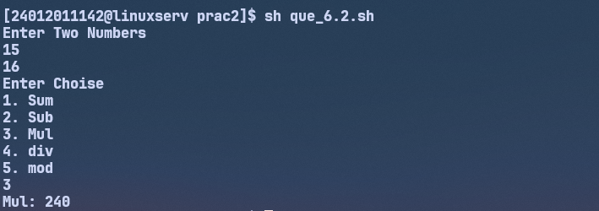

- Write a shell script to find greatest of two. Script must consider the case
where two numbers are equal.
Code:
echo "Enter Two Numbers: "
read num1
read num2
if [ $num1 -eq $num2 ]; then
echo "Both are Equal"
elif [ $num1 -gt $num2 ]; then
echo "$num1 is Greater than $num2"
else
echo "$num2 is Greater than $num1"
fi

Output:
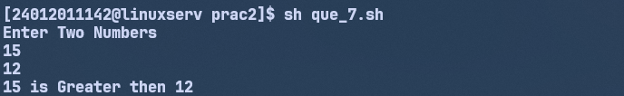
- Write a shell script to find greatest of three. Script must consider the case
where two numbers are equal.
Code:
echo "Enter Three Numbers: "
read num1
read num2
read num3
if [ $num1 -eq $num2 ] && [ $num2 -eq $num3]; then
echo "All are Equal"
elif [ $num1 -gt $num2 ] && [ $num1 -gt $num3 ]; then
echo "$num1 is Greater than $num2"
elif [ $num2 -gt $num1 ] && [ $num2 -gt $num3 ]; then
echo "$num2 is Greater than $num1"
else
echo "$num3 is Greater than $num1"
fi
Output:


