[ 2CEIT401 – Operating Systems ]

Practical: 6

AIM- Demonstration of process management system calls for multiprocessing.

r


Department of Computer Engineering

Aim: Demonstration of process management system calls for multiprocessing.
- Create a chain of processes where one parent has exactly one child as per sample chain given by the Instructor.
Sequence:1
PROCESS0--> PROCESS 1--> PROCESS2--> PROCESS3--> PROCESS4--> PROCESS 5--> PROCESS6
Display PIDs of all processes.
Code:

max_lvl=6
current_lvl=${1:-0}
echo "Current level: $current_lvl"
echo "Parent Process ID: $PPID"
echo "Process ID: $$"
echo "------------------------------"
if [ $current_lvl -lt $max_lvl ]; then
sh "$0" $((current_lvl + 1))
fi

Output:

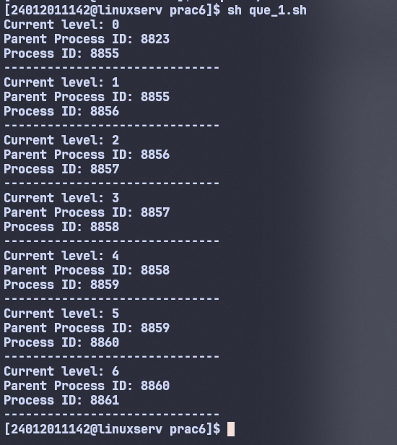

- Write a shell script to calculate the loss percentage of an article, given the cost price and the selling price as command line arguments.
Code:
parent_pross_name=$(ps -p $PPID -o comm=)

if [ "$parent_pross_name" = "sh" ]; then
sorted_args=$(echo "$@" | tr ' ' '\n' | sort -r | tr '\n' ' ')
echo "Child Process:"
echo "Reversely Sorted Coins are: $sorted_args"
else
sorted_args=$(echo "$@" | tr ' ' '\n' | sort | tr '\n' ' ')
echo "Parent Process:"
echo "Sorted Coins are: $sorted_args"
sh "$0" "$@"
fi

Output:
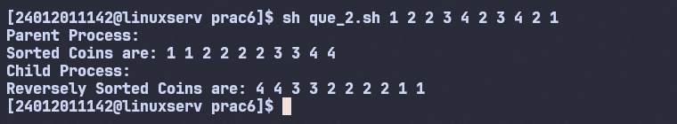

- Write a shell script to accept the name of the user and check out if the same has logged in or not.
Code orphan.c:
#include <stdio.h>
#include <stdlib.h>
#include <unistd.h>

int main() {
pid_t pid = fork();

if (pid < 0) {
fprintf(stderr, "Fork failed\n");
return 1;
}
else if (pid == 0) {
// Child process
sleep(3);
printf("Child Process ID: %d, New Parent Process ID: %d\n", getpid(), getppid());
}
else {
// Parent process
printf("Parent Process ID: %d, Child Process ID: %d\n", getpid(), pid);
exit(0);
}

return 0;
}

Output:
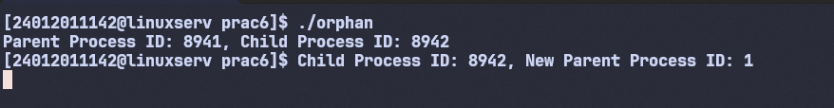

Code zombie.c:
#include <stdio.h>
#include <stdlib.h>
#include <unistd.h>

int main() {
pid_t pid = fork();

if (pid > 0) {
// Parent process
printf("Parent PID: %d\n", getpid());
printf("Child PID: %d\n", pid);

sleep(2);

printf("\nChecking process table (look for Z state):\n");
system("ps -l");

sleep(10);
}
else if (pid == 0) {
// Child process
printf("Child PID: %d exiting...\n", getpid());
exit(0);
}
else {
perror("Fork failed");
}

return 0;
}

Output:
