[ 2CEIT401 – Operating Systems ]

Practical: 7

AIM- Apply the concept of CPU Scheduling Algorithms.

r


Department of Computer Engineering

Aim: Apply the concept of CPU Scheduling Algorithms.
- Write a program to implement FCFS CPU scheduling Algorithm.
Code:

#include <stdio.h>

int main() {
// First Come First Serve (FCFS) Scheduling Algorithm
int n, i;
int bt[20], at[20], wt[20], tat[20], pid[20];
int current_time, start_time;
float avg_wt = 0, avg_tat = 0;
printf("Enter number of processes: ");
scanf("%d", &n); printf("Enter Burst Time:\n");
for (i = 0; i < n; i++) {
printf("P%d: ", i + 1);
scanf("%d", &bt[i]);
pid[i] = i + 1;
}

printf("Enter Arrival Time:\n");
for (i = 0; i < n; i++) {
printf("P%d: ", i + 1);
scanf("%d", &at[i]);
}

for (i = 0; i < n - 1; i++) {
int j;
for (j = 0; j < n - i - 1; j++) {
if (at[j] > at[j + 1]) {
int temp;
temp = at[j];
at[j] = at[j + 1];
at[j + 1] = temp;

temp = bt[j];
bt[j] = bt[j + 1];
bt[j + 1] = temp;

temp = pid[j];
pid[j] = pid[j + 1];
pid[j + 1] = temp;
}
}
}

current_time = 0;
for (i = 0; i < n; i++) {
start_time = (current_time > at[i]) ? current_time : at[i];
wt[i] = start_time - at[i];
tat[i] = wt[i] + bt[i];
current_time = start_time + bt[i];
avg_wt += wt[i];
avg_tat += tat[i];
}

printf("\nProcess\tArrival Time\tBurst Time\tWaiting Time\tTurnaround Time\n");
for (i = 0; i < n; i++) {
printf("P%d\t%d\t\t%d\t\t%d\t\t%d\n", pid[i], at[i], bt[i], wt[i], tat[i]);
}
printf("\nAverage Waiting Time = %.2f", avg_wt / n);
printf("\nAverage Turnaround Time = %.2f", avg_tat / n);
return 0;
}

Output:

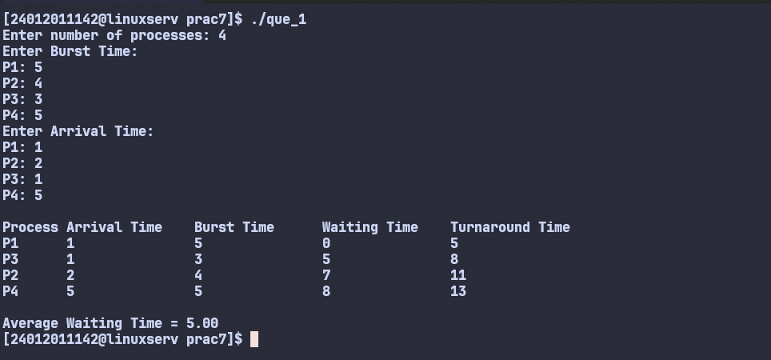

- Write a program to implement SJF CPU scheduling Algorithm.
Code:
#include <stdio.h>
int main() {
int n, i;
int bt[20], at[20], wt[20], tat[20], ct[20], pid[20], done[20];
int completed = 0, current_time = 0;
float avg_wt = 0, avg_tat = 0;

printf("Enter number of processes: ");
scanf("%d", &n);

printf("Enter Burst Time:\n");
for (i = 0; i < n; i++) {
printf("P%d: ", i + 1);
scanf("%d", &bt[i]);
pid[i] = i + 1;
done[i] = 0;
}

printf("Enter Arrival Time:\n");
for (i = 0; i < n; i++) {
printf("P%d: ", i + 1);
scanf("%d", &at[i]);
}

while (completed < n) {
int idx = -1;
for (i = 0; i < n; i++) {
if (!done[i] && at[i] <= current_time) {
if (idx == -1 || bt[i] < bt[idx] || (bt[i] == bt[idx] && at[i] < at[idx])) {
idx = i;
}
}
}

if (idx == -1) {
current_time++;
continue;
}

wt[idx] = current_time - at[idx];
ct[idx] = current_time + bt[idx];
tat[idx] = ct[idx] - at[idx];
current_time = ct[idx];
done[idx] = 1;
completed++;
}

for (i = 0; i < n; i++) {
avg_wt += wt[i];
avg_tat += tat[i];
}

printf("\nProcess\tArrival Time\tBurst Time\tWaiting Time\tTurnaround Time\n");
for (i = 0; i < n; i++) {
printf("P%d\t%d\t\t%d\t\t%d\t\t%d\n", pid[i], at[i], bt[i], wt[i], tat[i]);
}

printf("\nAverage Waiting Time = %.2f", avg_wt / n);
printf("\nAverage Turnaround Time = %.2f\n", avg_tat / n);
return 0;
}

Output:
