[ 2CEIT401 – Operating Systems ]

Practical: 9

AIM- Simulate various Disk Scheduling algorithms and different types of Page Replacement algorithms.

r


Department of Computer Engineering

Aim: Simulate various Disk Scheduling algorithms and different types of Page Replacement algorithms.
- Write a program to implement FIFO page Replacement algorithm.
Code:

#include <stdio.h>

int main() {
int frames, pages, i, j;

printf("Enter number of frames: ");
scanf("%d", &frames);

printf("Enter number of pages: ");
scanf("%d", &pages);

int page[pages];
printf("Enter page reference string: ");
for (i = 0; i < pages; i++){
scanf("%d", &page[i]);
}
int frame[frames];
for (i = 0; i < frames; i++){
frame[i] = -1;
}
int index = 0, faults = 0;

for (i = 0; i < pages; i++) {
int found = 0;

for (j = 0; j < frames; j++) {
if (frame[j] == page[i]) {
found = 1;
break;
}
}

if (!found) {
frame[index] = page[i];
index = (index + 1) % frames;
faults++;
}

// Display frames
printf("Page %d -> ", page[i]);
for (j = 0; j < frames; j++){
printf("%d ", frame[j]);
}
printf("\n");
}

printf("Total Page Faults = %d\n", faults);
return 0;
}

Output:

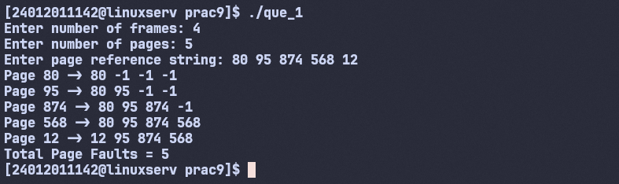

- Write a program to implement Optimal Page replacement algorithm.
Code:
#include <stdio.h>

int main() {
int frames, pages, i, j, k;

printf("Enter number of frames: ");
scanf("%d", &frames);

printf("Enter number of pages: ");
scanf("%d", &pages);

int page[pages];
printf("Enter page reference string: ");
for (i = 0; i < pages; i++) {
scanf("%d", &page[i]);
}
int frame[frames];
for (i = 0; i < frames; i++) {
frame[i] = -1;
}

int faults = 0;

for (i = 0; i < pages; i++) {
int found = 0;

// Check if page already in frame
for (j = 0; j < frames; j++) {
if (frame[j] == page[i]) {
found = 1;
break;
}
}

if (!found) {
int pos = -1, farthest = i;

for (j = 0; j < frames; j++) {
int k;
for (k = i + 1; k < pages; k++) {
if (frame[j] == page[k]) {
break;
}
}

if (k == pages) { // not used again
pos = j;
break;
}

if (k > farthest) {
farthest = k;
pos = j;
}
}

if (pos == -1) {
pos = 0;
}

frame[pos] = page[i];
faults++;
}

// Display frames
printf("Page %d -> ", page[i]);
for (j = 0; j < frames; j++) {
printf("%d ", frame[j]);
}
printf("\n");
}

printf("Total Page Faults = %d\n", faults);
return 0;
}

Output:
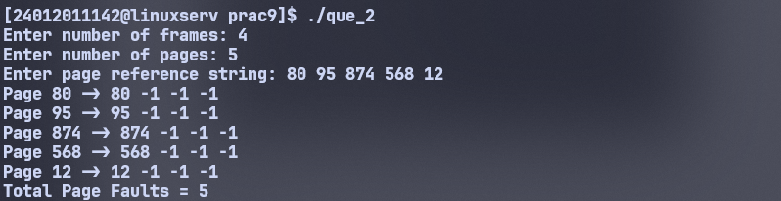

- Write a program to implement FCFS Disk Scheduling algorithm.
Code:
#include <stdio.h>
#include <stdlib.h>

int main() {
int n, head, i;
printf("Enter number of requests: ");
scanf("%d", &n);

int req[n];

printf("Enter disk requests: ");
for (i = 0; i < n; i++){
scanf("%d", &req[i]);
}

printf("Enter initial head position: ");
scanf("%d", &head);

int total_seek = 0;

for (i = 0; i < n; i++) {
int distance = abs(req[i] - head);
total_seek += distance;

printf("Move from %d to %d (Seek = %d)\n", head, req[i], distance);
head = req[i];
}

printf("Total Seek Time = %d\n", total_seek);

return 0;
}

Output:
