GANPAT UNIVERSITY
U. V. PATEL COLLEGE OF ENGINEERING
B.Tech CE/IT Semester IV
2CEIT404: Python Programming

Practical-10: Build the graphical user interface using the Tkinter module.

- Write a Python GUI program to create a simple calculator.
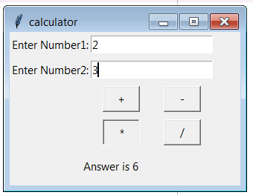

- Make weight conversion GUI from kg to gram, pound and ounce using tkinter.
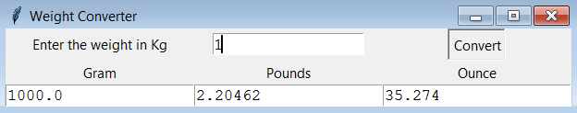

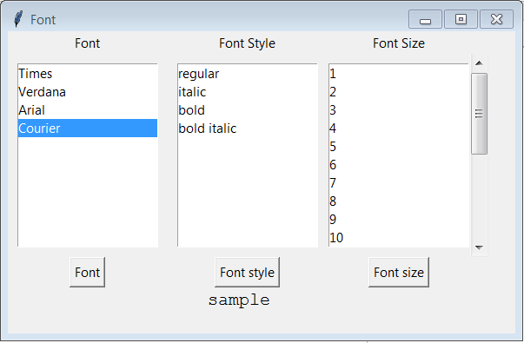
- Write python GUI to make font menu.

- Create a student registration page with enrollment, name, gender, address, branch name, mobile number and email address fields and store all data in the database.
