Practical - 12

Aim:
Build a web application using the Django framework.
- Install Django
- Create The Project Named “myprac”
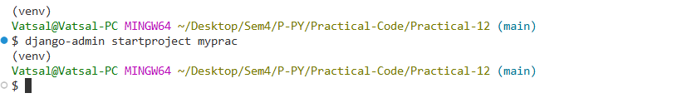
it will create Files in Directory
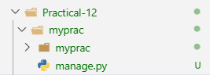
- Create App in Django
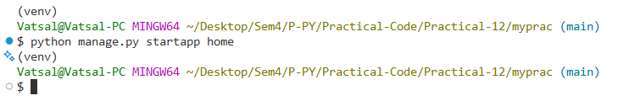
It will create Files in Directory
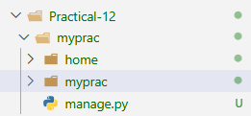
- Create a templates folder inside the home folder, and create a HTML file named home.html
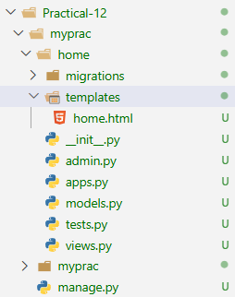
- Inside ‘myprac\myprac\urls.py’ Add Following Content
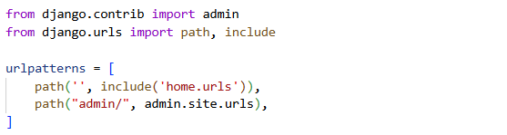
- Inside ‘myprac\home\views.py’ Add Following Content
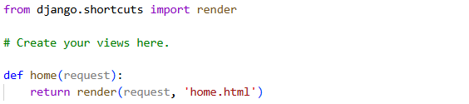
- Create ‘myprac\home\urls.py’ & Add Following Content
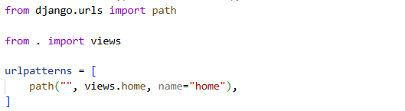
- Inside ‘myprac\myprac\settings.py’ Add Following Content
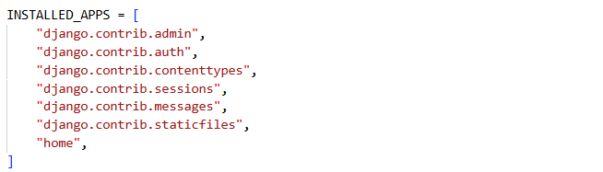
- Now Run The Server
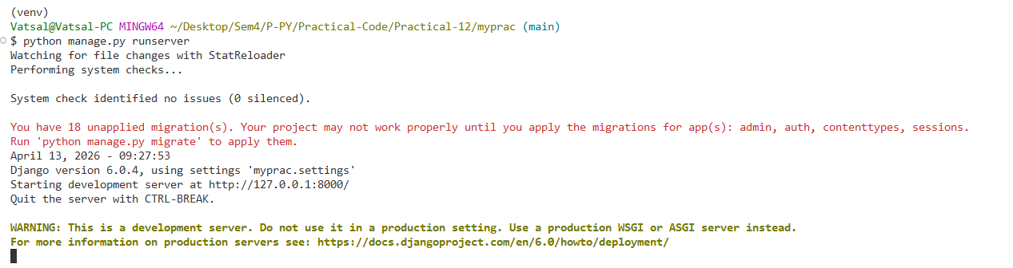
- Now at http://127.0.0.1:8000/ our App is Live
