Practical - 10

Aim:
Build the graphical user interface using the Tkinter module.
Q1: Write a Python GUI program to create a simple calculator.

Code:
import tkinter as tk

# Initialize the main application window
root = tk.Tk()
root.title("Calculator")
root.geometry("250x150")
tk.Label(root, text="Enter Num 1: ").grid(row=0, column=0, columnspan=1)
n1 = tk.StringVar()
n2 = tk.StringVar()
tk.Entry(root, textvariable=n1).grid(row=0, column=1, columnspan=2)
tk.Label(root, text="Enter Num 2: ").grid(row=1, column=0, columnspan=1)
tk.Entry(root, textvariable=n2).grid(row=1, column=1, columnspan=2)
op = tk.StringVar()
tk.Button(text="+", command=lambda :op.set("+")).grid(row=3, column=1)
tk.Button(text="-", command=lambda :op.set("-")).grid(row=3, column=2)
tk.Button(text="*", command=lambda :op.set("*")).grid(row=4, column=1)
tk.Button(text="/", command=lambda :op.set("/")).grid(row=4, column=2)

result = tk.StringVar()

def cal():
num1 = float(n1.get())
num2 = float(n2.get())
opr = op.get()
if opr == "+":
result.set(f"Ans : {num1+num2}")
elif opr == "-":
result.set(f"Ans : {num1-num2}")
elif opr == "*":
result.set(f"Ans : {num1*num2}")
elif opr == "/":
result.set(f"Ans : {num1/num2}")

tk.Button(text="=", command=cal).grid(row=4, column=0)
tk.Label(textvariable=result).grid(row=5, column=0, columnspan=3)

tk.mainloop()
Output:
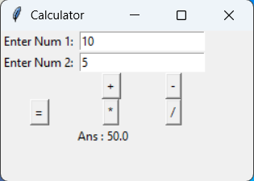

Q2: Make weight conversion GUI from kg to gram, pound and ounce using tkinter.

Code:
import tkinter as tk

# Initialize the main application window
root = tk.Tk()
root.title("Weight Converter")
root.geometry("380x100")
tk.Label(root, text="Enter Weight in Kg: ").grid(row=0, column=0, columnspan=1)
weight = tk.StringVar()
tk.Entry(root, textvariable=weight).grid(row=0, column=1, columnspan=1)
result_gram = tk.StringVar()
result_pound = tk.StringVar()
result_ounce = tk.StringVar()
def convert():
w = float(weight.get())
result_gram.set(f"{w*1000}")
result_pound.set(f"{w*2.20462}")
result_ounce.set(f"{w*35.274}")

tk.Button(text="Convert", command=lambda :convert()).grid(row=0, column=2, columnspan=1)

tk.Label(text="Weight in Gram: ").grid(row=2, column=0, columnspan=1)
tk.Label(text="Weight in Pound: ").grid(row=2, column=1, columnspan=1)
tk.Label(text="Weight in Ounce: ").grid(row=2, column=2, columnspan=1)
tk.Entry(root, textvariable=result_gram, state="readonly").grid(row=3, column=0, columnspan=1)
tk.Entry(root, textvariable=result_pound, state="readonly").grid(row=3, column=1, columnspan=1)
tk.Entry(root, textvariable=result_ounce, state="readonly").grid(row=3, column=2, columnspan=1)

tk.mainloop()

Output:
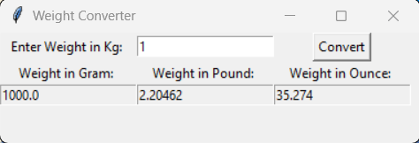

Q3: Write python GUI to make font menu.
Code:
import tkinter as tk

root = tk.Tk()
root.title("Font Dialog")

# -------- LEFT: Font list --------
font_frame = tk.Frame(root)
font_frame.grid(row=0, column=0, padx=10)

tk.Label(font_frame, text="Font").pack()

font_list = tk.Listbox(font_frame, height=6)
fonts = ["Times", "Verdana", "Arial", "Courier"]
for f in fonts:
font_list.insert(tk.END, f)

font_list.pack()

# -------- MIDDLE: Font Style --------
style_frame = tk.Frame(root)
style_frame.grid(row=0, column=1, padx=10)

tk.Label(style_frame, text="Font Style").pack()

font_style = tk.StringVar(value="Regular")
styles = ["Regular", "Italic", "Bold", "Bold Italic"]

for s in styles:
tk.Radiobutton(style_frame, text=s, variable=font_style, value=s).pack(anchor="w")

# -------- RIGHT: Font Size --------
size_frame = tk.Frame(root)
size_frame.grid(row=0, column=2, padx=10)

tk.Label(size_frame, text="Font Size").pack()

scrollbar = tk.Scrollbar(size_frame)
scrollbar.pack(side="right", fill="y")

size_list = tk.Listbox(size_frame, yscrollcommand=scrollbar.set, height=6)
for i in range(1, 101):
size_list.insert(tk.END, i)

size_list.pack(side="left")
scrollbar.config(command=size_list.yview)

# -------- SAMPLE TEXT --------
sample = tk.Label(root, text="Sample Text", relief="sunken")
sample.grid(row=2, column=0, columnspan=3, pady=10)

# -------- APPLY FUNCTION --------
def apply_font():
try:
selected_font = font_list.get(tk.ACTIVE)
selected_size = int(size_list.get(tk.ACTIVE))
selected_style = font_style.get()

weight = "normal"
slant = "roman"

if "Bold" in selected_style:
weight = "bold"
if "Italic" in selected_style:
slant = "italic"

sample.config(font=(selected_font, selected_size, weight, slant))

except:
print("Select all options properly")

tk.Button(root, text="Apply", command=apply_font).grid(row=1, column=0, columnspan=3, pady=10)

root.mainloop()

Output:
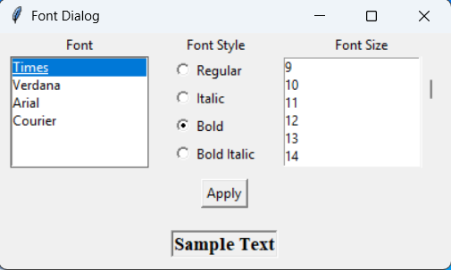

Q4: Create a student registration page with enrollment, name, gender, address, branch name, mobile number and email address fields and store all data in the database.
Code:
import tkinter as tk
import sqlite3

cnx = sqlite3.connect('student_details.db')
cursor = cnx.cursor()

query = "DROP TABLE IF EXISTS student_details"
cursor.execute(query)
cnx.commit()

query = """
CREATE TABLE IF NOT EXISTS student_details (
id INTEGER PRIMARY KEY AUTOINCREMENT,
enrollment_number TEXT,
student_name TEXT,
gender TEXT,
address TEXT,
branch TEXT,
mobile_number TEXT,
email TEXT
)
"""
cursor.execute(query)

def submit_form():
enrollment = enrollment_entry.get()
name = name_entry.get()
gender = gender_var.get()
address = address_entry.get()
branch = branch_var.get()
mobile = mobile_entry.get()
email = email_entry.get()

query = """INSERT INTO student_details (enrollment_number, student_name, gender, address, branch, mobile_number, email)
VALUES (?, ?, ?, ?, ?, ?, ?)"""
cursor.execute(query, (enrollment, name, gender, address, branch, mobile, email))
cnx.commit()
print("Form Submitted Successfully!")

def view_form():
query = "SELECT * FROM student_details"
cursor.execute(query)
records = cursor.fetchall()
for record in records:
print(record)

# Initialize the main application window
root = tk.Tk()
root.title("Register Form")
root.geometry("400x400")

# Create labels and entry fields for user input
tk.Label(root, text="Enter Enrollment Number:").grid(row=0, column=0, padx=10, pady=10)
enrollment_entry = tk.Entry(root)
enrollment_entry.grid(row=0, column=1, padx=10, pady=10, columnspan=2)

tk.Label(root, text="Enter Name:").grid(row=1, column=0, padx=10, pady=10)
name_entry = tk.Entry(root)
name_entry.grid(row=1, column=1, padx=10, pady=10, columnspan=2)

gender_var = tk.StringVar()

tk.Label(root, text="Select Gender:").grid(row=2, column=0, padx=10, pady=10)
tk.Radiobutton(root, text="Male", variable=gender_var, value="Male").grid(row=2, column=1, padx=10, pady=10)
tk.Radiobutton(root, text="Female", variable=gender_var, value="Female").grid(row=2, column=2, padx=10, pady=10)

tk.Label(root, text="Enter Address:").grid(row=3, column=0, padx=10, pady=10)
address_entry = tk.Entry(root)
address_entry.grid(row=3, column=1, padx=10, pady=10, columnspan=2)

branches = ["Computer Science", "Mechanical", "Electrical", "Civil"]
tk.Label(root, text="Select Branch:").grid(row=4, column=0, padx=10, pady=10)
branch_var = tk.StringVar()
branch_menu = tk.OptionMenu(root, branch_var, *branches)
branch_menu.grid(row=4, column=1, padx=10, pady=10, columnspan=2)

tk.Label(root, text="Enter Mobile Number:").grid(row=5, column=0, padx=10, pady=10)
mobile_entry = tk.Entry(root)
mobile_entry.grid(row=5, column=1, padx=10, pady=10, columnspan=2)

tk.Label(root, text="Enter Email:").grid(row=6, column=0, padx=10, pady=10)
email_entry = tk.Entry(root)
email_entry.grid(row=6, column=1, padx=10, pady=10, columnspan=2)

tk.Button(root, text="Submit", command=submit_form).grid(row=7, column=1, padx=10, pady=20)
tk.Button(root, text="View", command=view_form).grid(row=7, column=2, padx=10, pady=20)

tk.mainloop()

Output:
