Practical - 2

Aim: Console based node.js applications
1: Write a Node.js program that accept five numbers from command-line and compute their sum,
average, smallest and largest number.
Code:
const args = process.argv.slice(2);

if (args.length !== 5) {
console.error('Error: Please provide exactly 5 numbers.');
console.log('Usage: node compute.js <num1> <num2> <num3> <num4> <num5>');
process.exit(1);
}

const numbers = args.map(Number);

if (numbers.some(isNaN)) {
console.error('Error: All inputs must be valid numbers.');
process.exit(1);
}

const sum = numbers.reduce((acc, curr) => acc + curr, 0);
const average = sum / numbers.length;
const smallest = Math.min(...numbers);
const largest = Math.max(...numbers);

console.log('--- Results ---');
console.log(`Numbers: ${numbers.join(', ')}`);
console.log(`Sum: ${sum}`);
console.log(`Average: ${average}`);
console.log(`Smallest: ${smallest}`);
console.log(`Largest: ${largest}`);

Output:

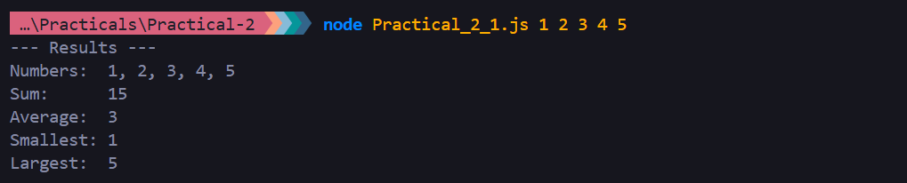

2: Create To-Do List App in Node.js using readline package that allows adding tasks one by one and viewing all tasks.
Code:
const readline = require('readline');

const rl = readline.createInterface({
input: process.stdin,
output: process.stdout,
});
const tasks = [];
function showMenu() {
console.log('\n--- TO-DO LIST MENU ---');
console.log('1. View All Tasks');
console.log('2. Add a Task');
console.log('3. Exit');

rl.question('\nChoose an option (1-3): ', handleMenuInput);
}
function handleMenuInput(choice) {
switch (choice.trim()) {
case '1':
viewTasks();
showMenu();
break;
case '2':
addTaskPrompt();
break;
case '3':
console.log('\nGoodbye! Have a productive day!');
rl.close();
break;
default:
console.log('\n❌ Invalid choice! Please enter 1, 2, or 3.');
showMenu();
break;
}
}
function viewTasks() {
console.log('\n=== YOUR TASKS ===');
if (tasks.length === 0) {
console.log('(No tasks added yet. Your list is clean!)');
} else {
tasks.forEach((task, index) => {
console.log(`${index + 1}. [ ] ${task}`);
});
}
}
function addTaskPrompt() {
rl.question('\nEnter the task description: ', (task) => {
const cleanedTask = task.trim();

if (cleanedTask === '') {
console.log('❌ Task cannot be empty!');
} else {
tasks.push(cleanedTask);
console.log(`✅ Success: "${cleanedTask}" has been added!`);
}

showMenu(); // Return to the main menu
});
}

showMenu();

Output:

