Practical - 3

Aim: Utilize core (http, fs, url, util, path, os, events) and local modules to demonstrate their output
1: Create an HTTP server using core modules that responds with different messages based on URL
paths:
- Respond with “Home Page” for /
- Respond with a formatted HTML table for /exam
- Respond with a 404 message for any other path.
Code:
const http = require('http');

const server = http.createServer((req, res) => {
if (req.url === '/') {
res.writeHead(200, { 'Content-Type': 'text/plain' });
res.end('Home Page');
} else if (req.url === '/exam') {
res.writeHead(200, { 'Content-Type': 'text/html' });

res.end(`
<!DOCTYPE html>
<html>
<head>
<title>Exam Details</title>
<style>
table {
border-collapse: collapse;
width: 60%;
}
th, td {
border: 1px solid black;
padding: 10px;
text-align: center;
}
th {
background-color: #f2f2f2;
}
</style>
</head>
<body>
<h1>Exam Schedule</h1>

<table>
<tr>
<th>Subject</th>
<th>Date</th>
<th>Time</th>
</tr>
<tr>
<td>Computer Networks</td>
<td>20 September 2026</td>
<td>10:00 AM</td>
</tr>
<tr>
<td>Machine Learning</td>
<td>22 September 2026</td>
<td>10:00 AM</td>
</tr>
<tr>
<td>Advanced Java</td>
<td>24 September 2026</td>
<td>10:00 AM</td>
</tr>
</table>
</body>
</html>
`);
} else {
res.writeHead(404, { 'Content-Type': 'text/plain' });
res.end('404 - Page Not Found');
}
});

server.listen(3000, () => {
console.log('Server running at http://localhost:3000');
});

Output:

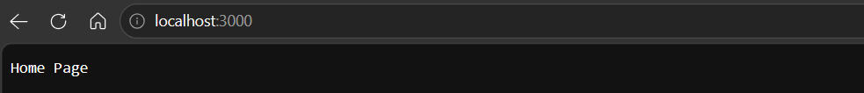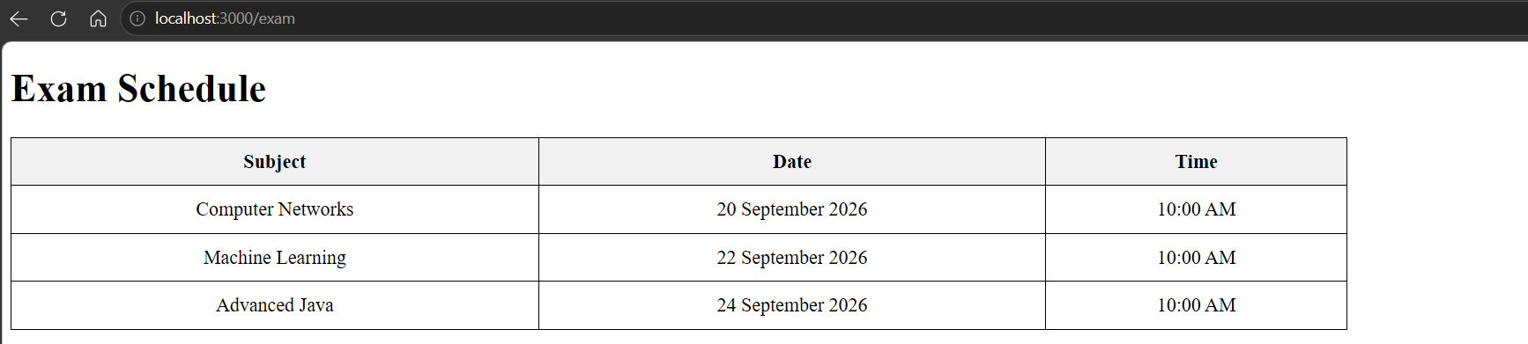
2: Build a Node.js HTTP server that takes a string via URL parameters and returns the reversed string:
- Example: /reverse?text=hello returns “olleh”
Code:
const http = require('http');
const { URL } = require('url');
const server = http.createServer((req, res) => {
const url = new URL(req.url, `http://${req.headers.host}`);
if (url.pathname === '/reverse') {
const text = url.searchParams.get('text');
if (text === null) {
res.writeHead(400, { 'Content-Type': 'text/plain' });
res.end('Please provide a text parameter.');
return;
}
const reversed = text.split('').reverse().join('');
res.writeHead(200, { 'Content-Type': 'text/plain' });
res.end(reversed);
} else {
res.writeHead(404, { 'Content-Type': 'text/plain' });
res.end('404 - Page Not Found');
}
});
server.listen(3000, () => {
console.log('Server running at http://localhost:3000');
});
Output:

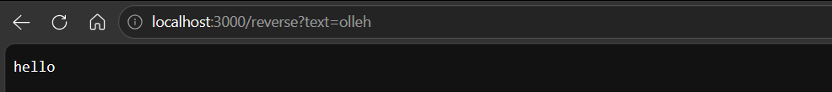

3: Create a module “TextProcessing” contain functions named countWords, countLines, countCharacters that takes a string as input from ‘file1.txt’ file and returns the total number of words, lines and characters in the console.
Code TextProcessing.js:
function countWords(text) {
return text.trim().split(/\s+/).length;
}

function countLines(text) {
return text.split(/\r?\n/).length;
}

function countCharacters(text) {
return text.length;
}

module.exports = {
countWords,
countLines,
countCharacters,
};

Code file1.txt:
Hello World
This is Node.js
Text Processing Module

Code:
const fs = require('fs');
const TextProcessing = require('./TextProcessing');
const text = fs.readFileSync('file1.txt', 'utf8');
console.log('Total Words:', TextProcessing.countWords(text));
console.log('Total Lines:', TextProcessing.countLines(text));
console.log('Total Characters:', TextProcessing.countCharacters(text));

Output:
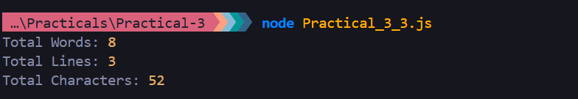

4: Demonstrate synchronous and asynchronous file operations with an example.
Code:
const fs = require('fs');

// Synchronous Operation
console.log('Synchronous File Read:');
const syncData = fs.readFileSync('file1.txt', 'utf8');
console.log(syncData);
console.log('Synchronous operation completed.');

// Asynchronous Operation
console.log('\nAsynchronous File Read:');
fs.readFile('file1.txt', 'utf8', (err, data) => {
if (err) {
console.log('Error:', err);
return;
}
console.log(data);
console.log('Asynchronous operation completed.');
});
console.log('This line executes before the asynchronous file read completes.');
Output:
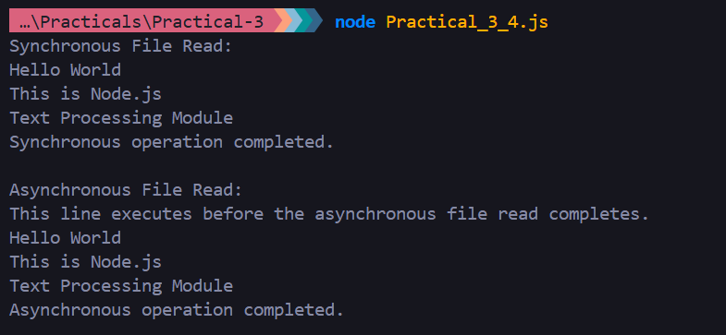
5: Create a file named file_info.txt and write some content in it. Implement a function that reads the content of file_info.txt using the fs module and create log file to maintain information about File name, File size (bytes), File creation date and time, File modification date and time.
Code:
const fs = require('fs');
fs.writeFileSync(
'file_info.txt',
'This is a sample file created using Node.js fs module.',
);
function getFileInfo() {
const content = fs.readFileSync('file_info.txt', 'utf8');
console.log('File Content:');
console.log(content);
const stats = fs.statSync('file_info.txt');
const log = `
File Name: file_info.txt
File Size: ${stats.size} bytes
File Creation Date and Time: ${stats.birthtime}
File Modification Date and Time: ${stats.mtime}
`;
fs.writeFileSync('file_info.log', log);
console.log('\nFile information saved in file_info.log');
}
getFileInfo();
Output:
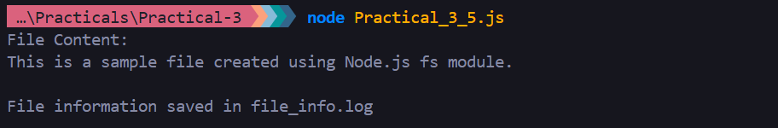
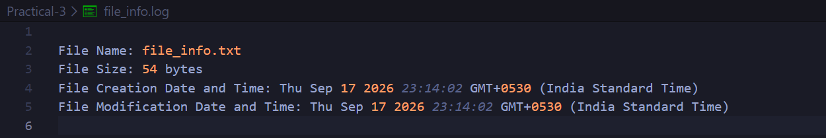
6: Check the output of following code:
Code A:
const path = require('path');
function checkPathType(filePath) {
if (path.isAbsolute(filePath)) {
console.log(`"${filePath}" is an absolute path.`);
} else {
console.log(`"${filePath}" is a relative path.`);
}}
// Example
checkPathType('/usr/local/bin');
checkPathType('data/info.txt');
checkPathType('C:\\Users\\Admin');
Output A:
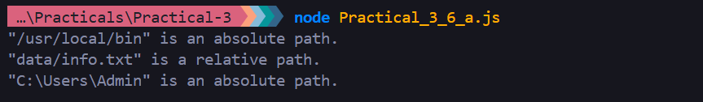
Code B:
const os = require('os');
function displayMemoryInfo() {
const freeMem = os.freemem();
const totalMem = os.totalmem();
console.log('Total Memory:', (totalMem / 1024 ** 3).toFixed(2), 'GB');
console.log('Free Memory:', (freeMem / 1024 ** 3).toFixed(2), 'GB');
}
// Example usage
displayMemoryInfo();
Output B:

7: Do as directed:
- Register a listener with customize event.
- Create multiple listeners with specific event.
- Remove a specific listener.
- Remove all listeners.
- How to get maximum size of listener will bind with specific event?
- How to change maximum size of listeners to bind with specific event?
- Find out name of active listeners for the specified event.
- Find out number of listeners listening to the specified event.
- How to change execution position of listeners?
Code:
const EventEmitter = require('events');
const eventEmitter = new EventEmitter();

// a. Register a listener with custom event
function welcomeListener() {
console.log('Welcome to Node.js!');
}
eventEmitter.on('welcome', welcomeListener);
console.log('a. Custom event:');
eventEmitter.emit('welcome');

// b. Create multiple listeners for a specific event
function listener1() {
console.log('Listener 1 executed');
}
function listener2() {
console.log('Listener 2 executed');
}
function listener3() {
console.log('Listener 3 executed');
}

eventEmitter.on('message', listener1);
eventEmitter.on('message', listener2);
eventEmitter.on('message', listener3);

console.log('\nb. Multiple listeners:');
eventEmitter.emit('message');

// c. Remove a specific listener
eventEmitter.removeListener('message', listener2);
console.log('\nc. After removing Listener 2:');
eventEmitter.emit('message');

// d. Remove all listeners
eventEmitter.removeAllListeners('message');

console.log('\nd. After removing all message listeners:');
console.log('Number of listeners:', eventEmitter.listenerCount('message'));

// e. Get maximum number of listeners
console.log('\ne. Maximum listeners allowed:');
console.log(eventEmitter.getMaxListeners());

// f. Change maximum number of listeners
eventEmitter.setMaxListeners(20);

console.log('\nf. New maximum listeners:');
console.log(eventEmitter.getMaxListeners());

// g. Find names of active listeners
eventEmitter.on('login', function userLogin() {
console.log('User logged in');
});
eventEmitter.on('login', function adminLogin() {
console.log('Admin logged in');
});
console.log('\ng. Active listener names:');
const listeners = eventEmitter.listeners('login');
listeners.forEach((listener) => {
console.log(listener.name);
});

// h. Find number of listeners for an event
console.log('\nh. Number of login listeners:');
console.log(eventEmitter.listenerCount('login'));

// i. Change execution position of listeners

function firstListener() {
console.log('First listener');
}
function secondListener() {
console.log('Second listener');
}
eventEmitter.on('order', firstListener);
eventEmitter.on('order', secondListener);

// Move firstListener to the beginning
eventEmitter.prependListener('order', firstListener);

console.log('\ni. Listener execution order:');
eventEmitter.emit('order');
Output:
