Practical - 4

Aim: Utilize core (http, fs, url, util, path, os, events) and local modules to demonstrate their output
1: Write a node.js code to establish connection with MySQL and create database “Node_test”.
Code:
const mysql = require('mysql2');

// Connect to MySQL
const con = mysql.createConnection({
host: 'localhost',
user: 'vatsal',
password: 'vatsal',
});

con.connect((err) => {
if (err) throw err;

console.log('Connected to MySQL!');

// Create database
con.query('CREATE DATABASE IF NOT EXISTS Node_test', (err) => {
if (err) throw err;

console.log("Database 'Node_test' created successfully.");
con.end();
});
});

Output:

2: Write a node.js code to create a table ‘Product’ with Id, Name, Brand, Quantity and Price as fields.
Code:
const mysql = require('mysql2');

const con = mysql.createConnection({
host: 'localhost',
user: 'vatsal',
password: 'vatsal',
database: 'Node_test',
});

con.connect((err) => {
if (err) throw err;

console.log('Connected to Node_test database!');
const sql = `
CREATE TABLE IF NOT EXISTS Product (
Id INT AUTO_INCREMENT PRIMARY KEY,
Name VARCHAR(100),
Brand VARCHAR(100),
Quantity INT,
Price DECIMAL(10,2)
)
`;
con.query(sql, (err) => {
if (err) throw err;
console.log('Product table created successfully.');
con.end();
});
});

Output:

3: Write a node.js program that takes product information like Name, Brand, Quantity and Price from the user using HTML form and stores it into the Product table as mentioned below:
Product
Id | Name | Brand | Quantity | Price
1 | Soap | Dettol | 3 | 20
2 | Shampoo | Loreal | 5 | 100
3 | Toothpaste | Colgate | 2 | 50
4 | Sanitizer | LifeBoy | 2 | 60

Code:
const http = require('http');
const mysql = require('mysql2');
const { URL } = require('url');

const con = mysql.createConnection({
host: 'localhost',
user: 'vatsal',
password: 'vatsal',
database: 'Node_test',
});

const server = http.createServer((req, res) => {
const url = new URL(req.url, `http://${req.headers.host}`);

// Display form
if (url.pathname === '/') {
res.writeHead(200, { 'Content-Type': 'text/html' });

res.end(`
<h1>Add Product</h1>
<form action="/add" method="GET">
Name:
<input type="text" name="name" required>
<br><br>
Brand:
<input type="text" name="brand" required>
<br><br>
Quantity:
<input type="number" name="quantity" required>
<br><br>
Price:
<input type="number" name="price" required>
<br><br>
<button type="submit">Add Product</button>
</form>
`);
}

// Insert product
else if (url.pathname === '/add') {
const name = url.searchParams.get('name');
const brand = url.searchParams.get('brand');
const quantity = url.searchParams.get('quantity');
const price = url.searchParams.get('price');

const sql = `
INSERT INTO Product (Name, Brand, Quantity, Price)
VALUES (?, ?, ?, ?)
`;

con.query(sql, [name, brand, quantity, price], (err) => {
if (err) {
res.writeHead(500);
res.end('Database Error');
return;
}
res.writeHead(200, {
'Content-Type': 'text/html',
});
res.end(`
<h2>Product added successfully!</h2>
<a href="/">Add another product</a>
`);
});
}
});

server.listen(3000, () => {
console.log('Server running at http://localhost:3000');
});

Output:
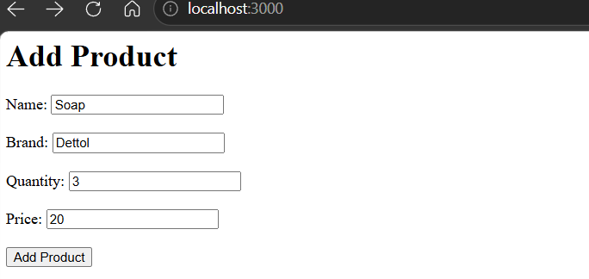
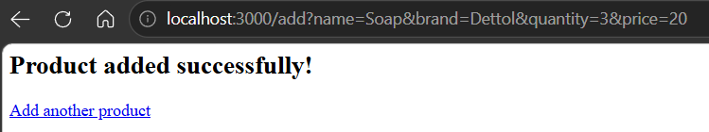

4: Write a node.js program to retrieve all the details of the product and display in browser.
Code:
const http = require('http');
const mysql = require('mysql2');

const con = mysql.createConnection({
host: 'localhost',
user: 'vatsal',
password: 'vatsal',
database: 'Node_test',
});
const server = http.createServer((req, res) => {
if (req.url === '/products') {
const sql = 'SELECT * FROM Product';
con.query(sql, (err, result) => {
if (err) {
res.writeHead(500);
res.end('Database Error');
return;
}
let html = `
<html>
<head>
<title>Products</title>
<style>
table {
border-collapse: collapse;
width: 70%;
}
th, td {
border: 1px solid black;
padding: 10px;
text-align: center;
}
th {
background-color: lightgray;
}
</style>
</head>
<body>
<h1>Product Details</h1>
<table>
<tr>
<th>Id</th>
<th>Name</th>
<th>Brand</th>
<th>Quantity</th>
<th>Price</th>
</tr>
`;

result.forEach((product) => {
html += `
<tr>
<td>${product.Id}</td>
<td>${product.Name}</td>
<td>${product.Brand}</td>
<td>${product.Quantity}</td>
<td>${product.Price}</td>
</tr>
`;
});
html += `
</table>
</body>
</html>
`;
res.writeHead(200, {
'Content-Type': 'text/html',
});
res.end(html);
});
} else {
res.writeHead(404);
res.end('404 - Page Not Found');
}
});

server.listen(3000, () => {
console.log('Server running at http://localhost:3000/products');
});
Output:
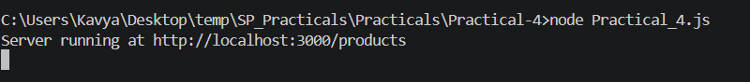
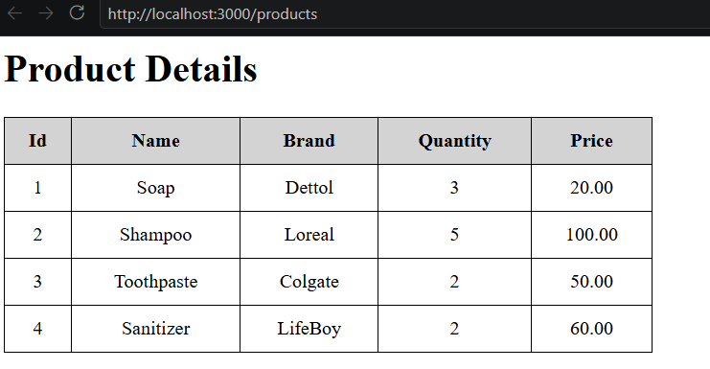

5: Write a node.js program to search any product by Name or Brand.
Code:
const http = require('http');
const mysql = require('mysql2');
const { URL } = require('url');

const con = mysql.createConnection({
host: 'localhost',
user: 'vatsal',
password: 'vatsal',
database: 'Node_test',
});
const server = http.createServer((req, res) => {
const url = new URL(req.url, `http://${req.headers.host}`);
if (url.pathname === '/') {
res.writeHead(200, {
'Content-Type': 'text/html',
});
res.end(`
<h1>Search Product</h1>
<form action="/search" method="GET">
Enter Name or Brand:
<input type="text" name="value" required>
<button type="submit">Search</button>
</form>
`);
} else if (url.pathname === '/search') {
const value = url.searchParams.get('value');
const sql = `
SELECT * FROM Product
WHERE Name LIKE ? OR Brand LIKE ?
`;
const searchValue = `%${value}%`;
con.query(sql, [searchValue, searchValue], (err, result) => {
if (err) {
res.writeHead(500);
res.end('Database Error');
return;
}
let html = `
<h1>Search Results</h1>
<table border="1" cellpadding="10">
<tr>
<th>Id</th>
<th>Name</th>
<th>Brand</th>
<th>Quantity</th>
<th>Price</th>
</tr>
`;
result.forEach((product) => {
html += `
<tr>
<td>${product.Id}</td>
<td>${product.Name}</td>
<td>${product.Brand}</td>
<td>${product.Quantity}</td>
<td>${product.Price}</td>
</tr>
`;
});
html += '</table>';
res.writeHead(200, {
'Content-Type': 'text/html',
});
res.end(html);
});
} else {
res.writeHead(404);
res.end('404 - Page Not Found');
}
});
server.listen(3000, () => {
console.log('Server running at http://localhost:3000');
});

Output:
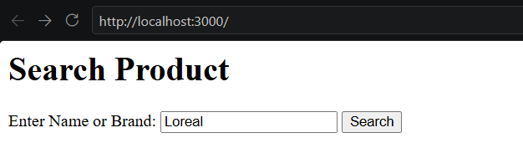
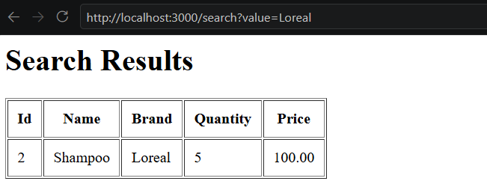
6: Write a node.js program to retrieve all the products whose quantity is less than 3.
Code A:
const http = require('http');
const mysql = require('mysql2');

const con = mysql.createConnection({
host: 'localhost',
user: 'vatsal',
password: 'vatsal',
database: 'Node_test',
});
const server = http.createServer((req, res) => {
if (req.url === '/products') {
const sql = 'SELECT * FROM Product WHERE Quantity < 3';
con.query(sql, (err, result) => {
if (err) {
res.writeHead(500);
res.end('Database Error');
return;
}
let html = `
<h1>Products With Quantity Less Than 3</h1>
<table border="1" cellpadding="10">
<tr>
<th>Id</th>
<th>Name</th>
<th>Brand</th>
<th>Quantity</th>
<th>Price</th>
</tr>
`;
result.forEach((product) => {
html += `
<tr>
<td>${product.Id}</td>
<td>${product.Name}</td>
<td>${product.Brand}</td>
<td>${product.Quantity}</td>
<td>${product.Price}</td>
</tr>
`;
});
html += '</table>';
res.writeHead(200, {
'Content-Type': 'text/html',
});
res.end(html);
});
} else {
res.writeHead(404);
res.end('404 - Page Not Found');
}
});

server.listen(3000, () => {
console.log('Server running at http://localhost:3000/products');
});
Output A:
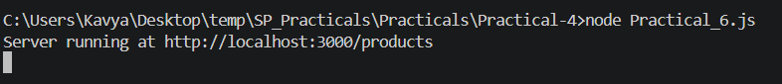
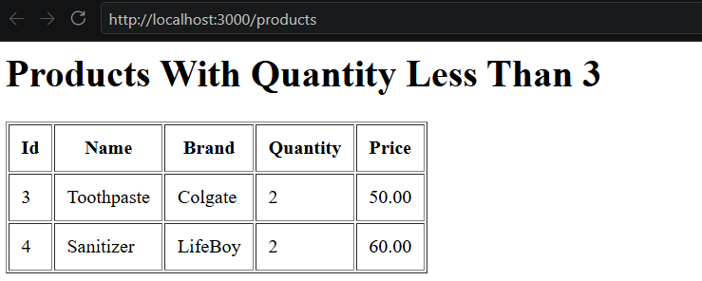

7: Write a node.js program to update price of a specific item in the product table.
Code:
const http = require('http');
const mysql = require('mysql2');
const { URL } = require('url');

const con = mysql.createConnection({
host: 'localhost',
user: 'vatsal',
password: 'vatsal',
database: 'Node_test',
});
const server = http.createServer((req, res) => {
const url = new URL(req.url, `http://${req.headers.host}`);
// Display form
if (url.pathname === '/') {
res.writeHead(200, {
'Content-Type': 'text/html',
});
res.end(`
<h1>Update Product Price</h1
<form action="/update" method="GET">
Product ID:
<input type="number" name="id" required>
<br><br>
New Price:
<input type="number" name="price" required>
<br><br>
<button type="submit">Update Price</button>
</form>
`);
}
// Update price
else if (url.pathname === '/update') {
const id = url.searchParams.get('id');
const price = url.searchParams.get('price');

const sql = `
UPDATE Product
SET Price = ?
WHERE Id = ?
`
con.query(sql, [price, id], (err, result) => {
if (err) {
res.writeHead(500);
res.end('Database Error');
return;
}
res.writeHead(200, {
'Content-Type': 'text/html',
});
res.end(`
<h2>Product price updated successfully.</h2>
<p>Product ID: ${id}</p>
<p>New Price: ${price}</p>

<a href="/">Go Back</a>
`);
});
} else {
res.writeHead(404);
res.end('404 - Page Not Found');
}
});

server.listen(3000, () => {
console.log('Server running at http://localhost:3000');
});
Output:
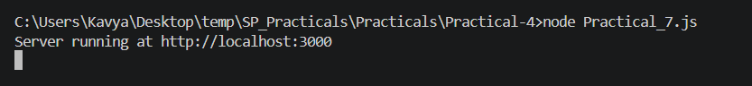
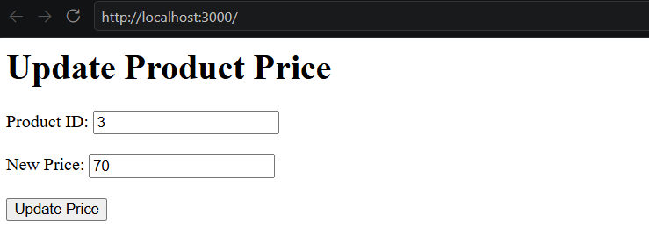
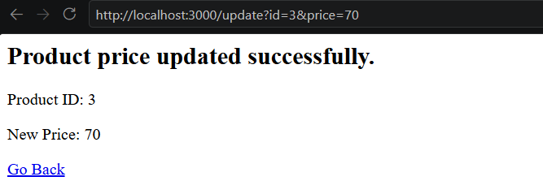

8: Write a node.js program to delete specific product from the product table.
Code:
const http = require('http');
const mysql = require('mysql2');
const { URL } = require('url');

const con = mysql.createConnection({
host: 'localhost',
user: 'vatsal',
password: 'vatsal',
database: 'Node_test',
});

const server = http.createServer((req, res) => {
const url = new URL(req.url, `http://${req.headers.host}`);

// Display form
if (url.pathname === '/') {
res.writeHead(200, {
'Content-Type': 'text/html',
});

res.end(`
<h1>Delete Product</h1>

<form action="/delete" method="GET">

Product ID:
<input type="number" name="id" required>

<button type="submit">Delete</button>

</form>
`);
}

// Delete product
else if (url.pathname === '/delete') {
const id = url.searchParams.get('id');

const sql = 'DELETE FROM Product WHERE Id = ?';
con.query(sql, [id], (err, result) => {
if (err) {
res.writeHead(500);
res.end('Database Error');
return;
}
res.writeHead(200, {
'Content-Type': 'text/html',
});
res.end(`
<h2>Product deleted successfully.</h2>

<p>Deleted Product ID: ${id}</p>

<a href="/">Go Back</a>
`);
});
} else {
res.writeHead(404);
res.end('404 - Page Not Found');
}
});

server.listen(3000, () => {
console.log('Server running at http://localhost:3000');
});

Output:
