Practical - 6

Aim: Make environment setup for React.js application. Create single page application using React.js.

1: Make environment setup for react application.
Command:
npm create vite@latest . -- --template react

Output:
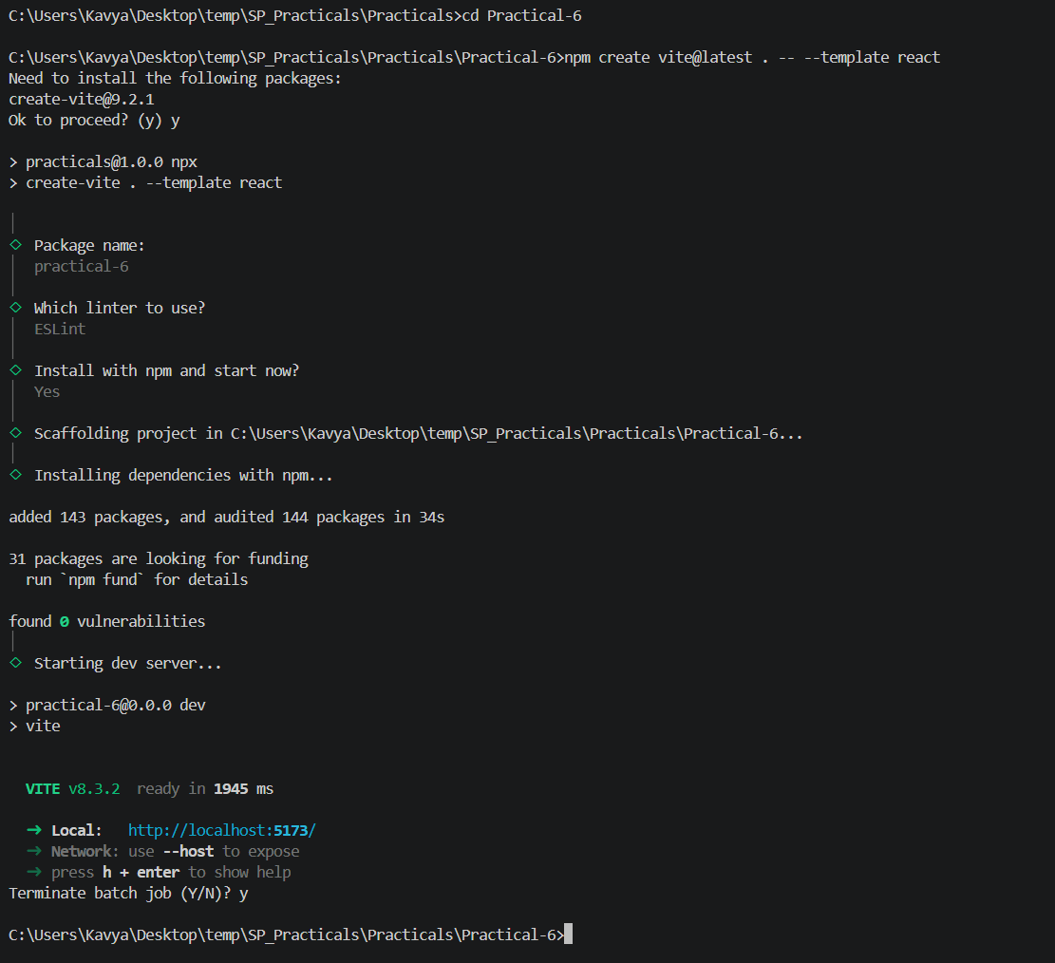

2: Create single page application using react.js that show Profile Page with Dynamic Data.
- Add website title and profile picture (logo)
- Create a navigation bar (horizontal or vertical)
- Display user details (name, age, profession, bio)
Code App.jsx:
import "./App.css";

const user = {
name: "Vatsal Patel",
age: 22,
profession: "Computer Engineering Student",
bio: "I am a passionate developer interested in web development, AI, and software engineering.",
profilePic: "https://media.licdn.com/dms/image/v2/D4D03AQEevuK8ZxyC5w/profile-displayphoto-shrink_400_400/B4DZY7GVttHIAg-/0/1744748240353?e=1792627200&v=beta&t=H1WAqpo_EnrHC5iOdDuGgMoyjj0YPuNC0hlizsGUOIA"
};

function App() {
return (
<div className="app">
{/* Website Title */}
<header>
<h1>My Profile</h1>
</header>

{/* Navigation Bar */}
<nav>
<a href="#home">Home</a>
<a href="#profile">Profile</a>
<a href="#about">About</a>
<a href="#contact">Contact</a>
</nav>

{/* Profile Section */}
<main id="profile">
<div className="profile-card">
<img
src={user.profilePic}
alt="Profile"
className="profile-picture"
/>

<h2>{user.name}</h2>
<p><strong>Age:</strong> {user.age}</p>
<p><strong>Profession:</strong> {user.profession}</p>

<p className="bio">
<strong>Bio:</strong> {user.bio}
</p>
</div>
</main>
</div>
);
}

export default App;

Code App.css:
* {
box-sizing: border-box;
margin: 0;
padding: 0;
}

body {
font-family: Arial, sans-serif;
background-color: #f2f2f2;
}

header {
background-color: #2563eb;
color: white;
text-align: center;
padding: 20px;
}

nav {
background-color: #222;
display: flex;
justify-content: center;
gap: 30px;
padding: 15px;
}

nav a {
color: white;
text-decoration: none;
font-size: 16px;
}

nav a:hover {
color: #60a5fa;
}

main {
display: flex;
justify-content: center;
padding: 50px 20px;
}

.profile-card {
background: white;
width: 400px;
padding: 30px;
text-align: center;
border-radius: 12px;
box-shadow: 0 4px 15px rgba(0, 0, 0, 0.15);
}

.profile-picture {
width: 150px;
height: 150px;
border-radius: 50%;
object-fit: cover;
margin-bottom: 20px;
}

.profile-card h2 {
margin-bottom: 15px;
color: #2563eb;
}

.profile-card p {
margin: 10px 0;
color: #444;
}

.bio {
line-height: 1.6;
}

Output:

