词法分析器
完整的程序
先是NFA到DFA：
public class Edge {
private String from;
private String change;
private String to;

public Edge(String from, String change, String to) {
super();
this.from = from;
this.change = change;
this.to = to;
}

@Override
public boolean equals(Object obj) {
if (this == obj)
return true;
if (obj == null)
return false;
if (getClass() != obj.getClass())
return false;
Edge other = (Edge) obj;
if (change == null) {
if (other.change != null)
return false;
} else if (!change.equals(other.change))
return false;
if (from == null) {
if (other.from != null)
return false;
} else if (!from.equals(other.from))
return false;
if (to == null) {
if (other.to != null)
return false;
} else if (!to.equals(other.to))
return false;
return true;
}

@Override
public String toString() {
return "(Edge)[" + from + "," + change + "," + to + "]";
}

public String getFrom() {
return from;
}

public void setFrom(String from) {
this.from = from;
}

public String getChange() {
return change;
}

public void setChange(String change) {
this.change = change;
}

public String getTo() {
return to;
}

public void setTo(String to) {
this.to = to;
}

}
import java.util.ArrayList;
import java.util.Collection;
import java.util.HashSet;
import java.util.Scanner;

public class Nfa2Dfa {

public Nfa2Dfa() {
// TODO Auto-generated constructor stub
// 构造函数输入边的属性
changes = new ArrayList<String>();
edges = new ArrayList<Edge>();
EdgesWithSet = new ArrayList<Edge_Set>();
dfaSets = new ArrayList<HashSet<String>>();

System.out.println("输入NFA(node~change~final,输入回车结束,eps代表epsilon)：");
Scanner scanner = new Scanner(System.in);
while (true) {
String[] strs = scanner.nextLine().split("~");// 输入
if (strs[0] == "-1" || strs.length < 3)// 防止错误
return;
String node = strs[0], change = strs[1], arrive = strs[2];// 分离出来的全部原始信息
for (String t : change.split(","))
insertOrContains(changes, t);// 增加中间信息
changes.remove("eps");// 去掉epsilon
/* 增加边信息 */
for (String nodeTemp : node.split(",")) {
for (String changeTemp : change.split(",")) {
for (String arriveTemp : arrive.split(","))
insertOrContains(edges, new Edge(nodeTemp, changeTemp,
arriveTemp));
}
}
}
}

public static <T> boolean insertOrContains(Collection<T> collection,
T element) {
if (collection.contains(element)) {
return false;
} else {
collection.add(element);
return true;
}
}

private HashSet<String> getFitstElement() {
HashSet<String> firstSet = new HashSet<String>();
firstSet.add(edges.get(0).getFrom());
return firstSet;

}

private HashSet<String> epsilon(HashSet<String> old_Set) {
HashSet<String> oldSet = (HashSet<String>) old_Set.clone();
HashSet<String> newSet = (HashSet<String>) old_Set.clone();
boolean existNewSet = false;
do {
existNewSet = false;
for (Edge edge : edges) { // 遍历一遍
if (edge.getChange().equals("eps")) {
for (String fromWhere : oldSet) {
if (edge.getFrom().equals(fromWhere)) {
newSet.add(edge.getTo());
if (!newSet.equals(oldSet)) {
existNewSet = true;
}
}
}
}
}
oldSet = newSet;
} while (existNewSet);
return newSet;
}

private HashSet<String> move(HashSet<String> old_Set, String change) {
HashSet<String> newSet = new HashSet<String>();
for (String element : old_Set) {
for (Edge edge : edges) {
// System.out.println("Rule:" + edge.getFrom() +
// edge.getChange()
// + edge.getTo());
if (edge.getFrom().equals(element)) {
// System.out.println("Element:" + element + change);
if (edge.getChange().equals(change)) {
newSet.add(edge.getTo());
// System.out.println(newSet);
}
}
}
}
return newSet;
}

public void nfa2Dfa() {
HashSet<String> hashset, newSet;
// 得到初态
hashset = getFitstElement();
hashset = epsilon(hashset);
dfaSets.add(hashset);// 加入首元素
// 开始循环
int i = 0;
try {
while (true) {
hashset = dfaSets.get(i++);
for (String cha : changes) { // 每次遍历即生成一行 原集合-Ia-Ib
newSet = this.move(hashset, cha);
newSet = this.epsilon(newSet);
if (!newSet.equals(hashset) && !newSet.isEmpty()) {
insertOrContains(dfaSets, newSet);
EdgesWithSet.add(new Edge_Set(hashset, cha, newSet));
// System.out.println(dfaSets);
}
}
}
} catch (java.lang.IndexOutOfBoundsException e) {
// System.out.println(e);
}
}

public ArrayList<Edge_Set> getNewEdges() {
return EdgesWithSet;
}

public ArrayList<HashSet<String>> getDfaSets() {
return dfaSets;
}

public static void main(String[] args) {
Nfa2Dfa x = new Nfa2Dfa();
x.nfa2Dfa();
System.out.println(x.getDfaSets());
return;
}

private ArrayList<String> changes;
private ArrayList<Edge> edges;
private ArrayList<Edge_Set> EdgesWithSet;
private ArrayList<HashSet<String>> dfaSets;
}
其运行截图是：
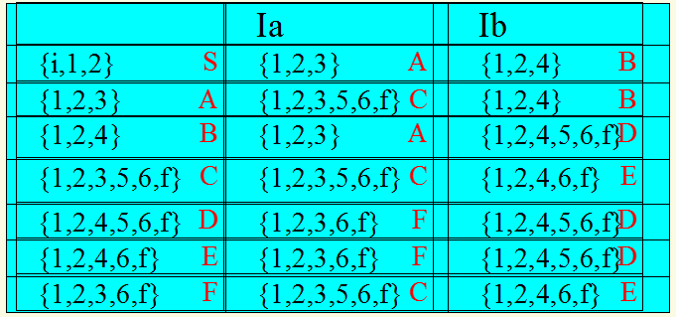i~eps~1
1~eps~2
5~eps~6
6~eps~f
1~a,b~1
2~a~3
3~a~5
2~b~4
4~b~5
6~a,b~6
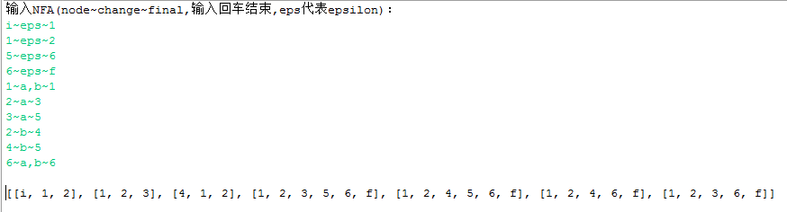
DFA的化简代码是：
import java.util.HashSet;

public class Edge_Set {

private HashSet<String> from;
private String change;
private HashSet<String> to;

public Edge_Set(HashSet<String> from, String change, HashSet<String> to) {
super();
this.from = from;
this.change = change;
this.to = to;
}

@Override
public boolean equals(Object obj) {
if (this == obj)
return true;
if (obj == null)
return false;
if (getClass() != obj.getClass())
return false;
Edge_Set other = (Edge_Set) obj;
if (change == null) {
if (other.change != null)
return false;
} else if (!change.equals(other.change))
return false;
if (from == null) {
if (other.from != null)
return false;
} else if (!from.equals(other.from))
return false;
if (to == null) {
if (other.to != null)
return false;
} else if (!to.equals(other.to))
return false;
return true;
}

@Override
public String toString() {
return "(Edge_Set)[" + from + "," + change + "," + to + "]";
}

public HashSet<String> getFrom() {
return from;
}

public String getChange() {
return change;
}

public HashSet<String> getTo() {
return to;
}

public void setFrom(HashSet<String> from) {
this.from = from;
}

public void setChange(String change) {
this.change = change;
}

public void setTo(HashSet<String> to) {
this.to = to;
}

}
import java.util.ArrayList;
import java.util.HashSet;
import java.util.Iterator;
import java.util.Scanner;

class DfaSimplifyInitiateException extends Exception {
public DfaSimplifyInitiateException() {
// TODO Auto-generated constructor stub
super("DfaSimplify类初始化错误。请检查参数的正确性！");
}
}

public class DfaSimplify {

DfaSimplify() {
nonFinalSet = new HashSet<String>();
finalSet = new HashSet<String>();
edges = new ArrayList<Edge>();
changes = new ArrayList<String>();
allSets = new HashSet<HashSet<String>>();

System.out.println("输入非终态(逗号隔开)：");
Scanner scanner = new Scanner(System.in);
for (String str : scanner.nextLine().split(",")) {
nonFinalSet.add(str);
}

System.out.println("输入终态(逗号隔开)：");
for (String str : scanner.nextLine().split(",")) {
finalSet.add(str);
}

System.out.println("输入DFA(node~change~final,输入回车结束)：");

while (true) {
String[] strs = scanner.nextLine().split("~");// 输入
if (strs[0] == "-1" || strs.length < 3)// 防止错误
return;
String node = strs[0], change = strs[1], arrive = strs[2];// 分离出来的全部原始信息
for (String t : change.split(","))
Nfa2Dfa.insertOrContains(changes, t);// 增加中间信息
/* 增加边信息 */
for (String nodeTemp : node.split(",")) {
for (String changeTemp : change.split(",")) {
for (String arriveTemp : arrive.split(","))
Nfa2Dfa.insertOrContains(edges, new Edge(nodeTemp,
changeTemp, arriveTemp));
}
}
}
}

/**
* 输入非终态字符串组，终态字符串组，所有Edge类型边的信息
*
* @param nonFinalState
* @param finalState
* @param edges
* @throws Initiate
* Exception
*/
public DfaSimplify(String[] nonFinalState, String[] finalState,
ArrayList<Edge> edgesInformation)
throws DfaSimplifyInitiateException {
if (nonFinalState == null || finalState == null
|| edgesInformation.isEmpty()) {
throw new DfaSimplifyInitiateException();
}
nonFinalSet = new HashSet<String>();
finalSet = new HashSet<String>();
edges = (ArrayList<Edge>) edgesInformation.clone();
changes = new ArrayList<String>();
allSets = new HashSet<HashSet<String>>();

for (String nonFinalSetElement : nonFinalState) {
Nfa2Dfa.insertOrContains(nonFinalSet, nonFinalSetElement);
}
for (String finalSetElement : finalState) {
Nfa2Dfa.insertOrContains(finalSet, finalSetElement);
}
for (Edge edge : edgesInformation) {
Nfa2Dfa.insertOrContains(changes, edge.getChange());
}
}

private void putStartAndEnd() {
allSets.add(nonFinalSet);
allSets.add(finalSet);
}

/**
* 将分离的元素进行分组
*/
private ArrayList<HashSet<String>> divideSetToChips(
HashSet<String> divideSet, HashSet<String> thisSet) {
ArrayList<HashSet<String>> dividedSets = new ArrayList<HashSet<String>>(); // 结果集合链表

for (HashSet<String> oneOfAllSets : allSets) {
if (oneOfAllSets.containsAll(thisSet)) // 如果遍历的是此集合
continue;
HashSet<String> tempSet = new HashSet<String>();
for (String element : divideSet) {
for (Edge edge : edges) {
String to = null;
if (edge.getFrom().equals(element))
to = edge.getTo();
if (oneOfAllSets.contains(to)) {
tempSet.add(element);
}
}
}
if (!tempSet.isEmpty())
dividedSets.add(tempSet);
}
return dividedSets;
}

public void dfaSimplify() {
int length = 0;
do {
length = allSets.size();
HashSet<String> getOutSet = new HashSet<String>();
HashSet<HashSet<String>> newAllSets = new HashSet<HashSet<String>>();

this.putStartAndEnd();
for (String change : changes) {
for (HashSet<String> thisSet : allSets) { // 得到每一个现存集合
HashSet<String> oneOfAllSet = (HashSet<String>) thisSet
.clone(); // 因为removeAll操作会改变原有allSets，所以需要clone一个副本
for (String element : oneOfAllSet) { // 得到集合里每一个元素
for (Edge edge : edges) { // 拿每一条边和元素进行规则对照
if (edge.getFrom().equals(element)
&& edge.getChange().equals(change)) { // 找到元素对应的规则
if (!oneOfAllSet.contains(edge.getTo())) { // 如果能推到其他集合
getOutSet.add(element);
}
}
}
}
if (oneOfAllSet.size() > 1)
if (oneOfAllSet.equals(getOutSet))
Nfa2Dfa.insertOrContains(newAllSets, oneOfAllSet);
else
oneOfAllSet.removeAll(getOutSet);
if (oneOfAllSet.isEmpty()) {
getOutSet.clear();
continue;
}
Nfa2Dfa.insertOrContains(newAllSets,
(HashSet<String>) oneOfAllSet.clone());
// System.out.println(newAllSets);
ArrayList<HashSet<String>> getOutSetsGoBack = divideSetToChips(
getOutSet, oneOfAllSet);
if (!getOutSetsGoBack.isEmpty())
for (HashSet<String> hash : getOutSetsGoBack)
Nfa2Dfa.insertOrContains(newAllSets,
(HashSet<String>) hash.clone());
getOutSet.clear();
}
}
allSets = newAllSets;
// System.out.println(allSets);

} while (allSets.size() != length);
}

/* 修复了存在赘余集合的bug */
private void removeExtraSets() {
HashSet<HashSet<String>> removeSets = new HashSet<HashSet<String>>();
for (HashSet<String> fatherHash : allSets) {
for (HashSet<String> hash : allSets) {
if (!fatherHash.equals(hash) && fatherHash.containsAll(hash))
removeSets.add(fatherHash);
}
}
allSets.removeAll(removeSets);
}

public HashSet<HashSet<String>> getAllSets() {
removeExtraSets();
return allSets;
}

public void setNonFinalSet(HashSet<String> nonFinalSet) {
this.nonFinalSet = nonFinalSet;
}

public void setFinalSet(HashSet<String> finalSet) {
this.finalSet = finalSet;
}

public static void main(String[] args) {
// TODO Auto-generated method stub
DfaSimplify x = new DfaSimplify();
x.dfaSimplify();
System.out.println(x.getAllSets());
}

private HashSet<String> nonFinalSet;
private HashSet<String> finalSet;
private HashSet<HashSet<String>> allSets;
private ArrayList<Edge> edges;
private ArrayList<String> changes;
}
其运行截图是：
非终：S,A,B
终：C,D,E,F
S~a~A
S~b~B
A~a~C
A~b~B
B~a~A
B~b~D
C~a~C
C~b~E
D~a~F
D~b~D
E~b~D
E~a~F
F~b~E
F~a~C
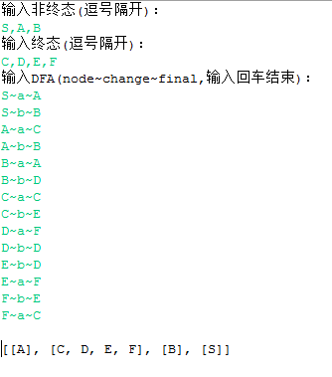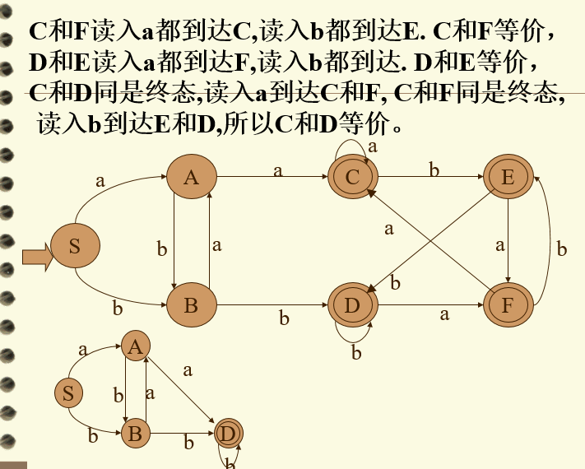

非终：1,2,3,4
终：5,6,7
1~a~6
1~b~3
2~a~7
2~b~3
3~a~1
3~b~5
4~a~4
4~b~6
5~a~7
5~b~3
6~a~4
6~b~1
7~a~4
7~b~2
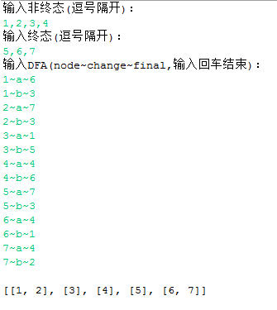
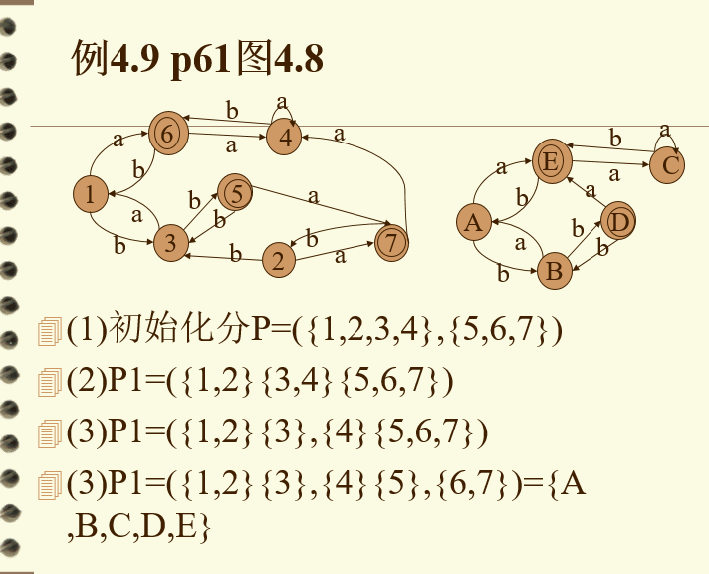

0~a~1
0~b~2
1~a~1
1~b~4
2~a~1
2~b~3
4~a~0
4~b~5
3~a~3
3~b~2
5~a~5
5~b~4
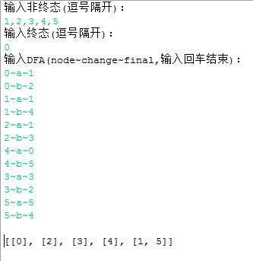
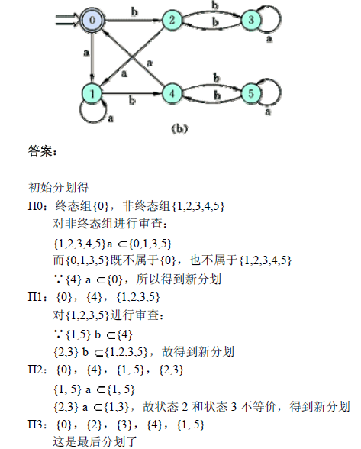
最后用一个主程序MAIN进行调用：
import java.util.ArrayList;
import java.util.HashMap;
import java.util.HashSet;
import java.util.Scanner;

public class Main {

private final static String nonNamesKey = "nonNames";
private final static String finalNamesKey = "finalNames";

private enum State {
终态, 非终态
};

private static String[] FinalStates;
private static HashMap<String, HashSet<String>> name2SetMap;
private static ArrayList<Edge> newEdges = new ArrayList<Edge>();
private static HashSet<String> nonFinalSet = new HashSet<String>();
private static HashSet<String> finalSet = new HashSet<String>();

private static void getNonFinalStateAndFinalState() {
System.out.println("输入终态(逗号隔开)：");
FinalStates = new Scanner(System.in).nextLine().split(",");
}

private static boolean contains(String[] strs, String str) {
boolean have = false;
for (String s : strs) {
if (s.equals(str))
have = true;
}
return have;
}

private static HashMap<String, String[]> renameAllSets(
ArrayList<HashSet<String>> dfaSets,
ArrayList<Edge_Set> oldEdgesWithSet) {
/* 把终态与非终态分成两个集合 */
HashSet<HashSet<String>> nonFinalSets = new HashSet<HashSet<String>>();
HashSet<HashSet<String>> finalSets = new HashSet<HashSet<String>>();
for (HashSet<String> everyDfaSet : dfaSets) {
State state = State.非终态;
for (String element : everyDfaSet) {
if (contains(FinalStates, element)) { // 找到这个集合包含终态元素
state = State.终态;
}
}
if (state == State.终态) {
finalSets.add(everyDfaSet);
} else {
nonFinalSets.add(everyDfaSet);
}
}

/* 给这些集合命名 */
String[] newSetNames = new String[26];
char ch = 'A';
for (int i = 0; i < 26; i++)
newSetNames[i] = new String("集合" + ch++);

/* 将集合的名字储存起来 */
name2SetMap = new HashMap<String, HashSet<String>>();
int setIndex = 0;
for (HashSet<String> nonSet : nonFinalSets) {
name2SetMap.put(newSetNames[setIndex++], nonSet);
}
for (HashSet<String> finalSet : finalSets) {
name2SetMap.put(newSetNames[setIndex++], finalSet);
}

/* 将名字重新排列成一个字符串，以便给DFA化简的构造函数使用 */
String[] nonNames = new String[nonFinalSets.size()];
String[] finalNames = new String[finalSets.size()];

ch = 'A';
for (int i = 0; i < nonFinalSets.size(); i++)
nonNames[i] = new String("集合" + ch++);
for (int i = 0; i < finalSets.size(); i++)
finalNames[i] = new String("集合" + ch++);

/* 将非终态和终态扔给DfaSimplify类 */
// for(String str:nonNames) {
// nonFinalSet.add(str);
// }
// for(String str:finalNames) {
// finalSet.add(str);
// }

/* 把最终结果全部扔回主函数 */
HashMap<String, String[]> returns = new HashMap<String, String[]>();
returns.put(nonNamesKey, nonNames);
returns.put(finalNamesKey, finalNames);
changeSetEdgesName(oldEdgesWithSet);
return returns;
}

private static void changeSetEdgesName(ArrayList<Edge_Set> oldEdgesWithSet) {
// System.out.println(oldEdgesWithSet);
// System.out.println(name2SetMap);
newEdges.clear();
for (Edge_Set edgeWithSet : oldEdgesWithSet) { // 遍历原来的信息
String startName = null, endName = null;
for (String keyName : name2SetMap.keySet()) { // 遍历key
if (edgeWithSet.getFrom().equals(name2SetMap.get(keyName))) { // 如果边属性内出现了这个集合
startName = keyName;// 则把这个集合改名字
}
if (edgeWithSet.getTo().equals(name2SetMap.get(keyName))) {
endName = keyName;
}
}
newEdges.add(new Edge(startName, edgeWithSet.getChange(), endName));
}
}

public static void main(String[] args) {
/* NFA到DFA */
getNonFinalStateAndFinalState();
Nfa2Dfa x = new Nfa2Dfa();
x.nfa2Dfa();
ArrayList<HashSet<String>> dfaSets = x.getDfaSets();

/* 集合重命名 */
HashMap<String, String[]> recieveReturns = renameAllSets(dfaSets,
x.getNewEdges());
String[] nonNames = recieveReturns.get(nonNamesKey);
String[] finalNames = recieveReturns.get(finalNamesKey);

/* DFA的化简 */
try {
DfaSimplify y = new DfaSimplify(nonNames, finalNames, newEdges);
// y.setNonFinalSet(nonFinalSet);
// y.setFinalSet(finalSet);
y.dfaSimplify();
System.out.println(y.getAllSets());
} catch (DfaSimplifyInitiateException e) {
// TODO Auto-generated catch block
System.out.println(e);
}
System.out.println(name2SetMap);
}
}
终态:f
i~eps~1
1~eps~2
5~eps~6
6~eps~f
1~a,b~1
2~a~3
3~a~5
2~b~4
4~b~5
6~a,b~6
