**Total Antioxidant Status (TAS)**

Lot numarası: EM19100A



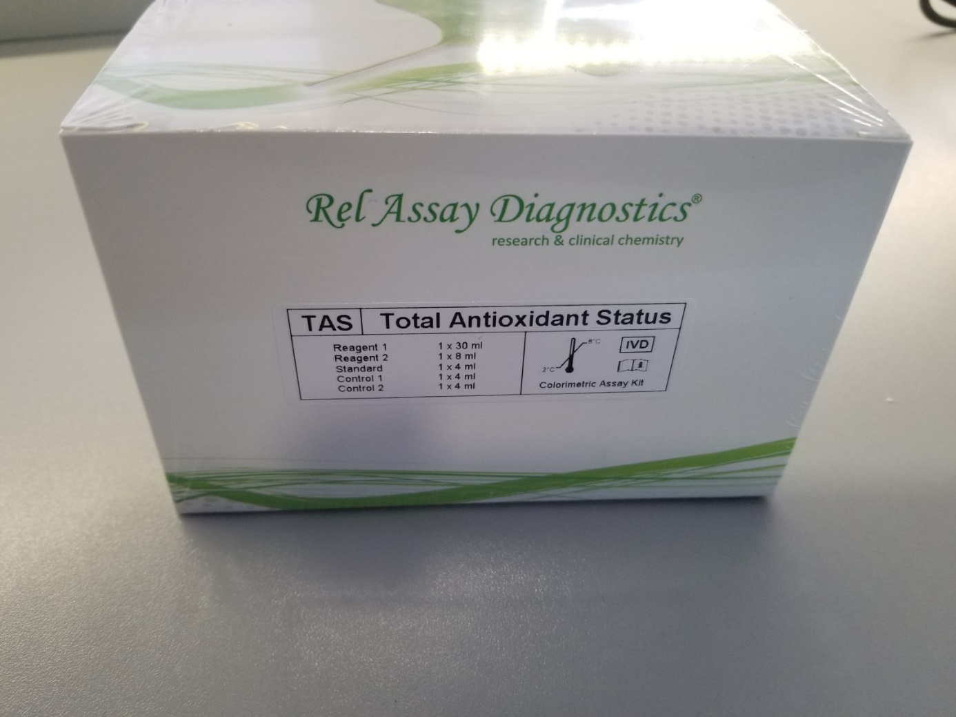

**Total Oxidant Status (TOS)**

Lot numarası: KM191110



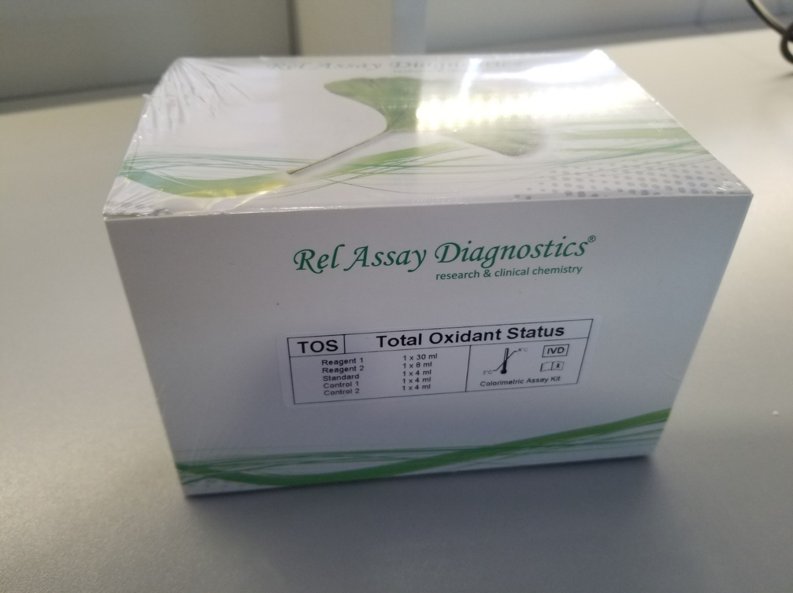

**Total Thiol**

Lot numarası: TZ1901T

**Native Thiol**

Lot numarası: TZ1901N

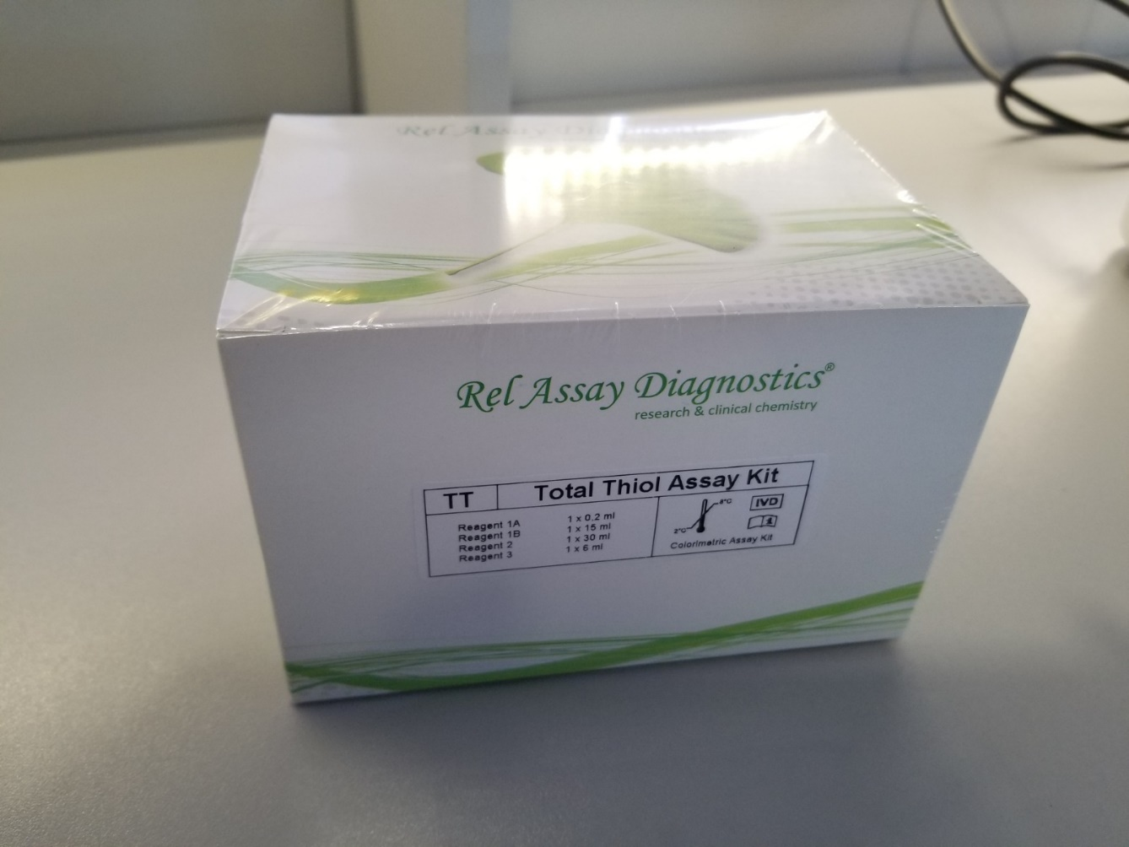

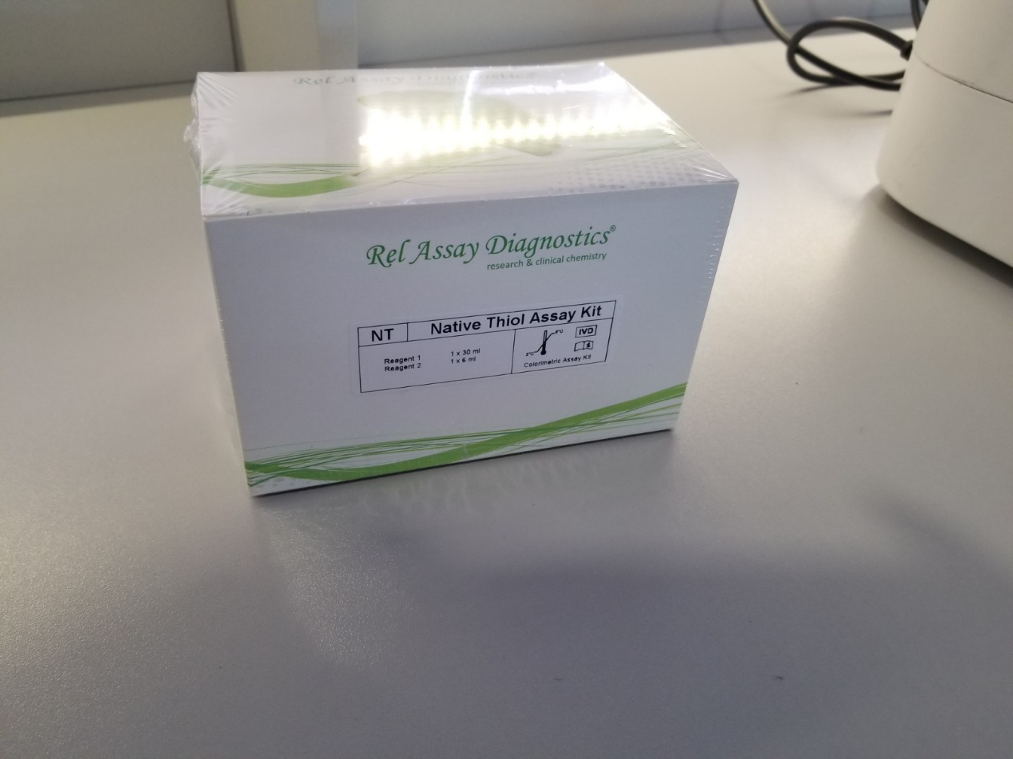

**Catalase (CAT)**

Lot numarası: TZ1901C

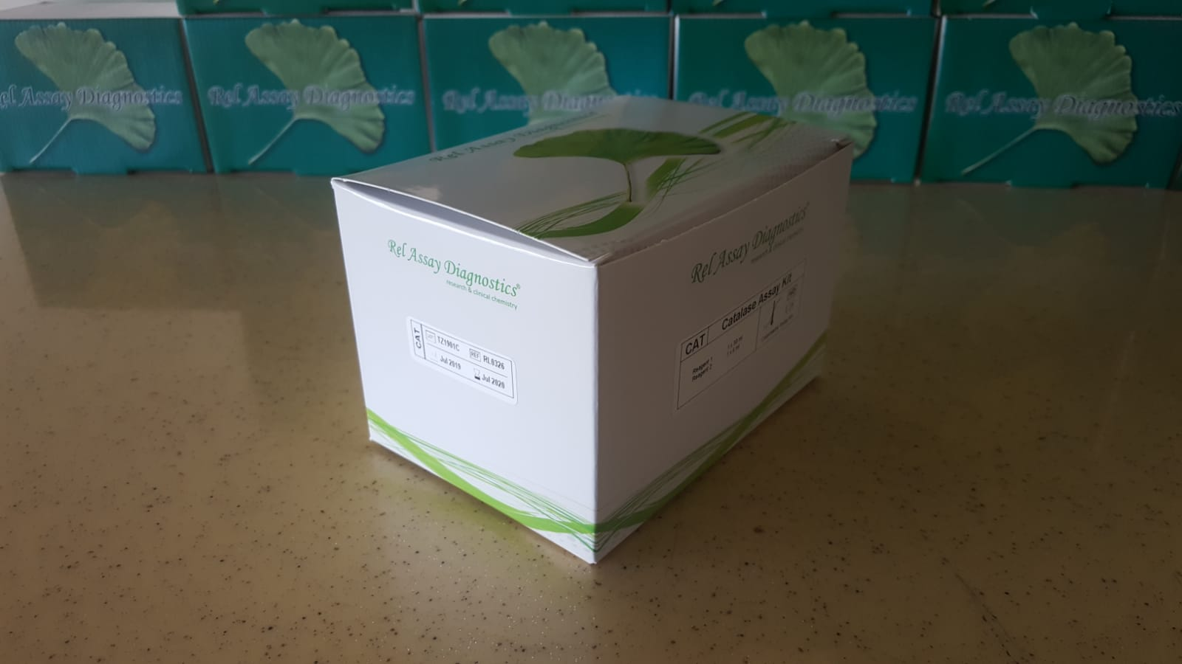

**Myeloperoxidase (MPO)**

Lot numarası: TZ1901M

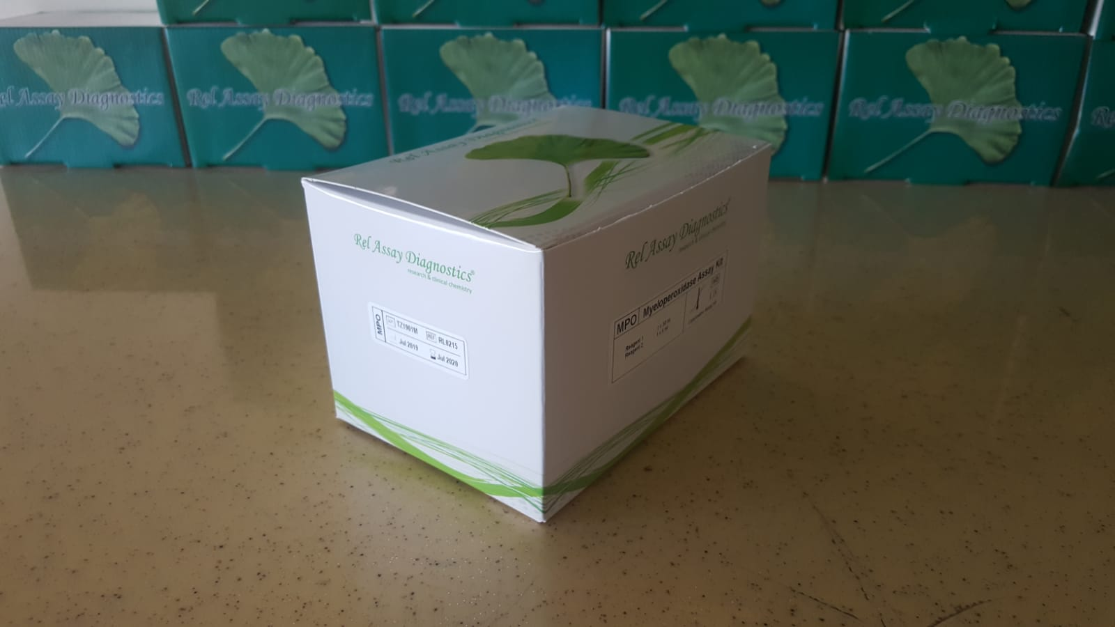

**Super Oxide Dismutase (SOD)**

Lot numarası: TZ1901S

