**YÖNTEMLER**

**TAS- TOS- OSI**

Venous blood was drawn into blood tubes and serum was separated from the cells by

centrifugation at 1500 g for 10 min, and theserum samples were stored at –80 °C until the

analyses.

Analytical methods

**TOTAL ANTIOXDANT STATUS (TAS)**

TAS levels were measured using commercially available kits (Relassay, Turkey). The novel

automated method is based on the bleaching of characteristic color of a more stable ABTS

(2,2 ′ - Azino-bis(3-ethylbenzothiazoline-6-sulfonic acid)) radical cation by antioxidants. The

assay has excellent precision values, which are lower than 3%. The results were expressed as

mmol Trolox equivalent/L (Erel O. A novel automated direct measurement method for total

antioxidant capacity using a new generation, more stable ABTS radicalcation. Clin Biochem

2004;37:277-85.)

**TOTAL OXIDANT STATUS (TOS)**

TOS levels were measured using commercially available kits (Relassay, Turkey. In the new

method, oxidants present in the sample oxidized the ferrous ion-o-dianisidine complex to

ferric ion. The oxidation reaction was enhanced by glycerol molecules abundantly present in

the reaction medium. The ferric ion produced a colored complex with xylenol orange in an

acidic medium. The color intensity, which could be measured spectrophotometrically, was

related to the total amount of oxidant molecules present in the sample. The assay was

calibrated with hydrogen peroxide and the results were expressed in terms of

micromolar hydrogen peroxide equivalent per liter (μmol H2O2 equivalent/L). ( Erel O. A

new automated colorimetric method for measuringtotal oxidant status. Clin Biochem

2005;38:1103-11. ).

**OXIDATIVE STRESS INDEX (OSI)**

The ratio of TOS to TAS was accepted as the oxidative stress index (OSI). For calculation, the

resulting unit of TAS was converted to μmol/L, and the OSI value was calculated according to

the following Formula : OSI (arbitrary unit) =

TOS (μmol H2O2 equivalent/L) / TAC (μmol Trolox equivalent/L). (1-3).

1. Yumru M, Savas HA, Kalenderoglu A, Bulut M, Celik H, Erel O. Oxidative imbalance in

bipolar disorder subtypes: a comparative study. Prog Neuropsychopharmacol Biol Psychiatry.

2009 Aug 31;33(6):1070-4.

2. Kosecik M, Erel O, Sevinc E, Selek S. Increased oxidative stress in children exposed to

passive smoking. Int J Cardiol 2005;100:61–4.

3. (Harma M, Harma M, Erel O (2003) Increased oxidative stress in patients with

hydatidiform mole. Swiss Med Wkly 133:563-536).

**Paraoxonase-1 (PON-1) / Arylesterase**

Measurements of paraoxonase and arylesterase activities;

Paraoxonase and arylesterase activities were measured using

commercially available kits (Relassay, Turkey).

The rate of paraoxon hydrolysis (diethylpnitrophenylphosphate)

was measured by monitoring the increase of

absorption at 412 nm at 37 °C. The amount of generated p-nitrophenol

was calculated from the molar absorption coefficient at pH 8.5, which

was 18.290 M−1 cm−1 Paraoxonase activity was expressed as U/L

serum. Phenylacetate was used as a substrate to measure the

arylesterase activity. Enzymatic activity was calculated from the molar

absorption coefficient of the produced phenol, 1310 M−1 cm−1. One unit

of arylesterase activity was defined as 1 μmol phenol generated per

minute under the above conditions and expressed as U/L

**HDL**

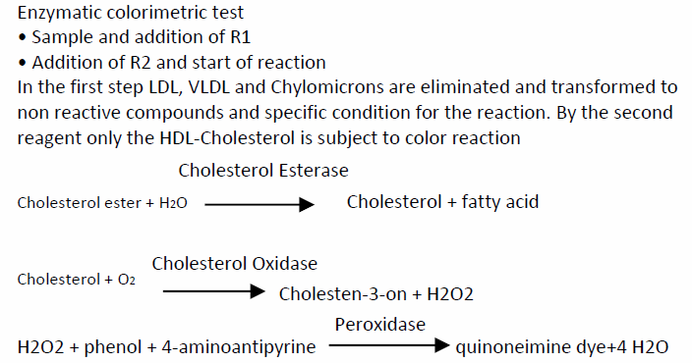

**LDL**

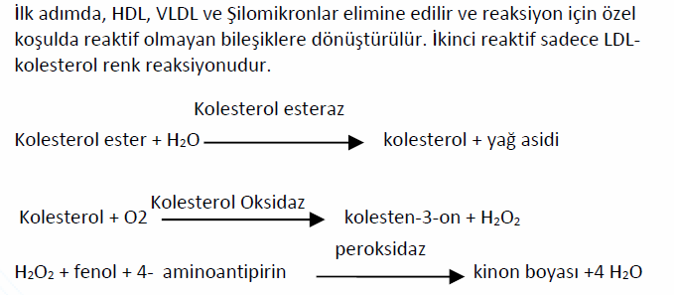

**Total Kolesterol**

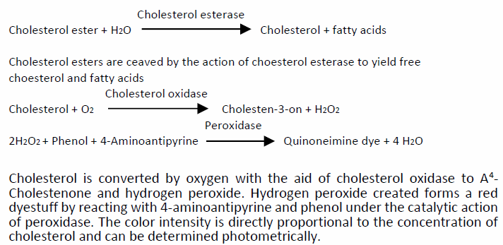

**Trigliserid**

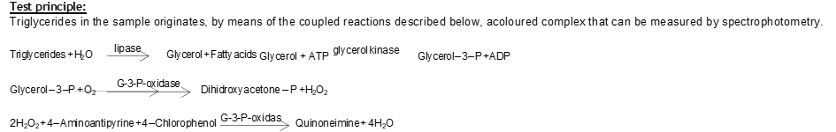

**Insülin**

This ELISA kit uses the Sandwich-ELISA principle. The micro ELISA plate provided in this kit has been pre-coated with an antibody specific to Rat INS. Standards or samples are added to the micro ELISA plate wells and combined with the specific antibody. Then a biotinylated detection antibody specific for Rat INS and Avidin-Horseradish Peroxidase (HRP) conjugate are added successively to each micro plate well and incubated. Free components are washed away. The substrate solution is added to each well. Only those wells that contain Rat INS, biotinylated detection antibody and Avidin-HRP conjugate will appear blue in color. The enzyme-substrate reaction is terminated by the addition of stop solution and the color turns yellow. The optical density (OD) is measured spectrophotometrically at a wavelength of 450 nm ± 2 nm. The OD value is proportional to the concentration of Rat INS. You can calculate the concentration of Rat INS in the samples by comparing the OD of the samples to the standard curve.