

**SCHOOL OF ELECTRICAL ENGINEERING AND COMPUTING**

**COMPUTER SCIENCE AND ENGINEERING PROGRAM**

**PROJECT TITLE: UDIS: Unlicensed Driver’s Identification System**

**List of members**

**Name Id**

**1. Elias Nursefa………………. ………………. R/0409/08**

**2. Yunus Ali...…………………. ………………. R/1274/08**

**3. Haymanot Tsegaye…………………………. R/0617/08**

**4. Esubalew Getachew………………………… R/0446/08**

**5. Gelana joffe…………………………………..R/0513/08**

**Acknowledgment**

We would like to thank our project advisor; Instructor Dawit kefyalew He always suggests useful information and give us the guidance of the project.

**Acronym**

**UDIS (Unlicensed driver identification system)**

**CCTV (Closed Circuit Television)**

**OPENCV (Open Computer Vision)**

**SDK (Software Development Kit)**

**GUI (Graphical User Interface)**

**HCI (Human Computer Interaction**

**MOT (minister of transport)**

**RP(Responsible person)**

**Table of contents**

Acknowledgmenti

Table of contentsii

Acronymiii

List of figuresiv

List of tablesv

**Table of Contents**

Chapter one

1.1. Introduction9

1.2. Background of the project9

1.3. Statement of the problem10

1.4. Justification of the project11

1.5. Objective of the project11

1.5.1. General objective 11

1.5.2. Specific object11

1.6. Scope and limitation11

1.6.1. Scope of the study11

1.6.2. Limitation of the project12

1.7. Feasibility study12

1.7.1. Technical feasibility12

1.7.2. Operational feasibility13

1.7.3. Economic feasibility13

1.8. Significance of the project 13

1.9. Beneficiary of the project 14

1.10. Methodology 14

1.11. Development tools 14

1.12. Required resource with cost 15

1.13. Task and schedule 15

1.14. Team composition 16

**2. Chapter two**

2.1 Description of existing system17

2.2. Major function of existing system17

2.3. User of existing system18

2.4. Drawback of the current system18

2.5. Business rules18

**3. Chapter Three**

**Proposed system**

3.1. Overview19

3.2. Functional requirements 19

3.3. Non-functional requirements20

3.4. Performance requirements21

3.5. System models22

3.5.1. Scenario22

3.5.2. Use case model25

3.6. Object models30

3.6.1. Dynamic models30

3.6.1.1. Sequence diagram30

3.6.1.2. Activity diagram31

3.6.1.3. State chart diagram33

**4. Chapter four**

**System design**

4.1. Overview of system design34

4.1.1. Purpose of system design34

4.1.2. Goal of system design34

4.2. Proposed system architecture39

4.2.1. System process39

4.2.2. Sub system decomposition41

4.2.3. Hardware/software mapping 41

4.3. Database 43

**5. Chapter five**

**Implementation**

5.1. Over view 49

5.2. Coding standards49

5.3. Development tools49

5.4. Prototype51

**6. Chapter six**

**System testing**

6.1. Objective54

6.2. Scope54

6.3. Resource54

6.4. Schedule54

6.5. Feature to be tested or not to be tested55

6.5.1. Feature to be tested55

6.5.2. Feature not to be tested 55

6.5. Pass Fail criteria 56

Reference

LIST OF FIGURES

Fig1. Use case diagram for UDIS system27

Fig2. Sequence diagram for face recognition30

Fig4. Activity diagram for face recognition31

Fig5.Activity diagram for plate identification……………………………………………………32

Fig6. State chart diagram for desktop app34

Fig7. Design goals36

Fig8. System activity diagram 40

Fig9. System processes41

Fig10. Hardware/ Software mapping42

Fig11. Flash screen51

Fig12. Desktop application52

Fig13. Face detection and recognition prototype……………………………………………….52

Fig 12. plate detection prototype………………………………………………………………...53

**LIST OF TABLES**

Table 1 Development tools14

Table 2 Required resources with cost15

Table 3 Task and schedule15

Table 4 Team composition16

Table 5 Use case description for add licensed users28

Table 6 Use case description for take live feed28

Table 7 Use case description for deliver report29

Table 8 Use case description for recognition29

Table 9 Schedule56

Table 10 feature to be tested57

Table 11 feature not to be tasted57

Table 12 pass/fail criteria58

Table 13 test case specification58

Table 14 estimated risk and contingency plan60

**CHAPTER ONE**

**1. Introduction**

Driver's license is an official document, often plastic and the size of credit card, permitting a specific individual to operate one or more types of motorized vehicles, such as a [motorcycle](https://en.wikipedia.org/wiki/Motorcycle), [car](https://en.wikipedia.org/wiki/Car), [truck](https://en.wikipedia.org/wiki/Truck), or [bus](https://en.wikipedia.org/wiki/Bus) on a public road. Every country issues a driving license to properly trained drivers. This is to ensure that people who drives vehicles are trained to drive it to avoid road accidents. Even though cars and buses are good transportation mechanisms, it can lead to injuries and death if the drivers have not been well trained to drive it. A small study in wolayta zone shows that from 520 motorcycle accidents 377 (72.5%) accidents are recorded by unlicensed riders and 143 (27.5%) are validly licensed riders (Impact of Unlicensed Riders on Motorcycle Crash Rates and its Counter Measures – a Case Study at Wolayta Zone, Snnpr, Ethiopia Dawit Kusa Kuma1 , Mengistu Mena Kuleno2 , Dr. Raju Ramesh Reddy3 , Gebrefilmuna Abera4). This result shows that unlicensed drivers cause most of the accidents in Ethiopia.

Our project aims at solving the accident caused by unlicensed drivers by identify peoples without driving license or expired licenses using the concept of artificial intelligence and computer vision. We proposed to implement the system using face detection and recognition technology.

**1.2 Background Information**

Until recently, face recognition technology was commonly viewed as something straight out of science fiction. However, over the past decade, this groundbreaking technology has not just become viable, it has become widespread. In fact, it is difficult to read technology news these days without seeing something about face recognition.

There are several industries benefitting from this technology. Law enforcement agencies are using face recognition to keep communities safer. Retailers are preventing crime and violence. Airports are improving travelers’ convenience and security. In addition, mobile phone companies are using face recognition to provide consumers with new layers of biometric security.

It may seem to some that facial recognition came out of nowhere. However, in truth, this technology has been in the works for some time. To see some historical background of face recognition and detection technology, in the 1960s, Bledsoe developed a system that could classify photos of faces by hand using what’s known as a RAND tablet, a device that people could use to input horizontal and vertical coordinates on a grid using a stylus that emitted electromagnetic pulses. The system could be used to manually record the coordinate locations of various facial features including the eyes, nose, hairline and mouth.

These metrics could then be inserted in a database. Then, when the system was given a new photograph of an individual, it was able to retrieve the image from the database that most closely resembled that individual. At the time, face recognition was unfortunately limited severely by the technology of the era and computer processing power. However, it was an important first step in proving that face recognition was a viable biometric. After a while, in 1988, Sirovich and Kirby began applying linear algebra to the problem of facial recognition. What became known as the Eigen face approach started as a search for a low-dimensional representation of facial images? Through technological advances face recognition and detection system has been implemented in places that should have high security protection such as airports and national military institutes. It also became applicable in social Medias such as Facebook that helped identify people whose faces may be featured in the photos that Facebook users update daily.

To summarize, Face recognition is the task of identifying an already detected object as a known or unknown face. Often the problem of face recognition is confused with the problem of face detection. Face Recognition on the other hand is to decide if the "face" is someone known, or unknown, using for this purpose a database of faces in order to validate this input face.

**1.3 Statement of the problem**

The current license identification system is burden to traffic polices. If an accident happened by unlicensed driver or expired license It is manually identified by nearby traffic polices. Unfortunately, the driver may run before caught by the police. Our system solves this problem by installing camera near a traffic light and at the interval the traffic light is red this camera checks whether the driver is license or unlicensed by detecting and recognizing the drivers face. If the driver is unlicensed it automatically send SMS message to the traffic police and the nearby traffic police will catch the driver before it moves.

**1.4. Justification of the project**

The main aim of the project is to develop and implement system, which uses face detection, and recognition system in traffic area that is capable of determining licensed drivers from unlicensed one and it is able to come across with the unlicensed drivers with the required information.

In addition, also notifying to the responsible security guard to stand against unlicensed driver will be another application of the system.

## **1.5. Object of** **the Project**

**1.5.1 The general objective**

The general objectiveof the project is to develop unlicensed driver’s identification system using Face Recognition, which is wide and applicable for different system. To develop an intelligent face detection and recognition system using Haar cascading frontal face detection and other essential algorithms.

**1.5.2 The Specific objective**

The specific objective of the project is:

* Creating image data set
* Learning different image characters
* Detecting the face of driver
* recognizing the detected face whether he is licensed or not

**1.6 Scope and Limitation**

**1.6.1** **The scope of the project includes**

* Detecting and recognizing images from stream observation.
* Checking detected image if it is licensed or image of unlicensed drivers from image data set.
* Driving image database in keeping with the existing data set if it is necessary.
* Notifying responsible security guard about unlicensed driver.

**1.6.2** **Limitation of the Study**

Here some of the limitation of our study:

* Recognition might not be able to takes place from behind.
* Number of faces to be identified in a time is restricted.
* In case of escape or trying to, the system is incapable to trace vehicle.
* System’s application is time, boundary bounded, the recognition and identification of unlicensed driver, leading to traffic can be done in 120 sec that is time bonded, and the system is applicable in boundaries there is traffic light this make it boundary bounded.
* Real time detection behind different kind of masks and helmets required special camera, those asks significant expenses.

**1.7. Feasibility Study**

The feasibility study is an evaluations and analysis of the potential of the project. Where feasibility assessment unveils some interesting facts on the economic, technical and operational areas. Also, risks that are involved in the implementation of the project. It is a best way to evaluate the cost and benefit of the new system. The following are major feasibly concerns that a business must be in clear light about.

**1.7.1. Technical feasibility**

Technical feasibility mainly focuses on the capability of the proposed system to be applicable in the technical part that is already in the existing world. Technically the proposed system will use Face recognition algorithms, camera and SMS notification. Assuming technological and hardware infrastructures are available. So technically the system we proposed will be technically feasible

**1.7.2. Operational feasibility**

Operational feasibility test is the process of making sure the system works with less difficulty when developed and used. In addition, talks about how well the proposed system solves the problem, and takes advantage of the opportunities identified during scope definition and how it satisfies the requirements identified in the requirements analysis phase. The proposed system is operationally feasible as it keeps the process of tiring process in a simple and specific way and accurately do the process that needs to be done. Those peoples who are participant of the process on the operation that the system does do and the actors that are involved in these will get the best and possibly the easiest way of doing the operation.

**1.7.3. Economic feasibility**

This is to determine the benefits and savings that is expected from a proposed system and  
compare them with costs. If benefits outweigh costs, then the decision is made to design and  
implement the system. It is must accurately weigh the cost versus benefits before taking an  
action.

The proposed system is economically feasible because the materials used to build and maintain this system are easy and cheap. In general, the cost to do the procedure manually could cost a lot of money than it does in computerized system.

**1.8. Significance of the project**

The significance of UDIS

* It minimizes the time wasted by the traffics to identify peoples without driving license or expired licenses
* It reduces the man power that is distributed to do these that means the traffics
* Reduces the road accidents that are happening with peoples who have fake, unlicensed and expired licenses
* Providing save streets

**1.9. Beneficiary of the project**

Beneficiary of UDIS

The Society: the accident on their street will reduce

The transportation minister: to track unlicensed drivers

The transport vehicle owner: to avoid the destruction of their cars

**1.10 Methodology**

Implementing an effective and intelligent system to observe and detect the faces observed in and identifying whether the driver is licensed or not is done via implementing algorithms, which are applicable in latest face detection and recognition technology through cameras allocated in traffic light. Not only using recognition algorithm but also different library found in python programming language like OpenCV (open computer vision) library ,Numpy and other related libraries. For the android related implementation, we might use framework like flutter and so on.

## **1.11****. Development tools**

In the development process, we will use the following tools.

* Software tools

Front & Back-End Development tools

|  |  |  |
| --- | --- | --- |
| **Tools / Frameworks** | **Use** | **Why is it preferred** |
| OpenCV (Open Computer  vision) library & required Algorithm | Implementing Detection and Recognition | Power full and simple Tools |
| Python | Desktop app’s interface |
| Flutter | Mobile app development |

## Table 1 Development tools

**1.12. Required resources with cost**

**1.12.1 The main required resources are listed below**

|  |  |  |
| --- | --- | --- |
| **Required Resource** | **Use** | **COST($)** |
| હ Camera | For Stream Recording | Undetermined yet |
| હ SMS server | For transmission (Notification) of SMS for the integrated cellphone. | Undetermined yet |

Table 2 Required resources with cost

**1.13. Task and Schedule**

|  |  |
| --- | --- |
| **Phases** | **Month** |
| Requirement gathering and Analysis | September 28/2019 – November 20/2019 |
| Design | November 20/2019 – January 30/2020 |
| Implementation | Oct. 30/2020 -Nov.15/2020 |
| Testing | Nov.29/2020 - Nov.30/2020 |
| Maintenance | Nov.15/2020 - Nov. 20/2020 |

Table 3 task and schedule

**1.14. Team Composition**

|  |  |  |  |
| --- | --- | --- | --- |
| **No_** | **NAME** | **ID** | **email** |
| **1** | **Elias Nursefa** | **R/0409/08** |  |
| **2** | **Yunus Ali** | **R/1274/08** |  |
| **3** | **Haymanot Tsegaye** | **R/0617/08** | **tsegahaymanot11@gmail.com** |
| **4** | **Esubalew Getachew** | **R/0446/08** |  |
| **5** | **Gelana Jofe** | **R/0513/08** |  |

Table 4 team composition

**CHAPTER TWO**

**2. Description of existing system**

the current system of identification of unlicensed drivers Usually takes a couple of minutes for the inspecting officer to perform a visual check of the whole situation (including the license check, the driver’s looks, the vehicle condition and interior, as well as asking 1-2 short questions). This makes the entire once-over inspection procedure insecure and at some point worthless

**2.1. Major function of existing system**

The following are major functions of the current system

Checking the license of a driver manually

Stop traffic to check the license

Following drivers who broke the rule by motors

Use whistles to stop the drivers who run away of the red light

**2.2. Users of existing system**

The actors involved in the current system are

* Traffic police officers
* Control the whole flow of the traffic
* Check the license of drivers
* Keep the safety of pedestrians
* Stop drivers who broke the rules of rode traffic light
* Take the expired or useless licenses
* Volunteers
* Collaborate with traffic polices
* Create awareness to pedestrians
* Facilitate the traffic flow

**2.3. Drawback of current system**

The current system of controlling the flow of traffic and checking the license of drivers is manually take place by traffic polices.

* The following are some of the drawbacks of the current system
* Overload the burden of traffic polices
* Slow traffic congestion control
* Check the license of drivers manually i.e. it is not electronic.

**2.4. Business rules**

1. The admin is the only user allowed to manage the system

2. The traffics must have android aided device to access notification from the system

3. The camera-capturing image of drivers

4. The central system is responsible in identifying the captured image

**CHAPTER THREE**

**3. Proposed system**

**3.1 Overview**

Facial recognition system are one of the biometrics used to process information about the individuals. As the world is going to the digital era of technology these Facial recognition systems can be used in many different part on problem solving, mainly for governmental institutions as they process many citizen data’s. The failures caused by doing things manually will decrease by a vast amount.

The System we are going to build will ease up the process of Identifying Unlicensed drivers from the streets. The system will use the technology of facial recognition. These will decrease the load on road traffics on controlling a majority of drivers simultaneously also, it will usually be more accurate than manual verification.

The system will use a Camera, a Personal Computer and a notification handler (probably SMS server or Cloud Server).

**3.2 Functional Requirement**

* **Adding new Licensed Drivers**

New Licensed Drivers should be added to the database

* **Acquiring images**

Getting the image from the live feed camera

* **Detecting Face from Image**

Detecting if there is any face in the Acquired image

* **Recognizing Face from Image**

Recognizing the faces and finding a perfect model to match up with the model we have in the database

* **Matching on the Database**

Matching the recognized image with the images, we have in the database and finalizing in which category

* **Verifying the identity**

Verifying is the image is in the licensed or unlicensed one

* **Send the Final Decision**

Sending the final Decision to the central system

**3.3 Non-Functional Requirement**

Nonfunctional requirements describe how a system must behave and establish constraints of its functionality.

**Usability**

The system is automated so the usability difficulty of the system will not be that much of difficult. The thing that would be difficult is that the notified traffic user might not be in the place.

**Reliability**

The System will not be mistaken as we have tested it. It have been 100% efficient to use. Their might be some difficult in processing the images while the persons are not in the correct frame to compare.

**Performance**

The system should be perfect in responding and notifying at instant as traffic movements are changing every second. In addition, the notification send by the central system to the server should be clear and fast.

**Accessibility**

The system should be able to provide to a vast community. The system should work anytime it should not be down any moment

**Maintainability**

The system should be maintained when there is a malfunction or a failure to execute process properly. The system should be easy to maintain.

**Error Handling and Extreme Conditions**

Error Handling should be a focus of the system as any system cannot be 100% correct all the time. Our system Extreme Conditions might be the conditions when there is a lot of traffic going on and is unable to handle processing those data in time.

**Documentations**

At the completion of the project, every activity of the entire development, design and other  
process will be documented for future reference. There will also be a documentation of  
implementation for maintenance during application failure. Furthermore, this will help for  
further maintenance and reusability of our system.

**Security**

The files that are saved in the licensed category should be kept secured as tampered files in the system might make our system slow and users can get away if they manage to get into the system and put their data

**3.4 Performance Requirement**

Performance requirements define acceptable response times for system functionality.

* The load time for to recognize image shall take no longer.
* The information shall be verified within few seconds.
* Queries shall return results within five seconds.

**3.5 System Models**

**3.5.1. Scenarios**

**Scenario:** one

**Name of use case:** licensing driver

**Participating Actor:** transport minster(MOT)

**Entry Condition**

* none

**Flow of Events:**

1. take photo of driver
2. Add to the system
3. Save to the dataset

**Exit Condition:** The System saves the data entered

**Scenario:** Two

**Name of use case:** Acquire Image

**Participating Actor:** Camera

**Flow of Events:**

1. Take a frame from live feed
2. Take a shot

**Exit Condition:** Save the acquired image in cache and send it to the system

**Scenario:** Three

**Name of use case:** Detect face

**Participating Actor:** System

**Entry Condition**

* Initiate camera

**Flow of Events:**

1. Get the shot frame
2. Detect if it is a face
3. Feed it to the system

**Exit Condition:** get the perfect detected face

**Scenario:** Three

**Name of use case:** Detect plate

**Participating Actor:** System

**Entry Condition**

* Initiate camera

**Flow of Events:**

1. Get the shot frame
2. Detect if it is a plate
3. Feed it to the system

**Exit Condition:** get the perfect detected plate

**Scenario:** Four

**Name of use case:** Recognize face

**Participating Actor:** System

**Entry Condition**

* Initiate camera

**Flow of Events:**

1. Get the perfect detected face
2. Recognize the driver (person)
3. Make it ready to match with the face trained

**Exit Condition:** get a perfect framed comparison version of driver

**Scenario:** Six

**Name of use case:** Verifying and report

**Participating Actor:** System

**Entry Condition**

* none

**Flow of Events:**

1. Get the matching result
2. Decide it its Licensed or not
3. Deliver to the responsible person

**Exit Condition:** go back to camera

* + 1. **Use Case Model**

A use-case model is UML (Unified Modelling Language) which is a de facto standard for  
object-oriented modelling, so use-cases and Use-case–based elicitation is increasingly used for requirements elicitation. Model of how different types of users interact with the system to solve a problem. As such, it describes the goals of the users, the interactions between the users and the system, and the required behavior of the system in satisfying these goals.  
A use-case model consists of a number of model elements. The most important model elements are use cases, actors and the relationships between them.

**Actor Identification**

An Actor is something that accomplish use cases upon a system. It is just an entity, meaning  
it can be a Human or other system that directly play an external role in the system.

**Name**: *MOT***Description**: MOT is a personal that can tamper information in the central system to make the system more efficient everyday  
**Role:** Adding new licensed users, removing any unnecessary things from the database

**Name**: *Camera***Description**: Camera is an instrument that can record real time events as it happens in the real world.  
**Role:** Recording and transmitting the data to the central system

**Name**: *Central system***Description**: Central system is the main part of a system that controls most the works that have been worked by the system itself.  
**Role:** Receive image, Detect person, recognize person, Verify and send message to road traffic

**Name**: Responsible person(R.P)**Description**: R.P is a personal that manage road safety and held accountable those who break road traffic laws  
**Role:** Receive notification who is unlicensed driver, manage to exercise the laws is the person is out of the law order

**Use case diagram and description**a use case diagram illustrates a set of use cases for a system, the actors of these use cases, the  
relations between the actors and these use cases, and the relations among the use cases. The  
UML notation for a use case diagram is shown on the figure, in which

* An oval represents a use case,
* A stick figure represents an actor,
* A broken arrow indicates included action
* Street line indicates action take place by an actor

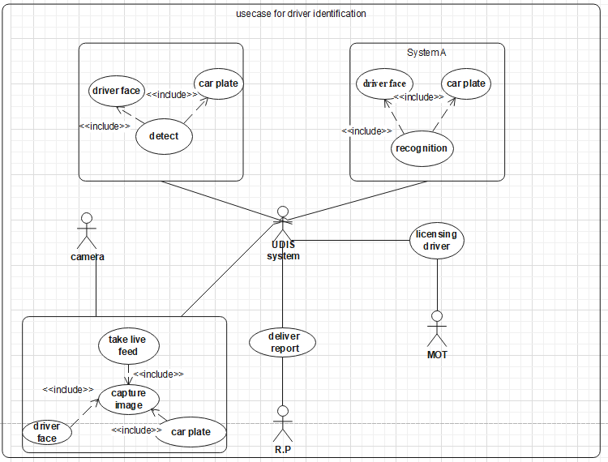

Fig1**.** use case diagram for UDIS system

**Use case description**

|  |  |
| --- | --- |
| Use case name | Licensing driver |
| Use case id | 1 |
| Use case description | Adding new licensing drivers |
| actor | Ministry of transport (MOT) |
| Pre-condition | none |
| Post-condition | Licensing drivers |
| Main flow | 1. driver photo capture  2. driver photo trained  3. driver added to the system |
| Exception flow | None |
| Frequency of use | When a new driver comes |

Table 5 use case description for add licenseduser

|  |  |
| --- | --- |
| Use case name | Take live feed |
| Use case id | 2 |
| Use case description | Recording and transmitting the data to the central system |
| actor | Camera |
| Pre-condition | Must have power |
| Post-condition | none |
| Main flow | 1.take live feed  2.capture image in frame |
| Exception flow | When occlusion occur it waits till it get face |
| Frequency of use | Always |

Table 6 use case description for take live feed

|  |  |
| --- | --- |
| Use case name | Deliver report |
| Use case id | 3 |
| Use case description | The captured photo is deliver to the responsible person(RP) by the central system |
| Actor | Central system |
| Pre-condition | None |
| Post-condition | Catch unlicensed driver |
| Main flow | 1.save photo  2.catch unlicensed user |
| Frequency of use | Always |

Table 7 use case description for deliver report

|  |  |
| --- | --- |
| Use case name | Recognize driver |
| Use case id | 4 |
| Use case description | Receive image, detect person, recognize person, Verify driver |
| Actor | Central system |
| Pre-condition | none |
| Post-condition |  |
| Main flow | 1.detect face  2.recognize face  3. verify driver face |
| Frequency of use | Always |

Table 8 use case description for recognition

**3.6 Object Models**

**3.6.1 Dynamic model**

**3.6.1.1 Sequence diagram**

A sequence diagram in a UML is a kind of interaction diagram that shows how processes operate with one another and in what order. A sequence diagram shows object interactions arranged in time sequence. It depicts the objects and classes involved in the scenario and the sequence of messages exchanged between the objects needed to carry out the functionality of the scenario. It shows, as parallel vertical lines (lifelines), different processes or objects that live simultaneously, and, as horizontal arrows, the messages exchanged between them, in the order in which they occur. This allows the specification of simple runtime scenarios in a graphical manner.

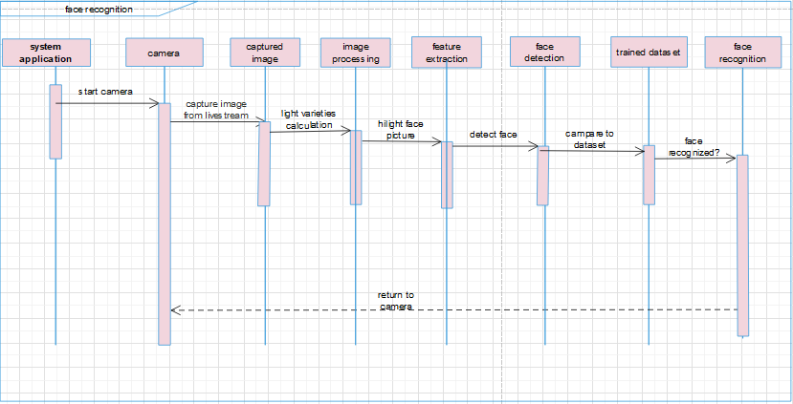

Fig2. Sequence diagram for face recognition

**3.6.1.2 Activity diagram**

An activity diagram describes a system in terms of activities. Activities are states that represent the execution of a set of operations. The completion of these operations triggers a transition to another activity. Activity diagrams are similar to flowchart diagrams in that they can be used to represent control flow (i.e., the order in which operations occur) and data flow (i.e., the objects that are exchanged among operations).

Fig4. Activity diagram for driver identification

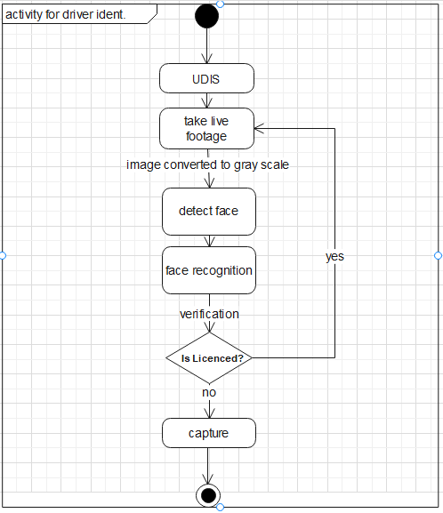

Fig5. Activity diagram for plate identification

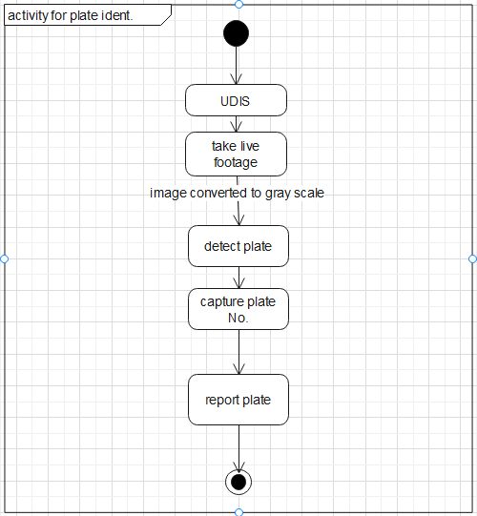

**3.6.1.3 State chart diagram**

It is used to describe the externally visible behavior of a system or of an individual object. Since our system is a camera that is mounted in street like a traffic light it has not a visible part. However, we have a desktop app visible to us.

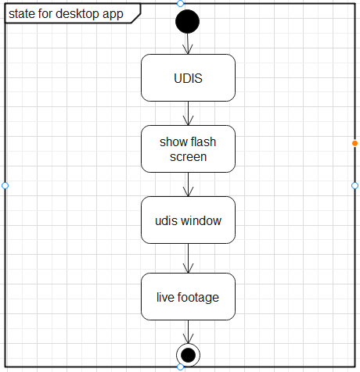

Fig5. state chart diagram for add licensed user

**CHAPTER FOUR**

**4. System deign**

**4.1 Overview of system design.**

The following overview of Face recognition system came across with its design, goal and purpose. Since system design is intended for interpretation of analytical model into designed model. As it is mentioned in, the former statements this chapter is intended to describe the outcome of design model from its analytic model.

**4.1.1 Purpose of the system design.**

The purpose of this complex image processing system design which is difficult in real world applications with complex effects of illumination, occlusion, and imaging condition on the live images is to describes the design issues of the overall system, and provide architectural overview. This system is a combination of face detection and recognition techniques in image analyzes. Detection application is used to find position of the faces in a given image. Recognition algorithm is used to classify given images with known structured properties, which are used commonly in most of the computer vision application s. Recognition applications use algorithm standard images, and detection items detect the faces and extract face images, which include eyes, eyebrows, nose, and mouth. That makes the algorithm more complicated than single detection or recognition algorithm.

**4.1.2 Design goal**

The Performance of the system derived from the main activities such as acquiring an image from a camera, detection from the acquired image and face recognition that takes the face images from output of detection part will be discussed in the design goal.

Design goals also acquaint onesystem’s qualities those shall be considered by the system developer:

1. Performance

**UDIS**

2. Dependability

3. Maintenance



4. End User

Fig6. design goals

**1. Performance**

The performance of the recognition system depends on the methodology, applicable infrastructure and recognition algorithms used determine overall system performance. For example: for the response time of the developing system the type of algorithm or the method we used for recognition do matter a lot.

* + - 1. acquaint means describing Classical face recognition algorithms
      2. Artificial neural networks
      3. Gabor wavelets
      4. Face descriptor‐based methods
      5. 3D‐based face recognition
      6. Video‐based recognition

(Waldemar Wójcik, Konrad Gromaszek and Muhtar Junisbekov (July 6 2016) Face Recognition: Issues, Methods and Alternative Applications, Face Recognition - Semisupervised Classification, Subspace Projection and Evaluation Methods, S. Ramakrishnan, IntechOpen, DOI: 10.5772/62950).

- Around 5 years later research statistics indicate that the response time for object detection demolished from two to 2ms, which means 1/1000 times speed up.

**2. Dependability**

In order to resist system failure and to be reliable and give required access the unlicensed driver’s identification system should achieve the mentioned dependability characteristics:

Focuses on local structure of the manifold. These methods projects face onto the linear subspace spanned by the Eigen face images. The distance from face space is orthogonal to the plane of the mean image, so may be easily turned to Mahalanobis distances with probabilistic interpretation.

Radial bases function artificial neural network is naturally integrated with non-negative matrix factorization. Also other approaches for process simplification regarding to ANNs native linearization feature and computation speed up. Ideal solution, especially for recognizing face images with partial distortion and occlusion.

The Gabor Wavelets exhibit desirable characteristics of capturing salient visual properties like spatial localization orientation selectivity and spatial frequency. Different biometrics application favors this approach.

The main idea behind developing image descriptors is to learn the most discriminant local features that minimize difference between images of the same individual, maximize that between images of the same individual, and maximize that between images from the other people. These methods discrimination and robust to illumination and expression changes. They offer compact, easy to extract and highly discrimination descriptor.

.

* **Robustness**: - recognizing face is natural process, because people usually do it effortlessly without much conscious. The first stage is face detection in the acquired image that is regardless of scale and location. It often uses an advanced filtering procedure to distinguish locations that represent faces and filters them with accurate classifiers. It is notable that all translations, scaling and rotational variations have to be dealt in the face detection phase. However, discovering such subspace to extract effective features and construct robust classifiers stands another challenge in this area.
* **Availability**: -Until the essential infrastructures and sufficient light (sun light or other source of light) are available, the system can be accessible throughout the day and night time.
* **Security**: - No matter where we apply the system other than UDIS like

Automated surveillance

Monitoring closed circuit television (CCTV)

Airplane‐boarding gate

Sketch‐based face reconstruction and other application areas are secured since direct interaction with human (stakeholder) very small comparing with non-bio metric systems.

* **Reliability**: The outcome gained from the system ought to be reliable and function able with respect to given information.

**3. Maintenance**

While maintenance is needed because of system failure or new technology being discovered and want to enhance some criteria fulfillment is essential like:

* + - 1. Where the objective is to recognize and track people.
      2. The facial recognition capability can be embedded into existing CCTV networks, to look for lost children or other missing persons or tracking known or suspected criminals.
      3. The face recognition may used in places of random check merely to screen passengers for further investigation. Similarly, in casinos, where strategic design of betting floors that incorporated cameras at face height with good lighting could be used not only to scan faces for identification purposed, but possibly to afford the capture of images to build a comprehensive gallery for future watch-list, identification and authentication tasks.
      4. Where law enforcement agencies in the world rely on practical methods to help crime witnesses reconstruct likeness of face. These methods range from sketch artistry to proprietary computerized composite systems.
* **Modifiable**: - Without affecting the existing system the required modification has to be accomplished whether it is for new upcoming technology modification, infrastructure changing or other modification for certain enhancement in security or quality or any other reason.
* **Extensible**: - Without affecting the existing system the required additional functionality has to be accomplished.
* **Portability**: - UDIS System’s operating system, platform and vendor independent make it portable except some requirements to be fulfilled.

**4.2 Proposed system architecture.**

**4.2.1 System Process**

The Overall System of the service is depicted as following:

**Verification**

Acquiring driver face

**Detect plate**

**Detect Recognize face**

Acquiring cars plate

**UDIS**

You can simply impress your audience and add a unique zing.

Fig7. System activity diagram.

**System Process**

***Face Detection***

**→ The input image, in the form of digital data, is sent to face detection algorithm part of a software for extracting each face in the image. Many methods are available for detecting faces in the images in the literature [1 Available method could be classified into two main groups as; knowledge based [ one –– 9]. 4] and appearance based [5 9] methods. Briefly, knowledge for features that makes a face. Appearance-- based methods are derived from human based methods are derived from training and/or learning methods to find faces.**

**Verification**

***Verify the identity of the driver***

***Face Recognition***

Recognize

Whether the detected face exist in image data set or not.

***Acquire Image***

**→ Acquiring images to computer from camera and computational medium (environment) via frame grabber is the first step in face recognition system applications.**





***Plate Detection***

**The input image, in the form of digital data, is sent to plate detection algorithm part of a system for extracting each plate in the image.**

***Image dataset***

Fig8. System processes

**\*\*\*** A throughout survey has revealed that various methods and combination of these methods can be applied in development of a new face recognition system. Among the many possible approaches, we have decided to use a combination of knowledge-based methods for face detection part and approach for face recognition part. The main reason in this selection is their smooth applicability and reliability issues.

**4.2.2 Subsystem Decomposition**

To diminish the complexity of the solution domain, we decompose a system in to simpler portions, called subsystem. The main need of this part is to design the external part of the system.

**4.2.3 Hardware/ Software mapping**

Hardware/Software mapping for this system by means describing how subsystem are allocated to hardware and off-the-shelf component

.

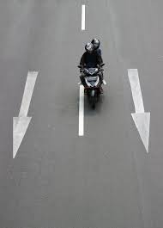

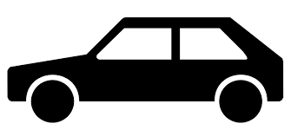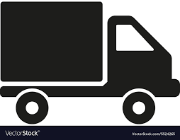

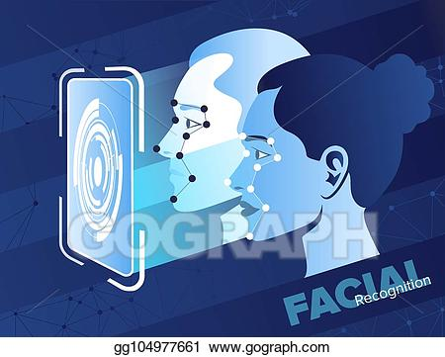

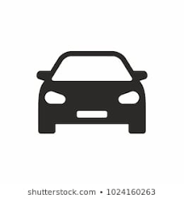

Fig. Hardware/Software mapping

Fig9. Hardware/ Software mapping

**4.3 Database:**

In recent decade, most of the researches are focused on the face detection. Many of the algorithms are proposed into different method. We need to use standard test data set for researches to compare the results. The following is the description of the face databases, which are widely used into face detection community.

1. FERET, http://www.itl.nist.gov/iad/humanid/feret/, it includes 1000 people with male and female faces. It was created by FERET program start from 1993 to 1997. Each face is a single person with expression. This database has 14051 images with different views. The time-range of each people was taken at least one year or more. As a result, it has robust information for testing face-related algorithms over time.

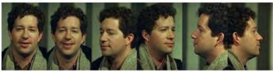Limitation: Only a limited pose of each one. No information about the captured

parameter.

2. CMUFaceDatabase,http://vasc.ri.cmu.edu//idb/html/face/frontal_images/index.html, it is a test set and composed of four set of testing images. Each test set has faces and non-faces picture. It has 511 frontal faces with 130 images. Images are grayscale with face sizes are varied.

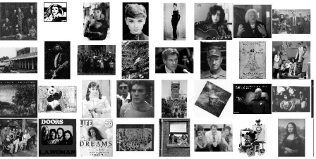

**3.** Bio ID, http://www.bioid.com, it has 1521 gray level images with images are 384x286 pixel. 23 peoples are involved.

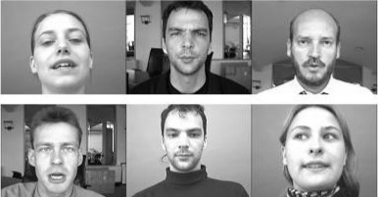

4**.** CAS-PEAL, http://www.jdl.ac.cn/peal/home.htm, it contains 99594 images with varying pose, expression and illumination. 595 males and 445 females are in this database.



5. Yale Face Database, http://cvc.yale.edu/projects/yalefaces/yalefaces.html, It has

15 peoples with 11 gray level images per each one with glasses, happy, center-light, normal, and right light, sad, sleepy, surprised and wink. Each image is 320x243.

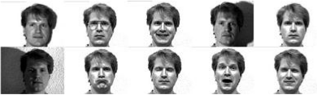

Limitation: limited number of people. Light parameters are not mentioned. Every faces are frontal and no pose angle.

6. XM2VTS, http://www.ee.surrey.ac.uk/CVSSP/xm2vtsdb/, it has 295 subjects with different pose which record four times with spread 4 months. Database contains 1180 color frontal images. Each image is 720x576.

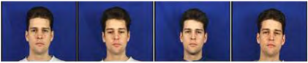

Limitation: No additional information about the captured parameters.

7. Purdue AR, http://cobweb.ecn.purdue.edu/~aleix/aleix_face_DB.html, it has 4000 color images consist of 126 people’s face. Images are included in variation of facial expressions, illumination conditions and occlusions.

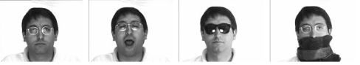

Limitation: No information about the illumination condition of the images.

8. Yale Face Database B, http://cvc.yale.edu/projects/yalefacesB/yalefacesB.html, it has 5760 images with 10 person. Each person have been taken 576 different conditions (9poses with 64 illumination conditions.)

Limitation: limited number of group.

9. AT&T (Olivetti) Database (ORL), http://www.uk.research.att.com, it has 40

Peoples with 10 images per person. Each image is 92x112.

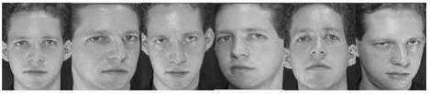Limitation: limited number of people. Illumination conditions are inconsistent.

10. PIE Database, <http://www.ri.cmu.edu/research_project_detail.html?project_id=418&menu_id=261>, it has 41368 images included 68 peoples. Each person has 13 different poses, 43 different illumination conditions, and 4 different expressions. Each image is 640x486.

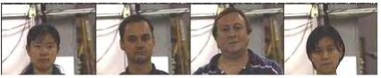

Limitation: Pose angle in the each images is not mentioned. Complex background of each images.

11. Japanese Female Facial Expression (JAFFE) Database, http://www.kasrl.org/jaffe.html, it has 213 images with seven facial expressions posed by 10 Japanese female models. Each model is contributed six emotional expressions. Each image is 256x256.

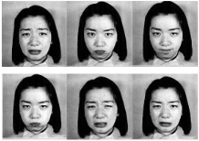

12. MITFaceDatabase,http://cbcl.mit.edu/software-datasets/FaceData2.html, it has two types of images, one is training set and other is test set. They are included 2429 faces, 4548 non-face in training set, 472 faces, and 23573 non-faces in test set respectively. They are all 19x19 size. Here is the faces sample:

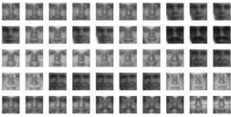

Herewith non-face sample:

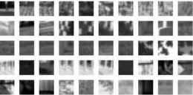

**CHAPTER FIVE**

**5. Implementation**

**5.1. Overview**

Implementation is the process of integrating system functionality. Through our project, we will be doing the functional and non-functional requirement. The project mainly focusses on the function it should incorporate.

**5.2. Tools and technologies utilized during system development**

We have used different tools in development, those we use to develop and those we use for developing. The material we used to develop is our personal computer and external camera.

On developing the system, we have used some programming languages. Frameworks, libraries.

Programming languages: -

**Python**

Python is high-level programming language like a Perl, Ruby and Tecla, which are used

as a scripting language. Guido van Rossum conceived it in 1989. [4] Also,

Python is one of the three “official languages” in Google which means that more

Application in Google was deployed this language. E.g. Google App Engine SDK.

Here are the points that make python is selected:

1. Free, Python is product of open source. People allows to use it in business or

Commercial without any charge.

2. Easy to read, Syntax in Python is clear and readable. Beginner can be easily to

Read and handle Python’s coding very well.

3. Rapid development, it is because it likes pseudo code. Everything coding in

Python is direct result.

4. Highly portability, Python is working on different platforms, because of Python is

Written portable ANSI C.

5. Reusability, Python is easily reused modules and packages. Peoples can be

Developed their own library and reused it later project.

6. Object-Oriented Programming. Unlike scripting language, Python is designed to

Be object-oriented. OO programming means you can implement using idea of

Inheritance and polymorphism.

Frameworks: -

**Tkinter, pyQt**

PyQt4 is a set of Python bindings for Qt4 [5]. PyQt4 has at least 300 classes and

6,000 functions and methods. PyQt4 support Linux, Windows and Mac OSX platform.

Classes are including with different field of programming. E.g., GUI, Network sockets,

Thread, Unicode, SVG, OpenGL, SQL database, Web browser, XML, Active X.

PyQt4 also has the following advantages:

1. Cross-application framework. Like Qtr. it is worked in different system platform.

2. GUI designer, PyQt4 has own GUI designer, it increases the time of development

Timing.

3. PyQt4 has all the advantage of Python, easy to read/code, reusability

Libraries: -

**OpenCV, Numpy**

OpenCV is a synonym of Open Computer Vision Library, which has at least 500 Algorithms, documentation and sample code for real time computer vision. OpenCV is originally developed by Intel and launched in 1999. It free for commercial. In addition, research used. OpenCV library is cross-platform which means its can execute On Windows, Mac OS X, Linux, PSP and other embedded devices. The library is mainly written in C, which makes it easily possible to transfer into specific platforms.

Example application of OpenCV library is Human-Computer Interaction, Object Identification, Segmentation, Recognition, and so on. OpenCV implemented Stanley, which was the winning entry to the 2005 DARPA Grand Challenge race. We have used these above technologies to finish the project.

**5.3. Prototype**

**Setup installed in tall plaza**

This installation can be seen is a client side as it will be surveying and sending information to the central system.

**Component**

* Camera

**Setup in the central system**

There will be a lot of storage area, and a server that can send a message to the people in charge of executing the law.

**Component**

* Dataset
* Detector and Recognizer

flash screen

This figure is a flash screen that is displayed during start up of the desktop application

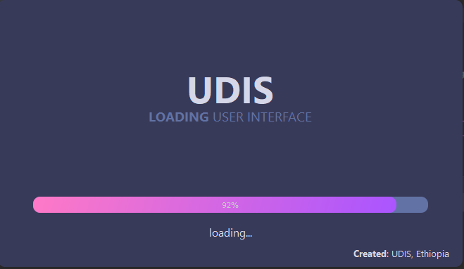

Figure 11 flash screen

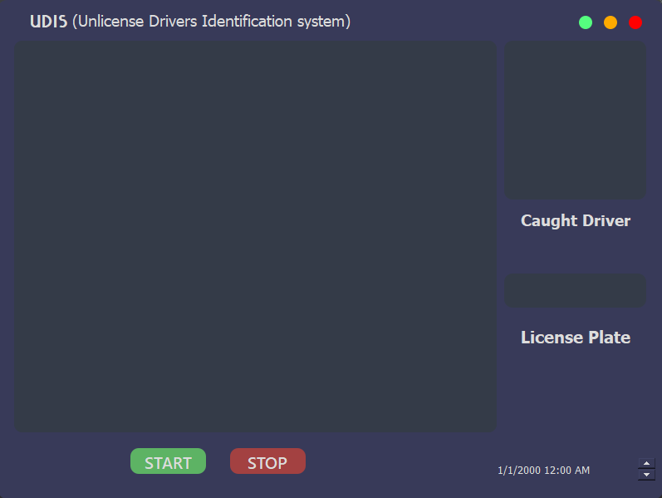**figure 12** desktop application GUI

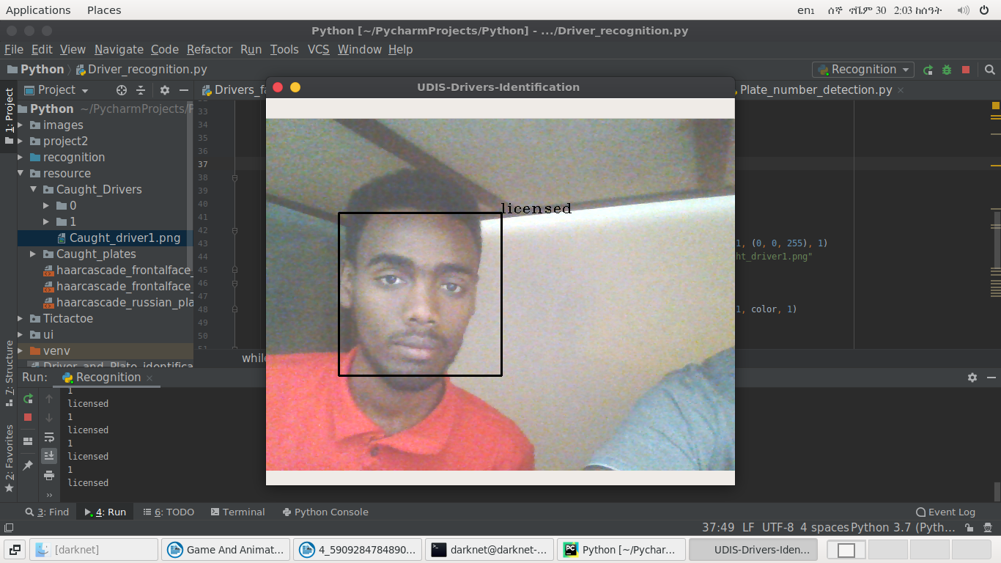live feed from the camera, captured unlicensed driver and captured plate number can be observed on the desktop application above.

Figure 13 face detection and recognition

Driver face is detected and recognized when the driver approaches to the tall plaza.

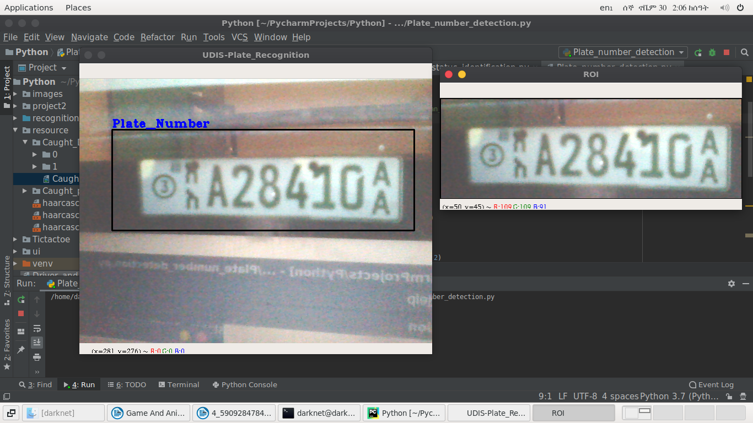

**Figure 13**plate detection

Plate detection and capturing came across with the identification of unlicensed driver.

**CHAPTER SIX**

**System Testing**

**6.1. Objective**

System testing is where complete and integrated software is tested. The purpose of this test is to evaluate the system’s compliance with the specific requirements. It helps in finalizing the software application or product against business and user requirements. It is very important to have a good test coverage in order to test the software application completely and make sure that it is performing well and as per the specifications. While determining the test coverage the test cases should be designed well with maximum possibilities of finding errors and bugs. The test cases should be very effective.

**6.2. Scope**

The scope of the system includes from the live footage feed, detection, recognitions, verification. In addition, sending message.

**6.3. Resource**

We have not used any resources for testing thus far but testing the limit of identification of a user have been tested.

**6.4. Schedule**

Scheduling is the time arrangements given by the responsible body of the system to perform whatever activities designed.

|  |  |  |
| --- | --- | --- |
| **Type of testing** | **Date of testing** | **Tested by** |
| Unit testing | 29/11/2020 | Elias yunus |
| Integration testing | 30/11/2020 | Haymanot Gelana |
| System testing | 30/11/2020 | Elias yunus |

**6.5. Feature to be tested or not to be tested**

**6.5.1. Feature to be tested**

Features to be tested mainly include the things that we have talked about it should be implemented.

**6.5.2. Feature to be tested**

These features are not going to be the system in other word that are the thing not directly related to the system.

|  |  |  |  |
| --- | --- | --- | --- |
| **No** | **Test target** | **Feature to be tasted** | **Tested by** |
| 1 | Functional requirement | General functionality of the system | Haymanot, Gelana, Esubalew, yusuf |
| 2 | Code | Each code and component | Yunus, Elias |

Table10 feature to be tested

6.5.3**. features not to be tasted**

are any activities of the system that are not mostly tested by the developer of the system.

|  |  |  |  |
| --- | --- | --- | --- |
| No | Test target | Feature to be tested | Tested by |
| 1 | Non-functional requirements | Non-functional requirements are not tested except security issue | Haymanot. Esubalew  Gelana Elias |

Table 11 feature not to be tested

**6.6. pass fail criteria**

It is the situation in which the pass and fail criteria of the system are determined using standard terminologies of pass/fail.

|  |  |  |  |
| --- | --- | --- | --- |
| **Functional requirements** | **Expected result** | **Outcome** | **Pass/fail criteria** |
| Add licensed user | pass | pass | pass |
| Acquire image | pass | pass | pass |
| Detect face and plate | pass | pass | pass |
| Recognize face | pass | pass | pass |
| Verify face |  |  |  |
| Send message | pass | fail | fail |

Table 12 pass fail criteria

**Methodology**

Once the image is captured the p face is detected by harr-cascade frontal face detection algorithm

And the plate is detected by using harr-cascade Russian plate number detection algorithm.

**6.7 test case specification**

Table below shows the test specifications of functional requirements used to write the test cases along with the test case numbers for each test case and a short description of the test cases.

|  |  |  |
| --- | --- | --- |
| **Functional requirement No.** | **Test case No.** | **Test case description** |
| F1 | TC1 | To test adding a driver |
| F2 | TC2 | To test the camera can take live footage |
| F3 | TC3 | To test detection accuracy |
| F4 | TC4 | To test recognition accuracy |

Table 13 teste case specification

The following list includes the steps that should be taken by the user, the conditions that should be met for the successful execution of the test case, and the end result that should be met for the test cases to pass.

1.TC1 To test adding license:

* Input: driver face
* Output: save to a folder

TC2. To test the camera can take live footage

* Input: live footage
* Output: display on UDIS window

TC3. To test detection accuracy

* Input: driver face
* Output: detected driver face

TC4. To test recognition accuracy

* Input: driver face
* Output: recognized driver face

**6.8 estimated risk and contingency plan**

|  |  |
| --- | --- |
| **Estimated risk** | **Contingency plan** |
| Lack of knowledge on programming languages | Allocate more time on programming languages |
| The camera may capture face of another person besides the driver | Decrease the angel of the camera as much as possible to capture only the drivers face |
| The time required to develop the software is under-estimated. | Allocate one week than deadline |
| Camera problem | Using phone camera |

Table 14 estimated risk and contingency plan

**­­**

**Chapter Seven**

**Conclusion and Recommendation**

**7.1. Conclusion**

UDIS is a system used to undertake the transport system by identifying unlicensed drivers

This system is a Desktop application to serve the transport as well as the working group of the  
system in different better manner. The benefits of our system can be summarized as improved  
the manual system that have been used in the transport system to identify the unlicensed drivers while on the go using image processing

While developing UDIS system we have gained more knowledge and experience about the  
different phases of the software development, Image processing algorithms and how to solve problems coming together as a team.

Through various challenging, now the team is coming to the end of this project. Those  
different challenges made possible by the cooperation of all the group members. In  
developing this project all group members contributed their full capability with  
maximum interest and all group members get ways toward developing a project.

**7.2. Recommendation**

While doing this system the team has faced different challenges. But by the cooperation of all  
the group members now able to reach to the final result. This UDIS system is developed by all  
the group members through strongly fought those challenge as much as possible. Now all the  
group members recommend to other developers who want to maintain this system, to add some  
features which are not completed on this system.

**Bibliography and References**

**Appendix-A: List Research Papers.**

[1](Waldemar Wójcik, Konrad Gromaszek and Muhtar Junisbekov (July 6th 2016)Face Recognition: Issues, Methods and Alternative Applications, Face Recognition - Semisupervised Classification, Subspace Projection and Evaluation Methods, S. Ramakrishnan, IntechOpen, DOI: 10.5772/62950).

[2] (Impact of Unlicensed Riders on Motorcycle Crash Rates and its Counter Measures – a Case Study at Wolaita Zone, Snnpr, Ethiopia Dawit Kusa Kuma1 , Mengistu Mena Kuleno2 , Dr. Raju Ramesh Reddy3 , Gebrefilmuna Abera4 ).

[3] (Real-Time Multiple Face Recognition using Deep Learning on Embedded GPU System(12-15 November 2018, Hawaii), Savath Saypadith and Supavadee Aramvith Department of Electrical Engineering, Chulalongkorn University, Bangkok, Thailand)

[4] (FaceSurv: A Benchmark Video Dataset for Face Detection and Recognition Across Spectra and Resolutions, Sanchit Gupta, Nikita Gupta, Soumyadeep Ghosh, Maneet Singh, Shruti Nagpal, Mayank Vatsa, and Richa Singh IIIT-Delhi, India)

[5] (Face detection and recognition using haar classifier and lbp histogram, Indrasom Gangopadhyay Anulekha Chatterjee Department of Information Technology Meghnad Saha Institute of Technology Kolkata, India, Department of Information Technology Meghnad Saha Institute of Technology Kolkata, India, Indrajit Das Department of Information Technology Meghnad Saha Institute of Technology Kolkata, India)(International Journal of Advanced Research in Computer Science(Volume 9, No. 2, March-April 2018))

[6] (Image-based Face Detection System, Tsang Tat Man (Oxford Brookes University))

[7] (Face Detection and Recognition, Anil K. Jain( 8/16/2004 ), Michigan State University Department of Computer Science & Engineering 3115 Engineering Building East Lansing, Michigan 48824).

[8] (Development of an automatic facial and license plate recognition (October 2015), Abayomi-Alli Adebayo University of Agriculture, Abeokuta)

[9] Automatic license plate recognition system using opencv library(August, 2018), Denisa Lippaiová, Miroslav Michalko, Ondrej Kainz, František Jakab(Department of Computers and Informatics, Faculty of Electrical Engineering and Informatics, Technical university in Košice, Slovakia)

[10](Continuous Real-Time Vehicle Driver Authentication Using Convolutional Neural Network Based Face Recognition, Ekberjan Derman and Albert Ali Salah , [ekberjan.derman@cutesafe.com](mailto:ekberjan.derman@cutesafe.com) Department of Computer Engineering, Bogazici University, Bebek, Istanbul, Turkey Future Value Creation Research Center, Nagoya University, Nagoya, Japan)

[11] (Real time Face Detection and Recognition in Video Surveillance, Bhavani K , Dhanaraj V , Siddesh N V , Ragav Vijayadev , Uma Rani S, (06 | June -2017) Dayananda Sagar College of Engineering, Shavige Malleshwara Hills, Kumaraswamy Layout, Bengaluru- 560078,

Karnataka, India)

[12] Face Detection and Modeling for Recognition, (Rein-Lien Hsu, Department of Computer Science & Engineering 2002 ).

[13] Face Detection & Recognition Report, Andreea Diana Dinca (University of Birmigham [itinnovation@contacts.bham.ac.uk](mailto:itinnovation@contacts.bham.ac.uk) ).

[14] (Overview and an Approach to Real Time Face Detection and Recognition(September 9th, 2017), Anagha P. Dhote , Vikramsingh R. Parihar Assistant Professor, Department of Computer Science Engineering, PRMCEAM, Badnera-Amravati, India Assistant Professor, Department of Electrical Engineering, PRMCEAM, Badnera-Amravati, India) International Advanced Research Journal in Science, Engineering and Technology

[15] (Face Recognition Documentation (Oct 09, 2019), Adam Geitgey).

[16] (Face Recognition: Issues, Methods and Alternative Applications( October 28th 2015 ), By Waldemar Wójcik, Konrad Gromaszek and Muhtar Junisbekov.( Reviewed: March 9th 2016 Published: July 6th 2016)

[17] Face recognition system with face detection, M.vineetha sai, G.varalahshmi, G.bala kumar, J.prasad ,(Electronics and comminication engineering)

[18] Human Face Recognition Using Image Processing, Khushbu Pandey , Reshma Lilani , Pooja Naik , Geeta Pol Electronics & Telecommunication Engineering Department, KCCEMSR, Thane, India khushipandey05@ gmail.com, reshmalilani1@ gmail.com, 3 Naik.Pooja60@ gmail.com [polgeeta1992@gmail.com](mailto:polgeeta1992@gmail.com).

[19] Face Detection in Real Time Based on HOG, Rekha N, Dr.M.Z.Kurian (International Journal of Advanced Research in Computer Engineering & Technology (IJARCET) Volume 3 Issue 4, April 2014)

[20] Design of Real Time Facial Tracking and Expression Recognition for Human-Robot Interaction, (Mada Sanjaya et al 2018 J. Phys.: Conf. Ser. 1090 012044), International Conference on Computation in Science and Engineering.

[21] Real Time Multiple Face Recognition(March- 2015), Sandhaya Sharma Assistant Professor Department of IT SRM University NCR Campus Modinagar, Ayush Srivastava, Kaustubh, Kandarp Singh B.Tech Student Department of IT SRM University NCR Campus Modinagar, International Journal Of Advanced Research In ISSN: 2394-2819 Engineering Technology & Sciences (editor@ijarets.org).

[22] Design of a Face Recognition System (June 2012), Cahit Gürel -Atilim University , AbdulkadirErden-BeytepeEngineeringAcademy(<https://www.researchgate.net/publication/262875649>).