DATA FLOW DIAGRAM (DFD)
Online Electricity Bill Payment Platform

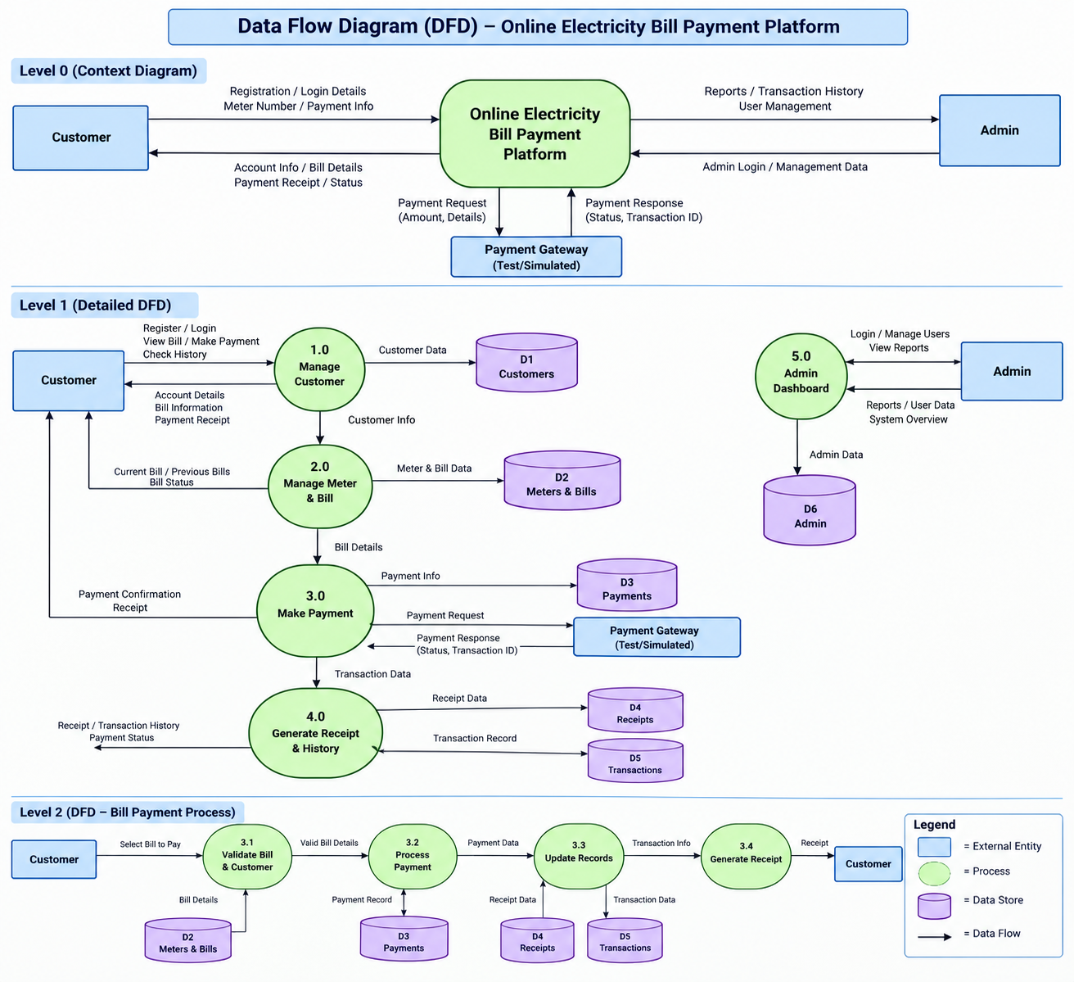
Figure: Data Flow Diagram (DFD) for the Online Electricity Bill Payment Platform

DFD Overview
The Data Flow Diagram shows how information moves between the Customer, Admin, the Online Electricity Bill Payment Platform, the simulated payment gateway, system processes, and the database data stores.
The diagram includes the overall system context (Level 0), the major system processes and data stores (Level 1), and the detailed bill-payment workflow (Level 2).

