DATA FLOW DIAGRAM (LEVEL 1)
Online Electricity Bill Payment Platform
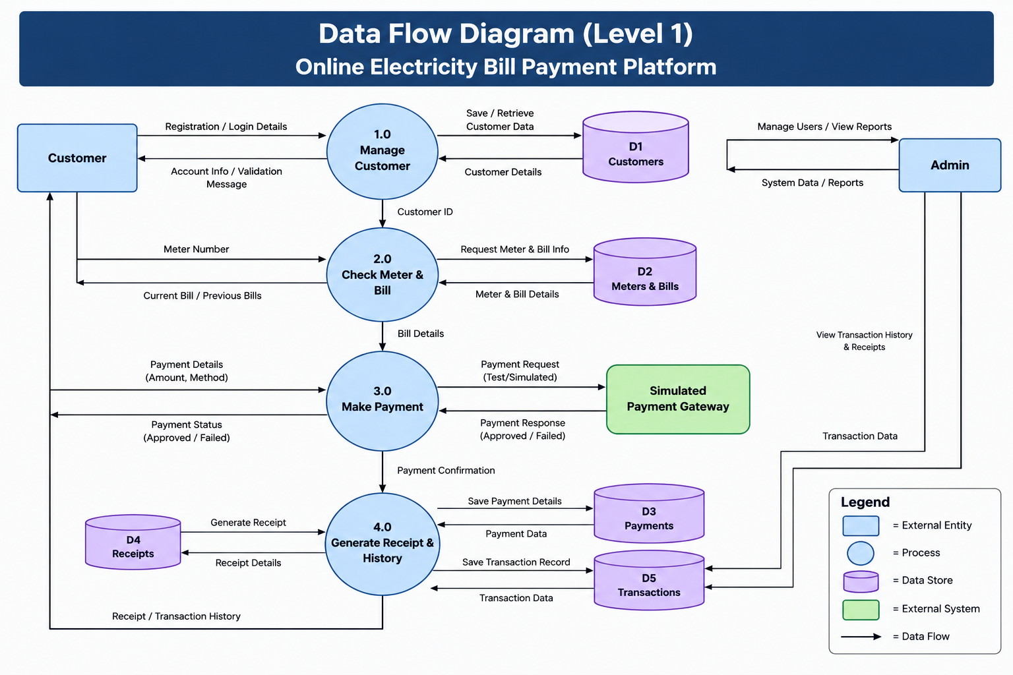
Figure: Level 1 Data Flow Diagram for the Online Electricity Bill Payment Platform

Presentation Explanation
The customer first registers or logs into the system. The system manages the customer information and stores it in the customer data store. The customer then enters a meter number, and the system retrieves the current or previous bill information.
When the customer chooses to pay, the payment details are sent to the simulated payment gateway. The gateway returns an approved or failed payment response. If the payment is processed, the payment and transaction records are stored, and the system generates a receipt and transaction history.
The administrator can manage users and view system reports and transaction information.

