**Tên: Vũ Đức Bình**

**Mssv: 20146478**

**BÀI TẬP CHƯƠNG 4**

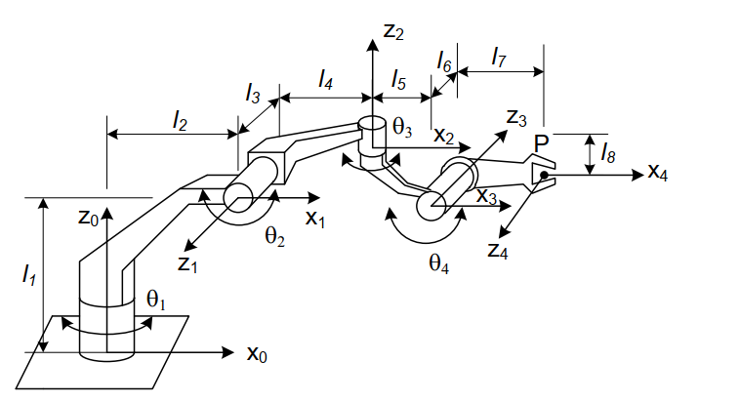

|  |  |  |  |  |  |
| --- | --- | --- | --- | --- | --- |
| # | θ | L | α | d | var |
| 1 | θ1 | L2 |  | L1 | θ1 |
| 2 | θ2 | L4 |  | -L3 | θ2 |
| 3 | θ3 | L5 |  | -L8 | θ3 |
| 4 | θ4 | L7 |  | L6 | θ4 |

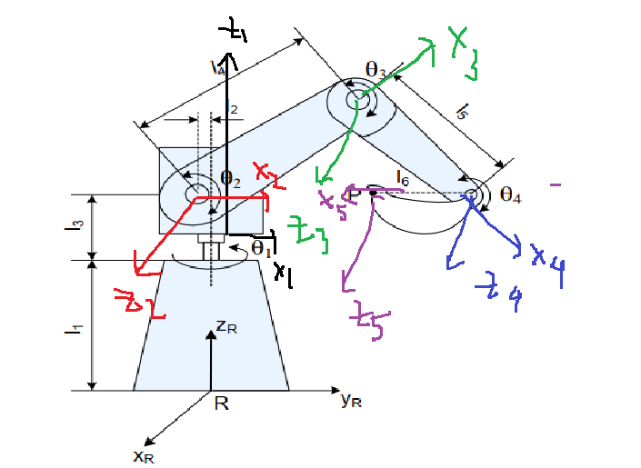

|  |  |  |  |  |  |
| --- | --- | --- | --- | --- | --- |
| # | θ | L | α | d | var |
| 1 | θ1 | 0 |  | L1 | θ1 |
| 2 | θ2 | L2 |  | L3 | θ2 |
| 3 | θ3 | L4 |  | 0 | θ3 |
| 4 | θ 4 | L5 |  | 0 | θ4 |
| 5 | 0 | L6 | 0 | 0 | 0 |

|  |  |  |  |  |  |
| --- | --- | --- | --- | --- | --- |
| # | θ | L | α | d | var |
| 1 | θ1 | 0 |  | L1+L2 | θ1 |
| 2 | θ2 | L3 | 0 | 0 | θ2 |
| 3 | θ3 | L4 |  | 0 | θ3 |
| 4 | θ 4 | L6 |  | L5 | θ4 |

|  |  |  |  |  |  |
| --- | --- | --- | --- | --- | --- |
| # |  |  |  |  | Var |
| 1 |  | 0 |  | L3 |  |
| 2 |  | 0 |  | 0 |  |
| 3 |  | 0 |  | L5+L4 | L5 |
| 4 |  | L6 | 0 | 0 |  |

|  |  |  |  |  |  |
| --- | --- | --- | --- | --- | --- |
| # |  |  |  |  | Var |
| 1 |  | 0 |  | L2 |  |
| 2 |  | L3 |  | 0 |  |
| 3 |  | L4 |  | 0 | L5 |
| 4 |  | 0 | 0 | 0 |  |
| 5 | 0 | L5 | 0 | L6 |  |

|  |  |  |  |  |  |
| --- | --- | --- | --- | --- | --- |
| # |  |  |  |  | Var |
| 1 |  | 0 |  | L1 |  |
| 2 |  | L4+L5 |  | L3+L2 |  |
| 3 |  | 0 |  | L6 | L5 |
| 4 | 0 | 0 | 0 | L7 |  |