QUERENT FTP UTILITY-UPLOAD

User Guide

Topic | Name | Developer | Approved By | Date | Version
Initial Create | Technical Specification | Brijesh Kumar | Praveen Pillai K B | 02,Aug,2015 | 1.0

Table of Contents

1.0. Introduction 1
1.1. Purpose 1
1.2. Scope of Application 1
2.0. FTP Upload Utility 2
2.1.1. UI Description 2
2.2. How to Use 3
2.2.1. FTP Server Configuration 3
2.2.2. FTP Scheduler Configuration 4
2.2.3. Configure Client File Upload Path 5
2.2.4. Trigger the Utility 7
2.2.5. Email Notification 10
2.2.6. Exit the UI 11
3.0. Security and Benefits 12
3.1. Security 12
3.2. Advantages of FTP Upload Utility 13
3.3. Limitations of FTP Upload Utility 13

Introduction

Purpose

The purpose of this document is to explain the usage of Enlightiks FTP Utility Upload. It will explain the purpose, features and the usage of the application.

Scope of Application

The File Transfer Protocol (FTP) is one of the oldest communication protocols the Internet community has been dealing with. It has been designed to allow platform independent data exchange over a network. Regardless, if you are using Windows, Mac or UNIX.
Data dump from client Hospital are shared to Enlightiks in multiple formats (i.e. .csv, .xls, .xlsx, .mdf etc). The data dump can come in progressive manner too. To manually upload data from client location for FTP server of Enlightiks becomes tedious on a regular basis and need extra man power. Enlightiks FTP Utility allows you to schedule/automate the upload process, notify the Admin user once the file is ready to download from FTP.

FTP Upload Utility

UI Description

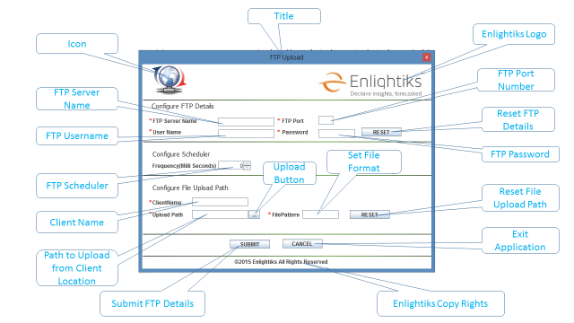
Figure 1

How to Use

FTP Server Configuration

- Execute the Application. An UI will be displayed as shown on Figure2

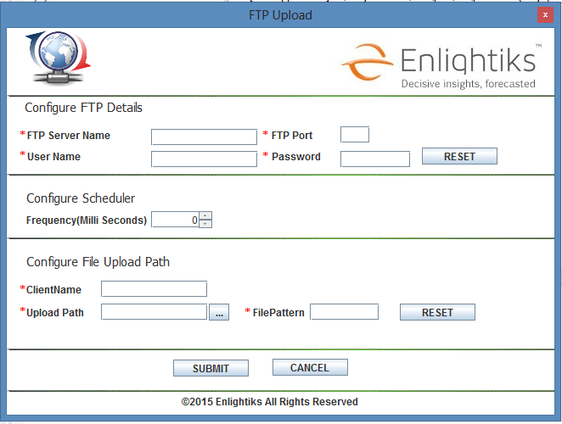
Figure 2
- First Enter the FTP Details like Username, Password, Server name, and Port Number As shown in Figure 3.

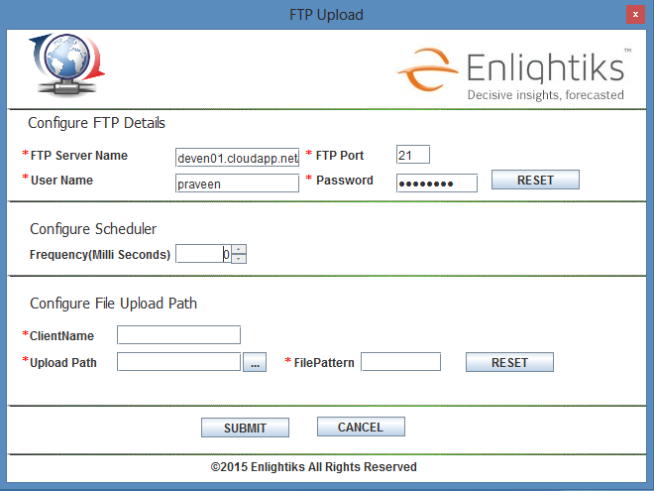
Figure 3

FTP Scheduler Configuration

- After entering the FTP Details, configure scheduler frequency. It’s configured by selecting from the list values (Milliseconds) e.g. 4000 Millisecond (4 Second). As shown in Figure 4.

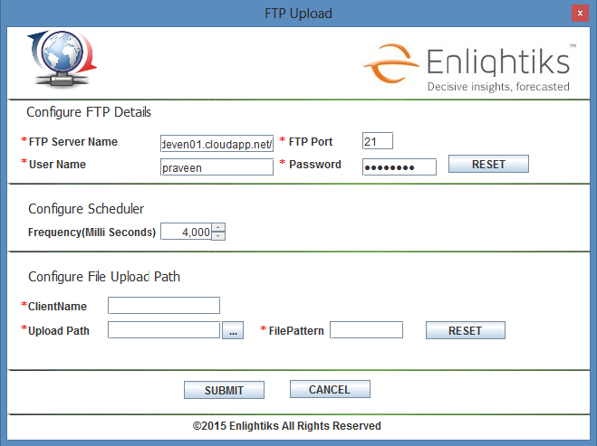
Figure 4

Note: FTP Scheduler Value can be set from 0 to 60,000 Milliseconds (0 to 60 Second i.e. 0 to 1 Minute).

Configure Client File Upload Path

- Enter Client Name for which the FTP is configured. It’s mandatory to distinguish the clients in FTP Server.
- Select the location from where the utility needs to pick files from, in ‘Upload Path’ by clicking on Download Path (…) Button.
- A pop up window will be opened to choose the location from where the files need to be upload as shown in the Figure 5.
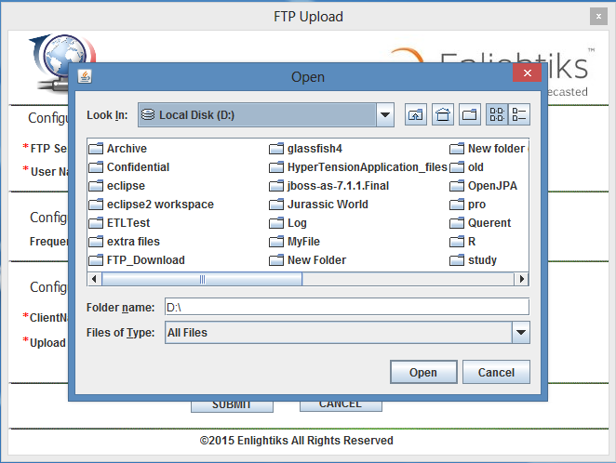
Figure 5
- Select the path and click on ‘Open’ Button of Pop up window to confirm the path.

- Selected path will be displayed in Upload Path ‘Text Field’.

- Set the File Format that we want to upload.

- After entering all information the final UI will be look like as show in Figure 6

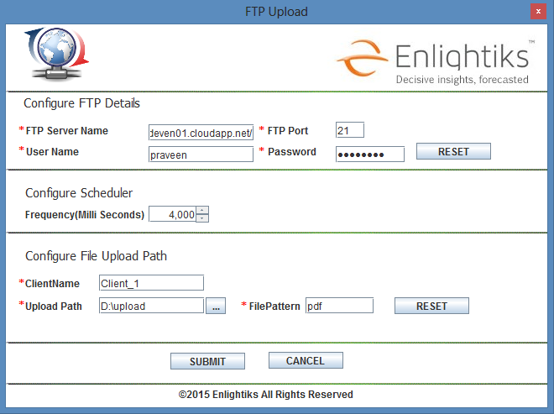

Figure 6

Trigger the Utility

- Click on ‘Submit’ Button to start uploading. Once uploading starts a UI will be exit automatically and a background program will start execution for every interval based on the configuration done in scheduler component.
- If files are available in the location configured the utility will upload into Enlightiks provided FTP server.
- Progress will be shown in console as shown below.
- Uploaded File Name ‘File Name’, ‘File Size’, File Size and Percentage Complete ‘Percentage Complete’ will be displayed on console as shown in Figure 6.

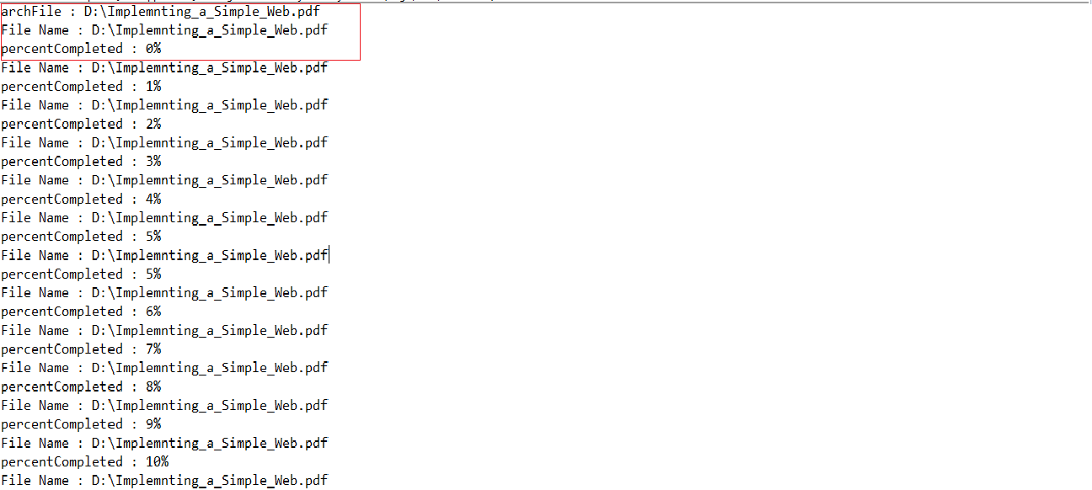
Figure 7
- On completion of upload console showing Percentage Complete ‘Percentage Complete 100%’ as shown in Figure 7.

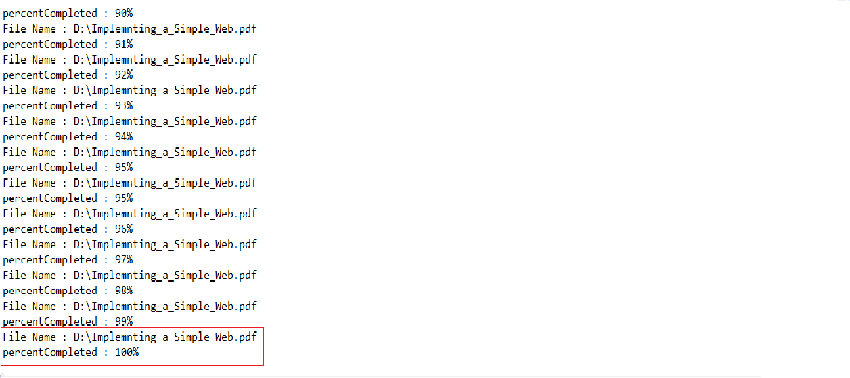
Figure 8
- Files will be moved from Client location and will stored on the Enlightiks provided FTP Server location.
Note: A copy of the files selected will be archive in Client location prior to upload the file.

- The Application will run on every interval as configured through UI to check the availability of files to be uploaded.
- If there are no file available to upload then console display a Message ‘No Files Available to processes’ as shown in Figure 8.
- On the next availability of file the Utility will automatically upload the files.

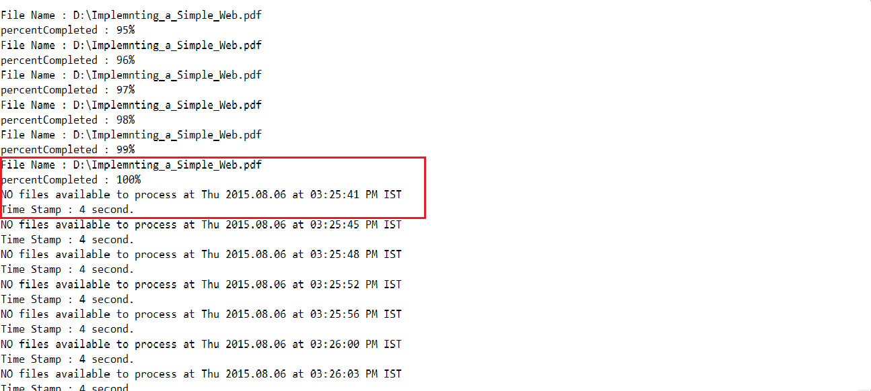

Figure 9

Email Notification

- On completion of upload an email notification will be send by the application to the user as shown in Figure 9 -

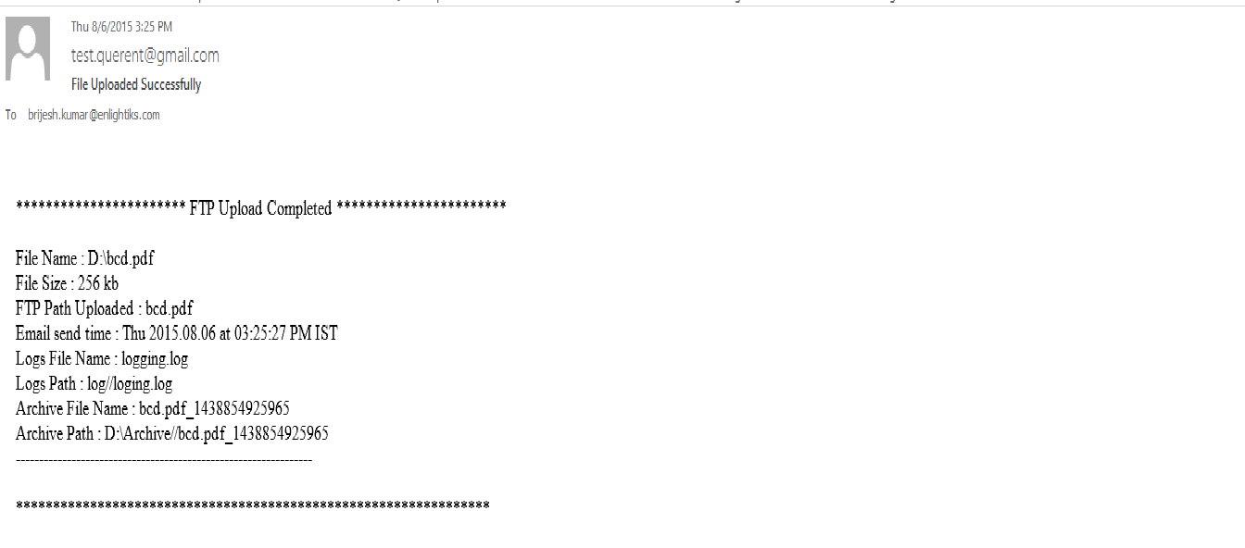
Figure 10

Exit the UI

- To exit from UI click on ‘Cancel’ Button. A pop up window open with ‘Do You Want to Exit’ Message’ as shown in Figure 10.
- To exit console you have to kill the application
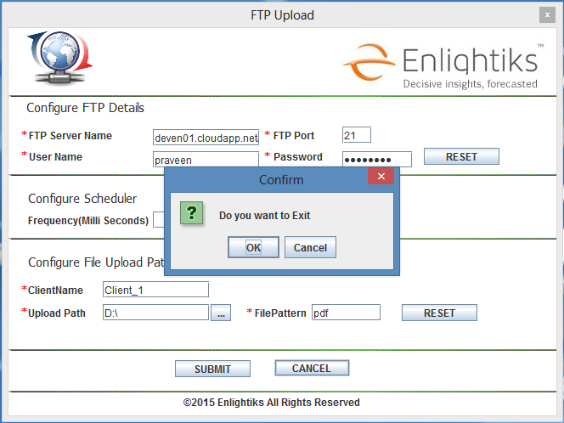
Figure 11

Security and Benefits

Security

For Security purpose an additional protocol layer is used - SSL (Secure Sockets Layer). In such configuration your FTP traffic is secured by the underlying SSL level first.
The encrypted information is then sent over an ordinary (unsecured) TCP/IP network.
Exactly the same mechanism is used when you use your online banking system or when you buy a book on the Internet, except that not the FTP but the HTTP traffic is secured by SSL.

Advantages of FTP Upload Utility

- The Application is Easy to use.
- Automatically schedule a post-transfer action, such as deleting, moving, archiving or renaming the source file.
- Simplify tasks and enhance productivity with built-in capabilities such as email notification, backup, synchronization, compression, post-transfer events, and scheduling of transfers.
- Files can be automatically compressed into .zip format before uploading if file size more than 10 mb.
- Automatic email notifications to alert that a transfer has occurred, and to verify that your transfer has been successful.
- One-time or recurring file transfers can be scheduled to occur automatically.
- Keep records of Transfer History, and Connection Log.
- For new client create directory with client name automatically.
- Remove uploaded file from client location.
- Log rolling allow logs to automatically be archived, or deleted.
- Faster Transfer then HTTP.
- The ability to add items to a “queue” to be upload.

Limitations of FTP Upload Utility

- Usernames, passwords and files are sent in clear text
- Servers can be spoofed to send data to a random port on an unintended computer

