QUERENT FTP UTILITY-DOWNLOAD

User Guide

Topic | Name | Developer | Approved By | Date | Version
Initial Create | Technical Specification | Brijesh Kumar | Praveen Pillai K B | 02,Aug,2015 | 1.0

Table of Contents

1.0. Introduction 1
1.1. Purpose 1
1.2. Scope of Application 1
1.3. FTP Download Utility 2
1.3.1. UI Description 2
1.4. How to Use 3
1.4.1. Select Client Name 3
1.4.2. Select File Format 4
1.4.3. Select File to Download 6
1.4.4. Set the Path 6
1.4.5. Download Selected Files 7
1.4.6. Email Notification 9
1.4.7. Exit the UI 10
2.0. Security and Benefits 11
2.1. Security 11
2.2. Advantages of FTP Download Utility 11
2.3. Limitations of FTP Download Utility 12

Introduction

Purpose

The purpose of this document is to explain the usage of Enlightiks FTP Utility. It will explain the purpose, features and the usage of the application

Scope of Application

The File Transfer Protocol (FTP) is one of the oldest communication protocols the Internet community has been dealing with. It has been designed to allow platform independent data exchange over a network. Regardless, if you are using Windows, Mac or UNIX.
Data dump from client Hospital are shared to Enlightiks in multiple formats (i.e. .csv, .xls, .xlsx, .mdf etc). The data dump can come in progressive manner too. To manually upload data from client location for FTP server of Enlightiks becomes tedious on a regular basis and need extra man power. Enlightiks FTP Utility allows you to schedule/automate the upload process, notify the Admin user once the file is ready to download from FTP.

FTP Download Utility

UI Description
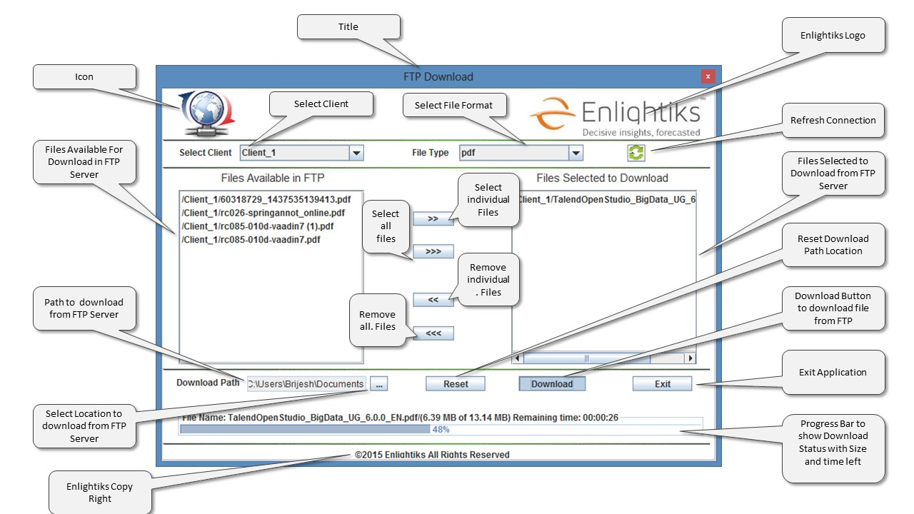
Figure 1

How to Use

Select Client Name

- Execute the Application. An UI will be displayed as shown on Figure2

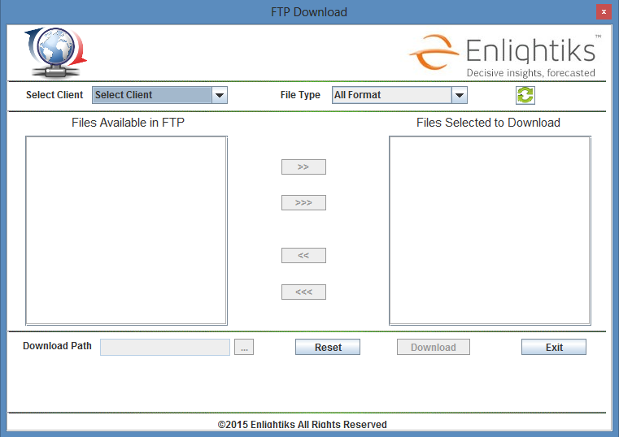
Figure 2
- First Select the Client Name by clicking on the Combo Box ‘Select Client’. As shown in the Figure3

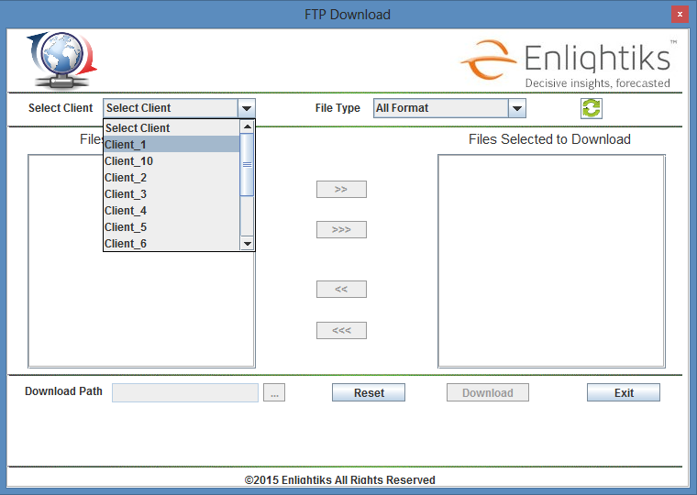
Figure 3
- Once the client is selected all files available in client folder on FTP Server will be displayed in ‘Files Available in FTP’ Box as shown in Figure 4.

Select File Format

- Select File format to filter specific format of files to download from FTP as shown in Figure 4.

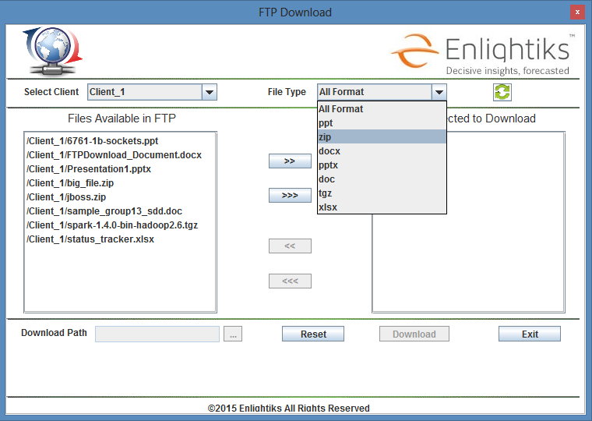
Figure 4

- Based on the file format selected only those files will be viewable in ‘Files Available in FTP’ Box. As shown in Figure 5

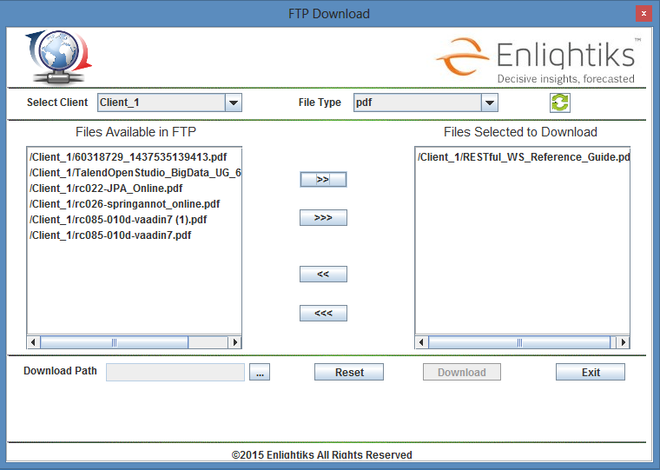
Figure 5

Select File to Download

- To download first select files from ‘Files Available in FTP’ Box and then click on Add (>>) button or Add All (>>>) button.

- Selected file names will be removed from ‘File Available in FTP’ Box and get added into ‘Files Selected to Download’ Box as shown in Figure5

Set the Path

- To download the selected file first set the path to save the downloaded file.

- Click on Download Path (…) Button. A pop up window will be opened to choose the location to where the files need to be saved as shown in the Figure 6
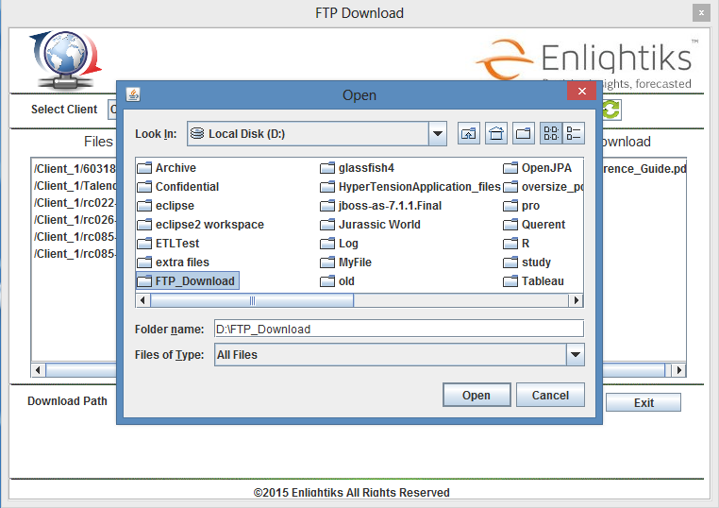
Figure 6
- Select the path and click on ‘Open’ Button of Pop up window to confirm the path.

- Selected path will be displayed in Download Path ‘Text Field’.

Download Selected Files

- Click on ‘Download’ Button to start downloading. Once downloading starts a progress bar on the UI will display the download status using progress bar.

- Download ‘File Name’, File Size, Downloaded File Size and Remaining Time’. Will be displayed as shown in Figure 7.

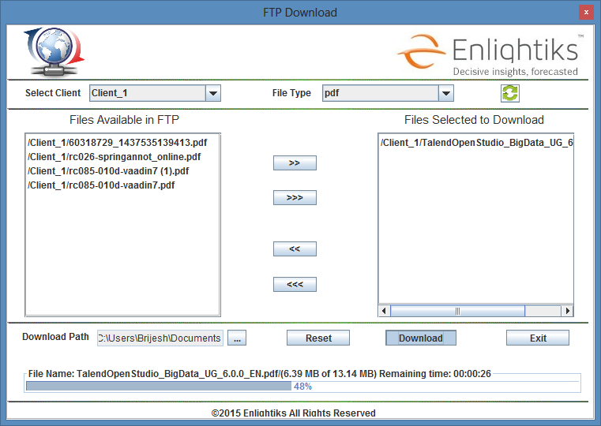
Figure 7
- On completion of download progress bar shows 100% and a pop up window will be displayed as shown in Figure 8

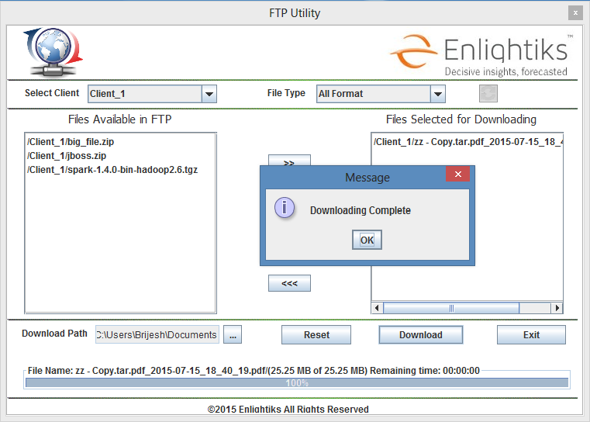
Figure 8
- Files will be moved from FTP location and will stored on the download path selected.
Note: A copy of the files selected will be archive in FTP server prior to download the file
An automated email will be send once the Download is success to the configured email as shown in figure (Need to add)

Email Notification

- On completion of download an email notification will be send by the application to the user as shown in Figure 10 -

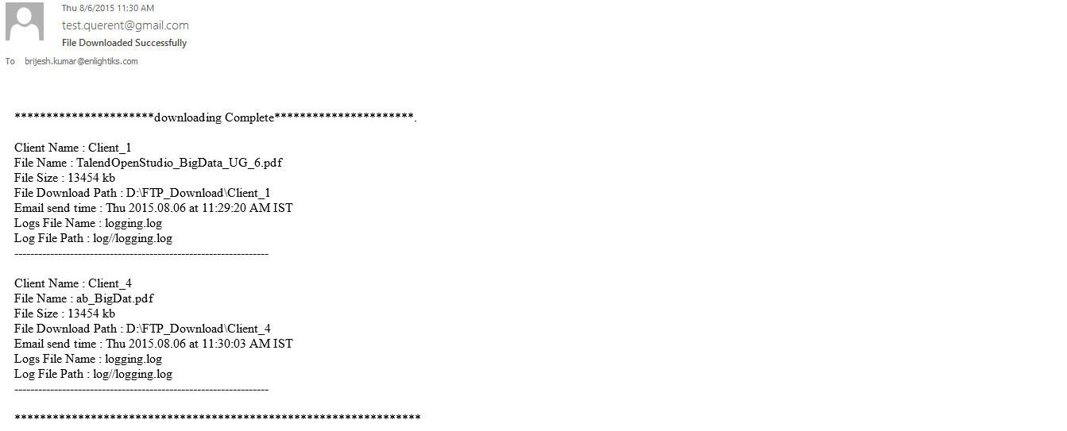
Figure 9

Exit the UI

- To exit from UI click on ‘Exit’ Button. A pop up window open with ‘Do You Want to Exit’ Message’ as shown in Figure 10.
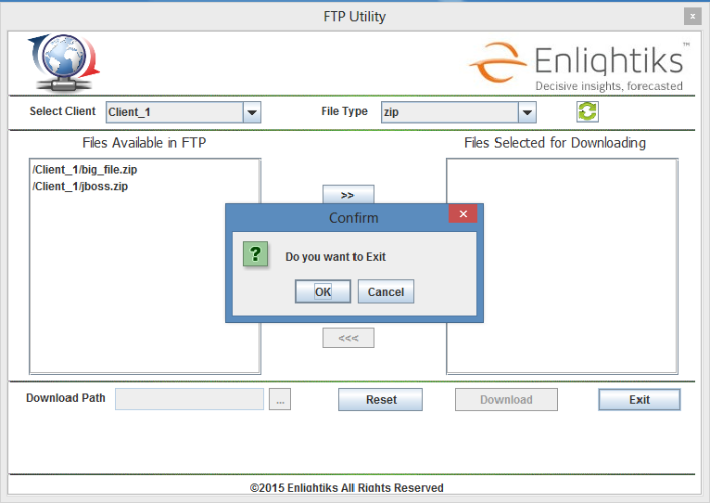
Figure 11

Security and Benefits

Security

For Security purpose an additional protocol layer is used - SSL (Secure Sockets Layer). In such configuration your FTP traffic is secured by the underlying SSL level first.
The encrypted information is then sent over an ordinary (unsecured) TCP/IP network.
Exactly the same mechanism is used when you use your online banking system or when you buy a book on the Internet, except that not the FTP but the HTTP traffic is secured by SSL.

Advantages of FTP Download Utility

- FTP is the fast and efficient way of transferring bulks of data across the internet.
- It has an automatic backup.
- Faster Transfer then HTTP.
- Allows you to download multiple files.
- The ability to add items to a “queue” to be download.

Limitations of FTP Download Utility

- Usernames, passwords and files are sent in clear text
- Servers can be spoofed to send data to a random port on an unintended computer

