FMI MCS10 J1939
Communication Protocol
Version 1.2 - Message Structure Clarified Edition

Item | Description
Product | FMI MCS10
Protocol | SAE J1939, extended CAN identifier
Default baud rate | 250 kbps
Default MCS10 ECU address | 0x7F
Default master address used in examples | 0x00

Revision History
Version | Description
V1.1 | Reorganized document structure and clarified CAN message structure, command frame layout, request/response rules, and broadcast data parsing.

Table of Contents
- 1. Communication Overview
- 2. Message Structure Overview
- 3. CAN Identifier Rules
- 4. Parameter Configuration Protocol (Privilege A)
- 5. Broadcast Data Protocol (Privilege B)
- 6. Quick Configuration Procedures
- 7. Appendix: Encoding Notes and Example Values

1. Communication Overview

1.1 Purpose and Scope
This document describes the FMI MCS10 J1939 communication interface. It explains how to build parameter configuration frames, how to identify request and response frames, and how to parse broadcast data frames.

1.2 Default Communication Settings
Parameter | Default Value | Remark
CAN baud rate | 250 kbps | Can be changed through BasicParam / CAN baudrate.
MCS10 ECU address | 0x7F | Used as destination address in configuration requests and source address in responses/broadcasts.
CAN frame format | 29-bit identifier | Extended CAN frame.
Payload length | 8 bytes | All examples in this document use DLC = 8.
Byte order | Little-endian | Multi-byte payload fields are sent low byte first.

1.3 Two Types of J1939 Messages
Message Type | Purpose | Direction | How to Identify
Parameter Configuration (Privilege A) | Read or write device parameters, reset/save/apply parameters. | Master <-> MCS10 | PGN = 0xEF00. DATA[0] is ctrl, DATA[1] is subcmd.
Broadcast Data (Privilege B) | MCS10 periodically outputs measurement data such as Euler angle, acceleration, gyro, quaternion, etc. | MCS10 -> bus | PGN = 0xFF00 to 0xFF06. DATA[0..7] are measurement fields, not ctrl/subcmd.

Important: configuration frames and broadcast frames have different DATA meanings. In configuration frames, DATA[0] is the control byte. In broadcast frames, DATA[0] is the first data byte of the selected PGN.

2. Message Structure Overview

2.1 One CAN Frame = CAN ID + DATA
Every J1939 frame in this document should be read in two layers: the 29-bit CAN identifier tells the message direction/type, and the 8-byte DATA field carries either a command or measurement data.
Layer | Field | Meaning | Customer Reading Method
Layer 1 | 29-bit CAN ID | Priority, PGN, destination/source address. | First confirm whether this is a configuration frame (0xEF00) or a broadcast data frame (0xFFxx).
Layer 2 | DATA[0..7] | Command bytes or sensor data bytes. | Interpret DATA according to the PGN. Do not use the configuration DATA format for broadcast messages.

2.2 Configuration Frame DATA Structure
Byte | Name | Meaning | Rule
DATA[0] | ctrl | Control byte: RW + Status + MainCommand. | Request: status bits must be 0. Response: status bits report result.
DATA[1] | subcmd | Subcommand / parameter index. | Selects the exact parameter under the MainCommand.
DATA[2..7] | payload | Parameter value or reserved bytes. | Little-endian. Read request uses zeros; write request carries the value.

2.3 Broadcast Frame DATA Structure
Byte | Meaning | Rule
DATA[0..7] | Measurement fields defined by the PGN. | No ctrl byte and no subcmd byte. For example PGN 0xFF00 means DATA[0..5] are Roll/Pitch/Yaw raw values.

2.4 Recommended Reading Order for Customers
- Step 1: Check the CAN ID. If PGN is 0xEF00, parse it as a parameter configuration frame.
- Step 2: If PGN is 0xFF00 to 0xFF06, parse it as a broadcast data frame according to the corresponding PGN table.
- Step 3: For configuration frames, decode DATA[0] first, then DATA[1], then DATA[2..7].
- Step 4: For broadcast frames, directly decode DATA[0..7] using the PGN field definition and scaling formula.

3. CAN Identifier Rules

3.1 Parameter Configuration Identifier, PGN 0xEF00
Parameter configuration uses J1939 Proprietary A style addressing. The destination address is placed in the PDU Specific field, and the source address is placed in the least significant byte.
Direction | 29-bit ID Formula | Example when MCS10=0x7F, Master=0x00
Master -> MCS10 | ID = 0x18EF0000 | (MCS10_Address << 8) | Master_Address | 0x18EF7F00
MCS10 -> Master | ID = 0x18EF0000 | (Master_Address << 8) | MCS10_Address | 0x18EF007F

ID Byte | Example Master -> MCS10 | Meaning
0x18 | Priority / data page field used by examples | Fixed in this document examples.
0xEF | PDU Format | Indicates PGN 0xEF00, parameter configuration.
0x7F | Destination Address | MCS10 ECU address.
0x00 | Source Address | Master address.

3.2 Broadcast Data Identifier
Broadcast data frames use the selected data PGN and the MCS10 ECU address as the source address. There is no destination address in the broadcast ID.
Direction | 29-bit ID Formula | Example
MCS10 Broadcast | ID = 0x18000000 | (PGN << 8) | MCS10_Address | Euler PGN 0xFF00 from MCS10 0x7F: 0x18FF007F

4. Parameter Configuration Protocol (Privilege A)

4.1 Command Frame Format
Byte | Field | Description | Example
0 | ctrl | RW + Status + MainCommand. | 0x81 = Write + STATUS_OK + BasicParam.
1 | subcmd | Parameter index under the selected MainCommand. | 0x05 = Output Enable.
2-7 | payload | Parameter value, little-endian. Unused bytes shall be 0. | 0x07 0x00 = Euler + Accel + Gyro enabled.

4.2 Ctrl Byte Definition
Bit | Field | Mask | Meaning
7 | RW | 0x80 | 0 = Read, 1 = Write.
6-4 | Status | 0x70 | Valid mainly in response frames. Request frames shall set this field to 0.
3-0 | MainCommand | 0x0F | 0 = Control, 1 = BasicParam, 2 = SystemParam.

Status | Decoded Meaning
0x0 | STATUS_OK
0x1 | STATUS_ILLEGAL_CMD response MainCommand has error.
0x2 | STATUS_ILLEGAL_SUBCMD response SubCommand has error.
0x3 | STATUS_ILLEGAL_PARAM response Param has error.
0x4 | STATUS_REJECTED response lack of prerequisite configuration conditions.

4.3 Request and Response Rules
Operation | Request DATA | Successful Response DATA | Explanation
Read parameter | ctrl=Read, subcmd=parameter index, payload=0 | ctrl=Read + STATUS_OK, same subcmd, payload=value | Master reads one parameter value from MCS10.
Write parameter | ctrl=Write, subcmd=parameter index, payload=new value | ctrl=Write + STATUS_OK, same subcmd, payload=accepted value or echo | Master writes one parameter value to MCS10.
Control command | ctrl=Write + Control, subcmd=control index, payload=0 | ctrl=Write + STATUS_OK + Control, same subcmd | Control commands are write only.
Error response | N/A | ctrl contains non-zero status bits | Check status bits 6-4 to identify illegal command, illegal subcommand, illegal parameter, or rejected.

Customer tip: for a configuration frame, always decode ctrl first. After ctrl is known, subcmd tells which parameter is being operated, and payload tells the value.

4.4 MainCommand List
MainCommand | Name | Access | Description
0 | Control | Write only | Reset, save parameters, load defaults, apply address/baudrate change.
1 | BasicParam | Read / Write | Common device parameters such as J1939 enable, SN, address, baudrate, work mode, output enable, output rate, LPF, termination resistor, install Euler angle.
2 | SystemParam | Reserved / system use | System parameter group.

4.5 Control Commands, MainCommand = 0
subcmd | Command | Request DATA | Description
0x00 | System Reset | 80 00 00 00 00 00 00 00 | Reset the device.
0x01 | Instant Save Param | 80 01 00 00 00 00 00 00 | Save current parameters immediately.
0x02 | Load Default Param | 80 02 00 00 00 00 00 00 | Restore default parameters.
0x03 | Param Take Effect Instant | 80 03 00 00 00 00 00 00 | Apply ECU address, baudrate and termination resistor changes immediately.
0x04 | Fusion Filter Reset | 80 04 00 00 00 00 00 00 | Reset Fusion Filter(DOZER)

4.6 Basic Parameters, MainCommand = 1
subcmd | Parameter | Data Length | Access | Value / Range | Read DATA Example | Write DATA Example
0x00 | Enable J1939 | 1 byte | R/W | 0=Disable, 1=Enable | 01 00 00 00 00 00 00 00 | 81 00 01 00 00 00 00 00
0x01 | Device SN | 6 bytes | R/W | Device serial number, little-endian | 01 01 00 00 00 00 00 00 | 81 01 56 34 12 00 00 00
0x02 | ECU J1939 address | 1 byte | R/W | 0x01-0x7F | 01 02 00 00 00 00 00 00 | 81 02 80 00 00 00 00 00
0x03 | CAN baudrate | 4 bytes | R/W | 250000, 500000, 800000, 1000000 | 01 03 00 00 00 00 00 00 | 81 03 20 A1 07 00 00 00
0x04 | Work Mode | 1 byte | R/W | See 4.7.1 | 01 04 00 00 00 00 00 00 | 81 04 01 00 00 00 00 00
0x05 | Output Enable | 2 bytes | R/W | Bit mask, see 4.7.2 | 01 05 00 00 00 00 00 00 | 81 05 07 00 00 00 00 00
0x06 | Output Rate | 4 bytes | R/W | 1,5,10,20,50,100 Hz | 01 06 00 00 00 00 00 00 | 81 06 14 00 00 00 00 00
0x07 | LowPassFilter Config | 3 bytes | R/W | Order, cutoff, disable flag | 01 07 00 00 00 00 00 00 | 81 07 02 04 01 00 00 00
0x08 | Termination Resistor | 1 byte | R/W | 0=Disable, 1=Enable | 01 08 00 00 00 00 00 00 | 81 08 01 00 00 00 00 00
0x09 | Install EulerAngle | 6 bytes | R/W | Roll, Pitch, Yaw as int16 degrees | 01 09 00 00 00 00 00 00 | 81 09 5A 00 00 00 5A 00
0x0A | FusionSlaveID | 1 byte | R/W | 0x01-0x7F | 01 0A 00 00 00 00 00 00 | 81 0A 60 00 00 00 00 00
0x0B | HeartPeriod | 2 byte | R/W | Unit:ms | 01 0B 00 00 00 00 00 00 | 81 0B F4 01 00 00 00 00
0x0C | OperateStatus | 1 byte | R/W | 5: operate 127:pre-operate | 01 0C 00 00 00 00 00 00 | 81 0C 7F 00 00 00 00 00
0x0D | VendorID | 4 byte | R |  | 01 0D 00 00 00 00 00 00
0x0E | ProductCode | 4 byte | R |  | 01 0E 00 00 00 00 00 00
0x0F | InstallOrientation | 1 byte | R/W |  | 01 0F 00 00 00 00 00 00 | 81 0F 00 00 00 00 00 00

4.7 SystemParams, MainCommand = 2 (Multi-packet reading, TP transport protocol)
subcmd | Command | Request DATA
0x00 | Firmware Version | 02 00 00 00 00 00 00 00
0x01 | System Config | 02 01 00 00 00 00 00 00
RTS/CTS peer-to-peer multi-packet transmission

4.7.1 Firmware Version
AHRS_H3_A3.0_f412b52ff68ec8253f0
Communication Process：
SendID J1939:18EF7F80 Data:02 00 00 00 00 00 00 00
RecvID J1939:1CEC807F Data:10 20 00 05 01 00 EF 00
SendID J1939:1CEC7F80 Data:11 01 01 FF FF 00 EF 00
RecvID J1939:1CEB807F Data:01 41 48 52 53 5F 48 33
SendID J1939:1CEC7F80 Data:11 01 02 FF FF 00 EF 00
RecvID J1939:1CEB807F Data:02 5F 41 33 2E 30 5F 66
SendID J1939:1CEC7F80 Data:11 01 03 FF FF 00 EF 00
RecvID J1939:1CEB807F Data:03 34 31 32 62 35 32 66
SendID J1939:1CEC7F80 Data:11 01 04 FF FF 00 EF 00
RecvID J1939:1CEB807F Data:04 66 36 38 65 63 38 32
SendID J1939:1CEC7F80 Data:11 01 05 FF FF 00 EF 00
RecvID J1939:1CEB807F Data:05 35 33 66 30 FF FF FF
SendID J1939:1CEC7F80 Data:13 20 00 05 FF 00 EF 00

4.7.2 System Config
Work Mode : 4
LowpassFilter: 0 3 0
Install Angle: 0 0 0
Device SN : 1234567
Sys Cfg : 6A 0 0
Data Rate : 100
Fusion Cfg : 7A
CAN Cfg : 500000 7F 0
CANopen TPDO1: 0 1FF 0 00000000 00000000 00000000 00000000
CANopen TPDO2: 0 2FF 0 00000000 00000000 00000000 00000000
CANopen TPDO3: 0 3FF 0 00000000 00000000 00000000 00000000
CANopen TPDO4: 0 4FF 0 00000000 00000000 00000000 00000000
J1939 Cfg : 1 00000017
ParaVersion : 1.0

4.8 Detailed Value Definitions

4.8.1 Work Mode Values
Value | Mode | Description
0 | Basic Tilt | Basic tilt mode.
1 | Dynamic Tilt | Recommended for construction machinery such as excavators.
2 | Magnetic Heading | Magnetic heading mode.
3 | Bulldozer | C-Frame / master mode. Output messages are configured automatically.
4 | Bulldozer | Blade / slave mode. Output messages are configured automatically.
5 | Dynamic Tilt, Smooth Convergence | Dynamic tilt mode with slow/smooth convergence.

4.8.2 Output Enable Bit Mask
Bit Mask | Message | PGN | Description
0x0001 | Euler | 0xFF00 | Roll, Pitch, Yaw.
0x0002 | Accel | 0xFF01 | Acceleration X/Y/Z.
0x0004 | Gyro | 0xFF02 | Angular velocity X/Y/Z.
0x0008 | Mag | 0xFF03 | Magnetic field X/Y/Z.
0x0010 | Time | 0xFF04 | Time data.
0x0020 | Quaternion | 0xFF05 | Attitude quaternion.
0x0040 | Dozer | 0xFF06 | Swing angle data.

Example: enable Euler + Accel + Gyro = 0x0001 + 0x0002 + 0x0004 = 0x0007. Because payload is little-endian, DATA[2]=0x07 and DATA[3]=0x00.

4.8.3 LowPassFilter Encoding
Payload Byte | Name | Value | Meaning
DATA[2] | Order | 0x00 / 0x01 / 0x02 | Order 1 / 2 / 3. Default is 0x00.
DATA[3] | Cutoff | 0x00 | 0.08 Hz
DATA[3] | Cutoff | 0x01 | 0.16 Hz
DATA[3] | Cutoff | 0x02 | 0.32 Hz
DATA[3] | Cutoff | 0x03 | 0.64 Hz, default
DATA[3] | Cutoff | 0x04 | 1.28 Hz
DATA[3] | Cutoff | 0x05 | 2.56 Hz
DATA[3] | Cutoff | 0x06 | 5.12 Hz
DATA[3] | Cutoff | 0x07 | 10.24 Hz
DATA[4] | Disable LPF | 0x00 / 0x01 | 0 = enable LPF, 1 = disable LPF.

4.8.4 InstallOrientation
Value | Orientation
0 | IO_TopFront
1 | IO_TopRight
2 | IO_TopBack
3 | IO_TopLeft
4 | IO_BottomFront
5 | IO_BottomRight
6 | IO_BottomBack
7 | IO_BottomLeft
8 | IO_RightFront
9 | IO_RightTop
10 | IO_RightBack
11 | IO_RightBottom
12 | IO_LeftFront
13 | IO_LeftTop
14 | IO_LeftBack
15 | IO_LeftBottom
16 | IO_FrontTop
17 | IO_FrontRight
18 | IO_FrontBottom
19 | IO_FrontLeft
20 | IO_BackTop
21 | IO_BackRight
22 | IO_BackBottom
23 | IO_BackLeft
IO_TopFront: Label facing up, X-axis pointing forward
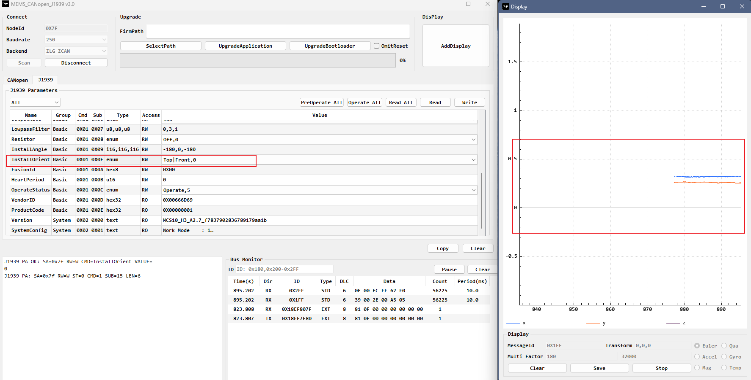
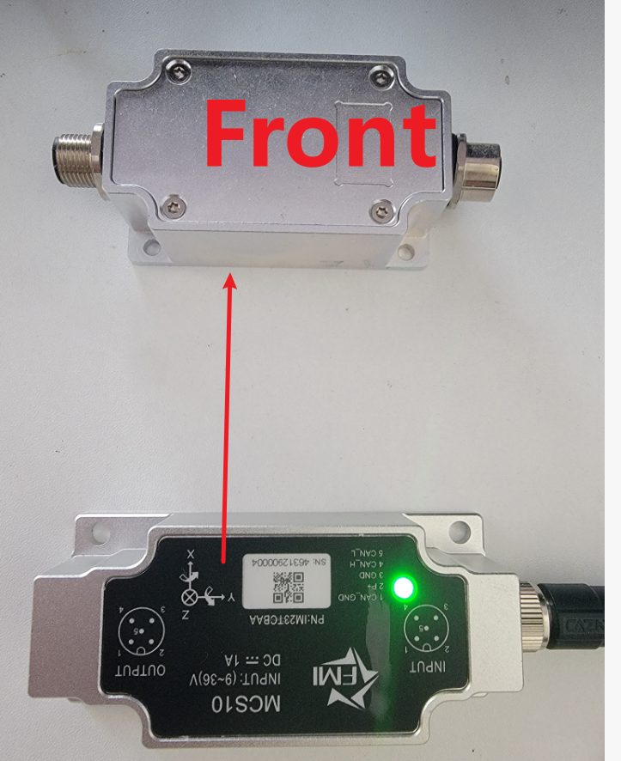

IO_LeftTop: Label facing left, X-axis pointing up
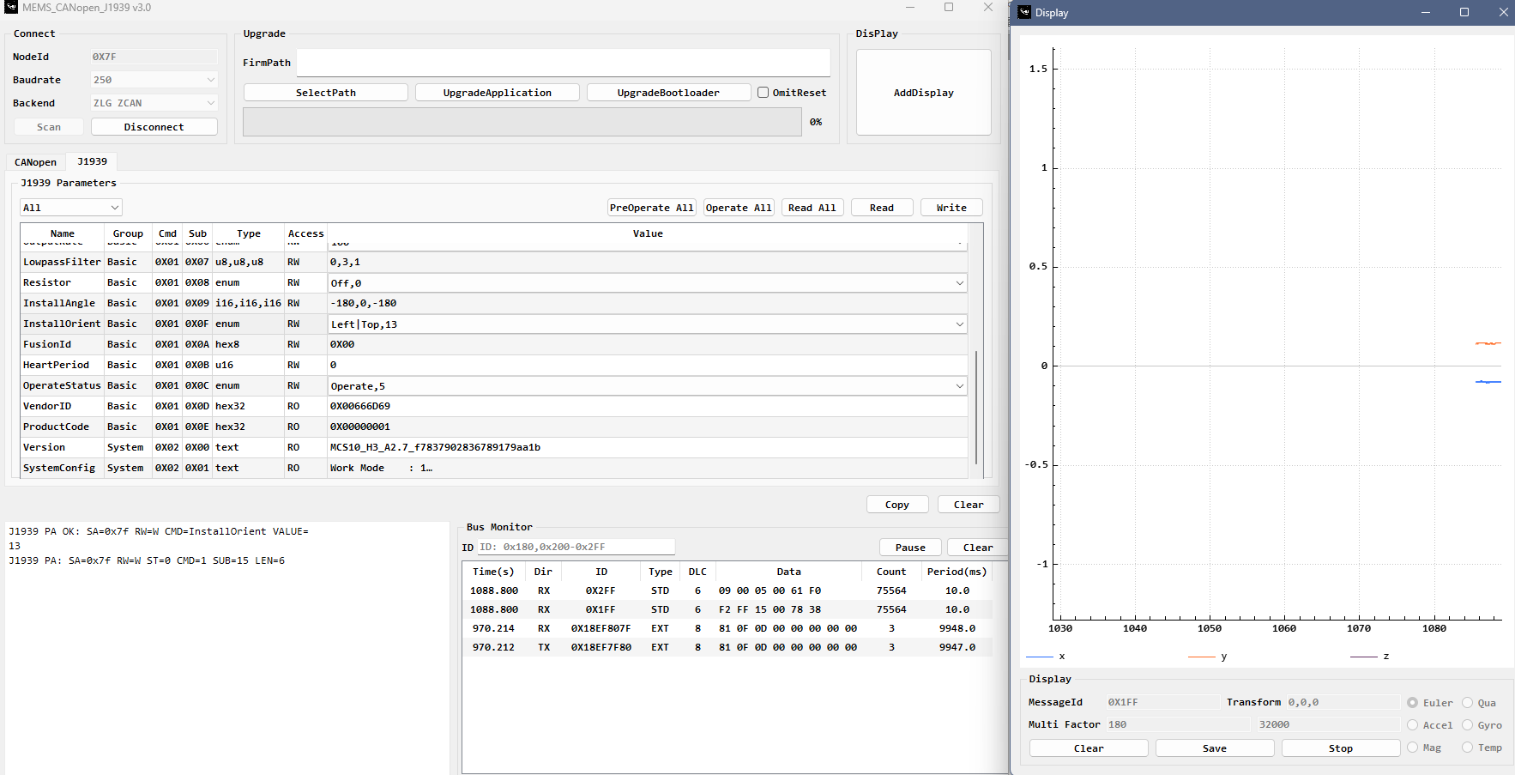
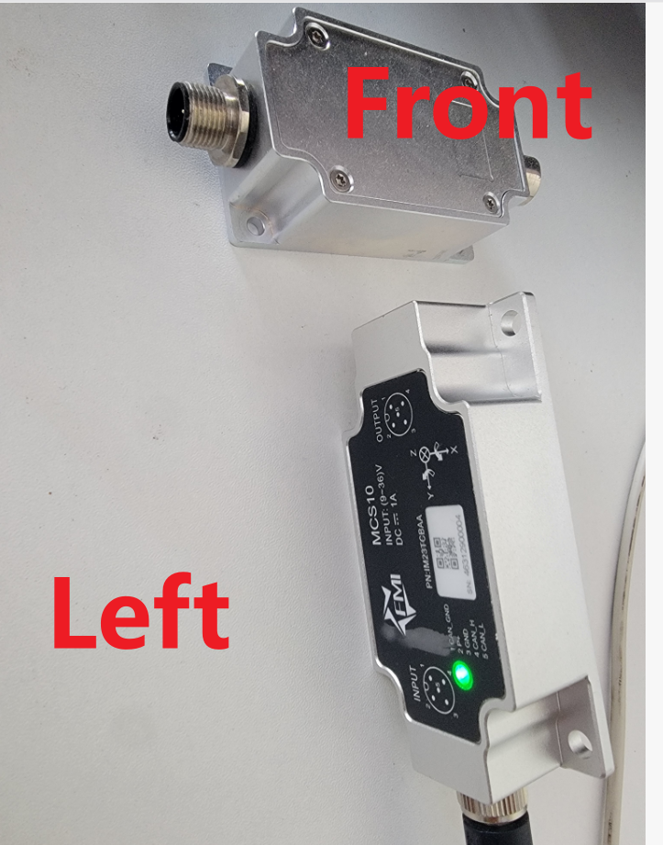

4.9 Fully Annotated Configuration Examples

4.9.1 Write Output Enable = Euler + Accel + Gyro
Item | Value | Explanation
CAN ID | 0x18EF7F00 | Master 0x00 sends to MCS10 address 0x7F.
DATA | 81 05 07 00 00 00 00 00 | 8-byte command frame.
DATA[0] = 0x81 | Write + STATUS_OK + BasicParam | Bit7=1 means Write, bits6-4=0, bits3-0=1 BasicParam.
DATA[1] = 0x05 | Output Enable | Selects Output Enable parameter.
DATA[2..3] = 07 00 | 0x0007 | Enable Euler, Accel, and Gyro messages.
DATA[4..7] | 00 00 00 00 | Unused bytes set to 0.

4.9.2 Write CAN Baudrate = 500000 bps
Item | Value | Explanation
CAN ID | 0x18EF7F00 | Master 0x00 sends to MCS10 address 0x7F.
DATA | 81 03 20 A1 07 00 00 00 | Write BasicParam / CAN baudrate.
Payload | 20 A1 07 00 | Little-endian 0x0007A120 = 500000 decimal.
After writing | 80 03 00 00 00 00 00 00 | Send Param Take Effect Instant when address or baudrate should take effect immediately.

4.9.3 Read Install EulerAngle
Frame | DATA | Explanation
Request | 01 09 00 00 00 00 00 00 | Read BasicParam, subcmd 0x09.
Response example | 01 09 A6 FF 00 00 00 00 | Roll = int16 0xFFA6 = -90, Pitch = 0, Yaw = 0.
Response example | 01 09 5A 00 00 00 00 00 | Roll = int16 0x005A = 90, Pitch = 0, Yaw = 0.

4.10 Parameter configuration notes
To use J1939, you must first enable J1939; otherwise, some parameters cannot be configured.
The following applies to MCS10 firmware version >= A2.4.
- Successfully setting up bulldozer mode will automatically configure the output parameters, eliminating the need for manual configuration changes, which could affect system operation.
- Modifying the address, baudrate or termination resistor will not take effect immediately; writing 0x03 in section 4.5 will make it take effect immediately.

5. Broadcast Data Protocol (Privilege B)

5.1 Broadcast Data Type and PGN
Data Type | PGN | CAN ID Example, MCS10=0x7F | Description
Euler Angles | 0xFF00 | 0x18FF007F | Roll, Pitch, Yaw.
Acceleration | 0xFF01 | 0x18FF017F | X/Y/Z acceleration.
Gyroscope | 0xFF02 | 0x18FF027F | X/Y/Z angular velocity.
Magnetometer | 0xFF03 | 0x18FF037F | X/Y/Z magnetic field.
Time | 0xFF04 | 0x18FF047F | Time data.
Quaternion | 0xFF05 | 0x18FF057F | Attitude quaternion.
Dozer | 0xFF06 | 0x18FF067F | Swing angle data.
Sync | 0xFFFE | 0x18FFFE00 | Sync Time
HeartBeat | 0xFFFF | 0x18FFFF7F | HeartBeat msg

5.2 Scaling and Physical Value Conversion
Unless otherwise specified, broadcast raw data is signed int16 in little-endian format. Convert raw values to physical values using the table below.
Data Type | Scale | Physical Unit | Formula
Euler Angles | 180 / 32000.0 | degree | Euler_deg = int16_raw x (180 / 32000.0)
Quaternion | 1 / 32000.0 | None | Quaternion = int16_raw x (1 / 32000.0)
Acceleration | 8 / 32000.0 | g | Acc_g = int16_raw x (8 / 32000.0)
Gyroscope | 500 / 32000.0 | degree/sec | Gyro_dps = int16_raw x (500 / 32000.0)
Magnetometer | 500 / 32000.0 | uT | Mag_uT = int16_raw x (500 / 32000.0)

Note: Install EulerAngle in BasicParam uses int16 degree values in the configuration payload. Broadcast Euler Angles use the scaling formula above.

5.3 Broadcast Data Field Definitions

5.3.1 Euler Angle, PGN 0xFF00
Byte Offset | Parameter | Type | Description
0-1 | Roll | int16 | Roll angle raw value
2-3 | Pitch | int16 | Pitch angle raw value
4-5 | Yaw | int16 | Yaw angle raw value
6-7 | Reserve | uint16 | Reserved

5.3.2 Acceleration, PGN 0xFF01
Byte Offset | Parameter | Type | Description
0-1 | AccX | int16 | X-axis acceleration raw value
2-3 | AccY | int16 | Y-axis acceleration raw value
4-5 | AccZ | int16 | Z-axis acceleration raw value
6-7 | Reserve | uint16 | Reserved

5.3.3 Gyroscope, PGN 0xFF02
Byte Offset | Parameter | Type | Description
0-1 | GyroX | int16 | X-axis angular velocity raw value
2-3 | GyroY | int16 | Y-axis angular velocity raw value
4-5 | GyroZ | int16 | Z-axis angular velocity raw value
6-7 | Reserve | uint16 | Reserved

5.3.4 Magnetometer, PGN 0xFF03
Byte Offset | Parameter | Type | Description
0-1 | MagX | int16 | X-axis magnetic field raw value
2-3 | MagY | int16 | Y-axis magnetic field raw value
4-5 | MagZ | int16 | Z-axis magnetic field raw value
6-7 | Reserve | uint16 | Reserved

5.3.5 Quaternion, PGN 0xFF05
Byte Offset | Parameter | Type | Description
0-1 | Q0 | int16 | Scalar component raw value
2-3 | Q1 | int16 | X component raw value
4-5 | Q2 | int16 | Y component raw value
6-7 | Q3 | int16 | Z component raw value

5.3.6 Dozer Data, PGN 0xFF06
Byte Offset | Parameter | Type | Description
0-1 | Status | uint16 | Flag bits
2-3 | BladeAngle | int16 | Blade angle raw value
4-7 | Reserve | byte[4] | Reserved

Status
No. | Name | Bit Mask | Meaning
1 | Init | 0X0001 | Heading has been established before
2 | Valid | 0X0002 | Current heading is valid

5.3.7 HeartBeat, PGN 0xFFFF
Byte Offset | Parameter | Type | Description
0-0 | Status | Uint8 | Operate status
1-7 | Reserve | byte[7] | Reserved

5.4 Fully Annotated Broadcast Example
Item | Value | Explanation
CAN ID | 0x18FF007F | PGN 0xFF00 = Euler Angle, source address = 0x7F.
DATA | 00 40 00 00 00 00 00 00 | Euler broadcast data, not a configuration command.
Roll raw | 0x4000 = 16384 | Physical roll = 16384 x 180 / 32000 = 92.16 degree.
Pitch raw | 0x0000 | Physical pitch = 0 degree.
Yaw raw | 0x0000 | Physical yaw = 0 degree.

6. Quick Configuration Procedures

6.1 Enable J1939 Output
- Send BasicParam / Enable J1939 write command: CAN ID = 0x18EF7F00, DATA = 81 00 01 00 00 00 00 00.
- Configure Output Enable according to required broadcast types. Example Euler + Accel + Gyro: DATA = 81 05 07 00 00 00 00 00.
- Configure Output Rate. Example 20 Hz: DATA = 81 06 14 00 00 00 00 00.
- Save parameters if required: DATA = 80 01 00 00 00 00 00 00.( Optional, as the system will automatically save the parameters after 3 seconds. )

6.2 Change ECU Address or Baud Rate
- Write the new ECU address or CAN baudrate using BasicParam.
- Send Param Take Effect Instant: DATA = 80 03 00 00 00 00 00 00.
- After the setting takes effect, use the new address or baud rate for subsequent communication.

6.3 Recommended Customer Debug Checklist
Check Item | Expected Result
CAN frame type | Extended 29-bit frame, DLC = 8.
Configuration request ID | For default address, master to MCS10 should use 0x18EF7F00.
Configuration response ID | For default address, MCS10 to master should use 0x18EF007F.
Read request payload | DATA[2..7] should be zero.
Write request payload | DATA[2..7] should contain the little-endian value.
Response status | Status bits in DATA[0] should be 0 for success.
Broadcast parsing | Use PGN field table. Do not parse broadcast DATA[0] as ctrl.

7. Bulldozer Mode Application
The following applies to MCS10 firmware version >= A2.6.
Prerequisites: baud rate 500 kbps, J1939 enabled.
- Configure the blade sensor: work mode to 0x4, configure the FusionID as the C-Frame sensor ID.
- Configure the C-Frame sensor: work mode to 0x3.
- Configure the body sensor: work mode to 0x1, and configure the output data and output rate.

