1 Hardware Connection

Harness Color Definitions
Color | Function
White | Power +
Blue | Power -
Gray | CAN Low
Black (thin) | CAN High
Brown, black (thick) | Shield ground

1.2 Notes
By default, the PC software uses the CAN1 channel of the analyzer.
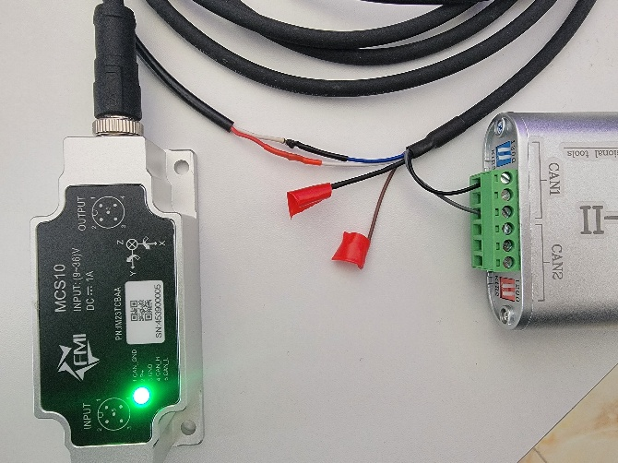

2 PC Software Usage - MEMS_CANopen_J1939 V2.6
Item | Current software behavior
Application | MEMS_CANopen_J1939 V2.6
Default target | NodeId 0x7F, 250 kbit/s
CAN channel | CAN1 channel of the analyzer by default
Numeric input | Decimal or hexadecimal with 0x prefix, for example 127 or 0x7F

2.1 Connect and read CANopen basic parameters
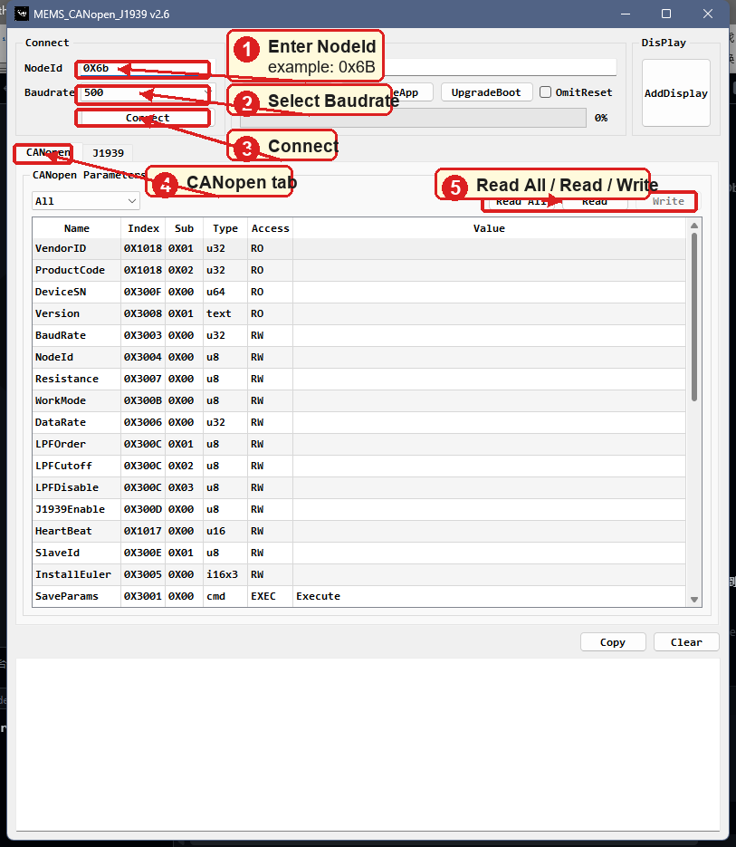

2.2 CANopen TPDO, NMT, and calibration actions
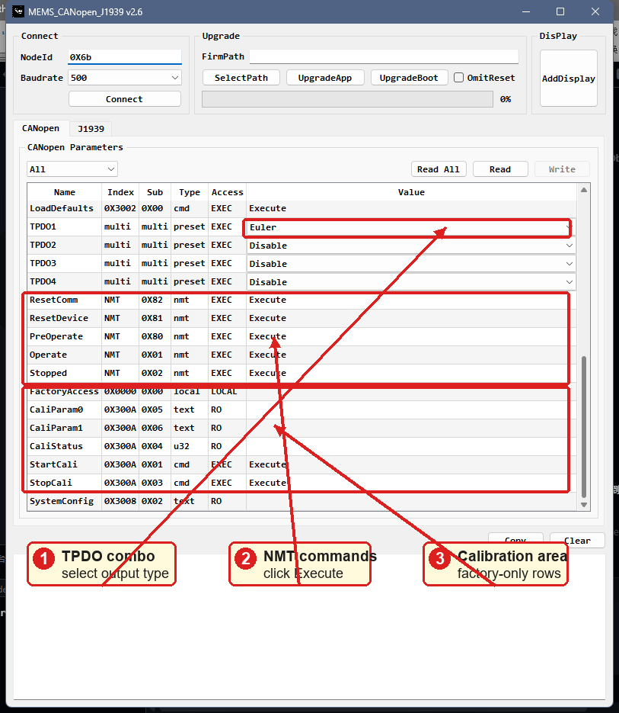

2.3 J1939 parameter command area
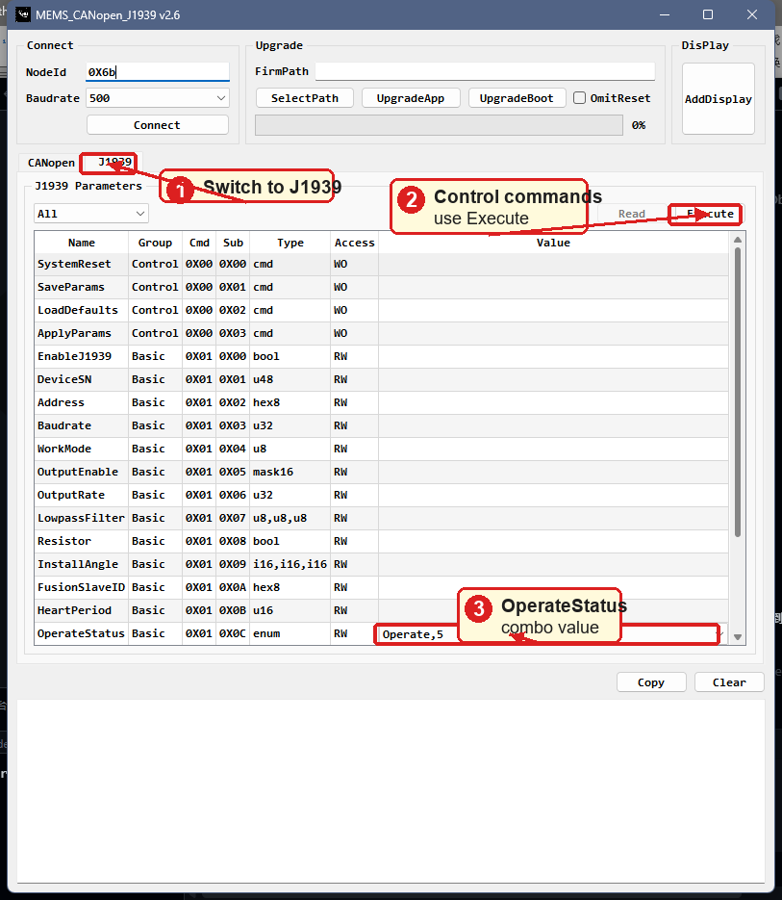
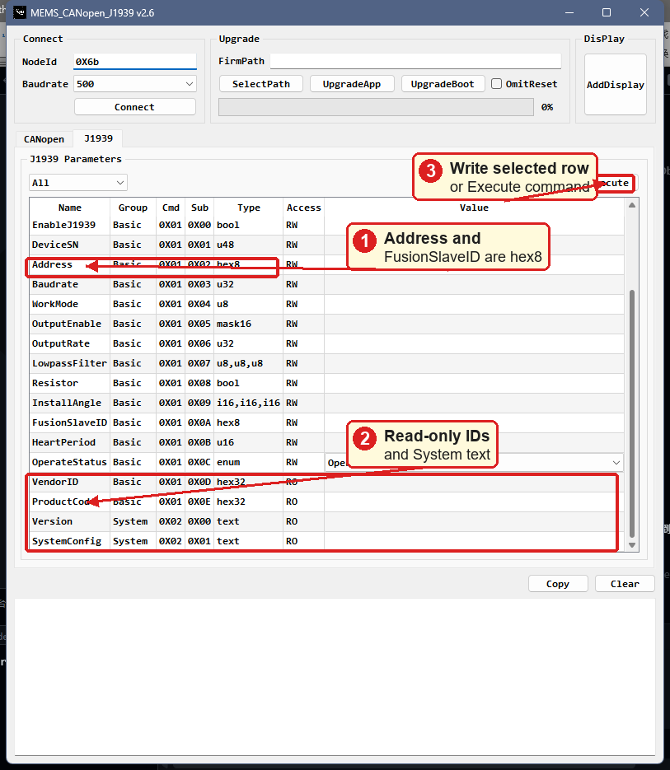

2.4 CAN Bus Connection
- Connect the MCS10 power and CAN wiring according to Section 1.
- Enter NodeId. The valid CANopen node ID range is 0x01 to 0x7F. The same field is used as the J1939 proprietary A target address.
- Select Baudrate. The current software supports 10, 20, 50, 125, 250, 500, 800, and 1000 kbit/s.
- Click Connect. After a successful connection, the button changes to Disconnect and NodeId/Baudrate are locked until disconnection.
Note: The software stores the last valid NodeId and Baudrate and restores them the next time it starts.

2.5 Firmware Upgrade
- Click SelectPath and select a firmware file with the .enc extension.
- Click UpgradeApp for application firmware, or UpgradeBoot for bootloader firmware.
- Watch the progress bar and debug window. Do not power off the device or disconnect CAN during the upgrade.
- Use OmitReset only when the device is already in the required upgrade state and automatic reset should be skipped.
Note: On a busy bus, point-to-point upgrade is recommended. Otherwise disable periodic outputs from other nodes before starting the upgrade.

2.6 Debug Log and Real-Time Display
The debug window records connection state, CANopen SDO results, J1939 PA responses, upgrade progress, and errors. Copy copies the log text. Clear removes the displayed log.
Click Add to open a real-time display window. Select a preset, then click Start to plot and record temporary data. Stop stops acquisition. Clear removes the current plot and temporary recording. Save exports the recorded data to CSV.
Preset | Scale factor
Euler | raw x 180 / 32000 -> deg
Quaternion | raw x 1 / 32000
Accel | raw x 8 / 32000 -> g
Gyro | raw x 500 / 32000 -> deg/s
Mag | raw x 500 / 32000 -> uT
Temp | raw x 1 / 100 -> deg C
Note: The InstallAngle box in the display window is a local display transform in roll,pitch,yaw format. It does not write device parameters.

2.7 CANopen Parameters Tab
The CANopen tab provides SDO access to manufacturer parameters, TPDO quick configuration, NMT commands, and calibration entries.
Control | Behavior
Filter | All, Basic, TPDO, NMT, or Calibration
Read All | Reads all visible readable rows
Read | Reads the selected readable row
Write | Writes an editable row or executes a command row
Double click | Edits a value cell, executes a command row, or reads a non-editable row

2.7.1 CANopen Basic Parameters
Name | Object | Type | Access | Usage
VendorID | 0x1018:01 | hex32 | RO | Vendor identifier
ProductCode | 0x1018:02 | hex32 | RO | Product identifier
DeviceSN | 0x300F:00 | u64 | RO | Device serial number
Version | 0x3008:01 | text | RO | Firmware/version text, block read
SystemConfig | 0x3008:02 | text | RO | System configuration text, block read
BaudRate | 0x3003:00 | u32 | RW | CANopen baud rate
NodeId | 0x3004:00 | hex8 | RW | CANopen node ID, 0x01 to 0x7F
Resistance | 0x3007:00 | u8 | RW | Termination resistor switch
WorkMode | 0x300B:00 | u8 | RW | Device operating mode
DataRate | 0x3006:00 | u32 | RW | Output data rate
LPFOrder | 0x300C:01 | hex8 | RW | Low-pass filter order code
LPFCutoff | 0x300C:02 | hex8 | RW | Low-pass cutoff code
LPFDisable | 0x300C:03 | u8 | RW | Low-pass filter disable switch
J1939Enable | 0x300D:00 | u8 | RW | Enable or disable J1939 function
HeartBeat | 0x1017:00 | u16 | RW | CANopen heartbeat producer time
SlaveId | 0x300E:01 | hex8 | RW | Fusion slave ID
InstallEuler | 0x3005:00 | i16x3 | RW | roll,pitch,yaw in degrees; each value must be a multiple of 90
SaveParams | 0x3001:00 | cmd | WO | Force immediate parameter save
LoadDefaults | 0x3002:00 | cmd | WO | Restore default parameters
Note: InstallEuler is entered as roll,pitch,yaw, for example 0,0,90. The current tool writes 0x3005 as 8 bytes: three little-endian int16 angles followed by two reserved zero bytes. This avoids CANopen abort 0x06070013 caused by a short 6-byte write.

2.7.2 CANopen TPDO Quick Configuration
Rows TPDO1 to TPDO4 are quick-configuration rows. Their Value column is a combo box.
Selection | Effect
Disable | Disable the selected TPDO channel
Euler | Map Euler output to the selected TPDO channel
Accel | Map accelerometer output
Gyro | Map gyroscope output
Mag | Map magnetometer output
Temp | Map temperature output
Quaternion | Map quaternion output
After Write, the tool writes the required communication and mapping objects, then sends Reset Communication automatically.

2.7.3 CANopen NMT and Calibration Rows
Group | Rows | Usage
NMT | ResetComm, ResetDevice, PreOperate, Operate, Stopped | Execute CANopen NMT state commands
Calibration | FactoryAccess, CaliParam0, CaliParam1, CaliStatus, StartCali, StopCali | Factory/calibration rows. Factory-only rows are enabled only after FactoryAccess succeeds.

2.8 J1939 Parameters Tab
The J1939 tab uses proprietary A commands. The target address is taken from the NodeId field in the Connect area.
Control | Behavior
Filter | All, Control, Basic, or System
Read All | Reads all visible readable rows
Read | Reads the selected readable row
Write | Writes the selected row or executes a command row
OperateStatus value | Combo box with Operate,5 and PreOperate,127

2.8.1 J1939 Parameter List
Name | Group | Type | Access | Usage
SystemReset | Control | cmd | WO | Execute device reset
SaveParams | Control | cmd | WO | Force immediate parameter save
LoadDefaults | Control | cmd | WO | Restore default parameters
ApplyParams | Control | cmd | WO | Apply pending parameters
EnableJ1939 | Basic | bool | RW | 0 or 1
DeviceSN | Basic | u48 | RW | Device serial number
Address | Basic | hex8 | RW | J1939 address, displayed/editable in hexadecimal
Baudrate | Basic | u32 | RW | J1939 baud rate
WorkMode | Basic | u8 | RW | Device operating mode
OutputEnable | Basic | mask16 | RW | Output data mask
OutputRate | Basic | u32 | RW | Output data rate
LowpassFilter | Basic | u8,u8,u8 | RW | order,cutoff,disable
Resistor | Basic | bool | RW | Termination resistor switch
InstallAngle | Basic | i16,i16,i16 | RW | roll,pitch,yaw; each value must be a multiple of 90
FusionSlaveID | Basic | hex8 | RW | Fusion slave ID, displayed/editable in hexadecimal
HeartPeriod | Basic | u16 | RW | Heartbeat period
OperateStatus | Basic | enum | RW | Select Operate,5 or PreOperate,127
VendorID | Basic | hex32 | RO | Vendor identifier
ProductCode | Basic | hex32 | RO | Product identifier
Version | System | text | RO | Firmware/version text
SystemConfig | System | text | RO | System configuration text

2.9 Recommended Configuration Workflow
- Connect using the current NodeId and Baudrate.
- Use CANopen Read All or J1939 Read All to confirm communication.
- Modify one parameter at a time and click Write.
- For CANopen TPDO/NMT actions, wait until the debug window shows OK.
- If NodeId, Address, BaudRate, or Baudrate is changed, reconnect with the new value after reset or communication reset.

3 Bulldozer Mode Application
The following applies to MCS10 firmware version A2.6.
Prerequisites: baud rate 500 kbps, J1939 enabled(J1939) or J1939 is not enabled(CANopen).
- Configure the blade sensor: work mode to 0x4, configure the FusionID as the C-Frame sensor ID.
- Configure the C-Frame sensor: work mode to 0x3.
- Configure the body sensor: work mode to 0x1, and configure the output data and output rate.
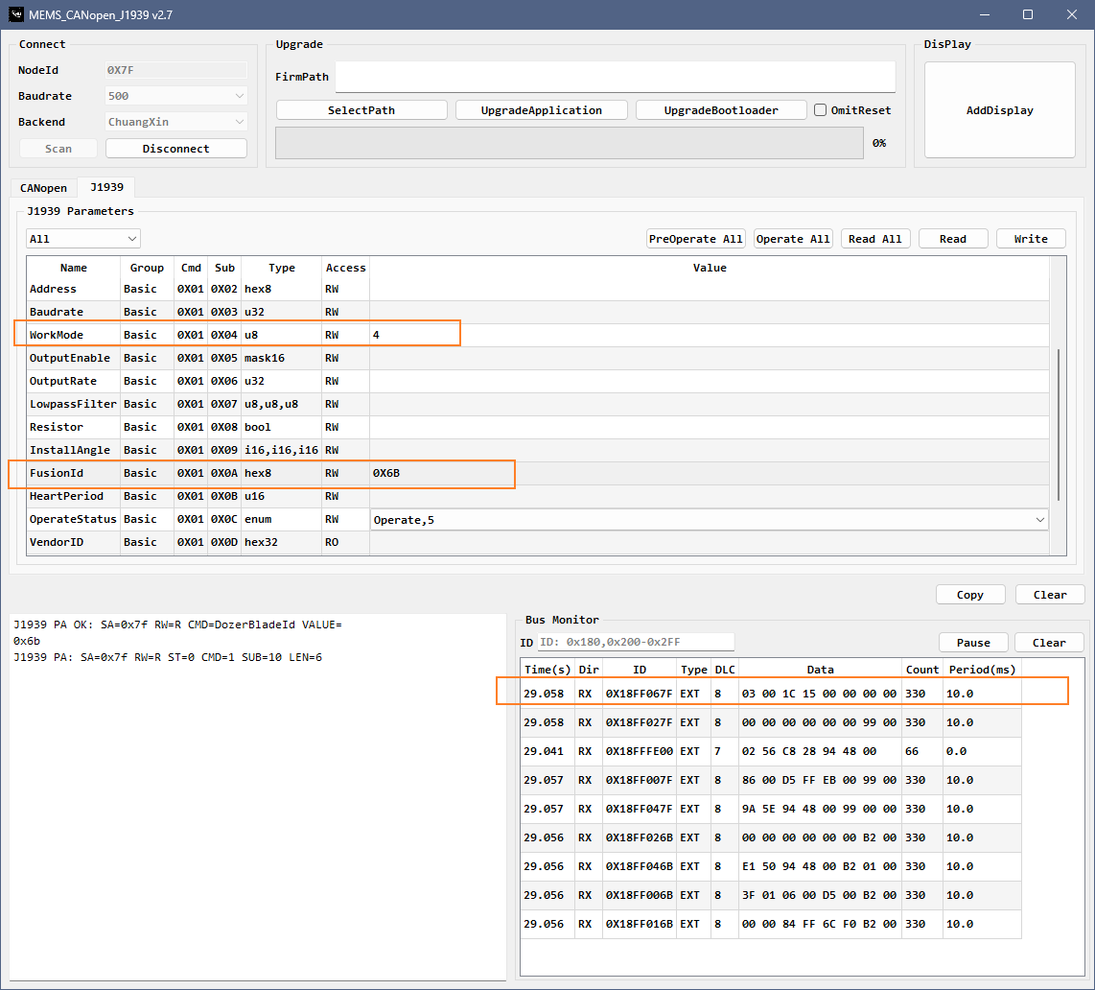
Byte Offset | Parameter | Type | Description
0-1 | Status | uint16 | Flag bits
2-3 | BladeAngle | int16 | Blade angle raw value
4-7 | Reserve | byte[4] | Reserved

Status
No. | Name | Bit Mask | Meaning
1 | Init | 0X0001 | Heading has been established before
2 | Valid | 0X0002 | Current heading is valid

