

**Tribhuvan University**

**Faculty of Humanities and Social Sciences**

**A PROPOSAL REPORT**

**BLOOD BANK MANAGEMENT SYSTEM**

**Submitted to**

**Department of Computer Application**

**Arniko Multiple College**

***In partial fulfillment of the requirements for the Bachelors in Computer Application***

Submitted by

Name: Gobinda Pd Jamakatel

Roll No: - BCA-19-02

February 2022

**Under the supervision of**



**Tribhuvan University**

**Faculty of Humanities and Social Sciences**

**Arniko Multiple College**

**Bhanimandal, Lalitpur**

**Supervisor’s Recommendation**

I hereby recommend that this project be prepared under my supervision by Gobinda Pd Jamakatel and Nitesh Mahat **entitled “BLOOD BANK MANAGEMENT SYSTEM”** in partial fulfillment of the requirements for the degree of Bachelor of Computer Application is recommended for the final evaluation.

**SIGNATURE**

Uddhav Dahal

**SUPERVISOR**

Lecturer

BCA Department

Arniko College

Bhanimandal, Lalitpur



**Tribhuvan University**

**Faculty of Humanities and Social Sciences**

**Arniko Multiple College**

**Bhanimandal, Lalitpur**

**LETTER OF APPROVAL**

This is to certify that this project was prepared by Gobinda Pd Jamakatel and Nitesh Mahat **entitled “BLOOD BANK MANAGEMENT SYSTEM”** in partial fulfilment of the requirements for the degree of Bachelor in Computer Application has been evaluated. In our opinion, it is satisfactory in the scope and quality as a project for the required degree.

|  |  |
| --- | --- |
| <<Signature of Supervisor>>  <<Name of Supervisor>>  BCA Department  Arniko Multiple College  Bhanimandal, Lalitpur | <<Signature of Campus chief>>  <<Name of Campus chief>>  Arniko Multiple College  Bhanimandal, Lalitpur |
| **Internal Examiner** | **External Examiner** |

**Arniko Multiple College**

**Ref no:**

**Date:**

**Subject: Approval of project proposal**

The project entitled “Blood Bank Management system” proposed by Mr. Gobinda Pd Jamakatel and Mr. Nitesh Mahat for the partial fulfillment of the requirement for Bachelor in Computer Application (BCA), the fourth semester has been approved for further development.

**Proposal Evaluation committee**

**1. ______________**

**2.________________**

**3.________________**

**4.________________**

**_________________**

**Mr.**

**Campus Chief.**

**ABSTRACT**

Blood Bank Management System is a web-based system that helps manage all the related work and stuff inside a blood bank, which includes handling blood and donation requests, bloodstock management, etc. It provides an interface for the blood donors and blood receivers.

This project can help people for connecting to the blood bank directly through the system for quick service. The main aim of this project is to make the blood bank management system effectively

and to make the collection and distribution of blood digital.

Table of Contents

Chapter 1 Introduction 1

**1.1 Introduction to Proposed project** 1

**1.2 Problem Statement** 2

**1.3 Objectives** 3

**1.4 Scope and limitation** 3

**1.4.1 Scope** 3

**1.4.2 Limitation** 3

Chapter 2: Literature Review 4

**2.2 Literature Review** 4

Chapter 3: Methodology 5

**3.1 System Development Methodology** 5

3.2 System Analysis 6

3.2.1 System Requirements 6

3.2.2 Feasibility study 7

Tools we use: 7

**3.3 System Design** 8

**3.3.1 System Flow Chart** 8

**3.3.2 ER Diagram** 9

**3.3.3 Use Case Diagram** 10

**3.4 Project Schedule** 11

Chapter 4 Conclusion 12

4.1 Expected Output 12

References 13

Bibliography 13

**List of Figures**

**Figure 3.1:** Waterfall Model …………………………………………….………………5

**Figure 3.3.1:** Flowchart of BBMS………………………….…………………….….......8

**Figure 3.3.2:** ER Diagram of BBMS…………….............................................................9

**Figure 3.3.3.1:** Super-Admin Use Case Diagram ………………….,.…………...…….10

**Figure 3.3.3.2:** Blood Bank Manager Use Case Diagram….............................................10

**Figure 3.3.3.3:** Clients Use Case Diagram........................................................................11

**Figure 3.3.4:** Gantt Chart………………………………………………………………...12

# 

# **Chapter 1 Introduction**

## **1.1 Introduction to Proposed project**

A blood bank is a centralized place that stores blood for its distribution. It collects blood from donors and other sources and provides blood to needy people or hospitals. There would be various processes and tasks in a blood bank between the collection and distribution of blood. It is designed for handling those tasks and processes effectively and easily. It also provides the platform for end-users to donate and request blood.

This system will provide the interface for 3 types of users. One is a Super-admin who creates an account for the blood bank manager (i.e., Admin) and handles the role and permission of the system. The second one is the Admin or Blood bank manager who manages an inventory of blood in the blood bank, handles blood requests and donation requests, manages donors and patients, etc. And the last user is a client who can request the blood as a patient or can make the donation request as a donor. In this system, a donor can be a patient, and also a patient can be a donor with equal permission.

In this system, the super-admin can create its account and log in to the system. It can create, view, update and delete other users of the system. Super-admin also plays its role in managing roles and permissions of the system. The blood bank manager (Admin) logs in to the system with the credential created by the super-admin. This user is responsible for handling donations and blood requests, viewing and updating the bloodstock with each blood group, can generate the blood certificates and blood request approval letter, can manage the clients and their history. The clients have to first register to our system by filling up different types of details. After they logged in to the system, they can make blood requests and also can make a donation requests by filling up the form. They can manage and edit their profiles as well.

Inside the system, there will be a relationship between the donor, the patient, and the admin of the system. A donor makes the donation requests, if the donation request is approved, admin will send the email about campaign address and details, then donor can go to campaign to donate the blood. After the donation is completed then that amount of blood will be added to the stock by the admin, generates a donation certificate, and send to the donor. Also, patients request the blood, the system will check there is available stock for the requested blood or not, patient medical report if everything is fine, If the blood is available, the admin will approve the request and send the approval email and approval letter. Then after patient can download the approval letter and go to blood bank with that approval letter and then blood is provided and also amount of blood is reduced from the stock.

## **1.2 Problem Statement**

It is not the fact that the blood bank management system already doesn’t exist. The blood bank management systems that are already available are not interactive and people might find some issues with their services. The current situation of the blood bank and the blood bank management system were analysed, and the following problems were found.

The problem of the current blood bank management system is listed below:

* Existing systems are slow for emergency case.
* The patient who requests blood online will not get the approval letter from their platform to get the blood from blood bank.
* General people may not have the access to watch the bloodstock available in the blood bank online.

## **Objectives**

The main objectives of this project are listed below:

* To develop a system that makes management of blood banks easy and to provide a platform for the donors and receivers.
* To improve the efficiency of bloodstock management by alerting the blood bank staff when the blood quantity is below its par level or when the bloodstock is expired.
* To store a proper computerized database of blood, donors, and receiver.
* To allow the patients to look up the stock available in the blood bank through our system.
* To give quick responses to the patients when they need the blood in emergency cases.

## **1.4 Scope and limitation**

### **1.4.1 Scope**

* The blood bank management system will be a web-based system that will be implemented in HTML, CSS, JS in the frontend and Django at the backend.
* It will provide the platform for donors, patients, and blood banks.
* Clients will be able to view the bloodstock and make the order accordingly.
* Blood bank managers will be able to manage blood banks with great efficiency and easily.

### **1.4.2 Limitation**

* This system requires an internet connection and the user must be a computer-literate person.
* This system is a web-based system, and its mobile application is not available.
* People in rural areas with no stable internet facilities may not be able to use this system.

# **Chapter 2: Literature Review**

## **2.2 Literature Review**

Teena, C.A, Sankar, K. and Kannan, S. (2014) in their study entitled “A Study on Blood Bank Management”, defined Blood Bank Information System as an information management system that contributes to the management of donor records and blood banks. Their system allowed an authorized blood bank administrator to sign in with a password to manage easily the records of donors and patients who need blood.

The system provided many features including the central database, quick access to the system content through the login, includes the search code to find donors on a given basis, and the ease of adding and updating donor data. The main aim of the system was to complete the process of the blood bank. This system was designed to suit all types of blood banks.

Once successful in the implementation of the application, it can be applied and rolled out in several blood banks. This application contains User Login Screen, Blood Management, Menu Form, Blood Stock, Donor Management, Donor Registration, Blood Reservation, Donor Blood Test, Recipient Management Blood Reservation. Similarly, the researchers planned in their application to have hospital administrators, doctors, and blood bank receptionists as users.

The authors did not mention the research method they used and failed to provide screenshots of the system prototypes, making it difficult for the researchers to visualize their application. No discussion also for their respondents, samples a sampling technique used. Subsequently, the researchers planned to provide figures to explain the system, screenshots of system prototypes, and other diagrams that can help other researchers to visualize the development of a web-based blood bank management system. In addition, the researchers will explicitly discuss its research methods, sampling procedures, and statistical treatment to be used for analysing the gathered data. [1]

# **Chapter 3: Methodology**

## **3.1 System Development Methodology**

To develop this system, we’ve used the traditional waterfall method as we are clear with our requirements and features for the system. It is the linear project management approach. At the beginning of the project, all the requirements are gathered, and a linear project schedule is also created. This model is effective and fast to use when we’ve all the information about our system’s requirementsand requirements won’t be changed often. It is a simple model with ease of use. As this is the sequential approach to developing a particular system, its next phase is started only after the completion of the current phase and cannot be returned.

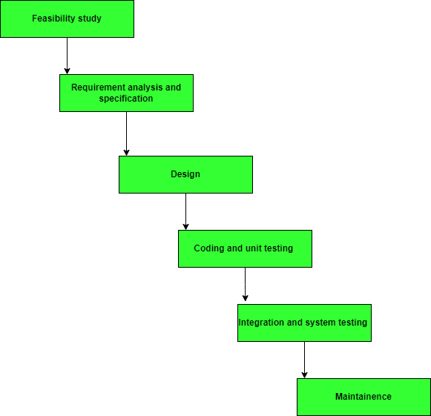

**Figure 3.1: -** Waterfall Model

## 3.2 System Analysis

System analysis is the phase in which facts and information are collected, problems are identified, and the system is decomposed into its components. Mainly, system analysis is done to understand the purposed system and identify its objectives and goals. In simple words, at the end of the phase, it is identified what the system should do. This phase is helpful to know about the business needs and process needs.

### 3.2.1 System Requirements

* **Functional requirements**
  + User registration (Donor/Patient).
  + User login/logout/profile update and management.
  + Request for blood.
  + Request for blood donation.
  + Request handling.
  + Bloodstock management.
  + Individual records.
* **Non-functional Requirements**
  + Maintainability
  + Flexibility
  + Security
  + Availability
  + Performance
  + Scalability
  + Feasible

### 3.2.2 Feasibility study

* **Technical feasibility**

Technical feasibility study defines to understand how feasible is the purpose system will be technical. Is that system is technically acceptable or not? Do we have all the required Technology for developing the purposed system or not? Or do we have enough technical knowledge to develop the purposed system or not? These are the questions the technical feasibility study has to answer.

Here, in our case, there is no technical barrier to the development of our system.

* **Economic feasibility**

This defines how much is the system is economically feasible or cost-effective. This will help to measure if the purposed system is economically feasible or not, to develop that system by the proper calculation and estimation of cost, and its future possible incomes. In our case, excepting the cost of the internet, there are no other costs to develop our system. So, this project has no economic barriers. In our case, excepting the cost of the internet, there are no other costs to develop our system. So, this project has no economic barriers.

* **Operational feasibility**

This feasibility study measures how easy is the system is to operate. After the completion of our system, there will be no hurdles to use our system. This system will be easy to use because of its user-friendly interface. To use our system, any well-trained people are not required, a person with a minimum understanding of the English language can easily operate our system.

## Tools we use:

* **Frontend**
  + HTML
  + CSS
  + JS
  + Bootstrap
* **Back-end**
  + Python/Django
  + SQLite3

## **3.3 System Design**

### **3.3.1 System Flow Chart**

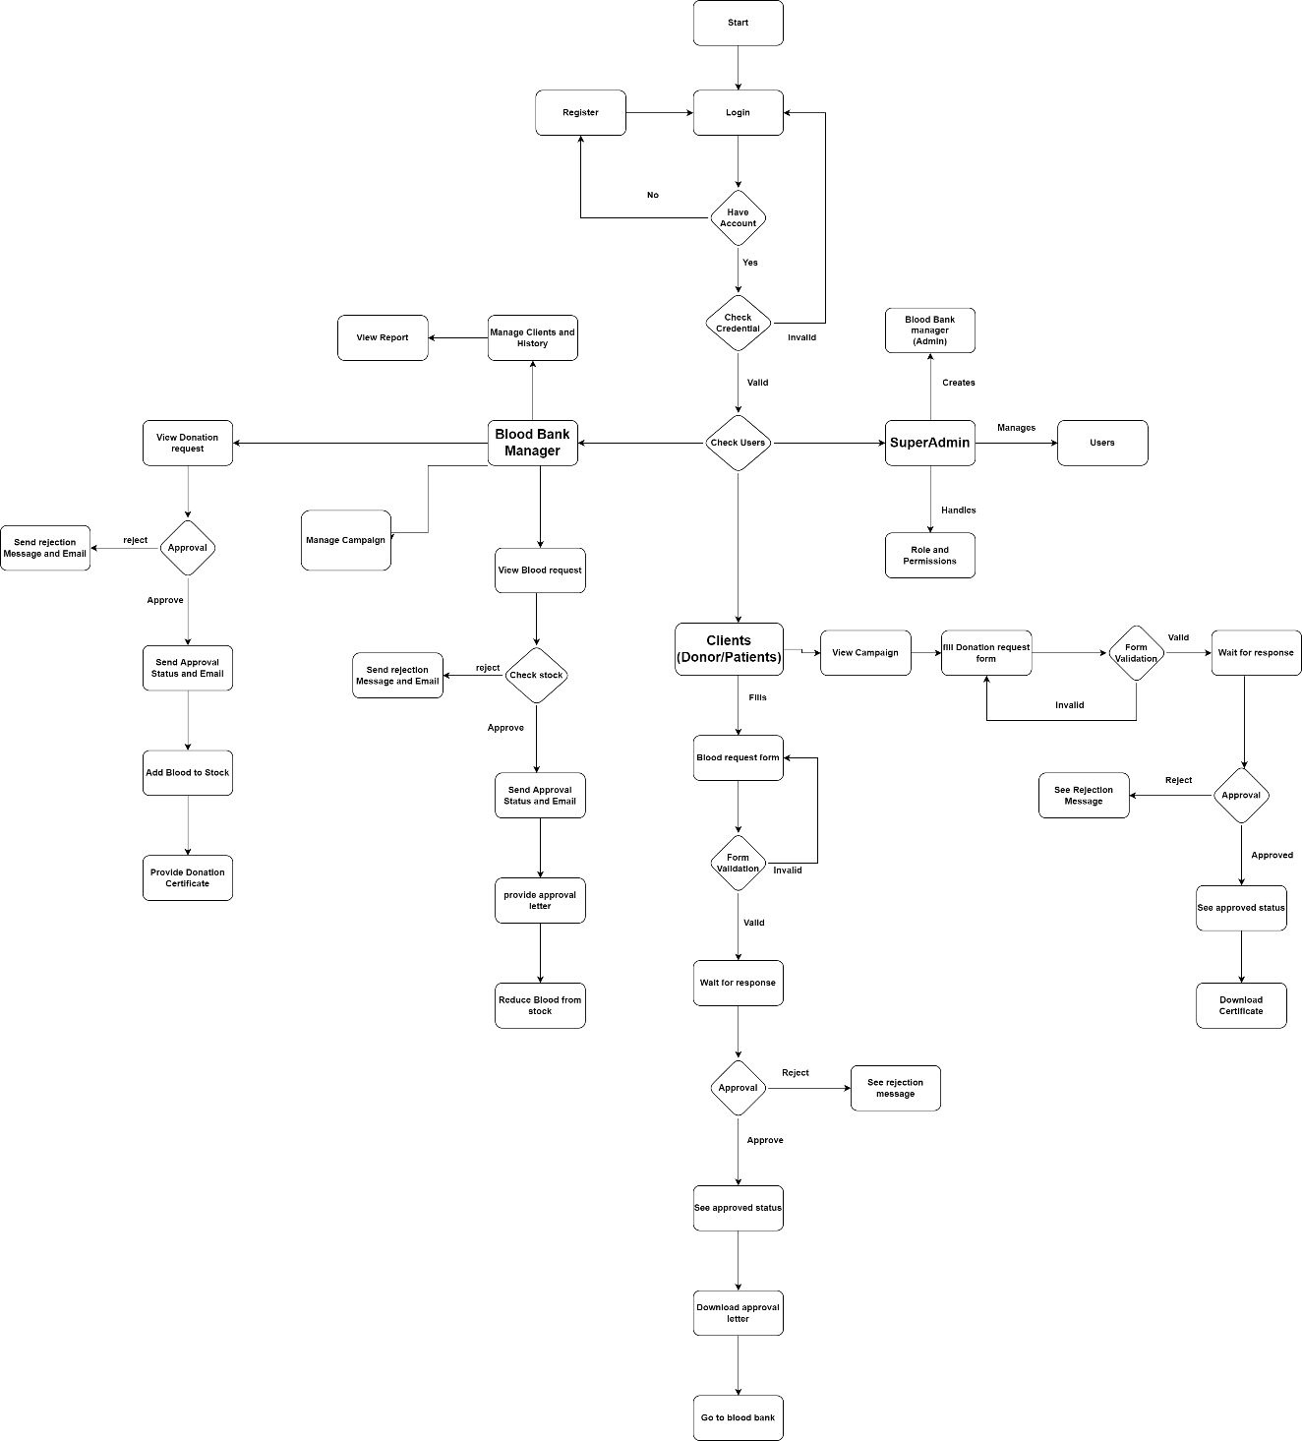

**Figure 3.3.1**: - Flowchart of BBMS

### **3.3.2 ER Diagram**

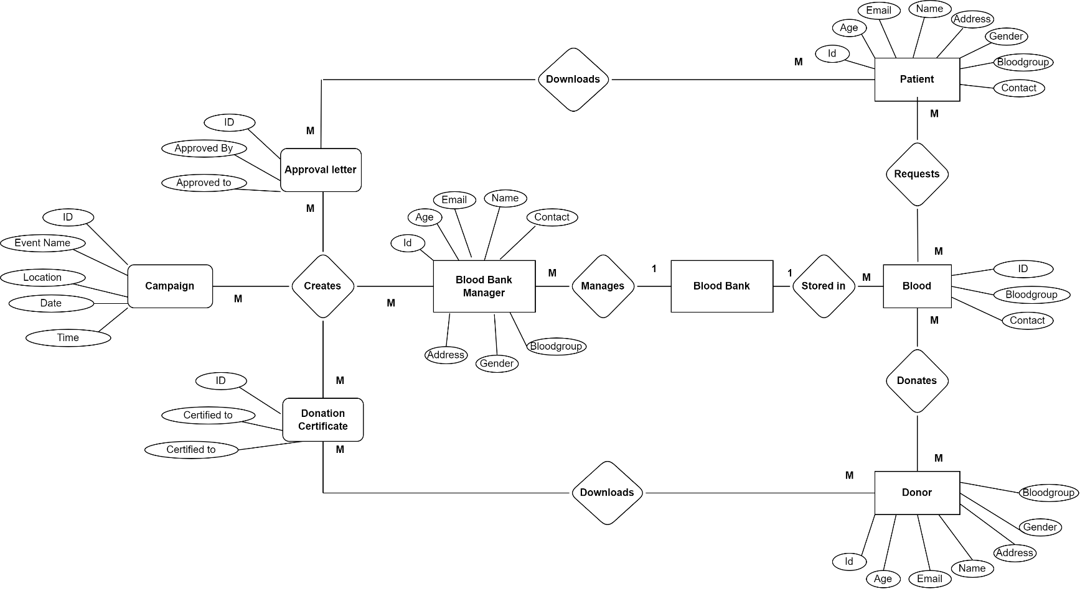

**Figure 3.3.2**: - ER Diagram of BBMS

### **3.3.3 Use Case Diagram**

* 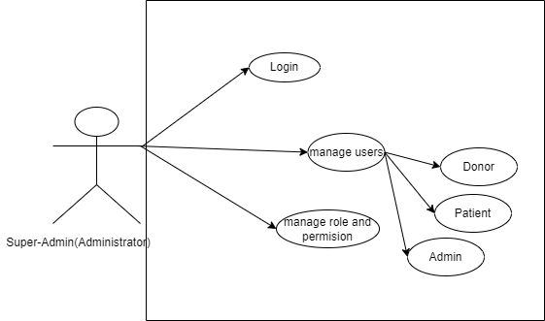**Use Case for Super-admin**

**Figure 3.3.3.1**: - Super-Admin Use-Case Diagram

* **Use Case for Blood Bank Manager (Admin)**

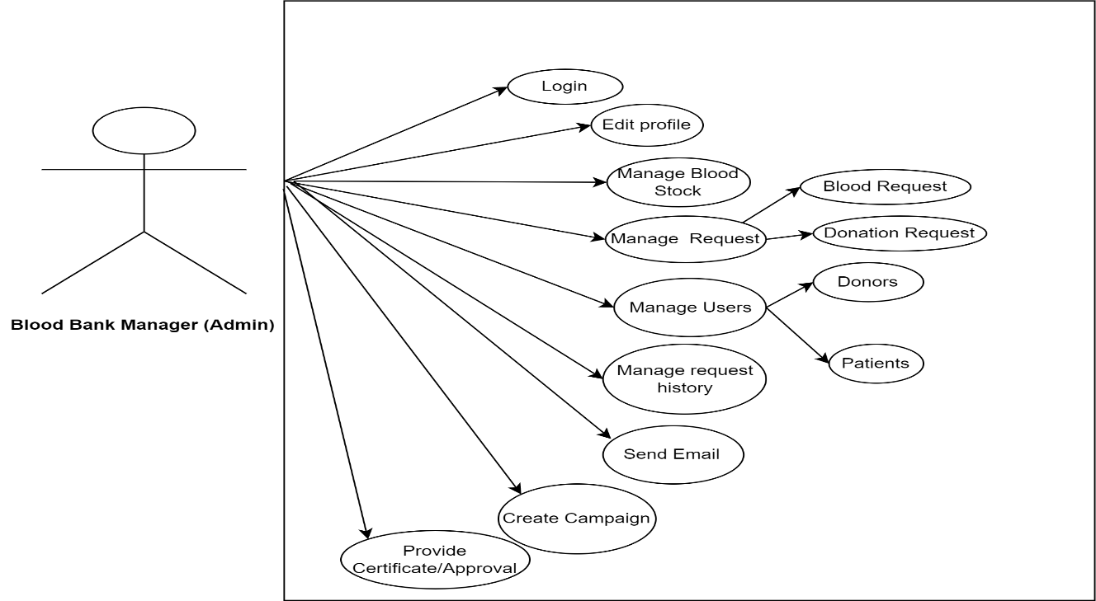

**Figure 3.3.3.2**: - Blood Bank Manager (Admin) Use-Case Diagram

* **Use Case for Clients (Donor/Patients)**

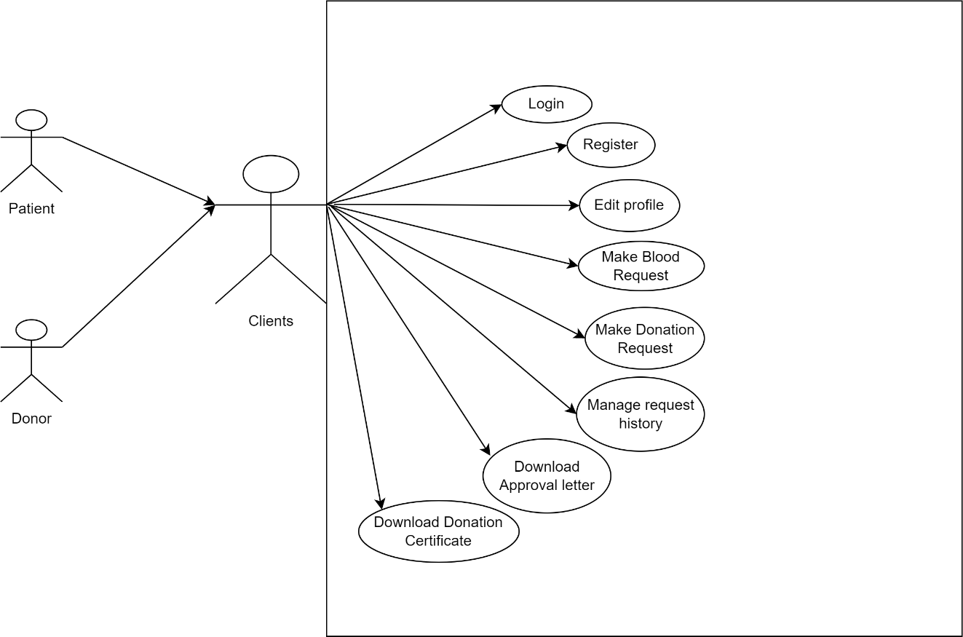

**Figure 3.3.3.3**: - Use Case Diagram for Clients (Donor/Patient)

## **3.4 Project Schedule**

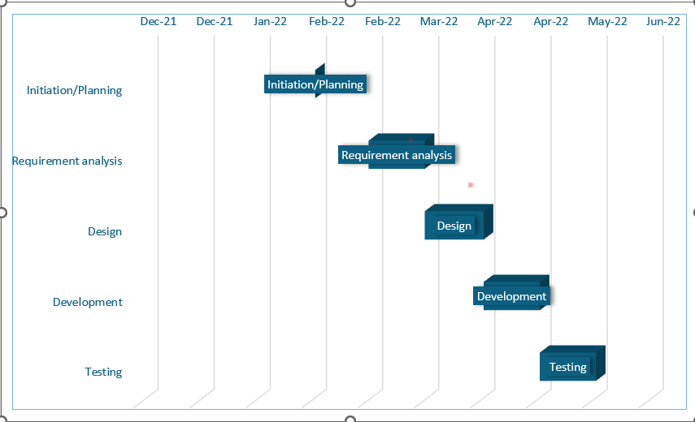**3.4.1 Gantt Chart**

**Figure 3.4: -** Gantt Chart

# Chapter 4 Conclusion

This project will be really helpful for solving the issues of blood bank management. People can rely on this system to donate blood and request blood. This system has the betterment in the user interaction and transparency of bloodstock. Through this platform, people can be connected to the blood bank easily when in an emergency. Our system has a feedback system that helps us to improve the system accordingly.

## 4.1 Expected Output

When the project is completed, blood bank management will be easier and more effective. People will be able to connect digitally with the blood bank for blood donation and blood requests. This will improve transparency on the bloodstock in the blood bank. People who donate blood will get a blood donation certificate for their appreciation.

# References

# Bibliography

1. HamedAl-WashahiNawaf, AhmedAal-abdulsalamAlsafa, Al-MamariAfrahSulaiman, (October 2018), Applied Research Project Report*,* [*Enhancing Blood Transfusion Safety Through the Use of Online Blood Bank Management System in Oman*](https://www.researchgate.net/project/Enhancing-Blood-Transfusion-Safety-Through-the-Use-of-Online-Blood-Bank-Management-System-in-Oman)[online] Available at:

<https://www.researchgate.net/publication/328305822_Blood_Bank_System/link/5bc59176458515f7d9bf4a58/download>  
https://github.com/sumitkumar1503/bloodbankmanagement