(Abdelhakim Boukerdoun)
Level 3 software development

Portfolio



Contents

1. Introduction 3
2. Requirements Gathering 3
3. Analysis 4
4. Design 4
5. Development 5
6. Source Development and Validation 6
7. Version Control and Collaboration 6
8. Testing 8
9. Deployment 9
10. Result 10
11. Reflection 10

Introduction
This portfolio documents a workplace-based project completed within a professional Customer Communications Management (CCM) environment. The project focused on applying object-oriented programming principles to a real production script used within a CCM environment. In my role as a CCM Developer, I work with Quadient Inspire Designer, Inspire Automation, and Node.js scripts that support document production processes.
The project involved analysing and refactoring an existing production script called SplitOutput, which had originally been developed using the Groovy programming language and was used within a live document processing environment. The script was responsible for processing customer data files, applying business validation rules, and routing records to different output files based on the outcome of those validations.
Although the script was fully operational and met business requirements, it had evolved over time and had become increasingly difficult to maintain, understand, and enhance. The existing implementation contained tightly coupled logic, limited error handling, and sections of code that were challenging to test and troubleshoot. As a result, future modifications carried a greater risk of introducing defects or impacting production processes.
The objective of this project was to review the existing solution and improve its overall quality by applying software engineering best practices and object-oriented programming principles. This included restructuring the code into smaller, more manageable components, improving readability through clearer naming conventions, enhancing validation and exception handling, and creating a design that would be easier to test, maintain, and extend in the future.
A key requirement throughout the project was to preserve the existing business functionality and ensure that the refactored solution continued to produce the same outputs as the original production script. By modernising the design while maintaining operational compatibility, the project delivered a more robust and maintainable solution that supports long-term development and reduces future maintenance effort.

Requirements Gathering
During the requirements gathering stage, I identified the key business and technical requirements. The refactored solution needed to maintain the existing production behaviour while improving the code structure. The system had to continue processing CSV files, validating records, generating output files, and producing summary reports.
I also identified non-functional requirements, including maintainability, readability, scalability, and testability. The project needed to follow team coding standards and support future enhancements without introducing risk to the production process.
The SplitOutput.js refactoring project was selected in discussion with my mentor because it addressed a genuine business requirement within the production CCM environment. The existing script was responsible for processing customer data files and routing records based on validation rules. While the script was fully functional, it had become difficult to maintain due to its procedural structure and limited error handling.
The objective of the project was to improve maintainability, readability, testing capability, and long-term support without affecting the existing business functionality. By completing this project, I was able to apply object-oriented programming principles within a real workplace environment while delivering value to the business through improved code quality and reduced maintenance effort.

3. Analysis
During the analysis stage, I reviewed the original procedural script and identified several limitations. The code contained global variables, limited error handling, and tightly coupled logic that made testing difficult. I analysed the existing workflow and separated the process into distinct stages, including configuration loading, file preparation, row processing, validation, and report generation.
This analysis allowed me to understand how each component interacted and provided a foundation for the object-oriented redesign.

4. Design
The design stage focused on converting the procedural script into an object-oriented solution. I designed a SplitOutput class that would encapsulate configuration, processing logic, validation functions, counters, and reporting functionality.
The constructor was designed to accept configuration values and store application state. Individual methods were created for loading header maps, preparing output files, processing records, validating required fields, validating dates, and generating reports. This design improved the separation of concerns and supported unit testing.

Title: Figure 1 SplitOutput class constructor
Description: This shows the constructor accepting a configuration object and storing application state, including file paths, processing flags, the header map, and the valid/invalid/large-print counters. This encapsulation replaces the global variables used in the original procedural script.

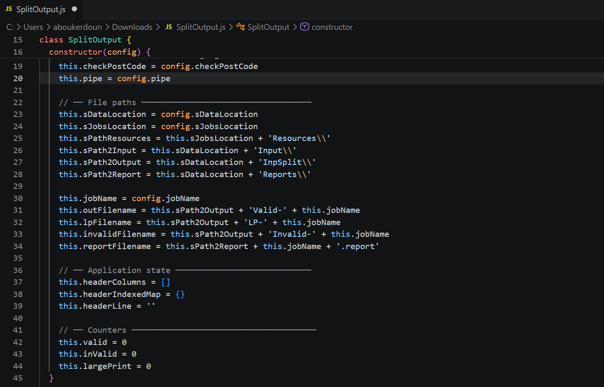

Title: Figure 2 — loadHeaderMap() method
Description: This method reads HeaderMap.txt, builds the indexed column map used throughout the class, and throws a descriptive error if the file is missing or malformed, demonstrating the try/catch error handling referenced in the Development section.

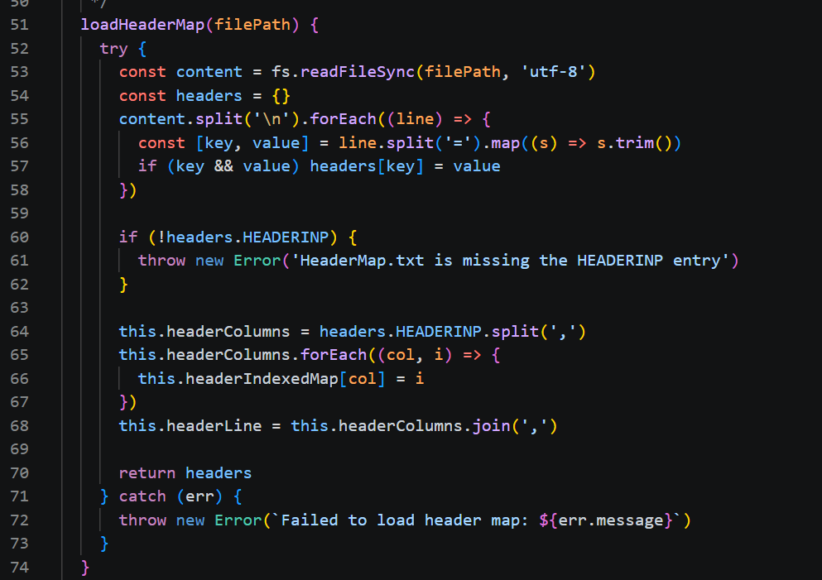

Title: Figure 3 — parseDate_ddMMyyyy() method
Description: This method validates that a date string strictly matches the dd/MM/yyyy format and rejects calendar-invalid dates (such as 31/13/1990), preserving the original Groovy SimpleDateFormat behaviour.

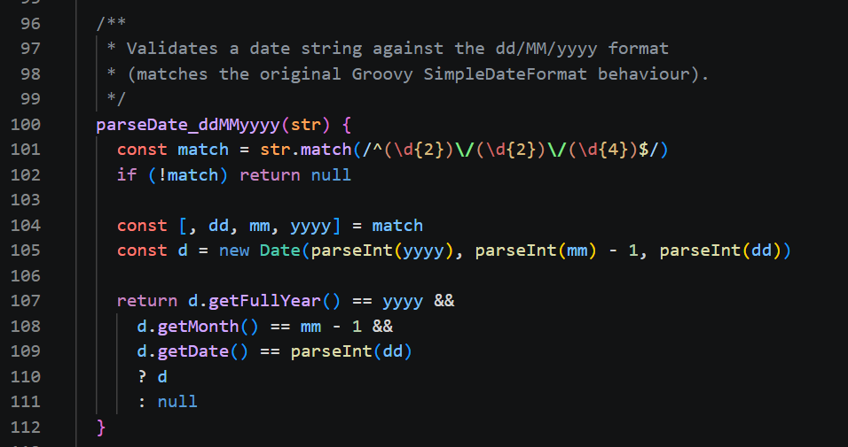

Title: Figure 4 — checkRequiredFields() method
Description: This method validates the mandatory fields on each row, applying the ignoreTitleCheck and checkPostCode configuration flags to determine which fields are required, matching the original business rules exactly.

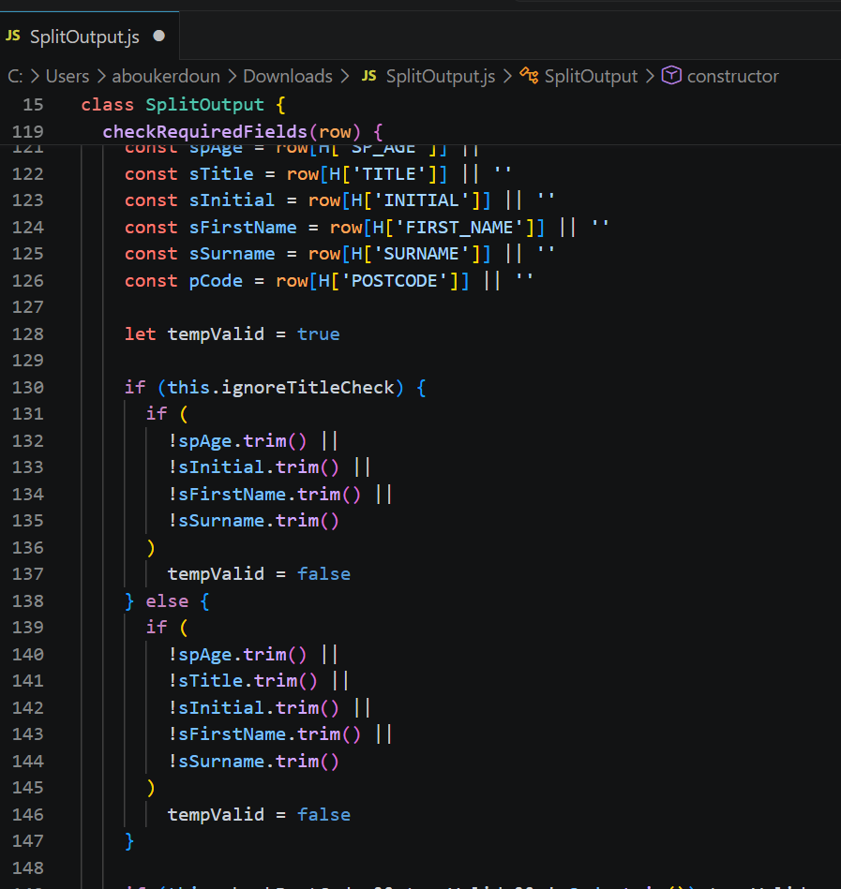

5. Development
During development, I implemented the SplitOutput class in Node.js. The class structure included methods such as run(), loadHeaderMap(), prepareOutputFiles(), processInputFile(), processRow(), checkRequiredFields(), parseDate_ddMMyyyy(), writeReport(), and getSummary().
I also improved variable naming by applying team coding standards. Descriptive names replaced short variable references, making the code easier to read and maintain. Error handling was added using validation checks and try/catch processing to improve reliability.
Once the class was implemented, I ran it against sample data alongside the original procedural script to confirm that the refactored solution produced identical results. Records were routed to the same Valid, LargePrint, and Invalid output files in every test case, and the generated summary report matched the original format and counts exactly. This confirmed that the object-oriented redesign preserved the existing business behaviour while improving the internal structure of the code.

Title: Figure 5 — processRow() method
Description: This method routes each record to the correct output file (Valid, LargePrint, or Invalid) based on the validation and date-check results, incrementing the appropriate counter as it goes — this is the core routing logic for the application.

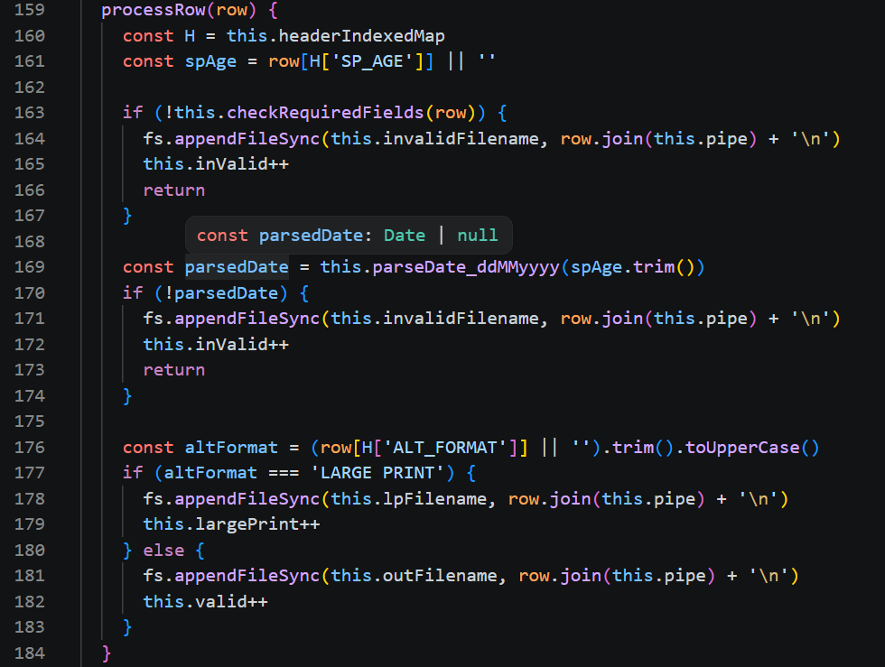

Title: Figure 6 — writeReport() and getSummary() methods
Description: These methods generate the final summary report file and return a structured summary object containing the valid, large print, invalid, and total record counts for the run.

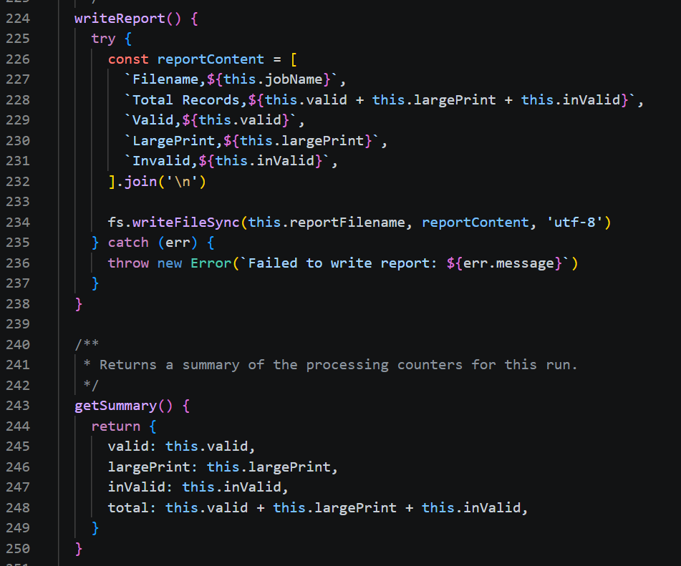

Title: Figure 7 — run() orchestration method
Description: This method ties the class together, calling each step in sequence (load header map, prepare output files, process input, write report) and wrapping execution in a try/catch block to catch and log any failure during the run.

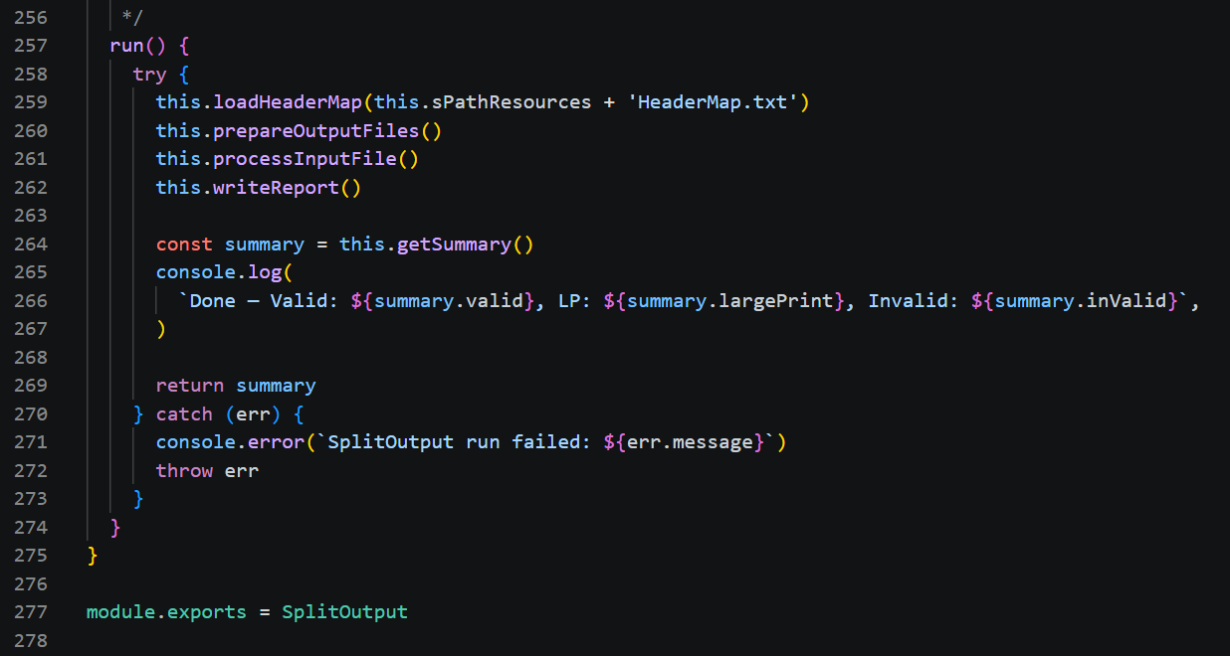

Database Principles and Data Sources

Although this project did not directly connect to a traditional database, it demonstrated my understanding of structured data sources and database principles.
The primary data source used by the application was a CSV file containing customer records. The HeaderMap.txt file acted as a configuration source that defined the expected column structure and field mappings.
In software development, relational databases such as MySQL, Microsoft SQL Server, and PostgreSQL store data within structured tables linked by relationships. These databases use Structured Query Language (SQL) to retrieve and manipulate data efficiently.
Non-relational databases, often referred to as NoSQL databases, such as MongoDB, Cassandra, and DynamoDB, store data in flexible formats including documents, key-value pairs, or collections. These databases are commonly used when applications require scalability and flexible data structures.
Although the SplitOutput.js solution used file-based data sources rather than a database, the same principles of data validation, integrity, and structured processing were applied. Understanding both relational and non-relational database technologies is important when designing software solutions that manage large volumes of business data.

6. Source Development and Validation

The application processes data from two primary sources: a CSV customer data file and a HeaderMap.txt configuration file. The HeaderMap file defines the expected column structure, while the CSV file contains customer records.
Validation was implemented to ensure that required fields are present and that dates are correctly formatted. Records failing validation are routed to an invalid output file, while valid records are directed to the appropriate output destination. This approach helps maintain data quality and processing accuracy.

7. Version Control and Collaboration
Throughout the project, I followed professional development practices by maintaining structured code and documenting changes. Using clear method names, consistent coding standards, and modular design principles made the solution easier to review, test, and maintain.
These practices support collaboration by allowing other developers to understand and modify the code efficiently while reducing the risk of introducing defects.

Development Process Using Git:
- I initialised a local repository:
- git init
- I added my project files:
- git add.
- I committed my changes regularly with clear messages:
- git commit -m "Added form validation"
- I connected my project to a remote GitHub repository:
- git remote add origin <repository-link>
- I pushed my code to GitHub.
Explanation:
Using GitHub allowed me to:
- Track changes and maintain version history
- Revert to previous versions if errors occurred
- Work on my project from different locations
- Organise and manage my code efficiently
This demonstrates how I used version control to support collaboration and manage a shared codebase, even when working independently.
I demonstrated my understanding of secure development principles by implementing input validation and preventing unsafe data handling.
I demonstrated my ability to use version control tools (GitHub) to manage my code, track changes, and support collaborative working practices.

Evaluation of Coding Standards

Coding standards play a critical role in both individual and team development environments. During this project, I followed organisational coding standards by using meaningful variable names, consistent formatting, modular methods, and clear code structure.
The use of coding standards improved readability and reduced the time required to understand the code. This is particularly important when multiple developers are responsible for maintaining the same application. Consistent coding practices also simplify debugging, testing, code reviews, and future enhancements.
If coding standards are not followed, software projects can become difficult to maintain, resulting in increased development costs and a higher risk of introducing defects. Through this project, I recognised that coding standards are not only a technical requirement but also an important factor in supporting collaboration and long-term software quality.

8. Testing
A comprehensive testing approach was implemented to verify that the refactored SplitOutput.js solution behaved as expected and preserved the original business functionality. A Jest test suite containing twelve test cases was developed to validate key areas of the application, including header map loading, mandatory field validation, date validation, output routing logic, error handling, report generation, and end-to-end file processing. The testing process included both valid and invalid input scenarios to ensure that records were processed correctly and that validation failures were handled appropriately.

Equivalence partitioning and boundary value analysis techniques were used to identify suitable test scenarios and reduce the number of test cases while maintaining effective coverage. Testing confirmed that valid records were successfully processed and routed to the correct output files, while invalid records were identified and redirected to the appropriate exception outputs. Additional tests verified that missing configuration files generated suitable error messages and that summary reports were produced accurately. All planned tests passed successfully, demonstrating that the object-oriented refactoring maintained the existing business behaviour while improving maintainability, reliability, and overall software quality.
The twelve-test Jest suite was implemented in SplitOutput.test.js and organised into four groups matching the application’s core responsibilities: loadHeaderMap (header map loading, including a missing-file error case), checkRequiredFields (mandatory field validation under both standard and strict postcode rules), parseDate_ddMMyyyy (date validation for valid, calendar-invalid, and malformed inputs), and processRow (routing of standard, large print, and invalid records). A final end-to-end test ran the complete process against a sample input file and confirmed that the generated summary report matched the expected valid, large print, and invalid counts exactly. Running the suite confirmed all twelve tests passed successfully.

9. Deployment
The solution was designed to operate within the existing production environment. The refactored code maintained compatibility with current file structures, data formats, and operational processes. Deployment could therefore be completed without changes to upstream systems or business workflows.

Evaluation of Secure Development Principles

Security was an important consideration throughout the refactoring process. Input validation was implemented to ensure that required fields were present and that data was correctly formatted before processing. Invalid records were identified and routed appropriately to prevent corruption of output files.
Error handling mechanisms were also implemented using validation checks and controlled exception handling. These controls reduced the likelihood of unexpected system failures and improved the reliability of the solution.
Without secure coding practices, invalid or malicious data could enter downstream processing systems, potentially causing production failures, inaccurate reporting, or data quality issues. The implementation of secure development principles therefore, contributed to system stability, data integrity, and business continuity.
This project demonstrated how secure coding practices can be incorporated into everyday software development activities while supporting maintainability and operational reliability.

10. Result
The project successfully transformed a procedural production script into a maintainable object-oriented solution. The new design improved readability, testability, error handling, and maintainability while preserving the original output behaviour. The solution also introduced a structured testing approach that provides confidence in future changes.

11. Reflection

Object-Oriented Programming Benefits
The use of object-oriented programming provided several advantages compared to the original procedural design. Encapsulating functionality within the SplitOutput class reduced dependency on global variables and improved organisation of the codebase.
Methods were grouped according to their responsibilities, improving the separation of concerns and making the solution easier to test and maintain. The constructor allowed configuration and application state to be managed consistently throughout execution.
The object-oriented approach also supports future enhancements by allowing additional functionality to be added without significantly affecting existing code. This improves scalability and reduces maintenance effort over the long term.
This project provided valuable experience in analysing and improving an existing production application. I learned that refactoring requires a detailed understanding of existing functionality before making architectural changes.
The project strengthened my understanding of object-oriented programming, coding standards, testing methodologies, and secure development practices. It also demonstrated the importance of maintainable code in professional software development environments.

